Rate My _____

CS 411

March 24, 2016

Project Assignment 3

Part 1 - Authentication Diagram

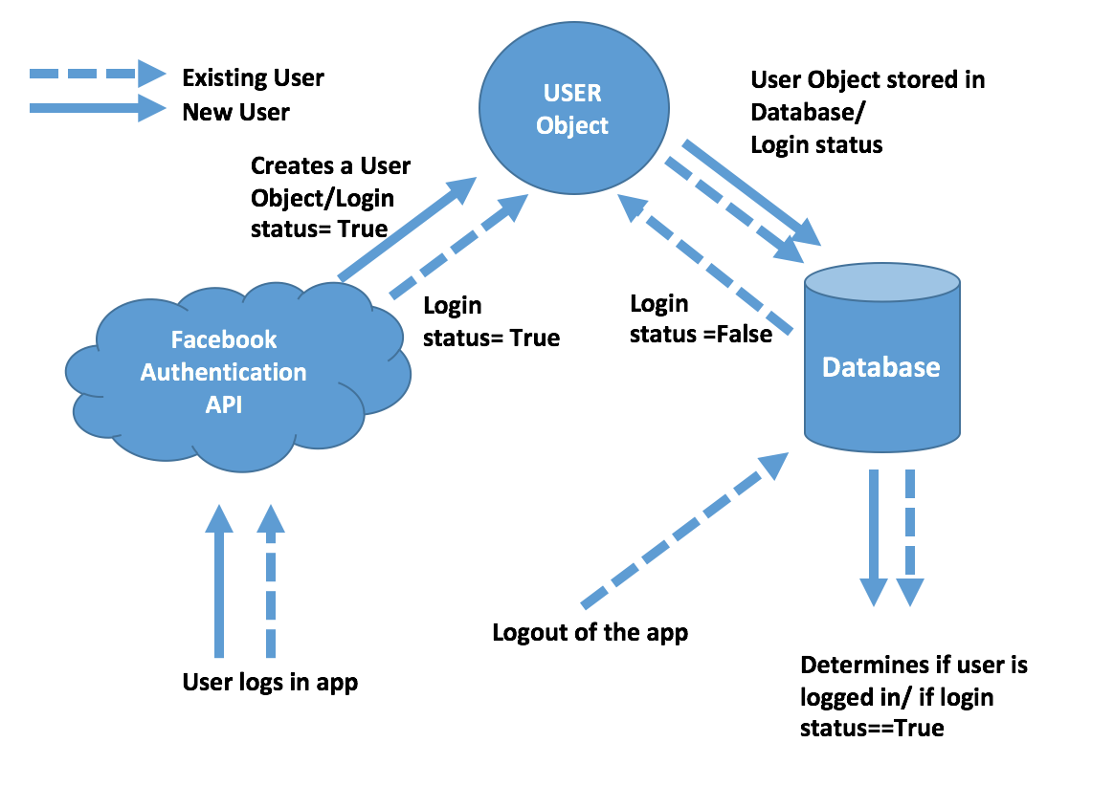

Part 2 - Flow Diagram for search:

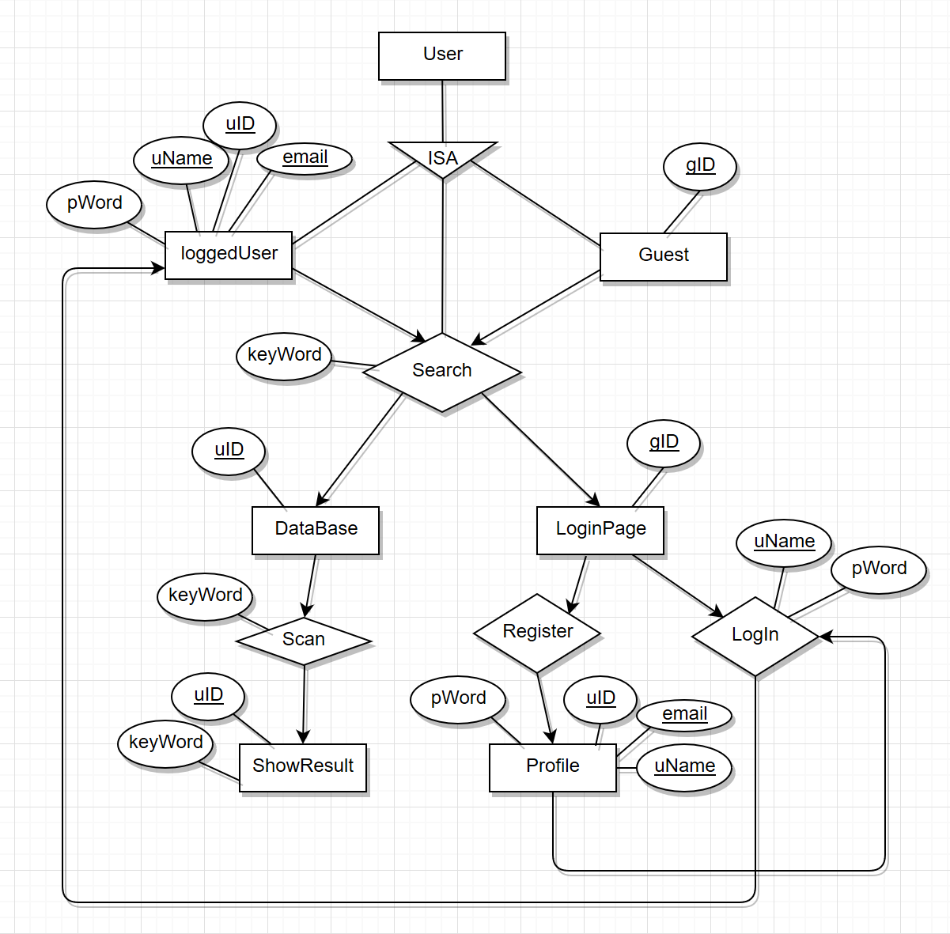

Part 3 - See updated use case documentation

Part 4 - platform choice:

We decided to use the flask platform. It is a micro web-framework written in Python. It is simple and straightforward using python approach. The flexibility it provides is a huge advantage. We can scale up the project simply through extensions, and it can be any choice we want. Another advantage is it provides great documentation so that all of us can learn the platform quickly.

JSP is an alternate platform and it is not the correct choice. The language itself requires us to mix html markup and java code which would be very painful to learn. Even if we eventually learned how to use the language, it is very inefficient to write both jsp and java code. It also requires a compatible web server with a servlet container like Tomcat to run the pages, which is also painful setting up.

Part 5 - Github Link and Demo Page:

<https://github.com/scarleth095/Rate-My-___>

[http://Cherchenko.com/index2.html](http://cherchenko.com/index2.html)