🚀 24/03/2026
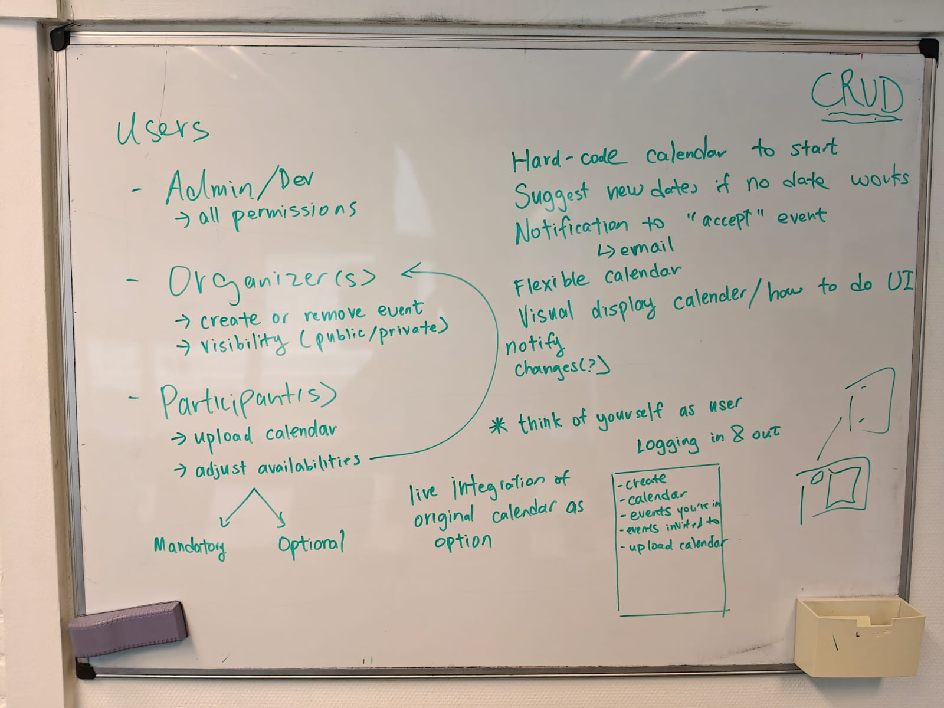

CRUD –
User stories

- Must have (M):

- Should have (S):
- Could have (C):
- Won't have (W) (this time):

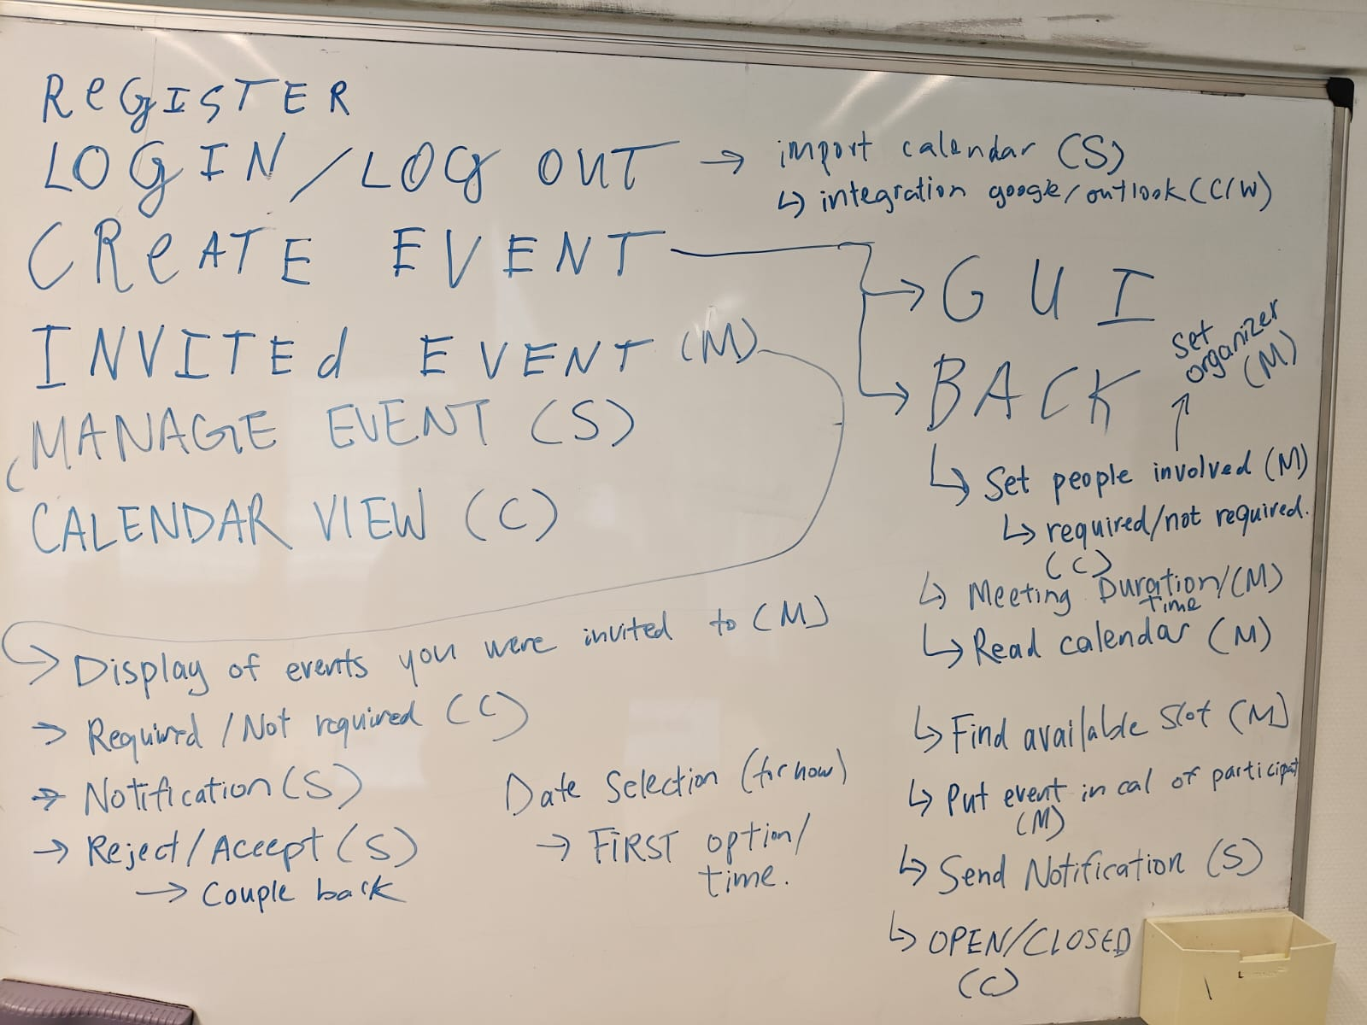

🖱️ 25/03/2026
- Chose PPs (to start)
- Figured out git incorporation
- UML Use case diagram
- UML Class diagram

💹 26/03/2026
