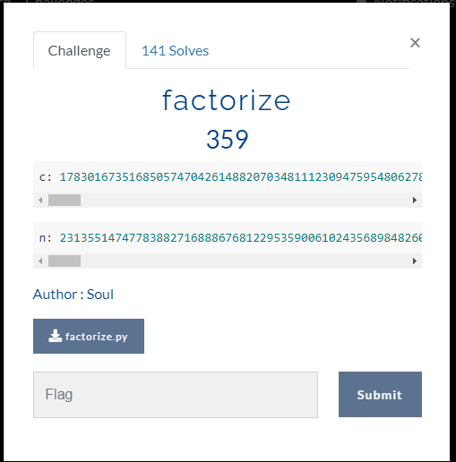

Factorize py

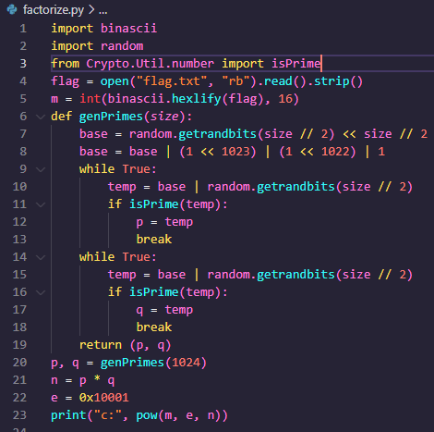

I search the factor of n using <https://www.alpertron.com.ar/ECM.HTM> and get 2 different factor



After that we calculate the value of phi(n) = (p-1)(q-1) where p and q is the factor of n(Euler’s totient function)

This is python code I wrote to decrypt the ciphertext(c)

I got e from factorize.py(e = 0x10001 which is hex number and convert it to decimal)

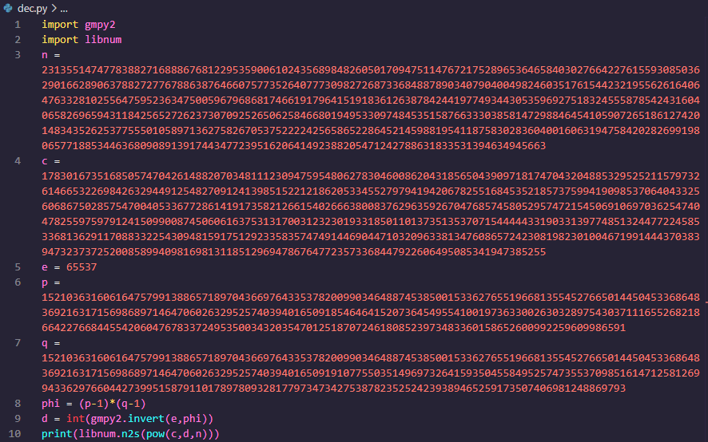

Run it

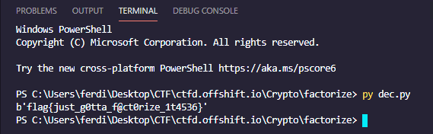

And we got the flag!