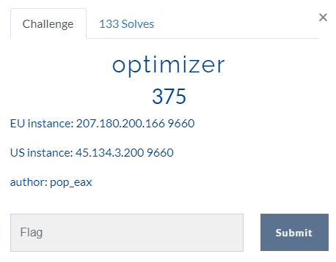

In this challenge I using python to get the flag

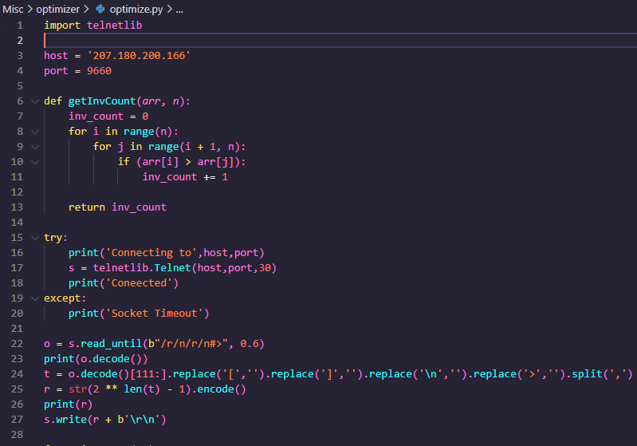

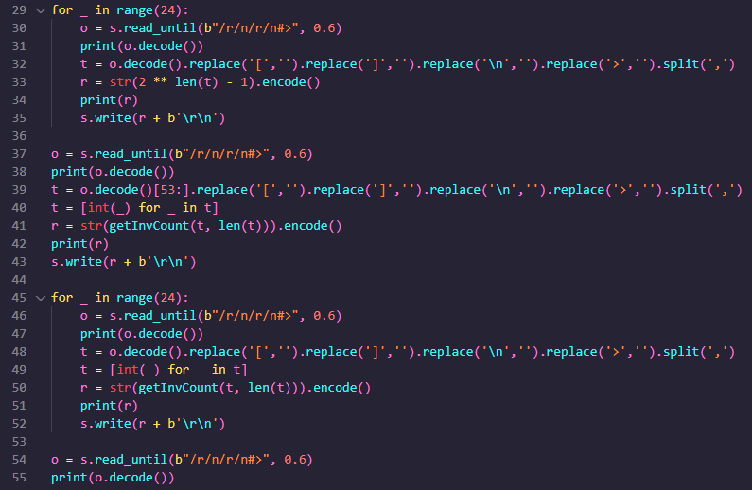

In this code I just loop through the question and answer it. After 50 questions(25 tower of hanoi move count and 25 merge sort inversion count) you get the flag

