Nominet Coding Challenge
Test Document
Author Steve: Cartwright

Table of Contents
Contents
Introduction 3
Test 1 4
Test 2 5
Test 3 6
Test 4 7
Test 5 8
Test 6 9
Test 7 10
Test 8 11

Introduction

In this test document there are presented several system level tests that verify the correct operation of the code developed to satisfy the Nominet Code Challenge. Each test is broken down into Description, Expected Result and Actual Result. The actual result contains a screen shot of the output on the required platform.
Given that each test requires modifications to (or deletion of) the input.txt file it was decided to execute the tests manually, ie edit the input.txt file manually with the vi editor, if necessary print out the updated data in input.txt with a ‘cat input.txt’ command and manually record the results with a screen shot and copy the screen shot into this document to have proof that each test passed.
For the purposes of these tests a terminal was opened in the directory where the grid.jar application file and the input.txt file were located. The program was executed with the following command line:
java -jar grid.jar

Test 1
Description: Verify that the program runs with an input file in the same directory as the application code. The input file in this instance will contain the following.
10 10
1 2 5 1
2 0 6 3
3 1 2 2
4 3 5 3
1 0 1
2 8 8
3 6 5

Expected Result: Verify that the following output is printed to a terminal window.

2 / 3
4 5

Actual Result(Linux):
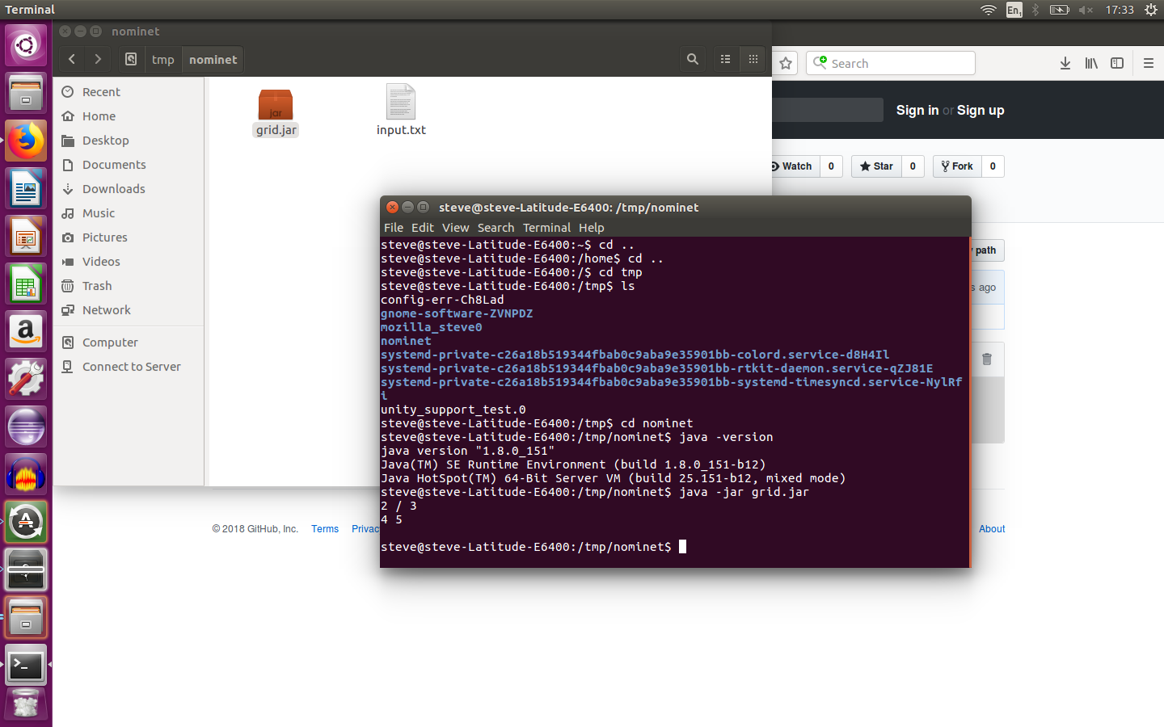

Test 2
Description: Test what happens when an input file called input.txt is not contained in the same directory.

Expected Result: An error message containing the following text is displayed.

Unable to find input.txt

Actual Result(Linux)
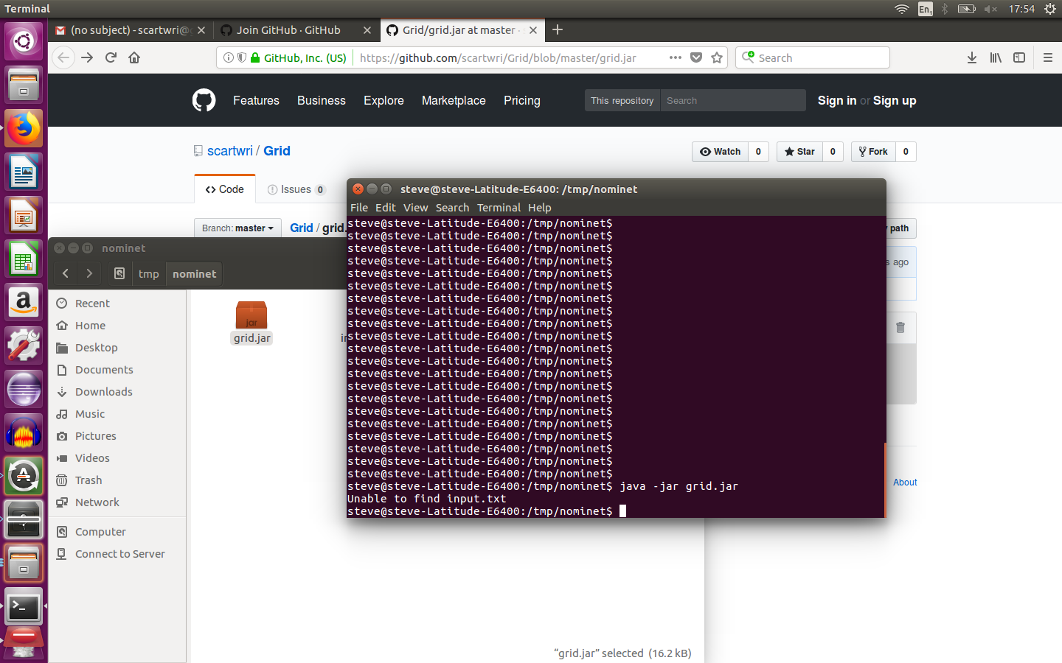

Test 3
Description: Test what happens when the input file contains a blank line.

Expected Result: An error message containing the following text is displayed.

Input File Format Error, exiting..

Actual Result(Linux)
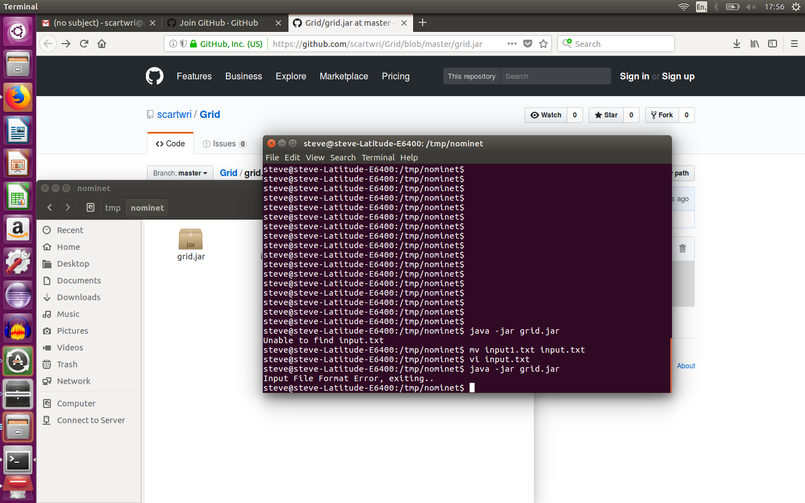

Test 4
Description: Test what happens when the input file contains a badly formatted line of data.In this case the first line contains ’10 10 aa bb’:
10 10 aa bb
1 2 5 1
2 0 6 3
3 1 2 2
4 3 5 3
1 0 1
2 8 8
3 6 5

Expected Result: An error message containing the following text is displayed.

Input File Format Error, exiting..

Actual Result(Linux)
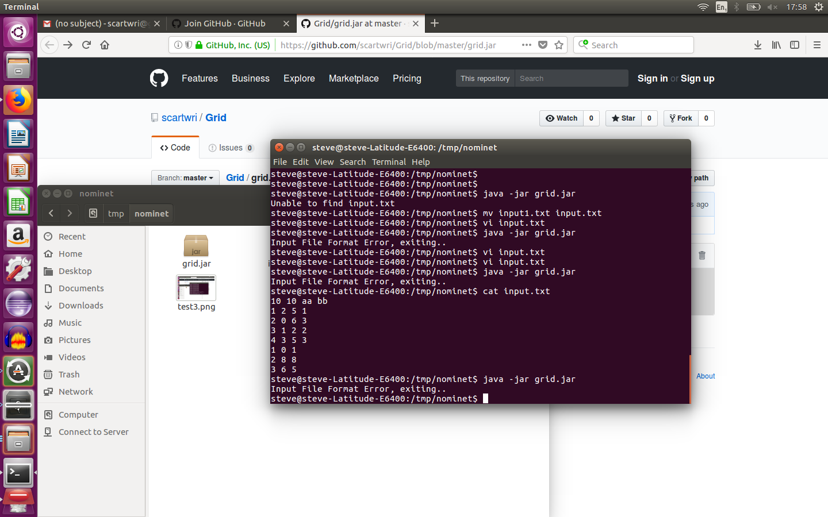

Test 5
Description: Test what happens when the input is modified such that receiver 2 is in a new location, ie one block closer to transmitter 4. This is to verify that the equation used to calculate the Chebyshev is correct with different data.
10 10
1 2 5 1
2 0 6 3
3 1 2 2
4 3 5 3
1 0 1
2 7 8
3 6 5

Expected Result:

2 / 3
4 4

Actual Result(Linux)
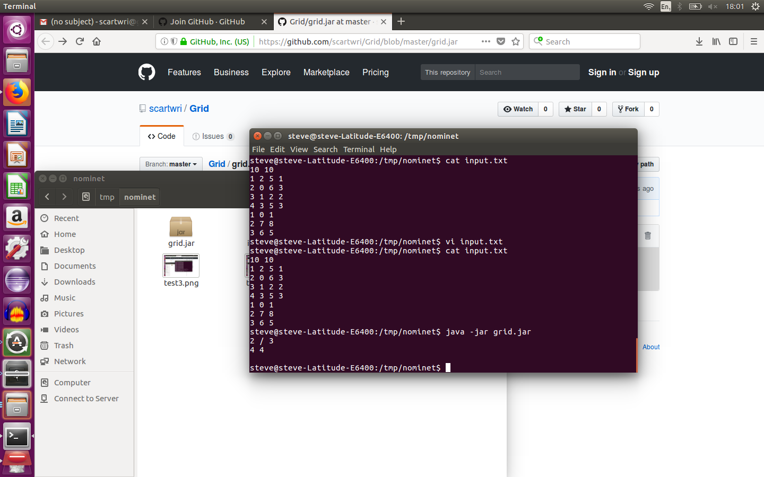

Test 6
Description: Test what happens when the input is modified such that there is an extra receiver
10 10
1 2 5 1
2 0 6 3
3 1 2 2
4 3 5 3
1 0 1
2 7 8
3 6 5
4 1 2

Expected Result:

3 / 4
4 4

Actual Result(Linux)
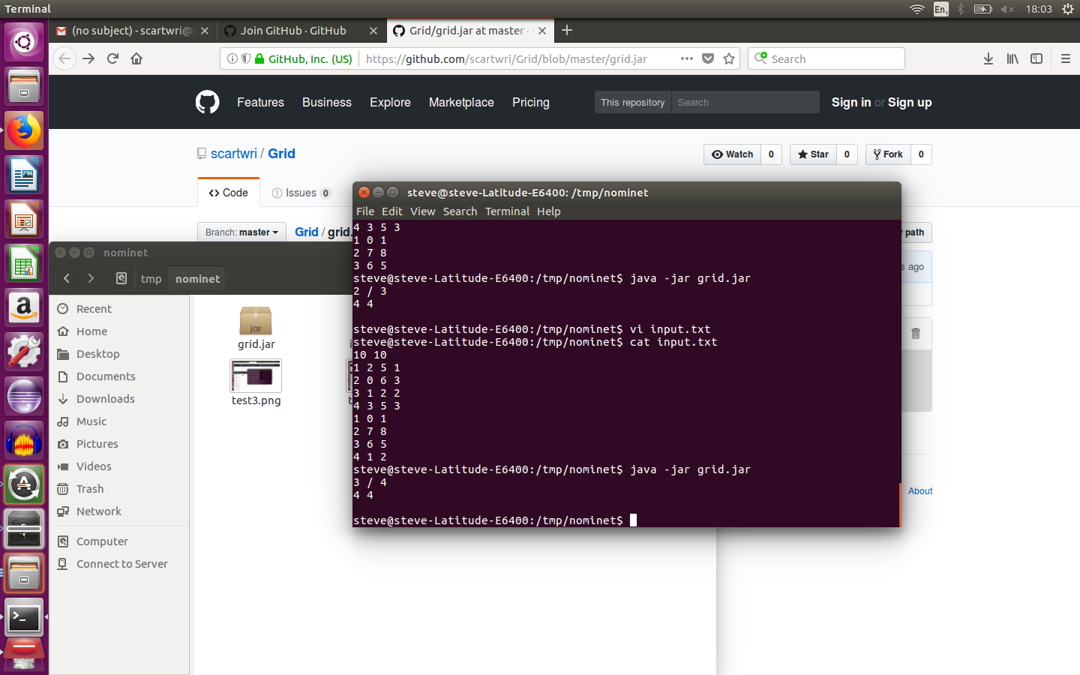

Test 7
Description: Test what happens when the input is modified to contain an extra transmitter. Note that with the added transmitter, there are no transmitters requiring extra power, therefore no second line of output.
10 10
1 2 5 1
2 0 6 3
3 1 2 2
4 3 5 3
5 6 8 4
1 0 1
2 7 8
3 6 5
4 1 2

Expected Result: With this data there are no receivers which cannot be reached by a transmitter.

4 / 4

Actual Result(Linux)
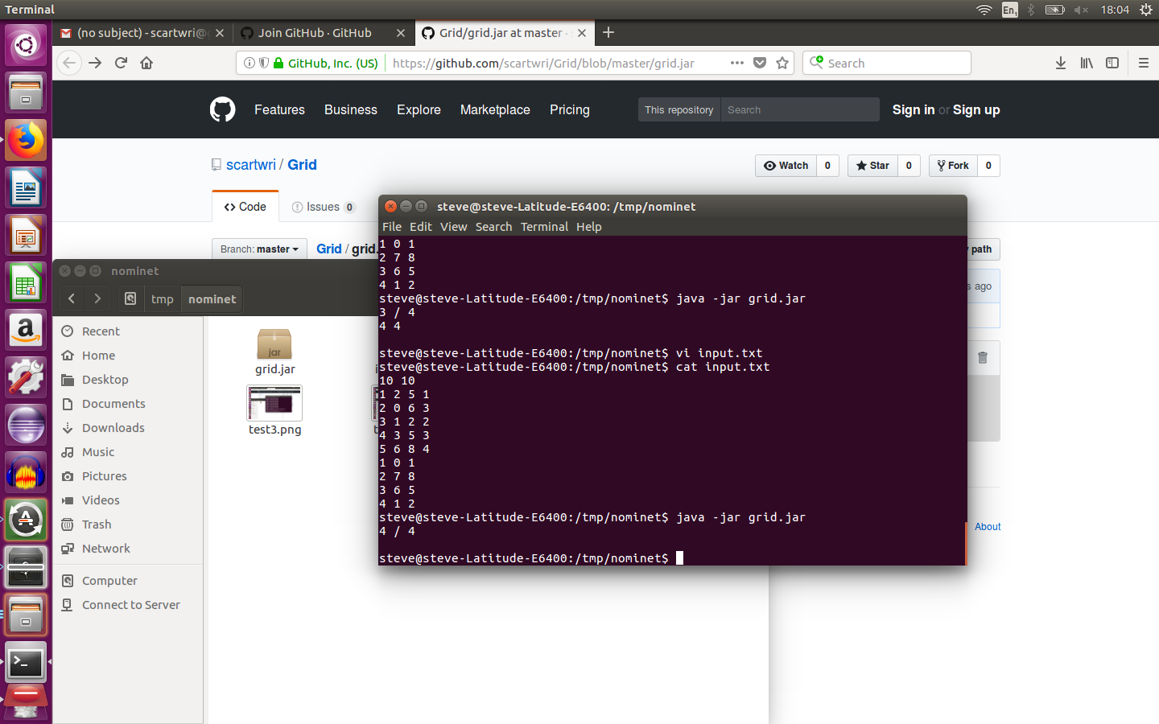

Test 8
Description: Test what happens when there is a trailing space character on one of the input lines.
10 10
1 2 5 1
2 0 6 3
3 1 2 2
4 3 5 3
5 6 8 4
1 0 1
2 7 8
3 6 5
4 1 2

Expected Result: With this data there are no receivers which cannot be reached by a transmitter.

Input File Format Error, exiting..

Actual Result(Linux)
