**CS421/621 Lab06**

**Flask Exercise 1 – Sign In**

In this lab, you will develop a password format checker. Create a simple application and ask user to enter his username and a password. Check the password and see whether it meets the following requirements;

* *It must contain a lowercase letter*
* *It must contain an uppercase letter*
* *It must end in a number*
* password should be at least 8 characters

Create the following files;

* **base.html** (create a navbar)
* **index.html** (a simple form that redirects to a report page upon hitting submit button)
* **report.html** (it should indicate if the password passed the requirements)

Optional features:

* store the username and password in the database
* if there are 3 consecutive failed attempt, display a warning

Please check the screenshots below.

**A failed attempt:**

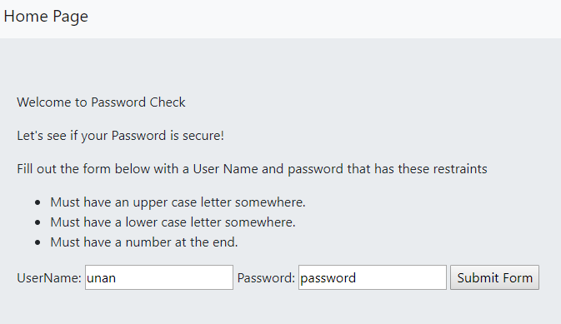

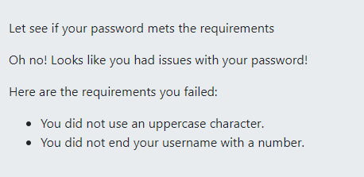

**A successful attempt:**

