Exercise 1 – Simple probabilistic time synchronization algorithm

Stop your NTP client altogether. Explain what you do to stop ntp. Consult the practice that we did in the course practices where we provided you details about how to stop NTP.
First we need to see the status of the systemd-timesyncd service.
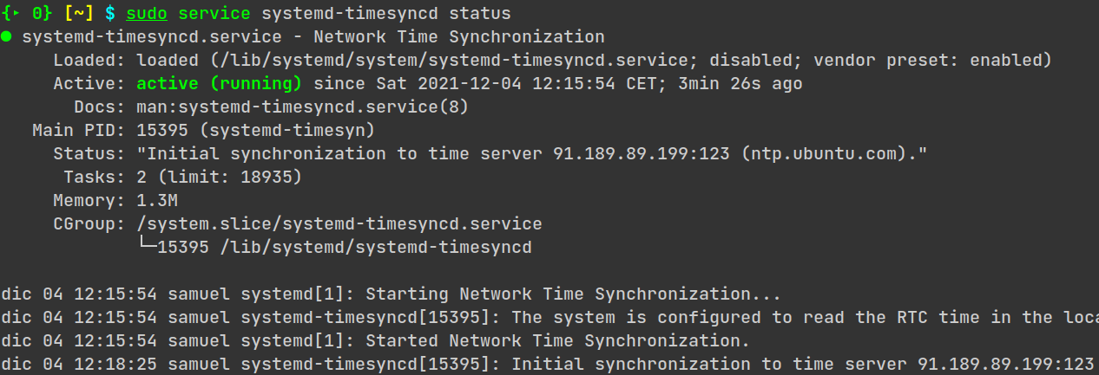Figure 1: State of systemd-timesyncd service before stopping it
As we can see in the image, it is currently active (if it is inactive, ignore this step). In order to stop it and disable the computer to adjust the time automatically, we must run the following command as super user. Later we check that the service is inactive (executing the previous command).
- $ sudo service systemd-timesyncd stop
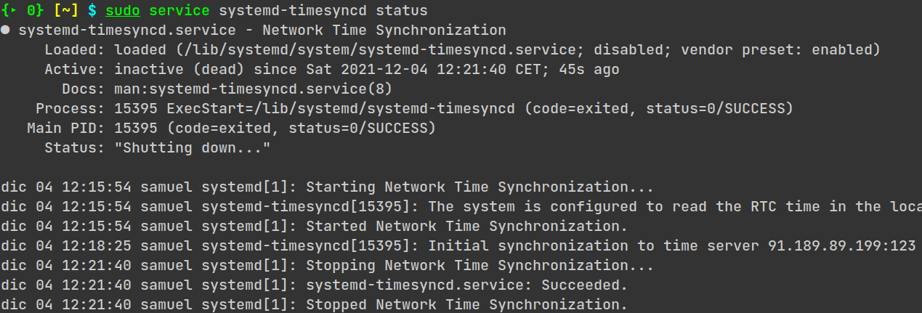Figure 2: State of systemd-timesyncd service after stopping it

Highlight the Linux commands involved in managing the local clock that you used to perform the tests.
- $ date -s ‘yyyy-mm-dd hh:mm:ss’ → Set a custom date. This is used for running the clock backwards or forwards.
- $ date --rfc-3339=ns → View the current date with nanoseconds precision.

How long does adjtime() take for reaching a target time that is 5 min forward? Devise an experiment to demonstrate that your results are reasonable.
In this exercise, I run a test with only a few milliseconds because 5 minutes takes a lot of time to synchronize.
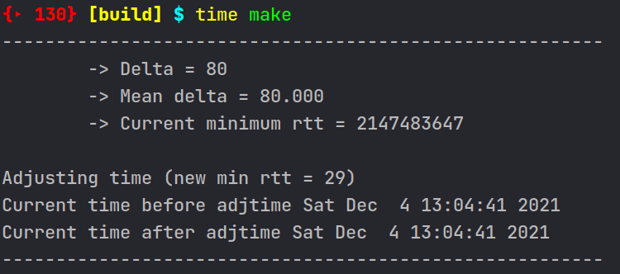Figure 3: Start trace
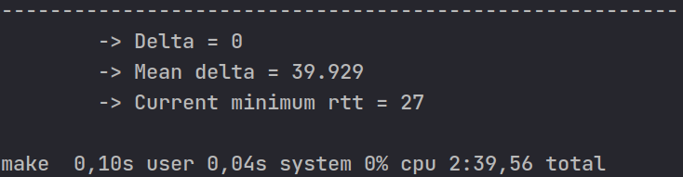Figure 4: Last trace
This example is explained in the following exercise.

Explain what tests you will perform to demonstrate that the program functions correctly.
The time that the program is executing for forwarding the local clock 80ms until synchronization is 2 minutes and 39 seconds (last trace of the previous exercise). The current date is not showed in the second trace because it is only displayed every time a new minimum rtt is obtained.
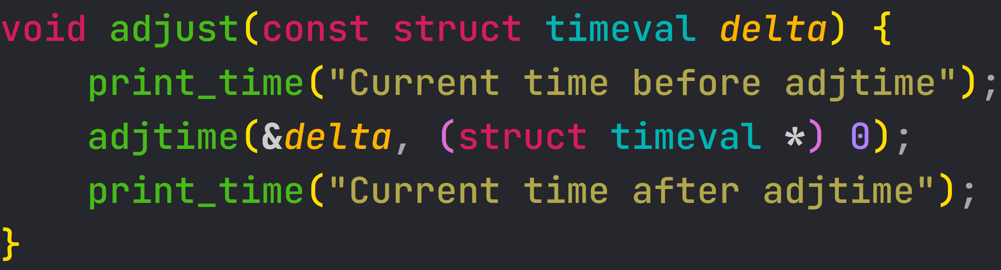Figure 5: Adjust time
This function is called when a new minimum RTT is obtanied. It receives a time delta to accelerate or decelerate the system’s clock. Other functionality I have implemented is to update the RTT after 15 times in which the RTT is not updated (see source code for more precise documentation).

