Exercise 2 – RFC 868 time protocol

Provide extensive explanations of the considerations and problems that you found in this question.
I only encountered one difficulty:
- In UDP part, when reading the number of seconds from 1900 until now, in the Java client I receive a number that does not correspond to the one sent by the server.
The solution I provide is tricky because I pass the number to its binary representation and store it in a string. After that, the Long.parseLong(String s) Java method returns the correct number of seconds which are going to be added to the RFC 868 base date.

Explain what role marshalization plays in this exercise.
I did not do the part of JRMP.

Explain the tests that you designed to check the code.
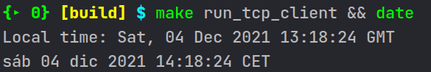Figure 1: Time obtanied with TCP
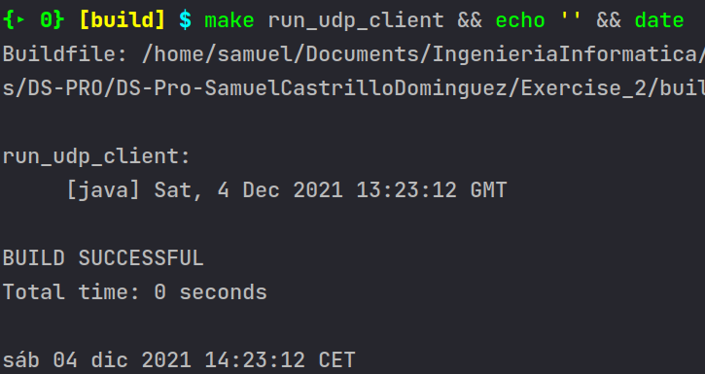Figure 2: Time obtained with UDP
NOTE: Extensive documentation in the source code.
In TCP (Figure 1): The server waits for a client in the accept() call.
In UDP (Figure 2): The server waits until receiving the message “GET_DATE” from the client.
When the server establishes the connection with the client, it calculates the number of seconds from 1900 and send them to the client.
In order to show better results, the execution of the programs is compared with the date function provided by Linux. As we can see, the time obtained differs in one hour. It is due to the timezone. The RFC 868 establishes that the timezone must be GMT (Greenwich Mean Time).

