15ene18:
solved bugs, remaining bugs, code

CONCEPTUAL MODEL DESIGN FOR DISSERTATION
(to be uploaded in Jupiter notebook)
(files to be saved in NetCDF)

FINER (SHIA NICO), learning lessons:

Objective:
hillslope supply: a) upscaling dx and dt (dx=12, 30, 60, 90, 120, 200m; subbasin as NicoSHIA) preserving Courant or b) key dimensionless numbers and anomalous exponents after finest dxdt numerical modeling.

Note: Take care, the process described here is not sequential. Searching for specific task in next sections is better

a. Create DIR map

Description
!!bug: create dir map, as shia requieres both dem and dir. I only get dem from web.
https://grass.osgeo.org/grass72/manuals/index.html

Theory
teoría sobre coordenadas (para crear carpetas iniciales en grass, donde ‘permanent’ exige prestablecer amarre geodésico): http://www2.igac.gov.co/igac_web/UserFiles/File/MAGNAWEB_final/documentos/tipos%20de%20coordenadas.pdf
Magna(red Colombia)-Sirgas(America). GGS84 es elipsoide. UTM pasa de elipsoidal a plana
alos palsar .tif: see .iso-xml for metadata, where there is info on X projection (search for ‘proj’)

http://comunidad.udistrital.edu.co/rfranco/files/2012/05/proyecciones_arcgis.pdf
geographic coord. Sytem: wgs84
projected cs: national grids- magna colombia bogota

http://spatialreference.org/ref/epsg/magna-sirgas-colombia-bogota-zone/

Best steps
-Create coordinates for location from ALOS raster DEM file, which is thus automatically imported. DEM coordinates are displayed in deg.min.seg format.
-Run w.watershed
-Export DIR to tif in selected folder

Case
https://www.gps-coordinates.net/
san Carlos town: 6.186704, -74.994564
https://www.latlong.net/lat-long-dms.html
6° 11' 12.1344'' N 74° 59' 40.4304'' W

ubuntu is not able to run Google Earth, then run GE in Chrome just to see 3D lanscape (no routes, no elevation..):
https://earth.google.com/web/@6.18435102,-74.99716194,984.3561223a,2092.71286303d,35y,-73.2814524h,77.2822363t,0r

b. create stream to set basin outlet (Class Stream)

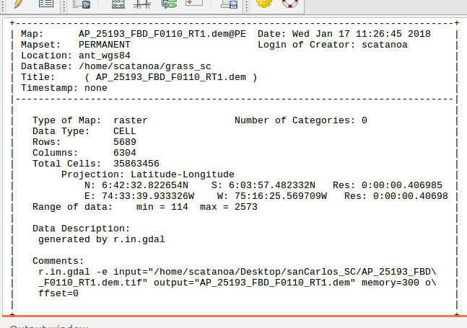
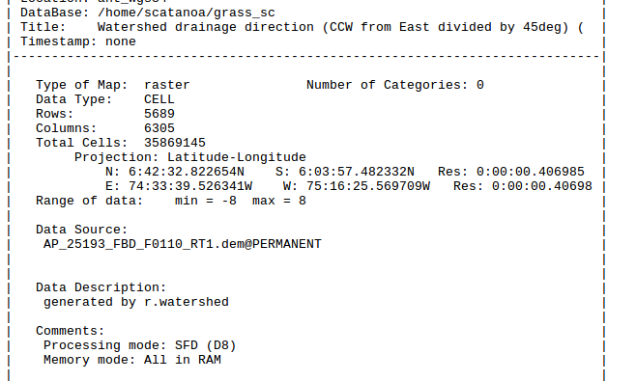
therefore, clipping last column of dir.tif is needed. I will do it in python:
DIR=DIR[:-1,:]

must be done before defining ncols and nrows, or:
wmf.cu.ncols=wmf.cu.ncols-1

SC: saving results to get support of your learning:
np.savetxt('/home/scatanoa/Desktop/sanCarlos_SC/egStreamProfile.txt',np.transpose(st.structure))

open with xls:

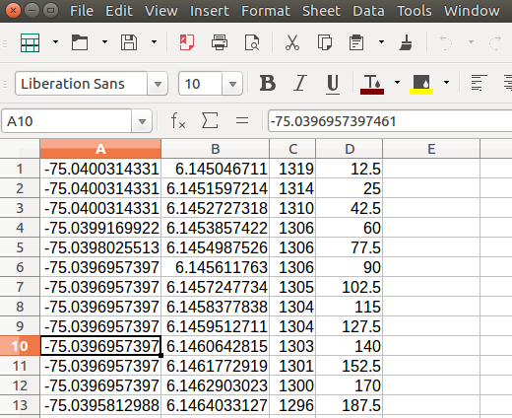

c. get basin (Class basin)

d. can get basin + variables required to simulate with SHIA (Class simubasin).

16ene:
piloto: cuenca San Juan

!!google earth pro no available nor v.7.3 (most recent) nor 7.1 (suggested in askUbuntu). Install Google Earth simple?

18 ene2018

But always, before:
DEM=wmf.read_map_raster('raster/dem2.tif',True)
DIR=wmf.read_map_raster('raster/dir.tif',True)
wmf.cu.nodata=-9999.0; wmf.cu.dxp=30.0
DIR[DIR<=0]=wmf.cu.nodata.astype(int)
DIR=wmf.cu.dir_reclass(DIR,wmf.cu.ncols,wmf.cu.nrows)
ouch!. I did not save coordinates of stream near San Carlos, nor I have stream to guide the automatic correction of them. Then, I will create again the stream, choose the elevation of the basin outlet, and get those coordinates:
any point as headwater of stream: -75.040,6.145
again, cut last column of DIR
DIR=DIR[:-1,:]
and
wmf.cu.ncols=wmf.cu.ncols-1
To find desired elevation of basin outlet elevation row (2) is examined:
np.where((st.structure[2]>890) & (st.structure[2]<910))
Out[23]:
(array([1554, 1555, 1556, 1557, 1558, 1559, 1560, 1561, 1562, 1563, 1564,
1565, 1566, 1567, 1568, 1569, 1570, 1571, 1572, 1573, 1574, 1575,
1576, 1577, 1578, 1579, 1583, 1584, 1585, 1586, 1587, 1588, 1589,
1590, 1591, 1592, 1593, 1594, 1595, 1596, 1597, 1598, 1599, 1600,
1601, 1602, 1603, 1604, 1605, 1606, 1607, 1608, 1609, 1610, 1611,
1612, 1613, 1614, 1615, 1616, 1617, 1618, 1619, 1620, 1621, 1622,
1623, 1624, 1625, 1626, 1627, 1628, 1629, 1630, 1631]),)
So get the coordinates of a point with z~900mnsm:
print st.structure[0,1600]
-74.9346

print st.structure[1,1600]
6.22339

Now, there are all the inputs for simubasin:
dt=300s=5min!! in Nico’s example in Salgar, because he has rain data from Siata fields. However, I will try to decouple hill and channel modelling for optimal performance of computer in mid-term scale simulations e.g. dt~1h at hill and dt~1s in channel.
cuSanCarlos=wmf.SimuBasin(-74.9346,6.22339,DEM,DIR,name='SanCarlos',dt=300)
Geomorphology parameters are also required to model (Lcell, acum, So, z). Then:
cuSanCarlos.GetGeo_Cell_Basics()
how to save basin? R/?:
1. save simubasin, to get netcdf file
2. use models.write_int_basin from models.f90
https://fileinfo.com/help/binary_vs_text_files

january 24th, 2018:
on compiled modules to run wmf: note that .so libraries are in: /usr/local/lib/python2.7/dist-packages, i.e. in default path for python external libraries likes pandas or netcdf.

netCDF (.nc): format netCDF4 allows unlimited dimension of arrays. Nc4 works with HDF5 library. Hierarchy: groups contain variables. Voy en components of data set, in users guide. https://www.unidata.ucar.edu/software/netcdf/docs/netcdf_data_set_components.html#data_access
http://www.h5py.org/
a-to use .nc downloaded for salgar rain: rain_radar2basin_from_array?
.hdr format: http://www.gdal.org/frmt_various.html#GenBin
header=hdr so .hdr is just a header file for georeference (https://fileinfo.com/extension/hdr). Related to .asc, but now UTF-8 is the most popular. That’s how I coded rain .py code
can be also esri or envi .hdr
future: use gdal & nc: http://www.gdal.org/frmt_netcdf.html
rain fields must enter as unique .bin to subroutine runShia called from Python, e.g.: ‘lluvia_201501010000_201501312355.bin’
b-Use selective modules to get just results needed. It implies running ficticious rain fields. Ideal to save them in easy format, like netCDF4.
C-SIATA tips (2017 AGU):
Lopez&Isaza: ERA 5 reanalysis as another source of rain fields, or only wind? . Obtain histogram of event durations.
Sepu: coefs A & B f(dt), like rain pdfs of Salas&Poveda.
NicoSalgar: He has raster of Salgar slide scars. Fig 5 is interesting about showing storages in space-time. Space can be represented as ‘groups’ by travel time or distance to outlet, as Nico; however, maybe I think that Strahler ordering can be other option, as MesaGupta14.
NicoBasinFlows: dt=1h to feed initial conditions for event, whose info has dt=5min.

Jan31th, 2018. Focus: rain then SHIA
get ficticious rain for event, shaped as array with elements (t, cells).
get the .bin using write_int_basin, a subroutine in models.f90.
!run_shia uses .deals with files .bin, and .hdr. However, Do not worry, parameters required include only .bin files, based on Salgar example.

example, not executed:
ruta_lluvia = 'lluvia/lluvia_201501010000_201501312355.bin'
what a short path!. It’s a location in C root, inside one folder to enclose daily work for easy backup. Then, do it, because anyway you need to do backup every day.
To understand rec in write in fortran:
http://www.pcc.qub.ac.uk/tec/courses/f90/stu-notes/F90_notesMIF_10.html

Res = cuSalgar.run_shia(Calibracion,ruta_lluvia,100,7200)
It means 100 intervals, starting from date # 7200.
M=3, N=6 seems reasonable, having San Carlos basin in mind. M and N must be calibrated with idf curves (deserves paper?).
N>10 takes long run time in python, then consider to produce < 128 x 128 map (N=7, 2**7=128). After that ‘imgzoom’ can be used to resample to finer resolution to get rain fields for SHIA in needed dx.
.txt or .bin?:
-Second answer in https://stackoverflow.com/questions/30329726/fastest-save-and-load-options-for-a-numpy-array says pytables -to get HDF5 binaries for netCDF- are fast for write and read, but take care with random values; which is my case with rain!!
-key point to store big arrays is serialization. Cite from wiki: “At Python, The core general serialization mechanism is the pickle standard library modul”
-Can manage data serialized in JSON format. Databases like SQL make predefined tasks and reduce risk.
-(unidata forum) Read paper: Gray,. Scientific Data Management in the Coming Decade. Critique NetCDF for ‘iid’ requests. CDF will be object type. ‘Requests must be related to specific order and data sets’. Relational data model is coming. OK=SQL=structured query language.
-https://www.paradigm4.com/
-Parallelization is the future, physically explained by chip concepts in crash course computers (youtube).

3feb: coding rain modules in .py, even calling external modules
In [1]: import rain
In [2]: r=rain.P()
In [10]: r.x_casc(.25,4,2,1,1,5.,2.,2**1)
when I put Salas module to generate daily rain, dT [hours] must be global variable of class P:
In [3]: r=rain.P(24*21)
when xt_genP included, this is the call:
r=rain.P(24*5,24,.3,5,2,2**1)

4feb, 2018: run Pxt
Err in field dims was solved. Exponent in power law, depending on N and M, must be float, them N and M must be real too.

5 and 6 feb, 2018: refine Pxt, run shia
-clean P code to save and control Pt amplifier:
new parameter EventT~2 ~integer(365/220), Medellin
r=rain.P(24*20, 365, 2, .3, 5, 2, 2**1)
!2 parameters: (1) #zeros as mean frequency lambda of Poisson process. (2) location parameter miu or theta. Mean rain~theta/lambda
tasks:
seasons+ENSO
Huff.
Dates visualization in series figure.
Decrease magnitud of field due to ARF, given freq, assuming event duration
Best, autodate= https://matplotlib.org/api/dates_api.html
https://scentellegher.github.io/programming/2017/05/24/pandas-bar-plot-with-formatted-dates.html
https://stackoverflow.com/questions/35517038/increasing-frequency-of-x-axis-labels-for-dates-on-dataframe-plot

First exercise to link rain .bin to DEM is done with dt=24h. Downscale in t when event occurs:
frequent error: operands could not be broadcast together with shapes (8,8) (4,4)
solution: float arguments for exponents. See this...
In [4]: r=rain.P(30*24,24,2, .3, 5., 2., 2**1)
more bugs…
a) txt saved with float numbers, even after converting each element of the field to integer(round)
R/ solved!

14feb: rain&basin
reorganized folders: code txts at /home, specific folder at home for results of each code.
Working on code rainBin.py
To improve efficiency: save metadata of basin vector ‘topolco’, then basin #cells can be read by rainBin without charge the large basin vector.
Now, topolco for smaller basin, case San Carlos: 10km2 instead 80km2. Then, extract basin again:
confluArenosa: see outlet coords in next image, from upper-right pixel (1070<z<1080 masl)

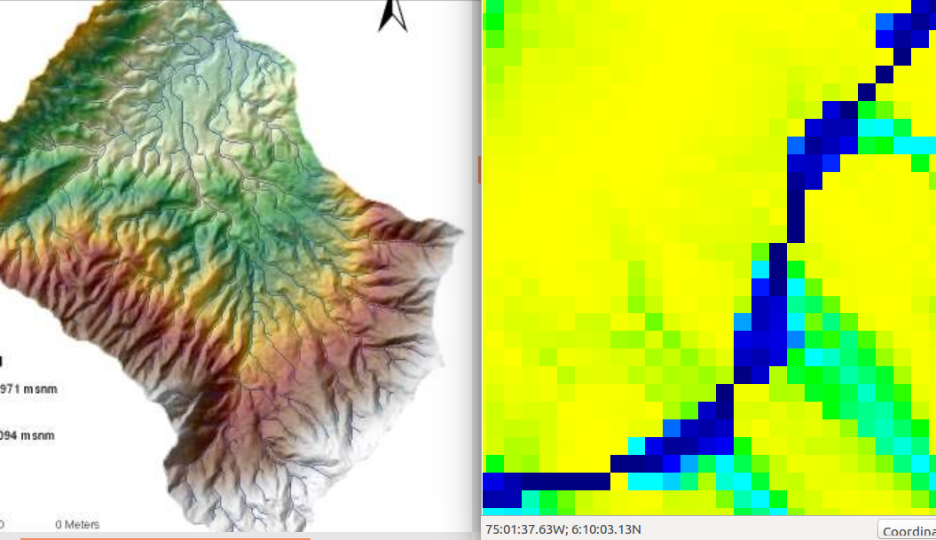

upper-right= point inside arenosa, to build stream to choose outlet
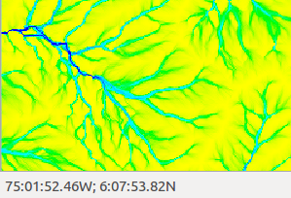

-75.03124, 6.131617

tiff files DEM and DIR are in home/doct_DEM
In [11]: from wmf import wmf
In [12]: DEM=wmf.read_map_raster('doct_DEM/AP_25193_FBD_F0110_RT1.dem.tif',True)
In [13]: DEM.mean()
Out[13]: 1124.7197260074433
In [18]: DIR=wmf.read_map_raster('doct_DEM/dir_SCa',True)
In [19]: DIR.mean()
Out[19]: -143.82723920517202

In [20]: wmf.cu.nodata=-9999.0; wmf.cu.dxp=12.5
12.5 =0.40698*111000/3600
In [21]: DIR[DIR<=0]=wmf.cu.nodata.astype(int)

In [22]: DIR.mean()
Out[22]: -41.48798219193683

In [23]: DIR=wmf.cu.dir_reclass(DIR,wmf.cu.ncols,wmf.cu.nrows)
In [24]: DIR.mean()
Out[24]: -41.115630969179776

mean as values check
OJO: SIZES NO COMPATIBLE
In [25]: wmf.cu.ncols
Out[25]: array(6305, dtype=int32)

In [26]: wmf.cu.nrows
Out[26]: array(5689, dtype=int32)
In [30]: DIR.shape
Out[30]: (6305, 5689)

In [31]: DEM.shape
Out[31]: (6304, 5689)
then:
In [32]: DIR=DIR[:-1,:]
In [8]: wmf.cu.ncols=wmf.cu.ncols-1
In [33]: DIR.shape
Out[33]: (6304, 5689)

Now, produce stream from a point inside basin of interest (-75.03124, 6.131617):
In [38]: st=wmf.Stream(-75.03124,6.131617,DEM=DEM,DIR=DIR,name='rioSanCarlos')
st.Plot_Profile()
find desired river reach coordinates where basin outlet is located
In [55]: n.where((st.structure[2]>1070) & (st.structure[2]<1080))
Out[55]:
(array([351, 352, 353, 354, 355, 356, 357, 358, 359, 360, 361, 362, 363,
364,

In [56]: print st.structure[0:1,400]

KeyboardInterrupt

In [56]: print st.structure[0:1,400]
[-75.0269165]

In [57]: print st.structure[0:2,400]
[-75.0269165 6.16844845]

In [58]: ArenBasin=wmf.Basin(-75.0269165,6.16844845,DEM,DIR,name='Arenosa',stream=st)

In [59]: ArenBasin.ncells
Out[59]: 76253
76253*12.5^2=11km2
show BasinQm
In [65]: ArenBasin.GetQ_Balance(2500)
In [69]: ArenBasin.Plot_basin(ArenBasin.CellQmed)
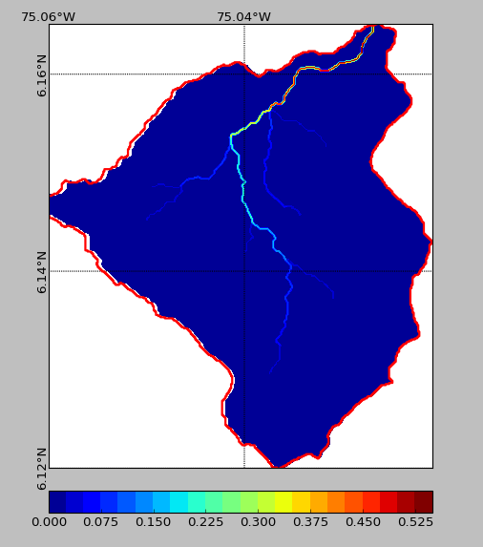

finally, this is the basin grid:
In [76]: ArenBasin.structure.shape
Out[76]: (3, 76253)

In [77]: min(ArenBasin.structure[1])
Out[77]: 1892

In [78]: max(ArenBasin.structure[1])
Out[78]: 2239

In [79]: max(ArenBasin.structure[0])
Out[79]: 76248

In [80]: min(ArenBasin.structure[0])
Out[80]: 0

In [81]: min(ArenBasin.structure[2])
Out[81]: 4782

In [82]: max(ArenBasin.structure[2])
Out[82]: 5181

In [83]: 5181-4782
Out[83]: 399

In [84]: 2239-1892
Out[84]: 347

In [85]: +399*347 (rows x cols)
Out[85]: 138453

After basin have been cut, cols and rows in basin vector must start with 0,0 in LEFT UP corner:

x=min(ArenBasin.structure[1])

ArenBasin.structure[1]=ArenBasin.structure[1]-x

x=min(ArenBasin.structure[2])

ArenBasin.structure[2]=ArenBasin.structure[2]-x

In [12]: import numpy as n

save basin vector as integer:

In [21]: n.savetxt('doct_DEM/ArenBasin.txt',n.transpose(ArenBasin.structure),fmt='%d')

rainBin

In [1]: import rainBin

In [2]: r=rainBin.Pread(24*30,16.)
Nrows= 399
Ncols= 347

In [3]: r.Pxt_fine()
zoomFact= 24.9375

15feb: Pvect+shia
ok: mask basin applied to rain field..
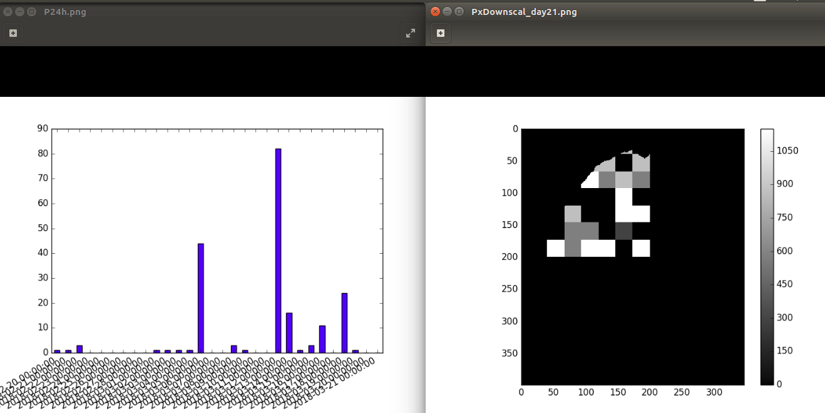
...but too much puntual daily rainfall when events. Then, area reduction factor is being needed to decrease magnitud of simulated rain daily series?

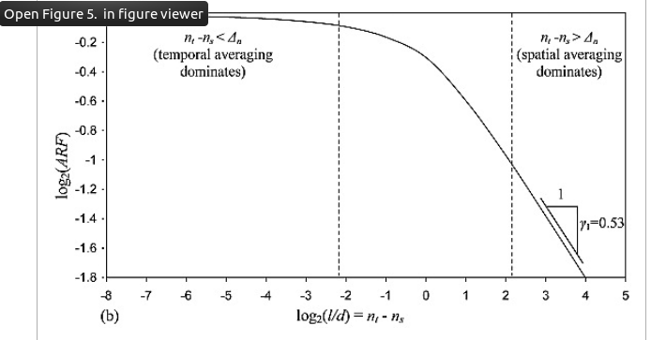

10.1029/2005WR004716

n~resolution, nt~temporal, ns~spacial
Then, producing again time series to amplify dimensionless cascade rain fields:

In [1]: import rain
In [2]: r=rain.P(30*24,24,2,.3,5.,2.,2**1)
In [7]: r.xt_genP()
In [7]: import rainBin
In [7]: r=rainBin.Pread(24*30,16.)
In [7]: r.Pxt_fine()

note that dt must be integer, it turns to float for log calculations of ARF inside the code

maybe spatial variability and ARF (currently .1-.15, in Arenosa basin, lumping daily in hill scale) can be improved…..
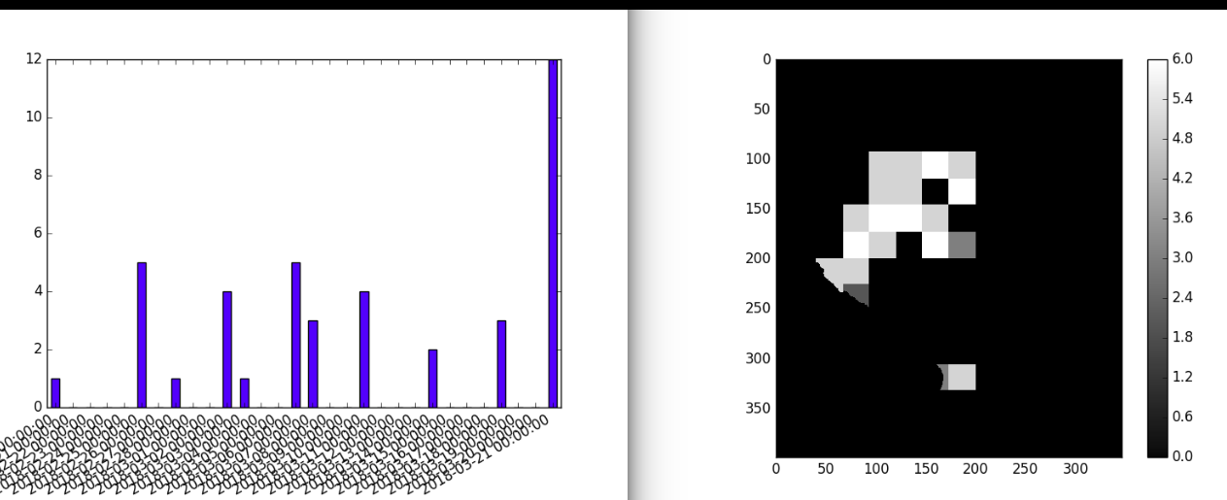

but let’s continue to get shia and seds.

As transform map 2 basin in python requires a global (class) variable self.structure I will import directly the fortran module to my python code.

(NOW: (ipython getBasin.py) to create easy basin topology saved)

lets see if vectorize from Nico’s cu.f90 works:

In [1]: import rainBin
In [3]: r=rainBin.Pread(24*30,16.,12.5,-9999.0)

16feb: shia

get vect and bin of rain for shia

err map2basin cos args must enter in order given in python call, not theorder in definition of subroutine in fortran

17 feb: py to f90 to get model inputs in shia format

vecPfine=cu.basin_map2basin(…args as called by python glue to f90, disordered compared to f90 subroutine definition) was tried. Transposition of input arrays was made to coincide with dimensions of Fortran variables declarated.

!The variable xll is different to xllm, because is general variable of the subroutine. Calling the complete subroutine demanded lots of RAM, then I will try to get pieces of code from Nico f90 to have own compiled subroutines to use. To compile them use f2py, as explained in first lines of cu.f90.

NOTE: Arenosa slide scars map shared by Edier need to show color legend from 1 to 2=max_value.

(based on: https://docs.scipy.org/doc/numpy-dev/f2py/getting-started.html)

scatanoa@scatanoa-K43E:~$ f2py -c map2basin.f90 -m map2basin

20feb:

solved bug for running f90 from py: arguments like ‘in decreasing size’, need consistency in number of element in rows and columns, according to how dimensions of array variable are stated in the declaration.

Bug in border cells is assumed as no significant

yes!, I produced rain.bin

25feb: shia

Steps: based on example SHIA Salgar.
-Create basin to set geomorphology parameters (wmf.SimuBasin, GetGeo_Cell_Basics). Save basin structure, which is topology vector used as template to organize spatial rain vectors per time step.
-Create and organize rain.
-Set SHIA parameters.

Parameterization:

a) vertical parameters
-bug estimating evp (ETP): Cenicafe equation [mm/day] use exp function of altitude. Nico translate evp to mm, but again multiply by dt to get vspeed from vcoef. Then, Evp_loss units in Salgar example are [mm.s]!. Thus, I program Cenicafe equation, which is ETR but can serve as surrogate of ETP, with no division by dt. Therefore, ETP parameter units are [mm/s] in my example to show to Hassan.

b) horizontal parameters

getBasin.py includes code to run SHIA

28feb: ok shia hg

line235 in models.f90:
Fortran runtime error: Cannot open file 'doct_rainBin/Pbin_day.dat.hdr': No such file or directory

Try with your own piece of code with SHIA model instructions, as planned from Colombia. Then, I can e.g. use t_ev array to report time steps with rain, avoiding hdr file.

Refresh of process, previous to UBC:
-get Pt and spatial cascade (import rain.py, instantiate class).
-convert to binary vector (import rainBin.py, instantiate class)
-Import getBasin.py and run getBasin.type(2) which calls wmfSC.py for selected wmf.py methods adapted to simulated rain.

IDEA: WHAT IF COMPUTE TRANSVERSAL SLOPE OF WATER SURFACE IN RIVER FLOW, GIVEN v AND CHANGE OF DIRECTION DOWNSTREAM?

Take care in shiaSC.f90 code. Lines that I consider unnecessary are commented in 1st column.

Mar4: ok shia hg

-record # to read binary rain

-call shiaSC module
https://www.numfys.net/howto/F2PY/
https://nbviewer.jupyter.org/urls/www.numfys.net/media/notebooks/fortran_to_python.ipynb

-save shia results

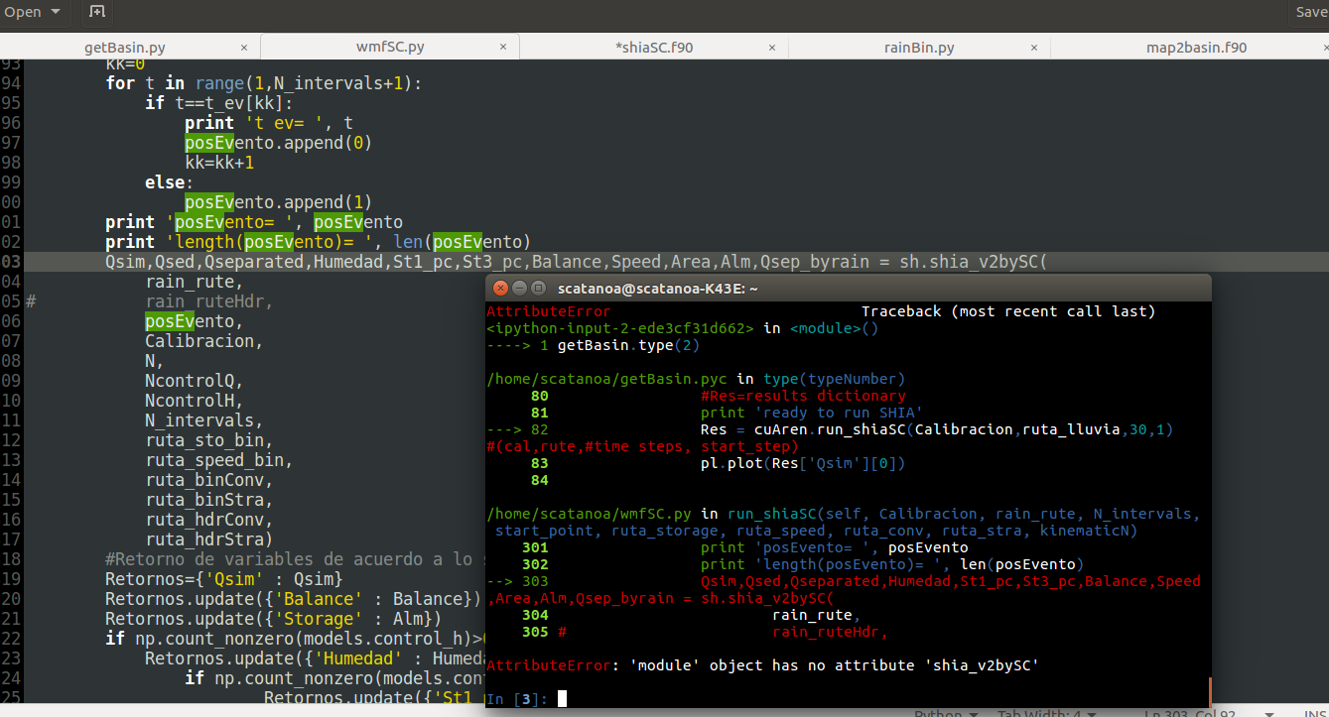

Complation of fortran module:

scatanoa@scatanoa-K43E:~$ f2py -c -m modelsSC shiaSC.f90

try_args.f90 demonstrates that problem identifying module name could be in args.
TAKING AGAIN FICTICIUS BASIN, PRACTICAL FOR RFG AND ELAP DISCUSSION (since Mar16/2018)

Nested modules given Mortecarlo approach is expected:

hill_s calls hill_w, which calls rain:

In [4]: fb=fictBasin.ideal(24*365*100,24,1.e5)

In [4]: fb.hill_s_t(.25,1,1e-5,.003,[.3,1.8e4,1.e4,.6,1e-3/365/3,1e-3/365/3,1e-3/365/3,1.,1.,1.])

new parameter: Sslid<>Swash, because wash is conceived at the hillslope’s outlet, meanwhile landslide ‘s slope is the average one in the ‘main rill’ of the hillslope.

In [4]: fb.hill_s_t(.2,.5,1,1e-5,.003,[.3,1.8e4,1.e4,.6,1e-3/365/3,1e-3/365/3,1e-3/365/3,1.,1.,1.])

Tokunaga Basin:
gral tips for translating Matlab to Python code:
-quit semicolon.
-preserve values in ‘for’ indexes. Remember range cuts one at the end.
-translate 1 when calling array elements, to account for arrays starting at index 0, different from Matlab where index starts at 1.
-change parenthesis by brackets to enclose index of array elements.
-if np.where function was used to find indexes where elements have certain value(s), the index if already considering Python array i.e. starting at 0.
-indentation must be with TAB, otherwise run does not enter to loops.

85 reaches (>21 reaches of 2017’s omega=3 fictitious basin)

In [4]: import fictFluvMphdyn
In [4]: fm=fictFluvMphdyn.idealStreams(24*30,24,1.e5)
In [2]: fm.fictNetwork(1,2,4)
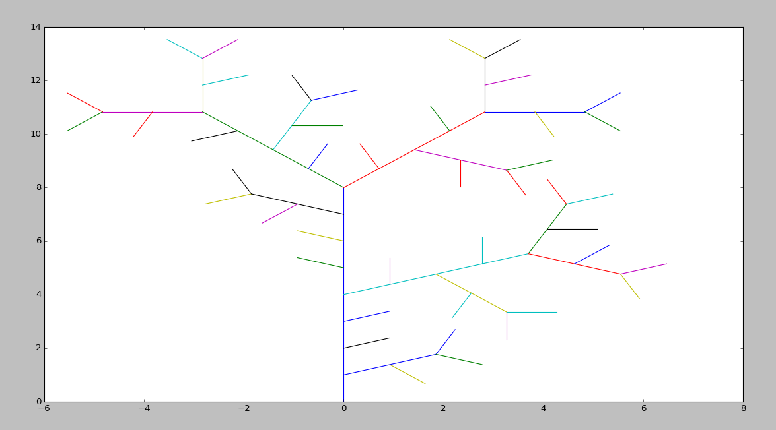

problem cumulating Area

Tried to give unique ID to each reach, then double sorting by w and ID. Now well, if ID is greater for downstream reaches is not clear. What if unique ID by fict elevation?:
-start with unique IDs as they are.
-Assign to each point w=1 path to follow. The path must not find adverse slopes (if so, interchange IDs). Make secondary sorting to X again, according to this.
-Alternative: no other reach is waiting to drain to ‘me’? + flag SOLVEDdrain

23mar: f90 RiverModel

SC: interesting chance to play with A_hs. Each value can consider own supply processes, as upscaling testing.

Thus I call other function in same python file (.py):
X=self.fictNetwork(1.,2.)
Seems analogous to call in Fortran

Thus I call other function in other python file, first instantiating:
fb=fictBasin.ideal(self.dT,self.dt,self.A_hs)
results_hillS=fb.hill_s_t(.2,.5,1,1e-5,.003,[.3,1.8e4,1.e4,.6,1e-3/365/3,1e-3/365/3,1e-3/365/3,1.,1.,1.])

While prints error when index exceeds dimension in boolean test. Then use BREAK

FORTRAN

Avoid upper case letter in names of subroutines or modules in Fortran!!

Special declaration avoid translate index in each line involving an array when translating code variables from python to fortran, e.g.:
dimension(0:NAtom-1, 0:Dim-1)

Subroutine arguments must be declarated with their associated intent: IN, INOUT or OUT.

F2py tips: https://engineering.ucsb.edu/~shell/che210d/f2py.pdf
-One should always put any arguments that specify dimensions at the end of the argument list.

Matlab and python require/suggest declare array as zeros(nr,nc), but Fortran initialize 0s by default when declared as real (.. ,..).

Nico uses real, allocatable Var(:,:) to declare memory space with undefined dimensions. Then, he uses this code to define dimensions during calculations:
if (allocated(Var)) deallocate(Var)
allocate(Var(nr,nc))

Tab indentation is not mandatory in Fortran

Flexibility: Note that dummy output is called zz in f90 and z in python

Changed names:
d→h
f→f_sub
Pa→pa_acu
Pss→pss_acu
OK: Already done along the code

Nico define global variables of fortran module in _init_ method of python class SimuBasin

Compilation by module:
scatanoa@scatanoa-K43E:~$ f2py -c -m mod_model_sc fluvMphdyn.f90
Still not able to define global variables

Trouble when inserting Qhill input: answer(?) is the arguments in the order in which they appear in the Fortran declaration (https://gcc.gnu.org/onlinedocs/gfortran/Argument-passing-conventions.html)

Lesson on how to read Qhill: Qhill has dimension nt. Then, last arguments in subroutine list, which are related to dimensions, must be written in same order as matrix requiring such dimensions are declared. Dimensions are given to fix space in memory, probably enhancing speed because no dynamic allocation is allowed.

SC: Eh, So must vary in each kk, at least to vary transport resistivity along cross section. However, So=Sf cannot vary thus, given that water level is horizontal

SC: all supply comes from hillslope. The deeper the supply mech the greater grain size:
.1, 1mm: wash (recover: exp weathering)
.1, 1, 10, 100mm: slid (recover: exp weathering)
.1, 1, 10, ,100, 1000mm: creep+bank erosion (recover: instantaneous recover at top of hill, like belt conveyor)
Boulder intake from bedrock is negligible. People say they find residual soil under alluvium, then it is assumed so cohesive to be incised (????)

ABOUT RAIN:
what if loop in nReaches to produce supply per reach in fm.setup?

How to deal with spatial variance?:
R/ prioritized by amount of work
R1/ use binary cascade algorithm to merge with fictitious basin mask
R2/ produce same timeseries on basin, but noise (color?) in estimation of supply in each reach. Imagine P(21, nt ) attached as additional columns in topology matrix X. Sum of P columns must be smoothed as AreaReductionFactor.

How to ensure more spatial correlation in spatially closer reaches?:
R/ amplitude of noise can increase with distance to reference location. Best reference can be hot spot of rain, like headwaters, where convective clouds are usually precipitated.

Qdelayed downstream by coarse temporal resolution

I will put wash supply to run less nt to debug code

Mar29, 2018
when translation of sediment code is started, do not run model until dynamic texture is translated, because it defines D84 for next time step.

Artificios to improve (via optimizing model resolution?):
-Fmin
-rescaling by sumFposit (how frequent: contOverLoad)
-filling subsurface to avoid organal!! (turned off, by now)

Mar30, 2018: Cases of TNC Bogotá are improved

Lin71 basin.py, no stochastic rain, but loaded from txt. Valid while debug in example run by 40 days.

Jref to study dynamics in certain reach, to analyze easily results and find bugs. However, isnan flag was required to stop when/where NaN appears. Then, jref= where NaN bug is located

Day ended updating Ubuntu software

Mar31: Cases of TNC Bogotá are improved

New subroutine to read binary files with results is not recognized from python. Other f2py tasks like rainBin are working well yet. Then, I will try to create new f90 with read function. Works!!

scatanoa@scatanoa-K43E:~$ f2py -c read_model_results.f90 -m read_model_results

Apr2, 2018:

About feedback hg-supply (Hassan mail Apr22018):
https://www.theguardian.com/world/2018/apr/01/argentina-new-river-soya-beans

What if bedrock exposure in certain zones of reach?. So, model will need also topographic nodes.

Apr3, 2018:
Marwan’s conditions:
a- no wash supply (cwash=0)
b- Qmax by Wcrowe
c- boulder source

April 4, 2018:

-run 4 years, with and without wash. See if reasonable armoring occurs (Marwan: D50a/D50ss~2). Armour ok, but intermediate widths does not last several time steps

Apr6, 2018:

Dss50 can be greater than Da50

Dealing with ddt:
new ‘..._ddt’ py and f90 files in home folder.

April 16, 2018:

Run ddt bynary (minutes or days according to Q>Qpctil | Qh>Qd) because you do not know velocity to assess Courant and you do not want to have reallocatable arrays for timeseries.

As f2py ‘.so’ module is not working, py and fortran codes are going to be totally decoupled, thus:
-python: produce and write to save array INPUTS for morphodynamics. These are basin topology and hillslope supply. As input resolution tends to be dt~daily and dx~reach then they files are not so heavy so they can be written as .txt (instead binary, to avoid time learning the know how)
-fortran: compile module mod_model_sc in fluvMphdyn_ddt.f90, e.g. using gfortran.

Ahh, avoiding f90 binary read/write process is going to slow process, because reading of results from f90 to py was being perfomed by fortran code read_model_results. Then, instead, please try to make the deep solution, upgrading numpy and f2py.

I activated venv thus (see new prompt in following image):
http://www.pythonforbeginners.com/basics/how-to-use-python-virtualenv

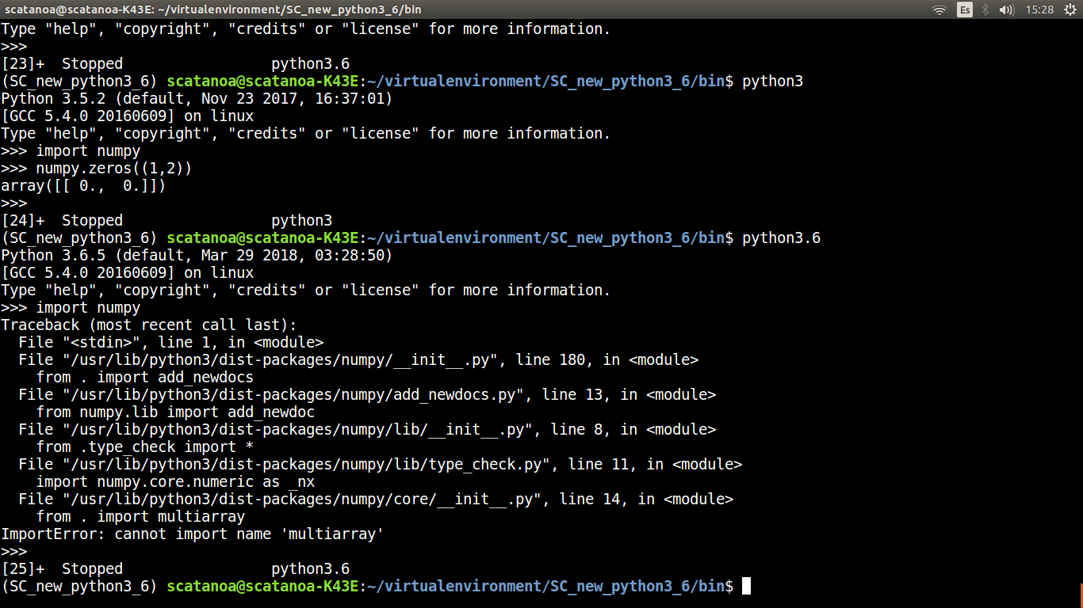

Now, numpy works in python 3.6.

Let us try to run old code developed in python 2.7(fictFluvMphdyn_ddt.py):

Old code is easily fixed. By now, new sintaxis from py2.7 to 3.6 is print() and fstrings used by Alex to read Qs files from Zimmerman’s light table.

Refreshing commands there:
scatanoa@scatanoa-K43E:~$ f2py -c -m mod_model_sc fluvMphdyn_ddt.f90

Now current machine is, calling ‘ipython’, by default for 3.6py:
Python 3.6.5 (default, Mar 29 2018, 03:28:50)
Type 'copyright', 'credits' or 'license' for more information
IPython 6.3.1 -- An enhanced Interactive Python. Type '?' for help.

In [1]: import fictFluvMphdyn_ddt
In [3]: fm=fictFluvMphdyn_ddt.idealStreams(24*30,24,4.e6,3)
fm.setup()

Yet printing f90 results as binaries to be read by my f90 code to be plotted in python.

Remember, never more run compiled fortran module without being sure you are using its last version. Erase homonyms:

April 17, 2018:
Q2=np.percentile(Qhill,100-10)
10 instead 2 as threshold pctil to refine dt. It did not solve ck=NaN in i=1445, j=15

April 18, 2018:

Dss is not changing.

April 19, 2018:

Schedule in remaining scholarship: 12 activities in 3 months= 4 activities per month= 1 activity per week. The goal is to achieve each activity in 2 days, so you have 50% extra time. Near 10 days out of office, due to field work or RGF2018 meeting, are not considered in this plan.
(model, extra)

-Make coherent results of simple alluvium washing in ~flume (var_t(Q)=0, no feed) conditions in Tokunaga basin. Review that changes in subsurface textures occur when sediment is deposited in reach, although it can be notable mostly after high input related to dynamic water or sediment supply.

Eh, why the break in t~700?: alluvium farther from thalweg becomes lower, then code resets by reshaping thalweg and redistributing sediment across cross-section.

On cuasi2D approaches:
Gstars (2008), I: theory, deals with particles going out of the stream tube only in sharp curves. Stream tube preserves head, but head decays downstream by losses. Santi, review energy preservation to estimate realistic low tao allowing fines to deposit in floodplain. Width closure requires trend to equilibrium, i.e. to minimum stream power Qsdx. GSTARS weights neighbor variables (x-1, x+1) as Tobias&Cui and relative importance of supply and bed in ‘SC.Budget’ sizes to use for transport capacity estimation. However, author suggests low importance of supply in budget sizes. Fig3 explains why transport is not at capacity for fines, because of non-equilibium (in Rouse profile?) estimated by longitudinal gradient in c. Then, eqn 17 must be used, which considers fall velocity.

Gstars (2008), II: examples.

CONCLUSION: GSTARS is more useful for single reach. If you achieve to build main modules of it, or you get the code, you can call it from drainage network topology. However, v.4 allows Routing Tributary. GTARS is not considering hillslope-channel feedback, studied in UBC flume with trench experiment.

CSDMS:
Malatesta2017. Entrench feedback valley
Terrapin: Terrace evolution. Dynamic width by changing deposit h and relating h and W with repose angle.
Shobe, 2017. SPACE model as fluvial module in landlab. 10 parameters.

IBER-Telemac...as 2D zooms

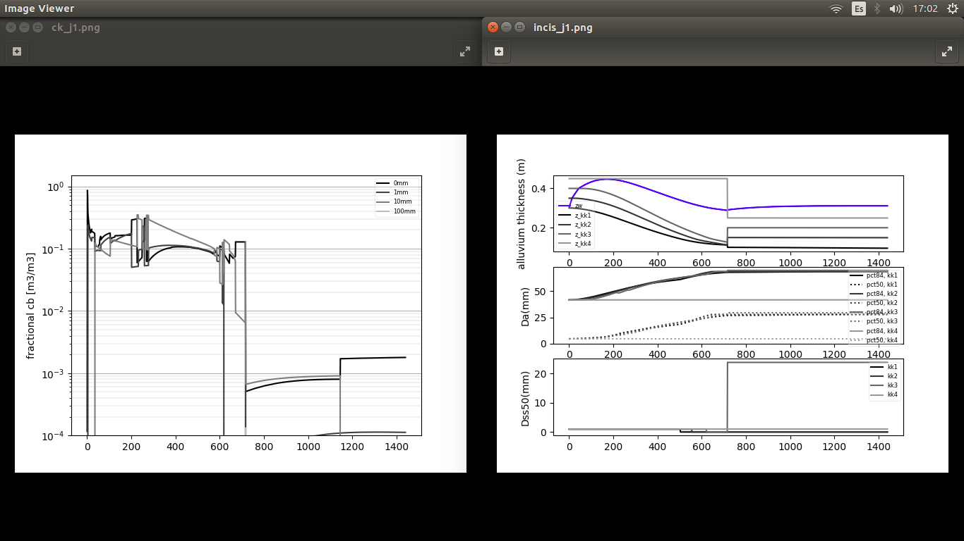

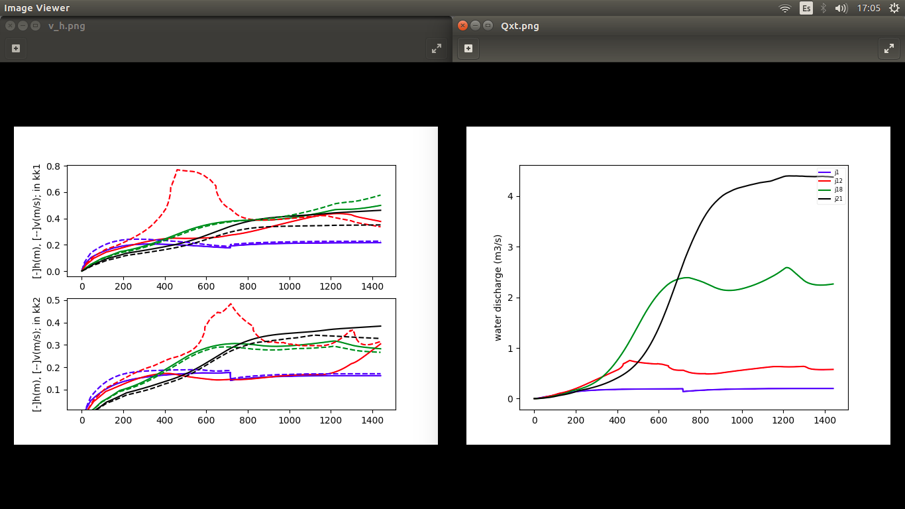
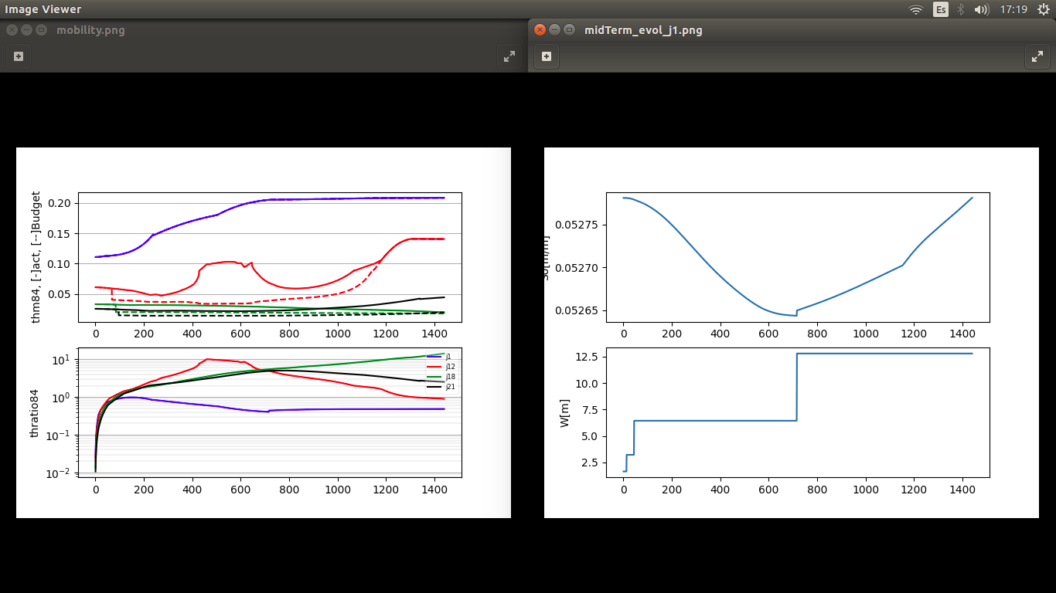

Take care about mass balance. From min 1300 to min 1400 Q=.205>Qhill=.2, then please review from min 0. There are fluctuations in Q inside 1% in such time period. Small feedback of homeostasis in water balance is that roughness tends to store water but increase in slope and storage compensate. Then, not only gravel bedload but also water go out of reaches as pulses.

May7,18: setup of flume code. Flag=1 so flume variables, else basin. Flag changes topology, supply, width, GSD and ddt. Supply was edited to account for spatial variations.

May8,18: dynamic trench in code, so bank cascading when bank angle exceeds repose angle (80% done, laking test). Z=0 in downstream elevation of flume floor as ‘bedrock’, i.e. base of control weir.
Slides are shallower enough to preserve gradient of alluvium texture in cross-section?
Changed nW from 5 to 8 then bed evolution of j7 and j8 was different

If degrees of freedom are refined (nw, nd?, dx, dt) then tension of river is reduced, i.e. time to steady, less dampening. Greater relative changes in evolution of smaller scales, e.g. grain size.

Simple response with less energy (Q=1 l/s instead 5 l/s), as logistic equation. So chaos emerges when several scales interact, e.g. changes in dz and grain size (Shawn CSDMS nondim numbers). This is argument on why special focus on tropical rivers. Interaction of signals of different scales emerge specially in downstream reaches. See waves in following figures.

On pink noise in landscape.
https://agu.confex.com/agu/fm17/meetingapp.cgi/Paper/274083
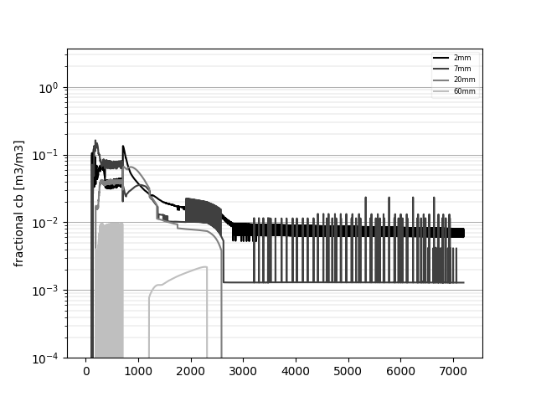
downstream, where enough signals are gotten from upstream, life~emerges; even
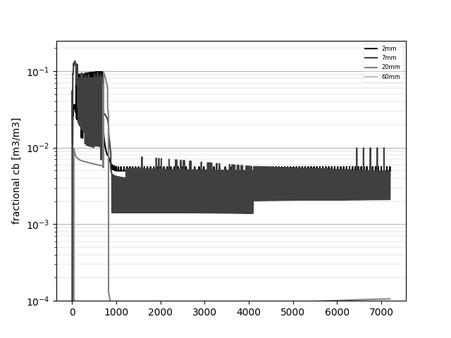

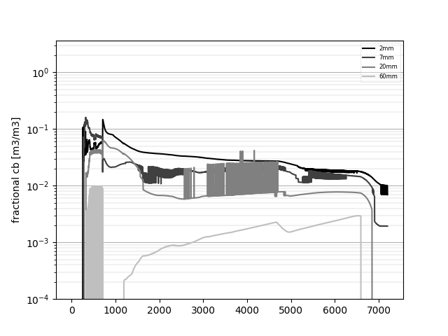

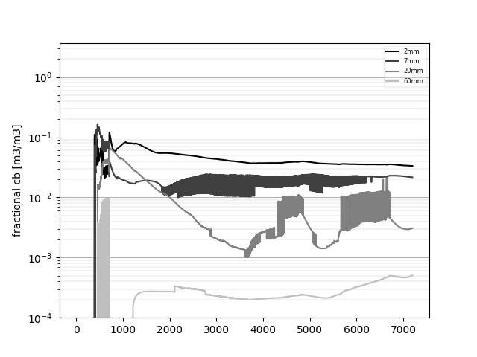

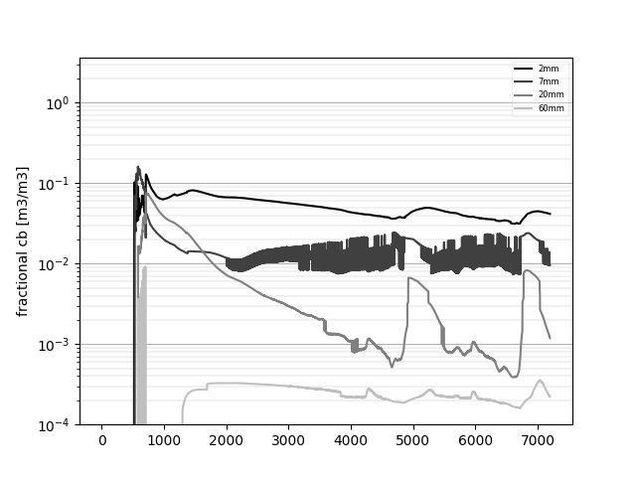
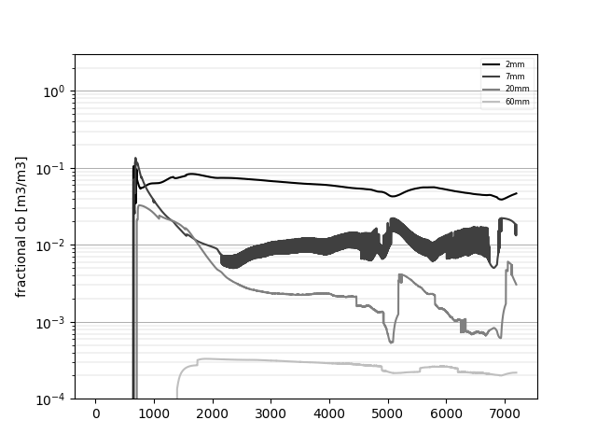

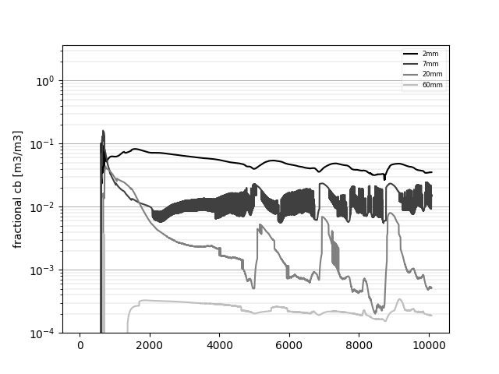

7mm harder to make alive??….why??….explains bimodality?

This emergent waves and May expo from SC to Marwan and Tobias, of erosion (exhaust, slower) + depositional (wedge, faster) waves gave me idea on study equilibrium through wave theory (e.g. ‘coherence’ instead correlation). Coherence could be the goal explaining stationary patterns of spacing between forms like meanders, riffle-pools, step-pools. These 3 examples increase 1/wavelenght with power, which is related to energetics of waves. (https://academic.oup.com/bioscience/article/64/10/870/1780369)

11may:
Solving bugs previous to calibration with flume data.
Bug1: z plot for kk>4. Code need to build paths to save binaries to plot in flexible way, i.e. allowing different nD or nW as 3rd dimension to plot for some variables. To explore way to deal with lists of paths, forum says to use numpy to convert list to byte string which is 2D with one character per element. Given complexity, I use auxiliar text file to explore this tech:

f2py -c -m byte2strarray paths_rebuild.f90

It worked, assuming 2D matrix whose rows are #paths and columns are characters/path. #char/path was prefixed from python by filling with ‘o’s

Now call model:
f2py -c -m mod_model_sc fluvMphdyn_ddt.f90
Internal variable xy was used to write path of each variable as series of strings.

Folder name can be changed easily from python, e.g. to save results of different cases in sensitivity analysis.

Seems error in random memory because the more advance variables in kk loop to print binary the less success. However, giving specific variable to write path of each variable did not solve bug

14may:
mass balance: why increase z even is not wet?. Bad conditional to cascade when trench. Fixed, but not running. So, Dm is fixed as geometric mean instead arithmetic one. Segmentation fault starts to be very frequent. Fault seems to be repaired by reducing variables to print from f90.
Numerical error emerges in different x,t each try with identical initial conditions, except random lognormal CSD (sampling 1e4 elements to be robust). Such exception can be raising differences in x,t of error. What a chaotic system!. So I need to save Shawn’s GSD with different nD in code to get absolutely deterministic initial conditions to be able to locate numerical bugs to solve.

15may:
Too steep banks implies sliding process is not working properly

-Calibrate with Maria’s experiment as Tobias did. Implies to be flexible with D array of grain size classes. Use armor break sensibility(omitted because break is deprecated. It was enabled only in Recking transport method) taoref (see draft sensWC) for calibration, as Marwan suggested to Tobias. Spatial setup to reproduce flume experiment implies to make flexible topology building. Put ‘serial’ topology building in single reach as parallel, i.e. alternative, method to Tokunaga basin topology. Serial topology must work when flume_else_basin=1 in model setup. Ddt is not needed because you can preserve fine temporal resolution for the whole set of runs, given high f90 speed. Review how relevant are deprecated terms in balance of grain size portions, given this fine temporal. Write document on design of experiment to test width as trench, reading GSTARS_ii=app.

15may:
New folder: Maria’s flume.

16may:
It is too relevant to have fine dt at beginning due to easy exhaustion while bed gains structure.
Event fine dt shows that too fine dx, e.g. in flume make backwater too probable in abscissas where exhaustion occurs. Then backwater module must be activated.
I plan to build matrix x vs t similar to characteristics method to move backwater signal upstream at v~celerity. On wave celerities: https://www.openswmm.org/Topic/1273/wave-celerity-in-natural-channel. Froude celerity is valid if h/L>20.

20may:
x vs t wave matrix is filled different depending if c>dx/dt.

h and v related to backwater implies recover Recking(2011) friction law, which is isometric not allometric i.e. dimensionally consistent.
22may: least action principle (LAP)?...first node in Marias experiment tend to increase dune height until becoming exhausted. Sf convergence starts to be less alternating.
On LAP:
https://onlinelibrary.wiley.com/doi/pdf/10.1002/esp.3999

Event with So=Sf(iterated)>Smin all alluvium is moved so first abscissa become exhausted. Then, I am trying with dt<minute (20s, 10s). 10s was used by Tobias. Epic failure. Better use backwater equation to preserve energy when iterating next water_elev. Initial elevation must be high enough to avoid supercritical flow.
On theory of gradually varied flow:
http://personalpages.manchester.ac.uk/staff/david.d.apsley/lectures/hydraulics3/gvf.pdf

I am not getting armoring. I think Recking equation to define bedload portions might work better than WC. But, I need to work with WC to calibrate with UBC data.

23may: new day + pressureMeeting = new ideas. Qramp to avoid exhaustion.

Hola Santiago,
Dejamos el lecho con un caudal bajo (jncapaz de transportar sedimento, pero capaz de cubrir el lecho) por algun tiempo (0.5-1 hora aprox.) para que estuviera bien mojado al subir a los 65 L/s y dar por iniciado el experimento.
Saludos,
Maria

24may-31may: emotional pulse to response with resilience thanks to love.
1St: Tobias, 2nd: rfgToku, 3rd: trench, 4th: lumper.

Core dump usually first time I use python again after compiling fortran. Nothing needs to be changed in code. Try again and it runs well.

tasks:
-put pbl consistent with qsmx(k). OK
-increase grain size classes to reduce likelihood of mobilization of every class. OK, it helped a few.
-refine dt to avoid sharp changes (no much hope, cos last time even hourly exhausted). OK, helped even refining until dt=1/6 min = dtTobias.

-refine dx. If dx=.5 then err fsub i=273, j=7
-use ramp with increasing dt each Qstep. Bah, ramp is not helping much
-review mass balance
-output: 2*reality=2.4m3 ( f(dt)!! )
-store can only decrease in time
-OK: magnitudes differ only by factor related to porosity
-smooth So, assuming big incision occur where So(t) is too steep. OK, it helped a few.
-consider backwater as further agent to reduce shear
-if alluvium is exhausted then turn off WC. So, fractional capacity is evaluated by Recking
-if alluvium is exhausted avoid insisting in building thalweg, because there is not available material.
-use Parker tao* formulation (parker ebook, ch5, pg 14)
-review if 1<submerg<10 as needed by my deduction of resistance law combined with water balance, using power law of following blue points of Recking11. v**=f(q**)
1.5471*fluvial_design.B36^0.7062*(1+(fluvial_design.B36/10.31))^-0.493

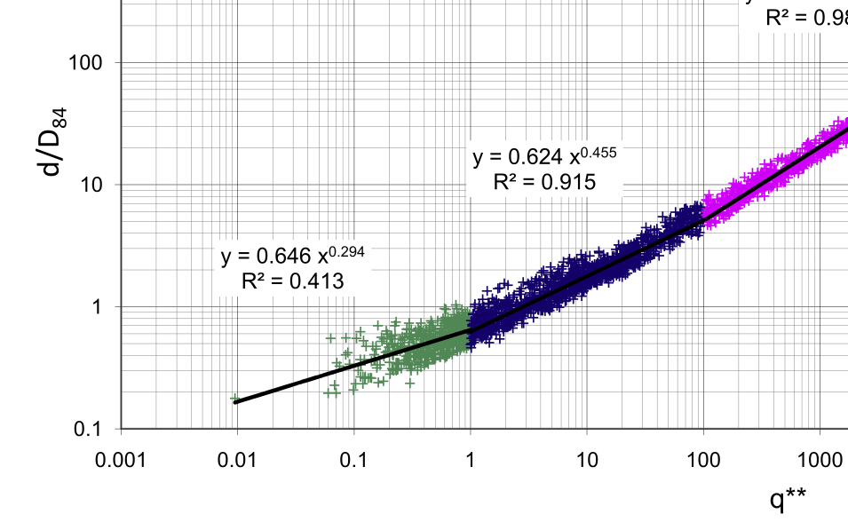

-Maria’s sigma GSD =1.8??, so why my ranodm lognormal generator does not work producng enough coarse sizes as it does with coarser Shawn’s GSD?. Ok, final roughness similar to Maria’s, but too much incision=loss of slope to get it.

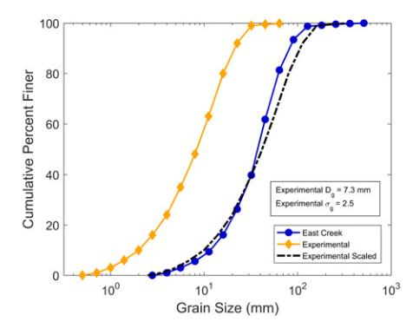
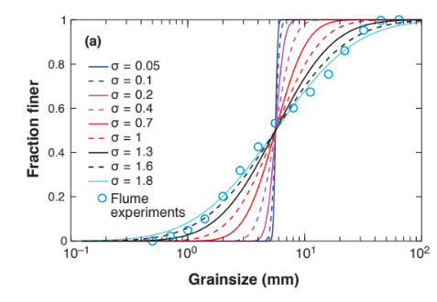

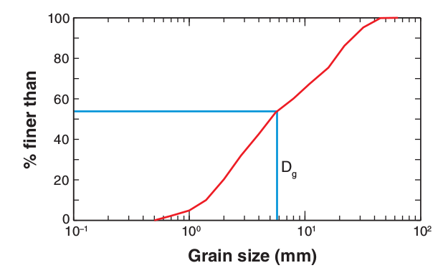

-Deal on why ddt implies ck NaN due to null Q more frequently when dt fine is coarser, e.g. dt=5min fails sooner than dt=1min. Check that you do not have DF or turn it off.

-Build solutions when dam & backwater for case of big episodic landslide supply exceeding flow capacity.

-Design and run experiments for RFG2018. Put presentation online to invite public, as suggested by rgf’s mail on April 19. Presentation is review of 1st Marwan’s plan about simple morphodynamics model in drainage network.

-Continue building review draft in HassanChurch document, related to alive basin. Cite RFG results.

-Cite Hassan, Eaton, Slaymaker and Church (and Kopper?) to discuss results and ask for real cases.

-Build and/or recover from Nico the lumper for real basins and rain generated from stochastic cascade.

-WEEKEND: Build proposal to Colombian Bank of Republic to earn grant to pay people dealing with SfM. This way my own tropical database of river shapes to calibrate model can be collected. Also push in Cornare.

-Work for 2nd objective according to Marwan proposal to me. Process Ferrer ConstantFlow data, on different recession duration before stepped rising limb of hydrograph.

-Build feedback mechanism as Golly2017 to deal with boulder supply in my model.

-Experiment in miniflume as Fan showed by MsC(c) in Spring Geog Symposium.

-Finish contents of hydrogeomorphology course.

-FLAG1(just activate and debug): Wcrow: see if now so no big c near t=1819 (was even with d84/50 reck).
Take case because pbl needed in further calculations, like fI (ToroEscobar)
*memories on own paper

-FLAG2(just activate and debug: check effect of DF, run 5 year to see slide at t~900
*memories on own paper

How to be sure that F no exhausted by too big dt

-t 1819: slide (when run by 5yr). upstr so backwat (must be dams <100m h, to believe)
-backwater works well only if bed, water and energy long profiles are coherent.
PPT TO MARWAN
-ddt
-topol&rain real xt
-cites people ubc
(col: sidle upscaling)

Priority is structuring codes in python and fortran, and being sure about right wrapping between languages.

Simple spatial rain (e.g. by 4 squared zones, or lumping cascade fields) and canyon in river width downstream can be refined later.

About real case in SCa or Canada as calibration: make code to call SHIA routine to define topology array X by reaches, considering hydrological nodes.
October 11, 2018:
I finally finished contents for hydrogeomorphology course. Then I am coding to analyze coarse timing data (~15min) of trench experiment to close mass balance with DEMs and get ready paper 1 with Marwan.

En bash:
Cd /home/scatanoa/Desktop/trench_code

En ipython (It was already updated to version 3..):
import trench as tr
trf=tr.flume_data()
trf.coarse_balance()

numpy.loadtxt is lasting 15s/dem to load in my laptop
May28, 2019:

GOALS:
-validate with trench: SC papers mw1.1 y 1.2.
-validate with Elgueta, RFG18.

While waiting for Marwan’s comments on papers on hydraulics (1) and transport (2) of trench experiment, I take again morphodynamic code to calibrate width evolution with trench experiment.

Key code pieces were found, after 1 year, by writing ‘code’ in mail search at reading the last one at june2018. Code files, initially located in the small storage ‘home’ folder were copied to D/trench_mw2.

The name mw2 which denotes this material is intended to calibrate experiment and numerical model, because this is the 2nd topic for papers with Marwan (3rd paper), after producing 2 papers on the 1st topic: experimental results.

RIVER CODE BUGS:

Direct machine to goal folder:
cd /media/scatanoa/DATA

Remember to refresh ‘.so’ (compiled) FORTRAN file before debugging:
f2py -c -m mod_model_sc fluvMphdyn_ddt.f90

Then, call python interface in Ipython3.6, to use the compiled module:
ipython
import fictFluvMphdyn_ddt
fm=fictFluvMphdyn_ddt.idealStreams(9, 1, 1, 1)
fm.run_model_sc(1,70,2,2)
fm.simul_plots()

- Qhill varies hourly, not daily, in trench experiment.

Chance: Can finer Qhill resolution (hour instead day) be solved by setting dt as 1 instead 24?: it’s hard, cos ndays is even parameter for model method; however it’s needed. It implies to change ‘24’ values if ddt loop for flume, which means ‘24’ will be flexible to other experimental Q time steps, like 1 hour.
R/ dt_dQ_coarse, which is 1 instead 24. This variable acts is py (in refine_dt method) and f90 (while downscaling Qhill). OK!!

- In assumed_vars method of fictFluvMphdyn_ddt.py: width is to be entrenched even if flume instead basin, to adapt trench flume experiment.
R/ trenchFlag was created. OK!!

- In calibration with Elgueta17: certain reaches touch flume floor in simulation.

31may19:

-Started with dt_event=15min instead 1min for fast run for debug. 1st run produced core dump without getting all binary results but next one, identical, run complete (e.g. adverse slope & other counters output ) ok.
-Remember reset ipython if code is edited.
-Last arguments to pass from py to f90 seem to be array size indexes.
-dx=1.5m, dt=15min; low c peak, dt5 and dt1 dont improve.
-dx=.5, dt=1/10 (run lasted 2min in laptop): dont improve.
-hypoth: too high taocr, err side slide (increase thickness if no flow on it!!).
dx.5, dt1,alfaWC=.8:
adelgazo ActiveLayer pa q acoraze mas fácil d modo q anche más, y refine dt (de 1min a 1/5) to avoid ck NaN because of outlier So in previous times:
..y dx.2<.5 pa caracterizar mejor zonas de desliz, pero pa no ckNaN bajo dt de 1/5min a 1/10=6seg.
…..no mejora con tanto refine en dx dt. Tos d nuevo: dx.5, dt.5 (dt1 unstable for the thinner active layer).
-conclusion: aunque ancho ok, flujo debe sedimentar thalweg y erodar bancas. Para eso corregiré módulo ‘trench’ del modelo morfodinámico en f90.

4jun19:

-repairing trenchingand braiding module. Trenching moves all colluvium to thalweg, allowing to repair multiple oversteepened zones of cross-section.
R/ did it work?

-challenge: refresh_texture after cross-section reequilibrium.

5jun19:

-repairing outlier values in qsbmax variables located external to indW. OK: initialize vars in 0 for each x,t step.

-i8, j1: oversedimentation higher than all cross section zones. Makes sense braiding algorithm?. Better to enhance inertial transport?. Indeed, this way experimental sediment load peaks after increasing Q would be better reproduced.

-dx pasó de 0.5 a 1m. Estabilizo excesiva pendiente producida por slides locales.

-parece ser que adaptacion es más dificil al comienzo del experimento, pues setup de GSD fue artificial y suelta mucho slide. Entonces doy tiempo de calentamiento poniendo taludes 1cm mas bajos que angulo crítico de reposo.

-alfaWC 2, instead 1, avoids alluvium depletion and produces the most realistic results by now.
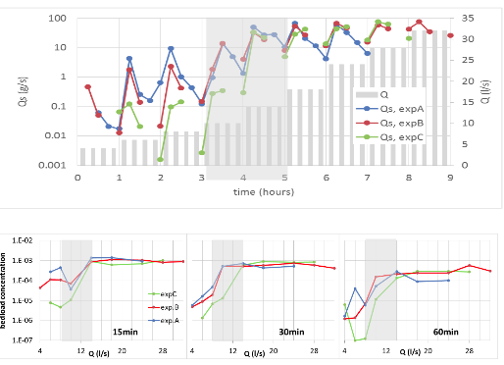

c do increase neither with x nor with t

Then code balance!!

se churretea cuando no deposito subsuperficial, e.g. low taocr cos alfaWC=.5

6jun2019
trying to develop transitional flows

-spread supply along cross-section according to flow capacity. OK

7jun2019:

goal: plots trench calib

-avoid alluvium exhaustion, cos it always brings bugs. For real rivers, prepare deep boulder store, with erosion resistivity high enough to act like bedrock.

10jun19:
goal: produce calibplots

-balance: off coarse alluvium take sense to increase during experiment. Then current storage results in draft of paper mw1.2 (trench experiment results on sediment) are wrong.

11jun19:
goal: produce ALL calibplots

-Qs aggr: no variability in subtransitional flows, no peaks in 15min.
-fractional transport, pi/fi: refine discretization of grain sizes from 5 to 7, to seek better calibration.
-even so, dx=1m and dt=.5min to avoid bugs, like this one with dt=1min ‘STOP there is not enough material to erode in this lateral redistribution’. Número de loops en fortran: 9*1800=16200 tardan cerca de 1min.

13jun19: leave OK in fulfilled task

adapt pcu: OK

-folder trench_mw2 was created to save modelling results. Create jupiter notebook for auto-run.
cd /media/scatanoa/DATA (or path related to Pcu)
jupiter notebook
html is opened. Open there file .ipynb containing the notebook of interest.
In fm=fictFluvMphdyn_ddt.idealStreams(15, .5, 1, 1), 15 is # of flow values including falling limb of trench experiment, and 0.5 is minutes of dt.

repairs stores for paper mw1.2:
-folder trench_code remains, with existing jupiter nb.
-in method lump_stor_and_Qs_per_stretch of trench_v2.py maybe channel store change (dst) in not accounting for increase in store due to increase in size of control volume boundaries (due to channel widening). This is way I prefer to standardize, in both model and lab data analysis (including Exner balance calculations), storage calculations as dot products of elevation and width.

module organization:

LEAVE BACKUP OF DATA CODE IN DRIVE

21jun2019:

PLEASE, BEFORE PRETTY PLOTS Y REDACTION, CHECK BALANCE!!
After 3 days, I discover sediment balance is fulfilled only in a given time, but not cumulatively during a given experiment. It might be related to the changing control volume. However, cumulative balance holds in trench numerical model; maybe having width changes discretized helps.

Then, from here, sediment balance is going to be checked only in whole alluvial channel and in hillslope. As trench experiment in whole alluvium, only delta_store = output will be checked.

3jul2019:
varying trench parameters, lets see If new bug emerge.
Full of bugs, see notes.

4jul2019:

Even same Wflume=1, varying discretization style (finer in center) or steps (9-15) produces different responses, some of which develop bugs. The finer the steps (nw=15), the more precise mass balance.

8jul2019:
When refreshing texture, I discovered that the way to refresh (if any) active layer thickness might be another degree of freedom for calibration.

I edited code to preserve bed texture evolution, via fractional mass balance, only is zones of the crosssection where no change occurred due to lateral redistribution.

I made initial alluvium thickness higher than flume (0.3 instead 0.2 in f90 variable ‘base_level’) for it to remain with enough active layer.

9jul2019:
Persistent weird patterns:
a-err balance.
b-no fining in thalweg when refill after trenching.

10jul2019:
a- some bugs were repaired, but problem is not fully solved.
b- seems to improve after setting intermediate evolution of bed texture, before lateral reequilibrium.

11jul2019:
I will calibrate GTM method as alternative to compute fractional bedload, to improve calibration of sediment output texture and impose higher critical shear stress when channel gets steep (e.g. slope greater than 10%). If channel become as steep as that, WC method always gets too high transport capacity that it consumes all alluvium, which did not happen in the trench experiment.

15jul2019:
GSD[mm] in txt of matlab code to analyze GSD via colors:

26.9, ltblue
19, ltgreen
13.5
9.5
6.7
4.8
3.4
2.4
1.7
1.2
0.8
0.6

My greater GSD was ltgreen = 19mm.

In pcu desktop is xls of exp trench with sheet of paper_figures. (currently, Shawns GSD)

16jul2019:
After some sensitivity analysis, initial GSD do not affect much results. Then, alfaGTM parameter is intriduced in f90 code to adjust streess threshold. It works, but still no bed fining is gotten below D84ini.

Eh, alfaGTM must be in range .4-.5 to get real sediment output, dont matter gamma’s parameterizaton. of GTM.

17jul2019:
Calibrating GH leads to recalibrate transport, which must show sharp increases in output slope with time in transitional flows. These seems to be a matter of GTM fractional parameters, not about alfaGTM which looses all taocr values.

Sediment balance errors emerge when z=0

19jul2019:
Msg2Recking: eh, parce, sospecho q hay redundancia de parámetros. Ud puede crear full mobility con alto M pa todo Q (bajo beta), o con alto gamma pa todo Q (bajo gamma2).

AlfaGTM (o alfaWC) flag <1...link to slids inertia?...how to..in code?

To avoid restart Jupyter, calibration parameters ought to be passed from py, not in f90, to avoid recompile.

4sep2019:
datos calib trench ubc:
