MEITRACK OTA Protocol

Version: V1.0

Contents

1 OTA Protocol Constraints and Communication Process - 3 -

1.1 Communication Process - 3 -

1.2 OTA Update Procedure of Our Platform - 3 -

2 OTA Commands - 4 -

2.1 Checking the Device Code (GPRS) – FC5 - 4 -

2.2 Checking the Firmware Version (GPRS) – FC6 - 4 -

2.3 Setting the OTA Sever (GPRS) – FC7 - 4 -

2.4 Authorizing the OTA Update (GPRS) – FC0 - 5 -

2.5 Sending OTA Data from the Platform (GPRS) – FC1 - 5 -

2.6 Obtaining OTA Data Checksum (GPRS) – FC2 - 6 -

2.7 Starting the OTA Update (GPRS) – FC3 - 6 -

2.8 Canceling the OTA Update (GPRS) – FC4 - 6 -

# OTA Protocol Constraints and Communication Process

## Communication Process

1. Send messages from the tracker to the server.
2. Send messages from the server to the tracker.
3. Send commands in sequence for the Over-the-Air (OTA) update: FC5 > FC6 > FC7 > FC0 > FC1 > FC2 > FC3.

Don't skip any command. Otherwise, you will receive **CMD,NOT** from the tracker. At any time, you can send the FC4 command to cancel the tracker upgrade.

## OTA Update Procedure of Our Platform

1. Our R&D department provides the OTA file (including firmware data) and then stores it to the OTA server for verification.
2. Verify the validity of the OTA file: The OTA file data consists of the OTA key, firmware data, and firmware version number (at the end of the OTA file data). The firmware version number must be the same as the OTA file name. If not, the OTA file is invalid. Offset of the firmware version number: HexLen + 256.
3. Send the E91 command to obtain the tracker's firmware version when the tracker is online and store it to the database.
4. A firmware name consists of fixed fields and its version number. For example, MT90_EV121, of which **MT90_EV** is the fixed fields. When you use the OTA update to deploy the firmware, the upgrade interface will pop up. Then locate the valid OTA file from the server whose fixed fields are the same as that of the tracker's firmware version.

After selecting the OTA file, click the upgrade button. Then the server will start upgrading according to the following process: FC5 > FC6 > FC7 > FC0 > FC1 > FC2 > FC3.

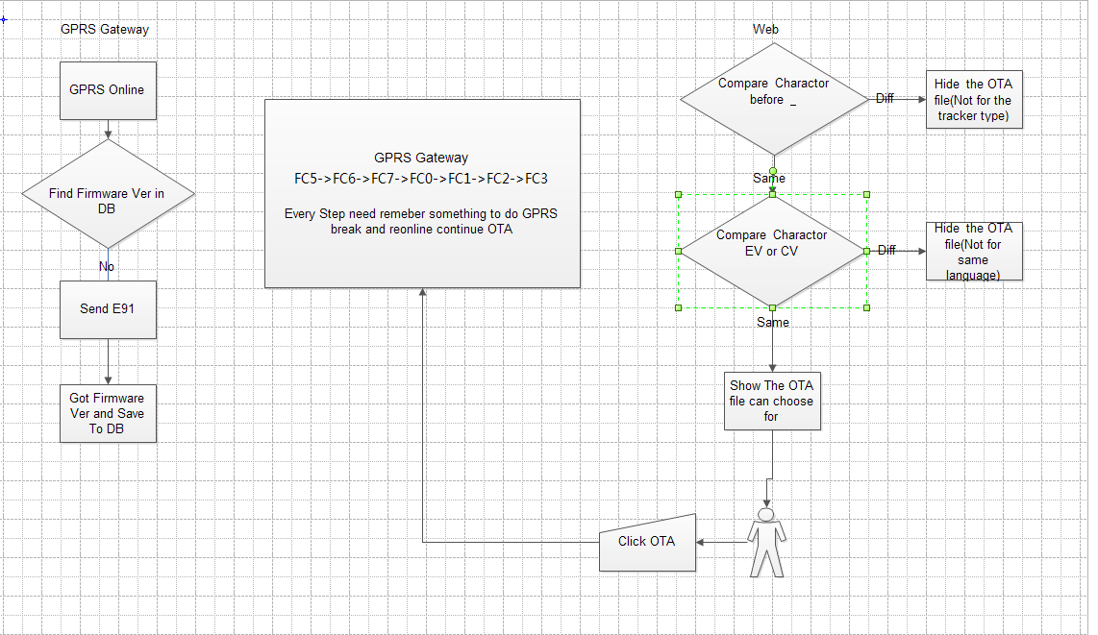

# OTA Commands

## Checking the Device Code (GPRS) – FC5

|  |  |
| --- | --- |
| Sent from the server to the tracker | FC5 |
| Sent from the tracker to the server | FC5,Device code |
| Command description | Device code: contains 2 bytes; hexadecimal. For details, see the Meitrack Product Code Table.  This command is not restricted by OTA authorization time.  Command sequence for the OTA update: FC5 > FC6 > FC7 > FC0 > FC1 > FC2 > FC3 > FC4.  At any time, you can send the FC4 command to cancel the tracker upgrade. |
| Platform description | Online upgrade |

## Checking the Firmware Version (GPRS) – FC6

|  |  |
| --- | --- |
| Sent from the server to the tracker | FC6,OTA file name |
| Sent from the tracker to the server | FC6,ACK |
| Command description | OTA file name: contains 32 characters; ASCII character.  ACK: Its three values are as follows:   1. **OK**: The OTA file maps the tracker and you are allowed to perform the next step. 2. **1**: decimal. The firmware version to be updated is the same as the tracker's version. On the platform, a prompt box will pop up. If you want to update the firmware, continue the next step. 3. **2**: decimal. The OTA file does not map the tracker. The tracker may be down due to the update. On the platform, a prompt box will pop up. If you want to update the firmware, continue the next step. |
| Platform description | Online upgrade |

## Setting the OTA Sever (GPRS) – FC7

|  |  |
| --- | --- |
| Sent from the server to the tracker | FC7,IP address,Port |
| Sent from the tracker to the server | FC7,OK  Or FC7,<Err>/<FFFF>  Or FC7,OTA |
| Command description | IP address: IP address or domain name. A maximum of 32 bytes are supported.  Port: a maximum of 5 digits; decimal.  Commands sent from the tracker to the server:   1. FC7,OK: When the platform sends the correct OTA server IP address and port, the tracker will reply "FC7,OK". When the IP address and port sent are wrong, the tracker will reply "FC7,Err" or "FC7,FFFF". 2. FC7,OTA: Obtain an OTA heartbeat report. To confirm the normal communication between the OTA server and the tracker, the tracker will automatically send "FC7,OTA". |
| Platform description | Online upgrade |

## Authorizing the OTA Update (GPRS) – FC0

|  |  |
| --- | --- |
| Sent from the server to the tracker | FC0,AUTH |
| Sent from the tracker to the server | FC0,Device code,OK,Data packet size,Current firmware version,OTA file name  FC0,Device code,Err |
| Command description | Device code: contains 2 bytes; hexadecimal. For details, see the Meitrack Product Code Table.  Data packet size: indicates the OTA data packet size; decimal. One packet contains at most 1408 bytes.  Current firmware version: indicates the current device version. It is the same as that obtained by E91. For example, MT90_FW1.21.  OTA file name: indicates the OTA update file name with a filename extension (.OTA) or not.  If you do not receive any OTA command from the platform half an hour after the authorization, the tracker will automatically cancel this authorization and will not respond to any OTA commands except FC0. |
| Platform description | Online upgrade |

## Sending OTA Data from the Platform (GPRS) – FC1

|  |  |
| --- | --- |
| Sent from the server to the tracker | FC1,INDEX/OTA data length/OTA data |
| Sent from the tracker to the server | FC1,Received INDEX/OTA data length received/Result  Or FC1,NOT |
| Command description | INDEX: indicates the offset address of the first data in OTA file packets; 4 bytes; hexadecimal.  OTA data length: 2 bytes; hexadecimal.  OTA data: indicates the OTA file data; contains 1–1024 bytes; hexadecimal.  Result: 1 byte; hexadecimal. **0x01** indicates the data is received successfully; **0x00** indicates the data fails to be received;  FC1,NOT: OTA unauthorized or authorization timeout.  Note: All OTA commands are available when the FC0 command is valid. |
| Platform description | Online upgrade |

## Obtaining OTA Data Checksum (GPRS) – FC2

|  |  |
| --- | --- |
| Sent from the server to the tracker | FC2,INDEX/Data length |
| Sent from the tracker to the server | FC2,OTA data checksum  Or FC2,NOT |
| Command description | INDEX: indicates the offset address of the first data in OTA file packets; 4 bytes (little-endian); hexadecimal.  Data length: 4 bytes (little-endian); hexadecimal.  OTA data checksum: indicates the checksum that the tracker replies; 2 bytes (little-endian); hexadecimal.  FC2,NOT: OTA unauthorized or authorization timeout. |
| Platform description | Online upgrade |

## Starting the OTA Update (GPRS) – FC3

|  |  |
| --- | --- |
| Sent from the server to the tracker | FC3 |
| Sent from the tracker to the server | FC3,1  Or FC3,2  Or FC3,3  Or FC3,NOT |
| Command description | FC3,1: The tracker have received the command of starting the OTA update and is ready to enter update mode. **1**: decimal.  FC3,2: After the OTA update succeeds, the tracker will automatically reply this command once it is powered on and connected to the platform. **2**: decimal.  FC3,3: verification error. **3**: decimal.  FC3,NOT: OTA unauthorized or authorization timeout. |
| Platform description | Online upgrade |

## Canceling the OTA Update (GPRS) – FC4

|  |  |
| --- | --- |
| Sent from the server to the tracker | FC4 |
| Sent from the tracker to the server | FC4,OK |
| Command description | The command is to cancel the OTA update.  It is not restricted by OTA authorization time. |
| Platform description | Online upgrade |