Title ((no stars))

Author(s), and Corresponding Author(s)*

((Optional Dedication))

((Abstract text. 12 point, double-spaced. Maximum length 200 words. Written in the present tense.))

Keywords: ((3–7 keywords, not capitalized, plural, separated by commas, no full stop))

1. Introduction

2. First-Order Heading

2.1. Second-Order Heading

2.1.1. Third-Order Heading

((Main Text Paragraphs. 12 Point, double-spaced. Please make the first reference to a display item bold (Figure 1). Do not abbreviate Figure, Equation, etc.; display items are always singular, i.e., Figure 1 and 2. Equations are always singular, i.e., Equation 1 and 2, and should be inserted using the Equation Editor, not as graphics, in the main text. Display items and captions should be inserted in-line within the main text))
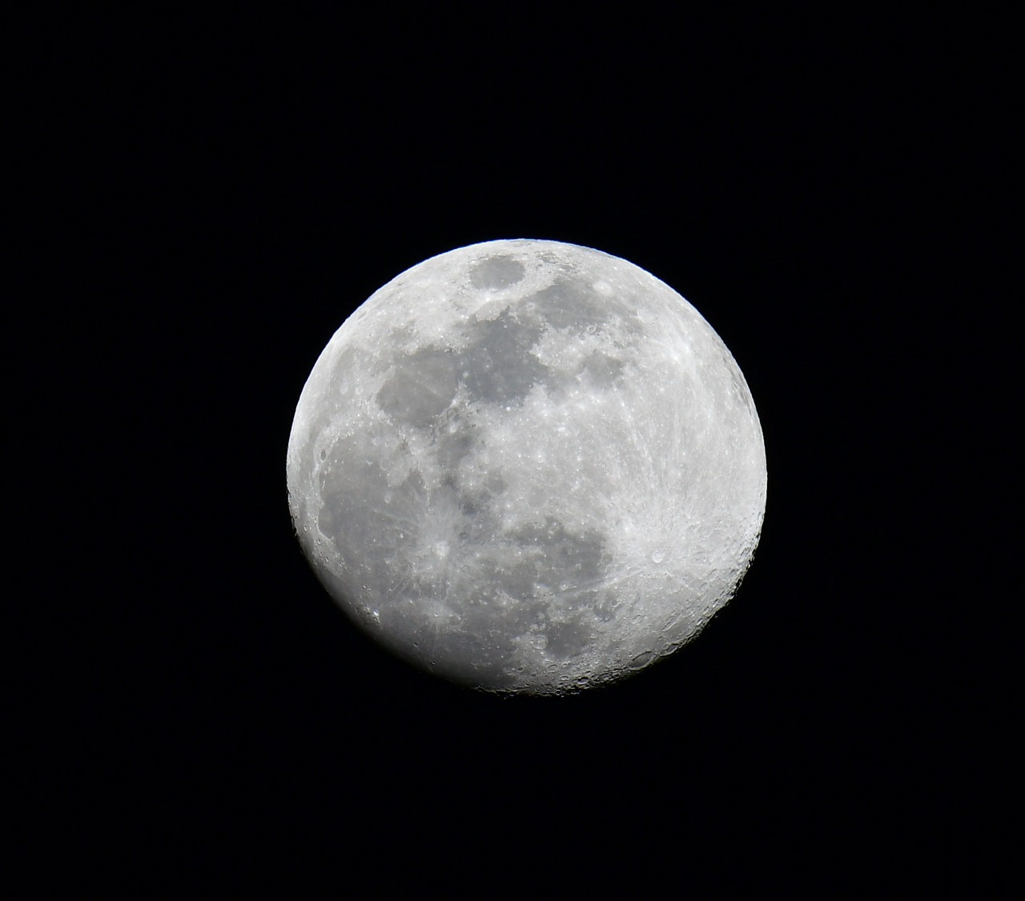
Figure 1 ((Figure Caption. Note: Please do not combine figure and caption in a textbox or frame.))

Reproduced with permission.^{[Ref.]} Copyright Year, Publisher. ((Permission statement required for all figures reproduced or adapted from previously published articles/sources; delete if not applicable))

Table 1((Table Caption. Note: Please do not combine table and caption in a textbox or frame and do not submit tables as graphics, please use Word’s “insert table” function.))
Head 1 [units]a) | Head 2 | Head 3 | Head 4 | Head 5 [units]
Column 1 | Column 2 | Column 3b) | Column 4 | Column 5
Column 1 | Column 2 | Column 3 | Column 4 | Column 5

((Equation)) (1)

((References should be superscripted and appear after punctuation.^{[1,2]} If you have used reference management software such as EndNote to prepare your manuscript, please convert the fields to plain text by selecting all text with [ctrl]+[A], then [ctrl]+[shift]+[F9]).^{[3–5]} Please do not use footnotes in the text, additional information can be added to the Reference list. Please define all acronyms except IR, UV, NMR, and DNA or similar (for a complete list of acronyms not requiring definition, please see the list available on the journal homepage in our “Author Guidelines” section.))

((Number)). Conclusion

((Number)). Experimental Section/Methods ((delete section if not applicable))
Experimental Subheading: Experimental Details. 12 point, double-spaced. References are superscripted and appear after the punctuation.^{[6]}

Physical data should be quoted with decimal points and negative exponents (e.g., 25.8 J K⁻¹ mol⁻¹), and arranged as follows where possible: mp/bp 20 °C; [α]_{D}²⁰ = −13.5 (c = 0.2, acetone) (please also give units for [α] and c, usually deg cm³ g⁻¹ dm⁻¹ and g cm⁻³, respectively); ¹H NMR (400 MHz, DMSO-d₆, δ): 7.15 (s, 2H, Ar H), 1.3 (q, J = 8 Hz, 2H; CH₂), 0.9 (t, J = 8 Hz, 3H; CH₃); ¹³C NMR (100 MHz, CDCl₃, δ): 175.4 (C=O), 156.5 (C4); IR (KBr): ν = 2972 (w), 2907 (w), ..., 1026 (s; ν_{as}(SiOSi)), 971 (ν_{s}), ..., 666 (w; ν_{s}(SiOSi)), ..., 439 (m), 401 cm⁻¹ (m); UV–vis (n-hexane): λ_{max} (ε) = 320 (5000), 270 nm (12000); EIMS m/z (%): 108 (20) [M⁺], 107 (60) [M⁺ − H], 91 (100) [C₇H₇⁺]; HRMS (ESI) m/z: [M + H]⁺ calcd for C₂₁H₃₈N₄O₆S, 475.2591; found, 475.2593. Anal. calcd for C₄₅H₂₈N₄O₇: C 62.47, H 3.41, N 6.78; found: C 62.27, H 3.46, N 6.80.

[CCDC ###### contains the supplementary crystallographic data for this paper. These data can be obtained free of charge from The Cambridge Crystallographic Data Centre via www.ccdc.cam.ac.uk/data_request/cif.] ((delete if not applicable))

Supporting Information ((delete if not applicable))
Supporting Information is available from the Wiley Online Library or from the author.

Acknowledgements
((Acknowledgements, general annotations, funding. Other references to the title/authors can also appear here, such as “Author 1 and Author 2 contributed equally to this work.”))

Received: ((will be filled in by the editorial staff))
Revised: ((will be filled in by the editorial staff))
Published online: ((will be filled in by the editorial staff))

References
[1] ((Journal articles)) a) A. B. Author 1, C. D. Author 2, Adv. Mater. 2020, 18, 2001086; b) A. Author 1, B. Author 2, Adv. Funct. Mater. 2019, 16, 1900965.
[2] ((Work accepted)) A. B. Author 1, C. D. Author 2, Macromol. Rapid Commun., DOI: 10.1002/marc.#########.
[3] ((Books)) H. R. Allcock, Introduction to Materials Chemistry, Wiley, Hoboken, NJ, USA 2008.
[4] ((Edited books or proceedings volumes)) J. W. Grate, G. C. Frye, in Sensors Update, Vol. 2 (Eds: H. Baltes, W. Göpel, J. Hesse), Wiley-VCH, Weinheim, Germany 1996, Ch. 2.
[5] ((Presentation at a conference, proceeding not published)) Author, presented at Abbrev. Conf. Title, Location of Conference, Date of Conference ((Month, Year)).
[6] ((Thesis)) Author, Degree Thesis, University (location if not obvious), Month, Year.
[7] ((Patents)) a) A. B. Author 1, C. D. Author 2 (Company), Country Patent Number, Year; b) W. Lehmann, H. Rinke (Bayer AG) Ger. 838217, 1952.
[8] ((Website)) Author, Short description or title, URL, accessed: Month, Year.
[9] ((Preprints)) A. B. Author 1, C. D. Author 2, (Preprint) Preprint server name, preprint identifier/DOI, version, submitted: Month, Year.
[10] …((Please include all authors, and do not use “et al.”))

