tex2docx Demo Document
tex2docx Project
2026-04-30
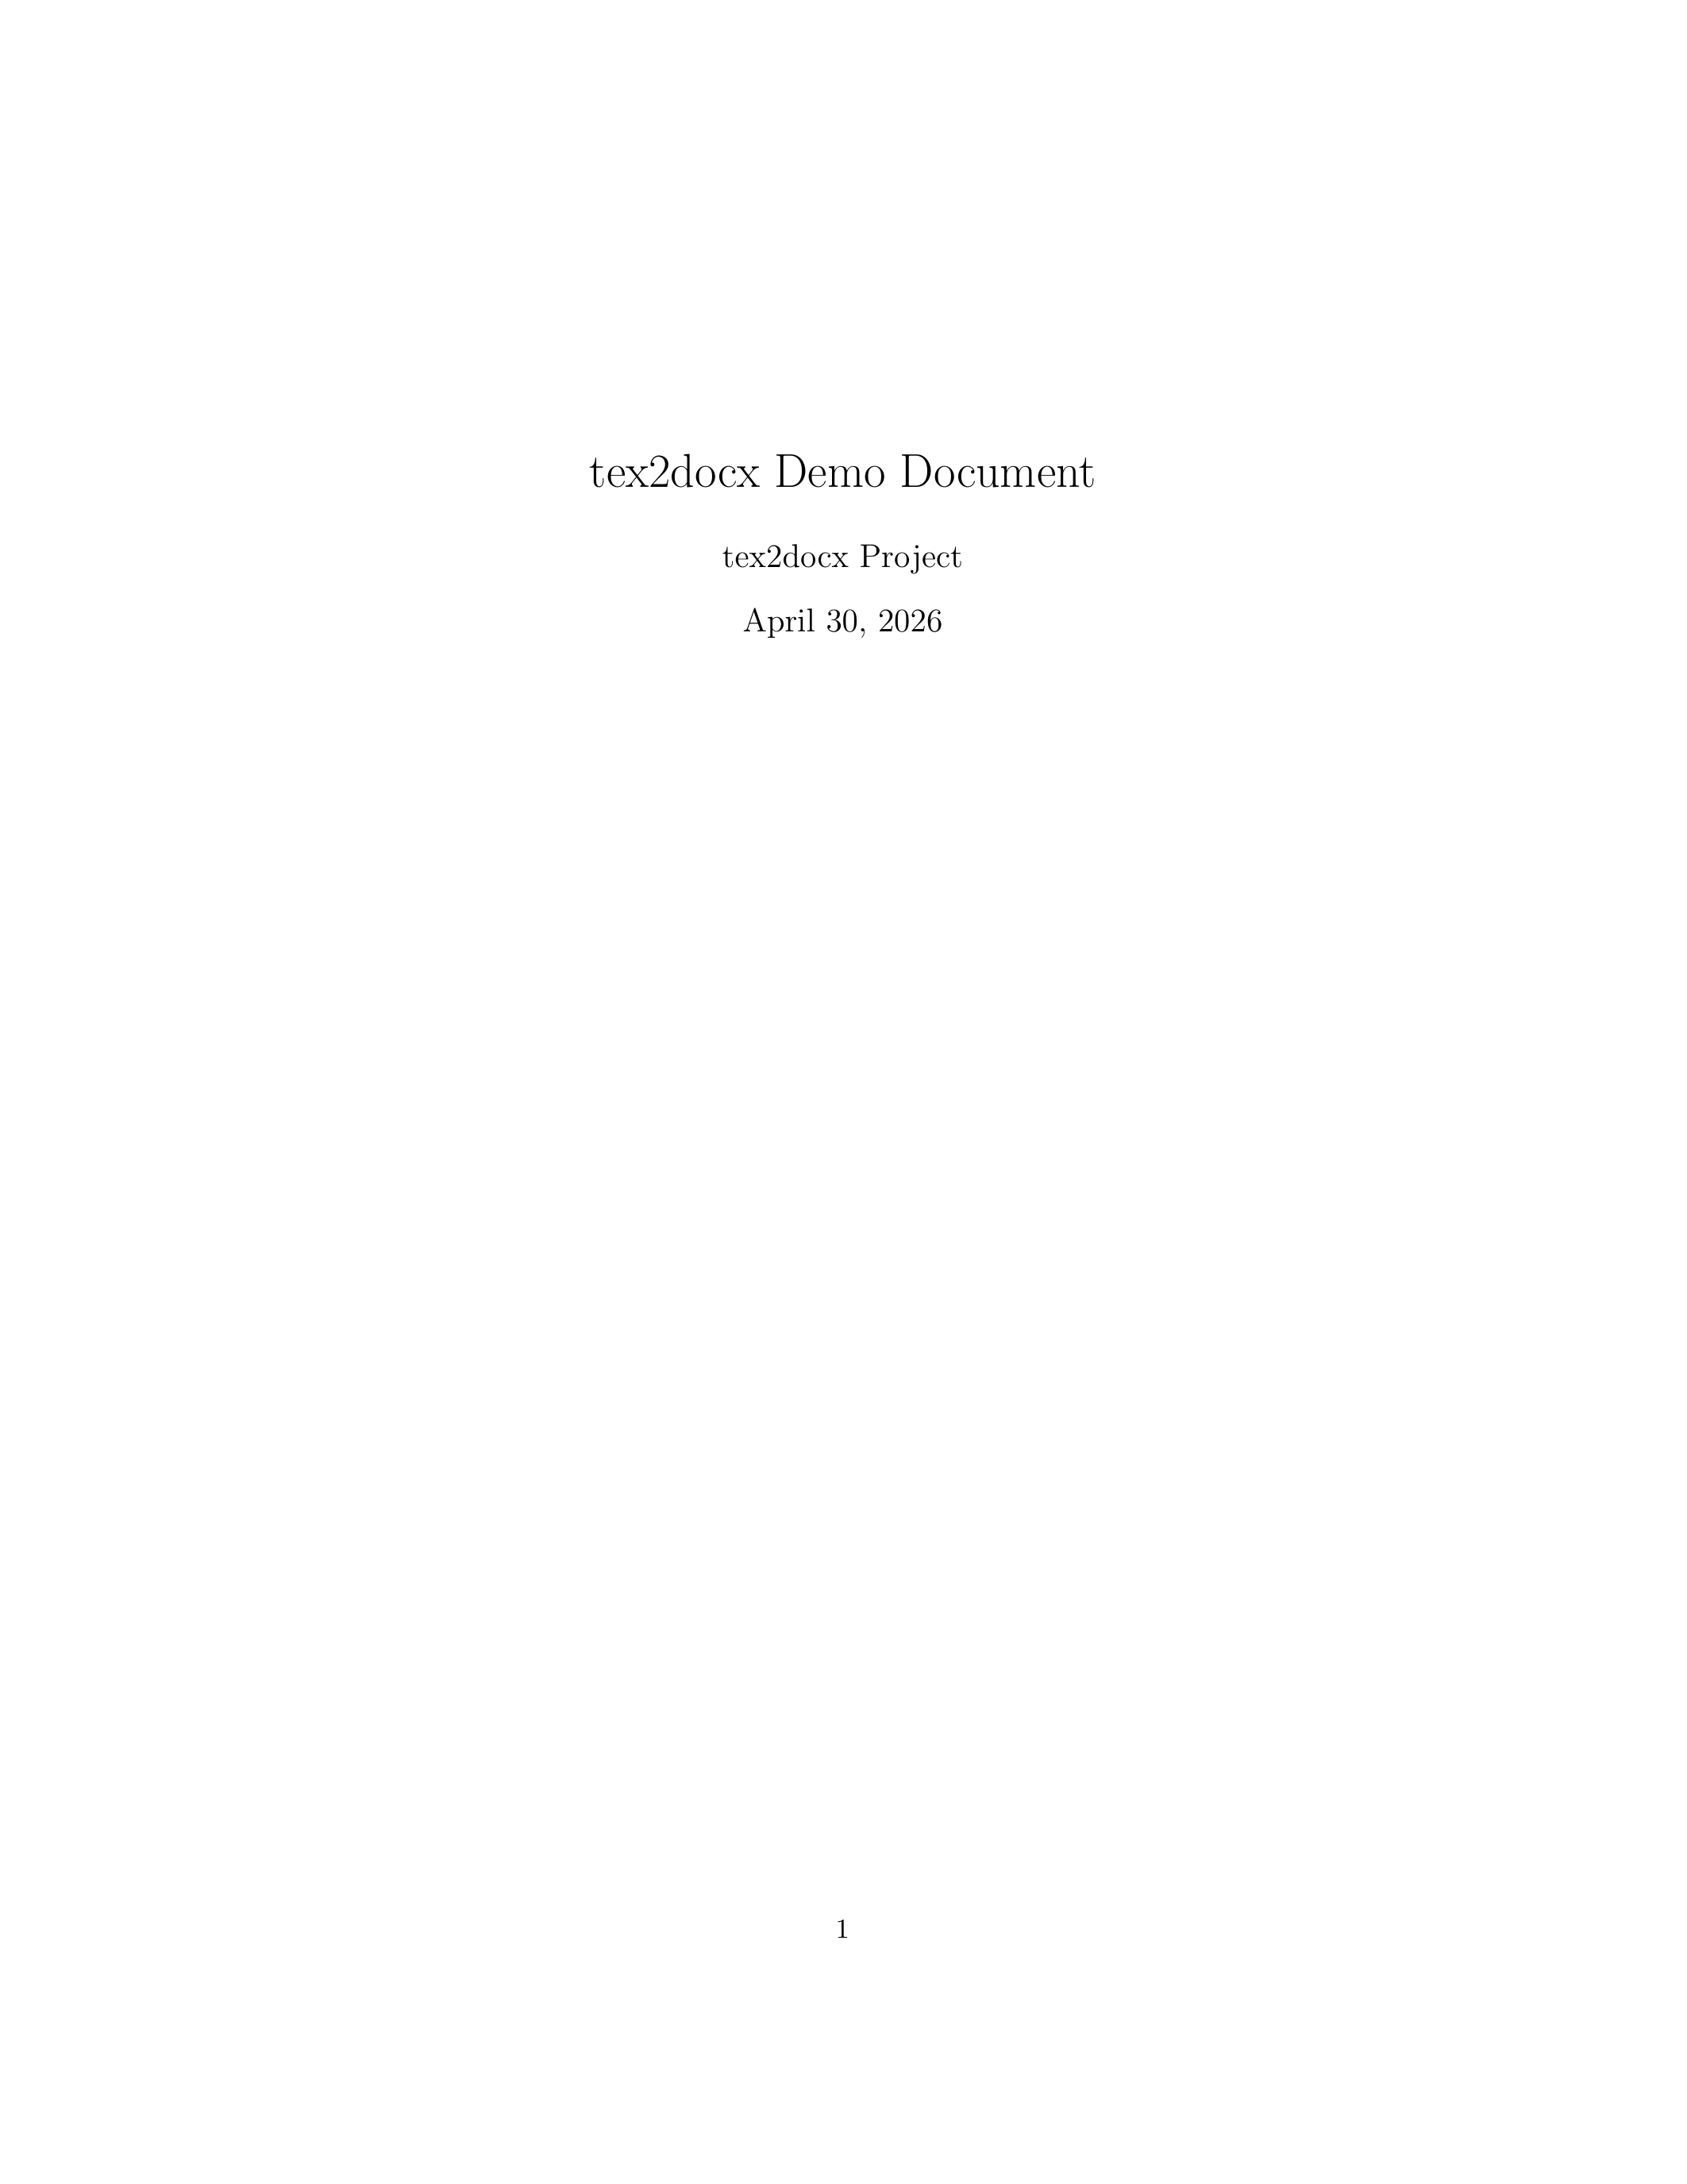



Introduction
This is a sample document to demonstrate the capabilities of tex2docx. It includes a title page, table of contents, acronyms, TikZ figures, and a bibliography.

Acronyms
Here we use some acronyms. The API allows different software components to communicate. Users interact with the system through the GUI. We can also use plural forms like APIs.

TikZ Diagrams
One of the main features is converting TikZ diagrams into high-resolution images. Below is a simple block diagram.
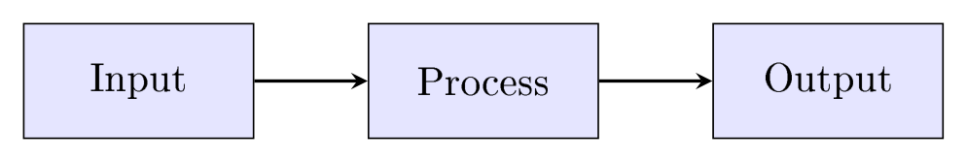
A simple process diagram.

Formatting
Standard LaTeX formatting is preserved:
- Bold text for emphasis.
- Italic text for terms.
- URLs like https://github.com/scavero/tex2docx.

Conclusion
This tool makes it easy to convert LaTeX to Word, especially when using complex packages like TikZ. For more details, see .

Referencias
[1]
Leslie Lamport, LaTeX: A Document Preparation System. Addison Wesley, Massachusetts, 2nd Edition, 1994.
[2]
Frank Mittelbach, Michel Goossens, The LaTeX Companion. Addison-Wesley, 2nd Edition, 2004.

