A User's Guide to the Central Portal of the Biosafety Clearing House

“Surfing the BCH Central Portal”

2nd Edition
June 2007
Module Outline

1. Introduction to the Module 3
A. Context 3
B. Audience 3
C. Purpose 3
2. Welcome Page 4
3. Left Side Menu Bar 5

Introduction to the Module

What you will learn in this module:
- To navigate the Central Portal
To understand the main functionalities of the BCH
- To know what information you can find in the BCH
- To search in the databases available on the BCH Central Portal

Context
The UNEP-GEF Project for Capacity Building for Effective Participation in the Biosafety Clearing House (BCH) is preparing a modular training package that aims to provide a practical “how-to” guide for countries to assist them in learning, understanding, using, and setting-up national access to the BCH. The training package is designed to be flexible and is tailored to meet diverse needs of different countries, allowing them to select those tools and ideas that are most useful to their situation, needs and priorities. The training package is divided into four modules, each addressing one element of the Biosafety Clearing House (BCH).

Audience
This module is designed to provide guidance to users of the Biosafety Clearing House (BCH). It is developed for a non-technical audience with little or no knowledge of the Cartagena Protocol and the BCH, but with a need to understand the requirements of the Biosafety Clearing House.

Purpose

This module describes the main functionalities and information that can be found on the BCH Central Portal. Users will learn how to navigate into the BCH Central Portal, knowing:

- the structure of information available on the BCH Central Portal
- the different categories of information found onto the BCH

While users are connected to the BCH Central Portal (http://bch.biodiv.org) they can read the sections of this module and surf the various component of the BCH Central Portal.

Welcome Page

URL: http://bch.biodiv.org/

The “Welcome page” is an entry gateway opening to the Central Portal of the Biosafety Clearing-House (BCH), hosted and maintained by the Secretariat of the Convention on Biological Diversity. This page provides access to all areas of the Central Portal, which is in turn linked to all of the international, regional and national nodes that provide information to the BCH.

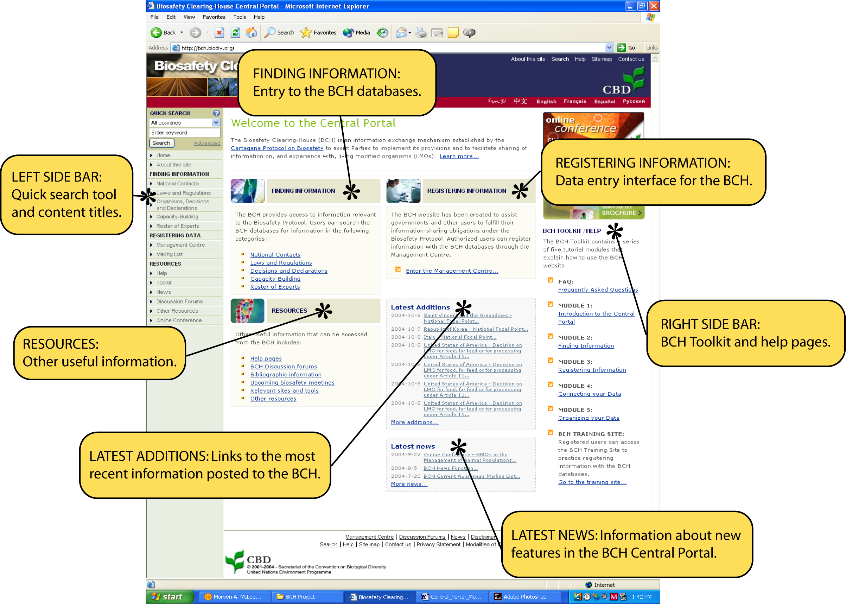

For ease of navigation, the welcome page can be broadly divided into seven sections:

Searching the databases
- Left Side Bar
Navigating the site
- Finding Information
- Registering Information
- Resources
- Latest Additions
- Latest News
Help functions
- Right Side Bar

This module presents the many functionalities of the BCH Central Portal, introducing the user to each of these sections.

Left Side Menu Bar

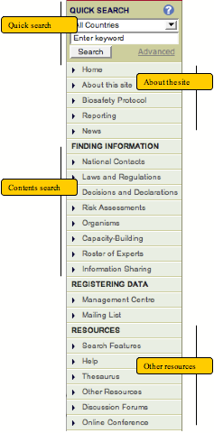
The left side menu bar of the Welcome Page is divided into several sections:
Quick search searxch
A Quick Search tool at the top of the side bar can be used to perform a simple search or an advanced search.

The About the Site Section provides information about the BCH and the Central Portal, about the Cartagena Protocol on Biosafety, information in national reports, and news items.

The Finding Information section allows you to Search the contents of the Central Portal. It provides short cuts to each of the databases elaborated earlier under the Finding Information section.

The Registering Data Section takes you to the sign-in page for the BCH Management Centre, which you can use to manage your subscriptions and to register new records with the BCH.

The Other Resources section provides access to other useful site resources, such as the BCH Thesaurus and Controlled Vocabulary, downloadable common formats and discussion forums.

