Table of contents
1. Table of contents 1
2. Objectives 1
3. Principle 1
4. Application in the field 2
a. Permanent elements 2
b. Temporary elements 3
5. Annex: Main elements recorded 3

Objectives

This field protocol aims to record elements linked to human activities to assess the level of human pressure on a given area, here Al Baten, Eastern Morocco. By applying an exhaustive and regular survey, it aims to assess both qualitative and quantitative evolution of this pressure over time.
This protocol is applied since 2012.

Principle

All elements are recorded along predefined transects helping ensure homogeneous coverage of the area. In addition, observation points are regularly realized along these transects.
Different types of elements are encountered and classified into the following categories:
- Permanent elements that can be represented as point, such as buildings, wells…
- Temporary elements, also be represented as point, such as grazing livestock, temporary shelters…
- Elements requiring polygon representation such as cultivated fields and farms.
This protocol focuses only on the 2 first categories. The last is covered by a separated survey.
Temporary elements are surveyed every 2-3 months while permanent elements are surveyed once a year. The two surveys can be done either simultaneously or in separate sessions.
Permanent elements identified during previous sessions and still active at the last session are recorded in the GPS ahead of the fieldwork. They are then verified in the field to confirm whether still in use or not. If not, they are reported as abandoned. New permanent elements are recorded.
For both surveys, one GPS point can encompass several elements of different types.

Application in the field

The survey is conducted along line transects joining defined observation points (Figure 1). These points are distributed on a grid of 3x3 kilometres covering the area.

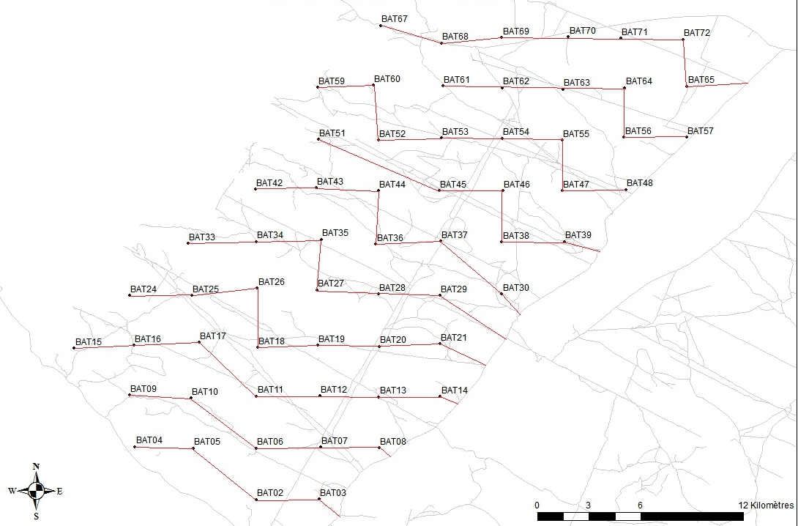
Figure 1. Transects and observation points to record anthropogenic impacts in Al Baten

The survey begins at least 2 hours after sunrise to make sure that livestock herds are already grazing in the steppe. It is realized on a single day to ensure simultaneous data collection and avoid duplicate counts.
Each transect is surveyed by a team, all teams beginning around the same time, progressing at low speed (around 20km/h) on the transects and recording/validating elements on the way. They stop at each observation point to perform a circular observation with binoculars to detect elements that could be missed during the transect.

Permanent elements
All permanent elements active from previous sessions are verified, locations adjusted if incorrect and information relative to their status of use documented on a field form.
When new permanent elements are detected, the teams approach them to record a location as precisely as possible. A GPS point is created and its name as well as details about the type and number of element(s) observed are noted on the field form.
After the survey, inactive elements should be updated, new elements added in a file for the survey of the following year.

Temporary elements

The teams do not need to approach temporary elements. They create a projected GPS point by assessing the distance and the angle from the place they detected them. Waypoint name and details of the type and number of element(s) observed are noted on the field form.

Annex: Main elements recorded

Table 1. Main human activity elements that can be recorded in Al Baten
Temporary elements |  | Permanent elements
Domestic animals | Temporary facilities | Permanent elements
Sheep  Goat  Cow  Camel  Donkey  Mule  Horse  Dog | Mobile enclosure  Temporary drinking trough  Tent | Permanent enclosure  Permanent drinking trough  Well  Dam  Hut or shed  Hangar  House  Hamlet  Village or town

