Stefan Brenner

20240610

Module 2.3

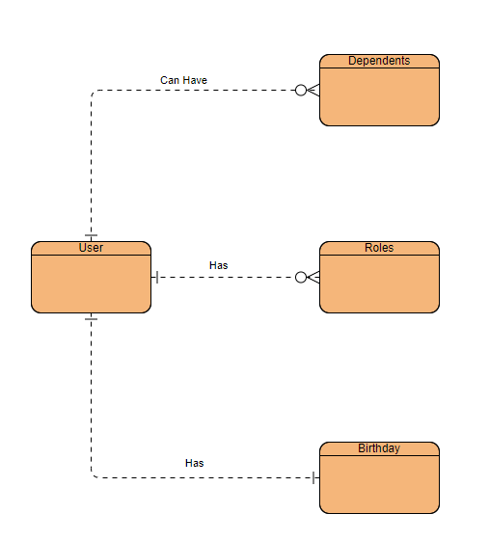

{

"user_id": "unique_user_id",

"birthdate": "YYYY-MM-DD",

"roles": [

"role1",

"role2",

"role3"

],

"dependents": [

{

"dependent_id": "unique_dependent_id_1",

"name": "Dependent Name 1",

"birthdate": "YYYY-MM-DD"

},

{

"dependent_id": "unique_dependent_id_2",

"name": "Dependent Name 2",

"birthdate": "YYYY-MM-DD"

}

]

}