Stefan Brenner

Module 5.2

20240623

**COUNT() Function:**

The COUNT() function counts the number of rows that match a specified condition. It is commonly used to determine the number of entries in a table or the number of entries that meet certain criteria, such as the number of orders placed by a customer or the number of products in stock.

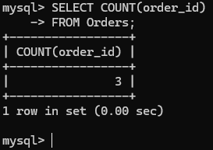

**MAX() Function:**

The MAX() function returns the maximum value in a set of values. It is often used to find the highest value in a column, such as the highest salary, the maximum score, or the most expensive product.

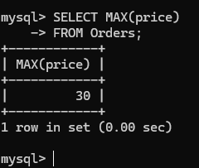

**AVG() Function:**

The AVG() function calculates the average value of a numeric column. This function is useful for finding average sales, average ratings, or average salaries, among other things.

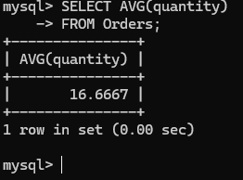

This is the table that was used to run these functions.

