Stefan Brenner

Module 6.2

20240630

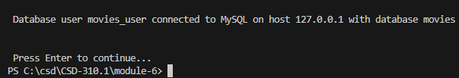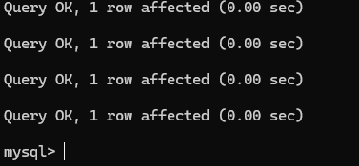

After running the db_init_2022.sql

Showing the table in the movies database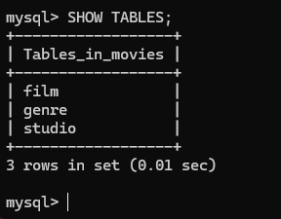

After running the mysql_test.py