Now You Can Designate Beneficiaries Online!

Easy... Login to your account through kpers.org
and click on Beneficiaries to get started.

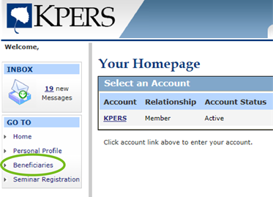

Updates are effective immediately and you can change anytime.

Questions?
• Email kpers@kpers.org
• Toll-free 1-888-275-5737



