|  |  |
| --- | --- |
| Team Number : | apmcm2112048 |
| Problem Chosen : | B |

**Optimization design of thermal emitter in thermal photoemission technology**

**Abstract:** Thermal emitter structure of different materials can be adjusted to absorb heat emission, the emission of light in a photovoltaic cell under the band gap wavelength, and the band gap wavelength under high-energy photons into electricity by photovoltaic effect, so the structure of different materials and the combination of different material structure and the relationship between the emission spectrum can improve the spectrum of the radiator control ability, Therefore, it is of great significance to study the relationship between material properties and emission spectra.

At the problem 1, Firstly, consider data fitting, through the analysis of the effect of fitting is not accurate, so this question from the perspective of energy conservation were analyzed, and the use of DE Broglie formula according to the principle of optical material thickness, refractive index and established the relationship between the wavelength, and then DE Broglie formula is used to establish the relationship with the energy, Finally, the relationship between the material properties and the emission spectra of the monolayer structure is obtained, and the emission spectra of 50 nm thick tungsten in micron are calculated by using the transfer matrix method.

At the problem 2, Analysis based on problem 1, so we choose the method of cluster analysis to cluster of materials provided by the attachment, divided into metal and dielectric materials by using problem a multilayer structure of the material performance and the relationship between the emission spectrum, considering the multilayer structure of electromagnetic field, Five transfer matrices are analyzed, then the emission spectra of the composite structure in micron are calculated by using the transfer matrix method.

At the problem 3, using the bayesian optimization algorithm to optimize model, considering the high launcher as narrow as possible and to improve the power conversion, reduce the heat loss, so this question to narrow and high as decision variables, heat energy consumption as objective function, the range of wavelengths as constraint conditions, establish a minimum for heat loss constraint optimization model. Then according to the optical principle and de Broglie formula, the layer number, material thickness and material selection are transformed into the relationship between wavelength and energy, and the design parameters are given according to the optimization model.

At the problem 4, the optimization model is improved on the basis of problem 3. Genetic algorithm is used to establish the optimization model. The objective function is loss efficiency, the decision variables are material thickness, refractive index, extinction coefficient, and thickness consideration is different material thickness and layer number. The constraint condition is that the wavelength is less than 1.71 microns. Finally, a constraint optimization model based on genetic algorithm is established, and a multi-layer emitter is designed by using this model and the design parameters are given.

**Key words:** optical principle; Conservation of energy; Transmission matrix method; Bayesian optimization; Genetic algorithm

Contents

1. Question restatement 1

2. Problem analysis 2

2.1 Analysis of Problem 1 2

2.2 Analysis of Question 2 2

2.3 Analysis of Question 3 2

2.4 Analysis of Question 4 2

3. Model assumptions 3

4. Symbol description 3

5. Model establishment and solution of problem 1 4

5.1 Establishment of model 4

5.2 De Broglie formula 5

5.3 Law of conservation of energy 5

5.4 Maxwell's equations 5

5.5 Transfer matrix method 6

6. Model establishment and solution of problem 2 8

6.1 Model establishment 8

6.2 Model solution 11

7. Establishment and solution of the model in Question 3 11

7.1 Bayesian optimization and model establishment 11

7.2 Performance parameter analysis of multilayer films 12

8. Model establishment and solution of problem 4 13

8.1 Thermal emitter optimization model based on gallium antimonide photovoltaic cells 13

8.2 Solution based on genetic algorithm 14

9.To summarize 16

References 16

Appendix 17

# Question restatement

* 1. **Problems Background**

In recent years, countries have developed all sorts of space exploration plan, to look on Mars for the discovery of more broad universe, it's need to ensure that lunar rover carry all kinds of instruments and equipment can be run without the sunshine is good, the thermal photovoltaic technology technology research and development for the long-term work provides the necessary technical support. Therefore, it is of great significance to improve the photoelectric conversion efficiency of batteries and optimize the emission spectrum of thermal emitters in thermal-photoelectric power generation technology.

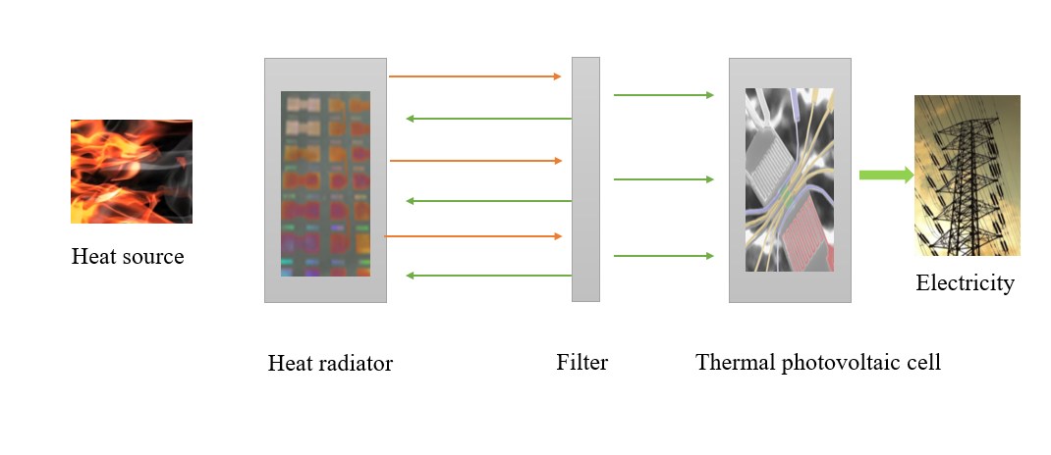Figure 1 Thermal photovoltaic cell structure diagram

* 1. **Problems to be solved**

Question 1: According to the wavelength, refractive index and extinction coefficient of the tungsten material in the attachment, use these data to analyze the relationship between the light wave and the refractive index, the light wave and extinction coefficient, and calculate the emission spectrum of the light wave 50 nm thick in the case of micron.

Question 2: For the tungsten silicon dioxide composite material, the relationship between the light wave and refractive index, extinction coefficient is analyzed, and the emission spectrum of the composite structure formed by the light wave length in the range of microns is calculated.

Question 3: Build an optimization model and determine the objective function to make the emission of the heat emitter as narrow and high as possible, so as to calculate the design parameters and emission spectrum of the multi-layer structure.

Question 4: According to the analysis in FIG. 4, consider in sections, choose the multi-layer structure to improve the thermoelectric conversion efficiency when the wavelength is in micron, and calculate the emission spectrum according to the proposed model.

# Problem analysis

## Analysis of Problem 1

Aiming at problem 1, the energy conservation relation of single-layer structure is established according to the energy conservation theorem. Then the relation between wavelength and energy is obtained by combining de Broglie formula. Finally, according to the energy loss and transfer matrix method, the emission spectrum of 50 nm thick in micron is obtained.

## Analysis of Question 2

Based on the analysis of Problem 1, we established the energy conservation relationship of multi-layer structure, and obtained the relationship between emission spectrum and material properties by using MATLAB software. Then, the transmission matrix of multilayer structure is deduced according to Maxwell's equation, and the emission spectrum of micrometer from tungsten to silica is calculated.

## Analysis of Question 3

Considering the bayesian optimization is an effective global optimization algorithm, designed to transmitter is narrow and high decision variables, and then with the energy of the loss as objective function, the wavelength for micron as constraint conditions, ultimately constrained optimization model is established to solve, and according to the established optimization model for the design of the multilayer structure parameters and the emission spectrum.

## Analysis of Question 4

According to the EQE and ideal emission spectrum of GaSb in the thermal photoelectric technology shown in FIG. 4, when the wavelength is in micron, the energy reaches the maximum, and when the wavelength is in micron, all the energy is converted into heat energy consumption, so. We are divided into two sections to consider, establish an optimization model, design a multi-layer structure of heat emitter, make the wavelength in micron, the minimum heat consumption, and give emission spectrum according to the designed multi-layer structure.

# Model assumptions

3.1 Assume the same density in the same medium;  
3.2 Assume that the interface is parallel and infinite;  
3.3 Assume that the wavelength of light entering the medium is constant.

# 4. Symbol description

|  |  |
| --- | --- |
| symbol | state |
|  | Represents the refractive index in the medium |
|  | Threshold wavelength of tungsten |
| and | Represents on interfaces 1 and 2 |
|  | magnetic intensity vector |
|  | Magnetic induction intensity vector |
|  | * electric intensity vector |
|  | electric displacement vector |
|  | conduction current density |
|  | electric density |

# 5. Model establishment and solution of problem 1

## 5.1 Establishment of model

First, data fitting of the refractive index, refractive index and extinction coefficient provided by the accessories is carried out, as shown in Figure 5-1

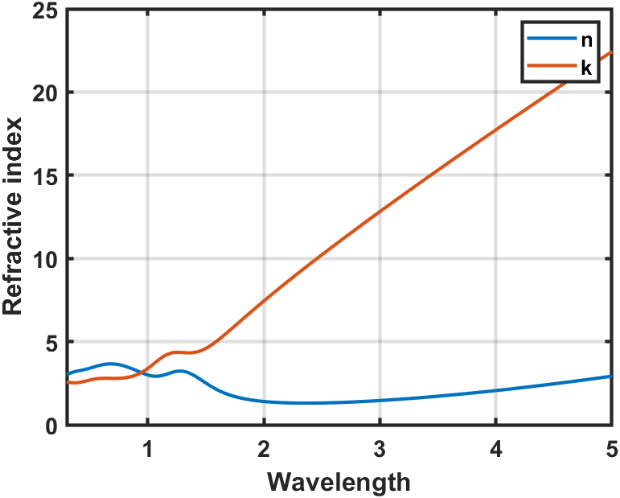

Figure 5-1 Fitting diagram of refractive index, wavelength and extinction coefficient

We found that the fitting effect was not good, so we adopted method two to solve it.

According to the optical principle, see Figure 5-2

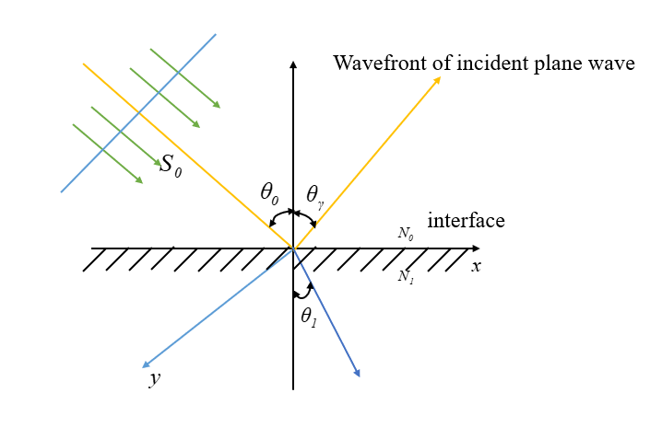

Figure 5-2 Refraction and reflection of light

In order to achieve projection maximum control, the quarter-wavelength relation and refractive index matching relation need to be satisfied. Therefore, when the optical thickness of the medium layer is one-quarter of the reflection center wavelength, the maximum reflection bandwidth and projection bandwidth can be obtained, which can be calculated by the following formula:



For the one-dimensional periodic structure, when the reflection bandwidth and projection bandwidth reach the maximum value, the optical thickness of the two intermediate layer is equal to the reflection center wavelength, then the thickness of the intermediate layer is

Where, and are the refractive index of air and tungsten respectively, and the threshold wavelength of tungsten is taken as the wavelength point of the left boundary of the reflection band of the thermal emitter, so the calculation can be carried out.

## 5.2 De Broglie formula

According to the derivation process of de Broglie wave



According to ，，we have

，

Where is Particle. Energy, isFrequency of particles.

## 5.3 Law of conservation of energy

According to the law of conservation of energy, yes

， (4)

Where, is the initial energy of light, is the energy after passing through the single-layer medium value, and is the energy lost in the process of light propagation

## 5.4 Maxwell's equations

Alternating electromagnetic fields shall be carried out in accordance with the laws of electromagnetic transmission electromagnetic waves are formed, so according to maxwell's electromagnetic field theory, the space electric field of a certain area change, can produce a magnetic field around it, magnetic moment change according to certain rule, change the result, and can produce electric field around transmission and interaction of the electric and magnetic fields, electromagnetic wave, To study the optical characteristics of thin film system is to study the amplitude and phase change of light wave after the electromagnetic wave passes through the multilayer dielectric film. So we can set up maxwell's equations in integral and differential form as follows

,

,

,

, (5)

，

，

,

.

## 5.5 Transfer matrix method

Transfer matrix method [1,2] is the magnetic field in real space lattice position, maxwell's equations can be converted to the form of transfer matrix, become the characteristic value to solve the problem, we first to monolayer film as an example to study the light through the film layer on both sides of the field changes in the relationship, because is alternating electric field and magnetic field, magnetic field changes caused by the change of the electric field that, Changes in the electric field also cause changes in the magnetic field. Therefore, when the light is incident vertically, E and H are parallel to the interface and continuous on both sides of the interface. Therefore, this paper first derives the transmission matrix of monolayer film by analyzing the electric vector E, and we draw the diagram as follows:

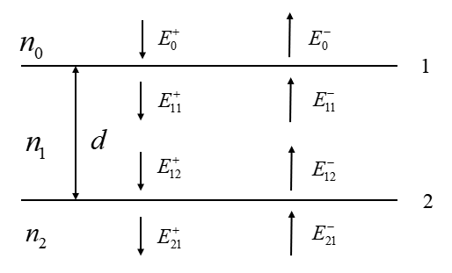

Figure 5-1 Transport matrix of monolayer

The film layer, the incident medium and the substrate form two interfaces 1 and 2. We merge all the waves in the same direction, and take + sign in the positive direction and - in the opposite direction.

Firstly, the electric field relationship on both sides of interface 1 is analyzed. The source considered is the refraction of light from the air medium, and part of light will be consumed by reflection in the medium. By the same analysis, the following relationship can be obtained

 (6)

 (7)

Here represents the amplitude reflection coefficient of the upper surface of interface 1, is the amplitude projection coefficient of interface 1, and thus the matrix form of the electric field relationship on both sides of interface 1 can be obtained

 (8)

Here is called the transmission matrix of interface 1. Similarly, we can obtain the transmission matrix between interface 1 and interface 2. Note that only the phase of light wave changes at this time, so it is expressed in the matrix as follows

 (9)

Here, called the transport matrix in the medium, is the one-way phase shift of the light wave in the film.

Then, the electric field relationship on both sides of interface 2 is analyzed using the analysis method similar to interface 1, and the following transmission matrix can be obtained

 (10)

Therefore, the electric field relationship on both sides of the two layers can be obtained by combining the transmission matrix of interface 1, interface 1 and interface 2 and interface 2



 (11)

Thus, it can be concluded that the transmission matrix of monolayer is

 (12)

At the same time, considering the magnetic field, based on the fact that the electric and magnetic fields at the interface are continuous, we only need to consider the propagation within a constant refractive index. When passing through a layer of uniform intermediate values (i.e. the refractive index is equal everywhere), we have

 (13)

The total transfer matrix can also be obtained by multiplying the transfer matrices of each part.

# 6. Model establishment and solution of problem 2

## 6.1 Model establishment

On the basis of Question 1, we first used cluster analysis to divide materials into medium and metal materials, and then considered the influence of multilayer structure on emission spectrum, so as to obtain the relationship between emission spectrum of multilayer structure and material properties, as shown in Figure 6-1

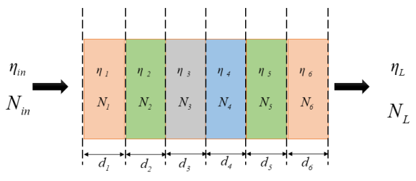

Figure 6-1 Structure of multilayer films

Secondly, the emission spectra of the composite structure formed by tungsten and silicon dioxide in the range of 0.3~5 microns are calculated. Firstly, the transmission matrix method [1] for multi-layer structure is shown in Figure 6-1

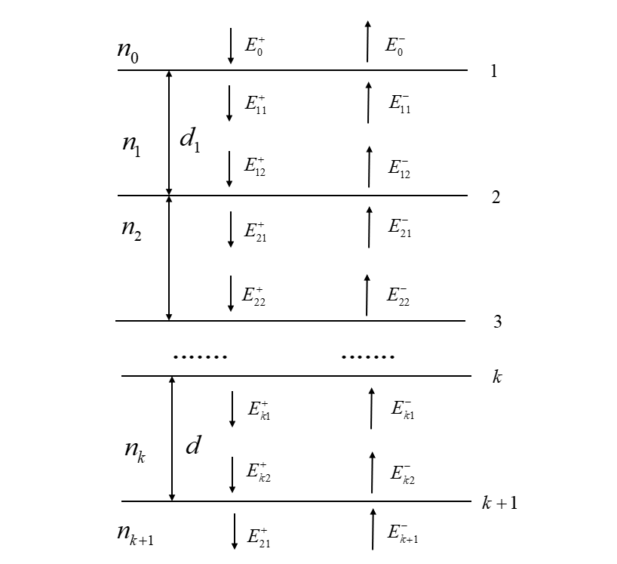

Figure 6-2 Schematic diagram of transmission matrix of multi-layer structure

Similar to problem 1, we multiply these transport matrices in turn to obtain the transport matrix of the entire multilayer system

， (14)

where，

Respectively are amplitude transmission coefficient and amplitude reflection coefficient of the interface at the first layer, and their values are in Fresnel formulaValue when CheckedIs the phase shift of light passing through the first layer. Is the amplitude transmission coefficient and amplitude reflection coefficient of the interface at layer K +1.

The transport matrix of the multilayer can be denoted as

,

Therefore, the electric field relationship between the incident medium side and the substrate side

.  (15)

Let's say there's no incident light on the fundamental side, so, so. The reflection and transmission characteristics of light passing through the whole membrane system can be calculated. The total amplitude reflection coefficient and amplitude transmission coefficient of the dielectric film [3,4] are respectively

，

。

The corresponding power reflectivity and transmittance are

，

。

After the light passes through the membrane system, its reflection phase and transmission phase become

，

。

At the same time, considering the magnetic field, based on the fact that the electric and magnetic fields at the interface are continuous, we only need to consider the propagation within a constant refractive index. When passing through a layer of uniform intermediate values (i.e. the refractive index is equal everywhere), we have



The total transmission matrix can also be obtained by multiplying the transmission matrix of each part, that is, the final transmission matrix to the multi-layer structure is

.

Finally, we established the energy conservation equation as



## fd915985b6f9d5f3b7fcf47efae69a76.2 Model solution

Figure 6-3 Relationship between emission spectrum and material properties

# 7. Establishment and solution of the model in Question 3

## 7.1 Bayesian optimization and model establishment

Bayesian optimization [5] is an effective global optimization algorithm, which can obtain the optimal solution of complex objective function under a few times of evaluation. In its optimization process, the famous "Bayes' theorem" is applied, namely,  
 Where, represents unknown objective function; Represents observed set, represents decision vector, represents observed value, represents observation error; Is also called "noise" due to the error of the observed value. Is the prior probability distribution, that is, the hypothesis of the unknown objective function state; Represents the marginal likelihood distribution of marginalization.Updating the probabilistic agent model can obtain a posterior distribution containing more data information. The collection function is constructed according to the posterior probability distribution. The next optimal evaluation point is selected by maximizing the collection function. At the same time, an effective collection function can ensure that the selected sequence of evaluation points can minimize the total loss

，

This is the current optimal solution.

Therefore, according to the Bayesian optimization theory, the optimization model is established as follows

， (19)

Here, the narrowness and height of the emitter, namely the decision variable, are the loss of energy into heat energy, namely the objective function. The constraint condition is that the range of wavelength is between microns. Thus, the algorithm framework of the optimization model can be established as follows

|  |
| --- |
| Bayesian optimization model algorithm |
| Step1: for t = 1, 2,... do Step2: maximize the collection function to get the next evaluation point:; Step3: Evaluate the value of the objective function; Step4: Integrate the data:, and update the probability proxy model; Step5: end the for |

## 7.2 Performance parameter analysis of multilayer films

Considered in the actual application of thin film dielectric film and metal film, dielectric film refractive index generally lower than that of metal film refractive index, so we can apply metal film optics instrument of reflector system, not high demand for high performance of multiple beam interferometer reflective film, demand a higher reflectivity and absorption energy consumption as small as possible, Because of the large absorption loss of metal film, the mechanical strength is also low, so the combination of better effect, this question is based on this combination of use, so the multi-layer structure of the heat transmitter.

# 8. Model establishment and solution of problem 4

## 8.1 Thermal emitter optimization model based on gallium antimonide photovoltaic cells

According to the third question, the band gap wavelength of the gallium antimonide battery is considered to be 1.71, that is, the spectrum emitted by the thermal emitter reaches the spectrum wavelength of the battery

 (20)

And the quantum efficiency (EQE) maximization needs to be considered, i.e

 (21)

The multilayer thin film transfer matrix has

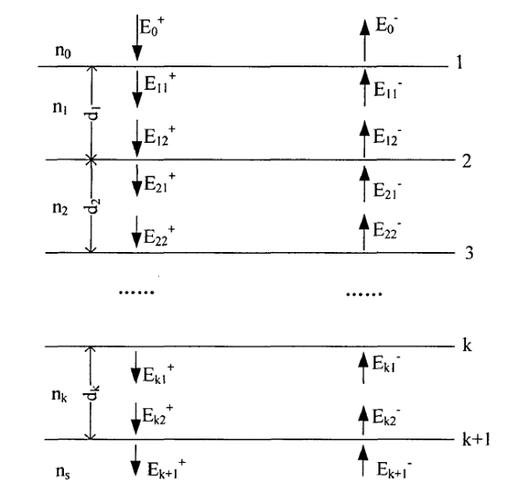

FIG. 8-1 Solving the multilayer plasma membrane transfer moment

The optimization model is established as follows

，

## 8.2 Solution based on genetic algorithm

Genetic algorithm was used to solve the optimization model (14). Genetic algorithm is an adaptive global optimization search method, which applies the combination of several parameters to the model to solve the optimal solution [4]. The specific algorithm flow is as

follow

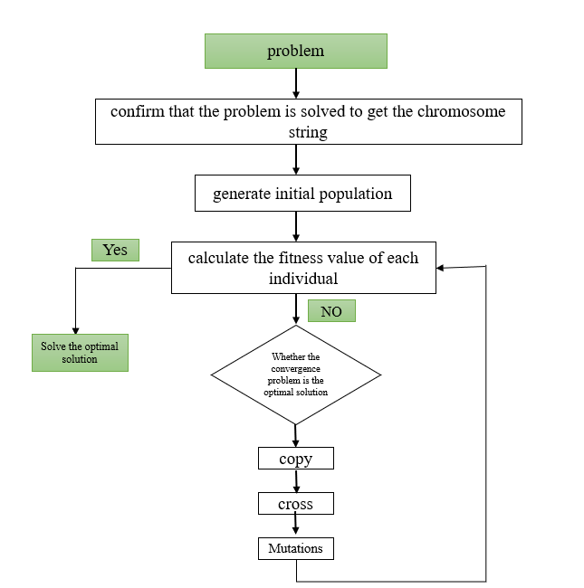

Figure 8-2 Process diagram of genetic algorithm

Algorithm: Genetic algorithm for optimal parameters of emitter

Input: various parameter combinations satisfying optimization model (20);  
Output: Heater highest EQE. Step1: Encode the optimal solution combination of model (20) and record the different layers.

Step2: initialize the data according to the algorithm parameter table, and meet the requirements.

Step3: build fitness function.

Step4: enter the optimal solution obtained by each iteration into the next generation, and introduce the mutation operator to expand the search space.

Step5: Iterate until the maximum evolutionary situation stops.

In this question, in order to determine the maximum EQE, the population size was set as 72 according to the results in Table 1, crossover probability 0.6 and 0.7, mutation probability 0.001 and 0.01, and evolution algebra 400 were respectively taken in theexperiment. The two results were compared, as shown in the figure below.

FIG. 8-3 Comparison and prediction of different variation probability results of genetic algorithm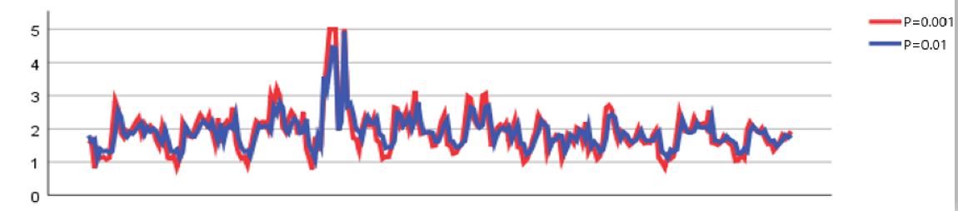. Finally, the optimal parameters are shown in the following table

Table 8-1 Optimal parameters obtained by solution

|  |  |  |
| --- | --- | --- |
| Layer | Material | thickness |
| level one |  | 13 |
| Second floor |  | 6 |
| the third floor |  | 22 |
| Fourth floor |  | 7 |
| Fifth floor |  | 11 |
| Sixth floor |  | 19 |

# 9.To summarize

**9.1 Evaluation of the model**  
9.1.1 Advantages of the model  
(1) Based on the optical principle, it is more reasonable to establish the relationship between emission spectrum and material properties according to the energy conservation law than to directly perform data fitting.  
(2) Cluster analysis is used to classify the material structure, and the results obtained are more representative.

(3) Bayesian optimization modeling method can obtain the optimal solution of complex objective function under a few times of evaluation.

(4) The optimization model based on genetic algorithm is easy to be mixed with other technologies, and the results are closer to the reality.  
9.1.2 Disadvantages of the model  
The clustering analysis is considered roughly, and is divided directly from metal and medium.  
**9.2 Improvement of model**  
Data fitting can first do clustering, divide the same features into one class, and then fit to see the fitting effect of the same feature will be more convincing.

# References

1. FU Y J. Study on characteristic analysis and design technology of thin film optical filter [D]. Beijing Jiaotong University,2009.
2. Buranasiri Prathan,Plaipichit Suwan,Puttharugsa Chokchai,Wicharn Surawut. Hybrid nanowire-hyperbolic metamaterial based broadband absorber for the visible and near-infrared regions[J]. Radiation Physics and Chemistry,2021,189:  
   [3] MIN Jie. Design and Optimization of micro-thermal photovoltaic cell System [D]. Southwest Jiaotong University,2016.  
   [4] ZHANG X Y. Research on selective heat emitter based on metamaterial perfect absorber [D]. Dalian University of Technology,2018.  
   [5] Cui Jiaxu, Yang Bo. Journal of software,2018,29(10):3068-3090.

# Appendix

**Appendix 1: MATLAB program for solving TMM**

|  |  |
| --- | --- |
| **Matlab** | TMM_Ref_Trans.m |
| function [reflectivity,transmissivity,angle_out] = TMM_Ref_Trans(wavelength, thicknesses,layers,angle)  % INPUT: Wavelength (in m), Layer thicknesses (in m), refractive_indices (layer/column), angle (degrees)  % OUTPUT: Reflectance (R), p-pol R, s-pol R  % COMMENTS: This function does not load and interpolate refractive indices  % of the specific materials.  n = length(layers(1,:));  N = layers;  wL = wavelength;  d = thicknesses;  c = 2.9979e8; % speed of ligth in vacuo m/s  o = zeros(length(n),1);  p_p = zeros(length(n),1);  p_s = zeros(length(n),1);  phi = zeros(length(n),1);  R_p = zeros(length(wL),1);  R_s = zeros(length(wL),1);  T_p = zeros(length(wL),1);  T_s = zeros(length(wL),1);  for w=1:length(wL)  %layer 1  M_p = 1;  M_s = 1;  o(1) = angle*pi()/180;  p_p(1) = cos(o(1)) ./ (N(w,1)./c);  p_s(1) = cos(o(1)) ./ (-c./N(w,1));  if n <= 2  j = 2;  o(j) = asin(N(w,j-1)./N(w,j).*sin(o(j-1)));  L1 = 1;  L2 = 2;  rp = (N(w,L1)*cos(o(L2))- N(w,L2)*cos(o(L1))) / (N(w,L1)*cos(o(L2))+ N(w,L2)*cos(o(L1)));  rs = (N(w,L1)*cos(o(L1))- N(w,L2)*cos(o(L2))) / (N(w,L1)*cos(o(L1))+ N(w,L2)*cos(o(L2)));  R_p(w) = (abs(rp)).^2;  R_s(w) = (abs(rs)).^2;  tp = 2*N(w,L1)*cos(o(L1)) / (N(w,L1)*cos(o(L2))+ N(w,L2)*cos(o(L1)));  ts = 1 + rs;  T_p(w) = real(conj(N(w,L2)) * cos(o(L2))) / real(conj(N(w,L1)) * cos(o(L1))) * tp*conj(tp);  T_s(w) = real(N(w,L2) * cos(o(L2))) / real(N(w,L1) * cos(o(L1))) * ts*conj(ts);  else    %layer j  for j=2:(n-1)  o(j) = asin(N(w,j-1)./N(w,j).*sin(o(j-1)));  p_p(j) = cos(o(j)) ./ (N(w,j)./c);  p_s(j) = cos(o(j)) ./ (-c./N(w,j));  phi(j) = 2*pi*d(j).*N(w,j).*cos(o(j))./wL(w);  M_pj = [cos(phi(j)) -1i.*p_p(j).*sin(phi(j)); -1i./p_p(j).*sin(phi(j)) cos(phi(j))];  M_sj = [cos(phi(j)) -1i.*p_s(j).*sin(phi(j)); -1i./p_s(j).*sin(phi(j)) cos(phi(j))];  M_p = M_p*M_pj;  M_s = M_s*M_sj;  end  %layer n  o(n) = asin(N(w,n-1)./N(w,n).*sin(o(n-1)));  p_p(n) = cos(o(n)) ./ (N(w,n)./c);  p_s(n) = cos(o(n)) ./ (-c./N(w,n));  % p or TM polarization  r_p = ((M_p(1,1) + 1./p_p(n).*M_p(1,2)) - (M_p(2,1) + 1./p_p(n).*M_p(2,2)).*p_p(1))./...  ((M_p(1,1) + 1./p_p(n).*M_p(1,2))+(M_p(2,1) + 1./p_p(n).*M_p(2,2)).*p_p(1));  R_p(w) = r_p*conj(r_p);  c_p = cos(o(1))/cos(o(n));  t_p = 2*c_p /((M_p(1,1) + 1./p_p(n).*M_p(1,2))+(M_p(2,1) + 1./p_p(n).*M_p(2,2)).*p_p(1));  T_p(w) = real(conj(N(w,n)) * cos(o(n))) / real(conj(N(w,1)) * cos(o(1))) * t_p*conj(t_p);  % s or TE polarization  r_s = ((M_s(1,1) + 1./p_s(n).*M_s(1,2)) - (M_s(2,1) + 1./p_s(n).*M_s(2,2)).*p_s(1))./...  ((M_s(1,1) + 1./p_s(n).*M_s(1,2))+(M_s(2,1) + 1./p_s(n).*M_s(2,2)).*p_s(1));  R_s(w) = r_s*conj(r_s);  t_s = 2 / ((M_s(1,1) + 1./p_s(n).*M_s(1,2))+(M_s(2,1) + 1./p_s(n).*M_s(2,2)).*p_s(1));  T_s(w) = real(N(w,n) * cos(o(n))) / real(N(w,1) * cos(o(1))) * t_s*conj(t_s);  end  end  reflectivity = 0.5.*(R_p + R_s);  transmissivity = 0.5.*(T_p + T_s);  angle_out = o(n);  end | |

**Appendix 2: matlab drawing program**

|  |  |
| --- | --- |
| **Matlab** | TMM_Ref_Trans.m |
| function plot_optical_props(layers)  %Livescript modified version  % plot optical properties  % clear all;  % INPUTS %%%%  %layers = {'Si'};  wavelenght_min = 0.35 ; % microns  wavelength_max = 1.2 ; % microns  pts = 1e2;  %%%%%%%%%%%%%%%%  n = 1;  wL = linspace(wavelenght_min,wavelength_max,pts)*1e-6;  addpath(genpath([cd '/Materials/']));  N = zeros(length(wL),n);  for j = 1:n    if strcmp(layers{j},'Vac')  N(:,j) = 1;  elseif strcmp(layers{j},'InGaAs')  x = 0.47;  layer_props = str2func(layers{j});  N(:,j) = layer_props(wL,x);  else  layer_props = str2func(layers{j});  N(:,j) = layer_props(wL);  end    end  eps = N.^2;  wavelength_range = wL*1e6;  figure(1)  plot(wavelength_range,[real(N) imag(N)],'LineWidth',2.0)  ylabel('Refractive index','FontSize',14,'FontWeight','bold')  xlabel('Wavelength','FontSize',14,'FontWeight','bold')  xlim([wavelenght_min wavelength_max]);  set(gca,'Fontsize',14,'FontWeight','bold','LineWidth',2.0)  grid ON  legend('n', 'k');  figure(2)  plot(wavelength_range,[real(eps) imag(eps)],'LineWidth',2.0)  ylabel('Rel. Permittivity','FontSize',14,'FontWeight','bold')  xlabel('Wavelength','FontSize',14,'FontWeight','bold')  xlim([wavelenght_min wavelength_max]);  set(gca,'Fontsize',14,'FontWeight','bold','LineWidth',2.0)  grid ON  legend('\epsilon_{real}', '\epsilon_{imag}');  end | |

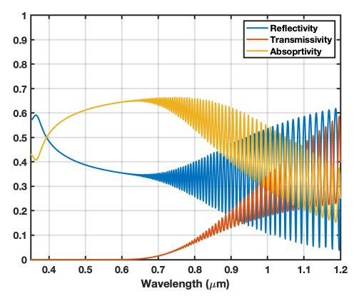**Appendix 3: Detailed spectrogram**

**Figure1 Multilayer structure spectrum**

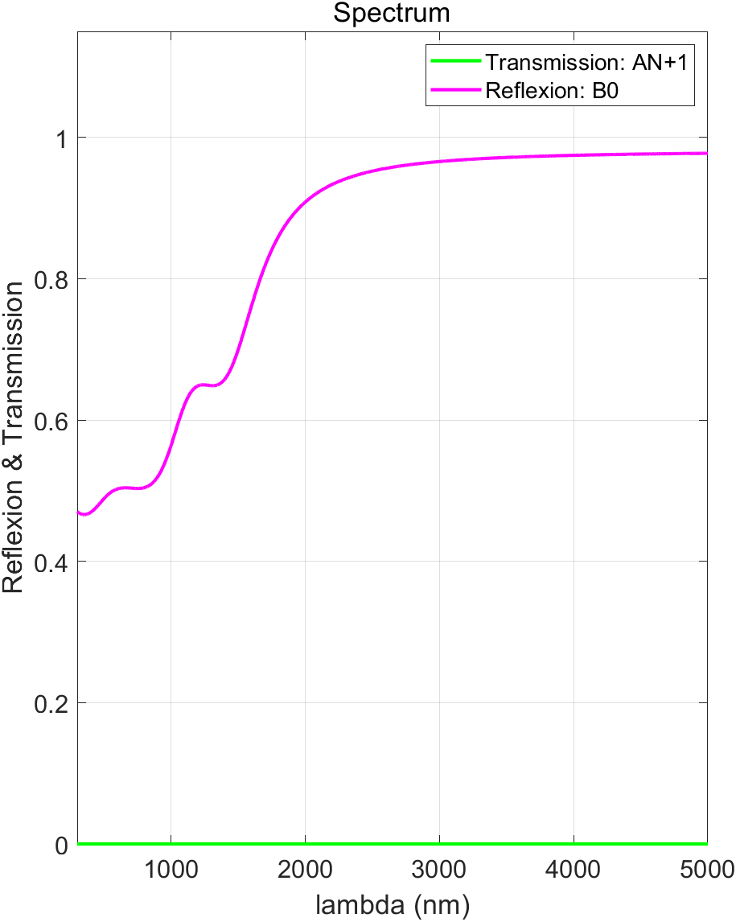

**Figure2 Spectral wavelength diagram**

**Figure4 The true wavelength and ideal wavelength of the spectrum**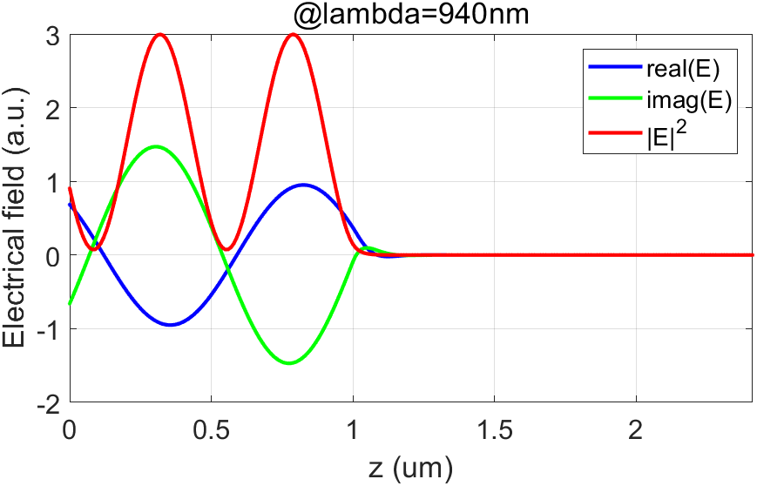

**Figure5 Spectral picture**