Hardware and Equipment Management System

Project Documentation Submitted

To the Faculty of School of

Computing and Information Technologies Of

Asia Pacific College

In Partial Fulfillment of the Requirements for the subject

Applied Projects 2 or Software Development

By

Curato, Kent Wendell

Ebreeo, Sebastian

Mondejar, Mark Daniel

Contents

**Executive Summary** 6

**List of Figures, List of Tables, List of Notations** 6

**I.** **Introduction** 7

**Project Context** 7

**Project Purpose** 7

**Objectives** 8

**Scope and Limitation** 8

**Scope** 8

**II.** **Technical Background** 11

**III.** **Methodology, Results and Discussion** 11

**Requirements Analysis** 11

**Requirements Documentation** 11

**Design of Software, Systems, Product, and/or Processes** 12

Graphical User Interface Screen Layouts 12

14

**Implementation Plan** 15

**IV.** **Conclusions and Recommendations** 15

**V.** **Appendices** 16

**Use-Case Diagram** 16

Supervisor, Technician Admin, Management 16

Supervisor, Technician, Management 16

Use-Case Narrative 17

Class/Object Diagram 22

State Transition Diagram 23

Equipment State Transition Diagram 23

New Equipment State Transition Diagram 24

Activity Diagram 25

Technician Admin Manages Account 25

Technician Admin Manages Account 26

Supervisor Sends Problem Report, Technician Diagnose Problem 27

Data Flow Diagram 28

Data Flow Diagram Level 0: Context Diagram 28

Data Flow Diagram Level 1: Management 29

Data Flow Diagram Level 1: Supervisor 29

Data Flow Diagram Level 1: Technician 30

Data Flow Diagram Level 1: Technician Admin 31

Entity Relational Diagram 32

Sequence Diagram 33

Agent Reports Problem 33

Supervisor Sends Report 33

System Generates Report 34

Technician Admin Manages Account 34

Technician Admin Manages Equipment 35

Technicians Check Problem Report 35

Technician Fixes Problem 36

User Login/Logout 37

**Functional Decomposition Diagram** 37

**Component Diagram** 38

**Deployment Diagram** 39

**Vision and Scope Document** 39

**Business Requirements** 39

**Background** 39

**Business Opportunity** 40

**Business Objectives and Success Criteria** 40

**Customer or Market Needs** 41

**Business Risks** 42

**Vision of the Solution** 42

**Vision Statement** 42

**Major Features** 43

**Assumptions and Dependencies** 43

**Scope and Limitations** 43

**Scope of Initial Release** 44

**Scope of Subsequent Releases** 44

**Limitations and Exclusions** 45

**Business Context** 45

**Stakeholder Profiles** 45

**Project Priorities** 47

**Operating Environment** 48

**Software Requirements Specifications** 48

**Purpose** 48

**Document Conventions** 48

**Intended Audience and Reading Suggestions** 48

**Product Scope** 48

**References** 49

**Product Perspective** 49

**Product Functions** 49

**User Classes and Characteristics** 49

**Operating Environment** 50

**Design and Implementation Constraints** 50

**User Documentation** 50

**Assumptions and Dependencies** 50

**User Interfaces** 50

**Hardware Interfaces** 51

**Software Interfaces** 51

**Communications Interfaces** 51

**System Features** 51

**Other Non-Functional Requirements** 53

# **Executive Summary**

Founded in 1988, Datascope Communications Phils., Inc. (DCPI) is one of the premier offshore facility for title and non-title related processing services. It is the main production facility of Honolulu Data Entry Project (HDEP) that specializes in real estate title plant conversion and searching of title plants serving most of the counties in US and Hawaii. Its customers include state and county governments that requires computerization of historical information, particularly related to land transactions, vital statistics, UCC filings, personnel documents, etc. Today, DCPI works on 10% non-title and 90% title keying projects, all U.S. based.

# **List of Figures, List of Tables, List of Notations**

1. Figure 1-A: Use-Case Diagram
2. Figure 2-A: Use-Case Narrative
3. Figure 3-A: Class/Object Diagram
4. Figure 4-A: State Transition Diagram
5. Figure 5-A: Activity Diagram
6. Figure 6-A: Data Flow Diagram
7. Figure 7-A: Entity Relational Diagram
8. Figure 8-A: Sequence Diagram
9. Figure 9-A: Functional Decomposition Diagram
10. Figure 10-A: Component Diagram
11. Figure 11-A: Deployment Diagram
12. Table 1-A: Single Equipment/Item Management Process
13. Table 2-A: Review of Related Systems/Alternatives
14. Table 2-B: Review of Related Systems/Alternatives

# **Introduction**

## **Project Context**

The proposed project is composed of:

* User account management
* Hardware & Equipment assets management
* Troubleshoot service requesting
* Equipment Reports

## **Project Purpose**

The purpose of this project is to improve the equipment management process of Datascope Communications Philippines Inc., by creating a reliable design for the infrastructure of the proposed automated Hardware and Equipment Management System (HEMS).

Currently the company is experiencing issues in equipment management such as:

a.) Slow manual process of data input / encoding that leads to an average of 2 - 8 minutes of managing a single process in the system.

b.) Confusing and repetitive manual process of data input / encoding because the admin must switch from 3 – 5 different excel files and sheets.

c.) Inaccurate records of equipment assets that causes inconvenience to the admin when managing the system.

These issues include inconvenience for their equipment users, inaccurate/redundant records of existing and available equipment in the company. Although MS excel is used as a means of storing & managing Hardware and Equipment assets, the client’s processes are mostly paperwork i.e. letters, forms.

## **Objectives**

* Reduce the current equipment management time by 20%

Single Equipment / Item Management Process

|  |  |  |  |
| --- | --- | --- | --- |
| Process Name: | Current System(Average): | Time reduced(Average): | Proposed System(Average): |
| Insert / New Equipment Acquisition | 8 minutes & 30 seconds | 2 minutes & 35 seconds | 5 minutes & 55 seconds |
| Equipment Issuance | 1 minute & 30 seconds | 25 seconds | 1 minute & 5 seconds |
| Technical Support | 10 - 15 minutes | 1 minute & 20 seconds | 2 minutes & 40 seconds |
| Dispose Equipment | 4 minutes | 1 minute & 20 seconds | 2 minutes & 40 seconds |
| Hardware Support | 2 minutes | 40 seconds | 1 minute & 20 seconds |
| Repair Equipment | 4 minutes | 1 minute & 20 seconds | 2 minutes & 40 seconds |

Table 1.1

* Increase in accuracy and speed in terms of searching for equipment information by displaying complete equipment information (equipment name, id, quantity, etc.) as compared to searching one by one in Microsoft Excel.

## **Scope and Limitation**

## **Scope**

• Improvement of the equipment management process of DCPI.

a.) Automation of the current Excel-based process by migrating to a web-based database application

b.) Design for the infrastructure of the HEMS.

c.) Reduce the current equipment management time by 20%

d.) Increase in accuracy and speed in terms of searching for equipment information by displaying complete equipment information (equipment name, id, quantity, etc.)

**Limitation**

• Control and monitoring of system are limited to technicians only.

• The system can only be used for Hardware and Equipment assets only.

**Review of Related Systems/Alternatives**

|  |  |  |  |  |
| --- | --- | --- | --- | --- |
| **Name of Software** | **Description** | **Pros** | **Cons** | **Cost** |
| TraceTM IT Asset Inventory and Equipment Management Software | TraceTM offers a wide variety of IT asset inventory and equipment solutions designed to fit your specific needs. | - Generate faster service provisioning by Integrating network / service provision tools and processes.  - Designed for inventory and equipment management.  - Automatically track and maintain assets throughout their lifecycles. | - Large system with many unnecessary modules for our client. | -Monthly licensing fee.  -Not open-source |

Table 1.2

Source: http://www.tracetm.com/it-asset-network-server-management/

|  |  |  |  |  |
| --- | --- | --- | --- | --- |
| **Name of Software** | **Description** | **Pros** | **Cons** | **Cost** |
| Agilent CrossLab’s Laboratory Equipment Management | With Agilent CrossLab’s Laboratory Equipment Management services your laboratory, operations and facilities managers can quickly identify what equipment is in the laboratory, where it is and how often it is being used. | - RFID Inventory Management.  - Cuts hundreds of labor hours required to conduct audits for finance and regulatory compliance. | - Designed for Laboratory Equipment  - Large system with many unnecessary modules for our client. | -Monthly licensing fee.  -Not open-source |

Table 1.3

Source: https://www.agilent.com/crosslab/laboratory-equipment-management/

# **Technical Background**

To develop the system, the developers used HTML, PHP, Javascript, CSS, mySQL, and Bootstrap. This will help to develop the system that supports frontend and backend of the system. The developers will start from scratch when using HTML and PHP, this also includes using bootstrap. Both frontend and backend has almost the same bootstrap template but they have different functions depending on the user.

# **Methodology, Results and Discussion**

## **Requirements Analysis**

After the interview with the client, the group found out the problem and came up with possible and feasible solutions that the system could provide. Most of the problems were about recording, retrieving and storing the records of the equipment because of the usage of MS Excel. With HEMS, the problem should be minimized and resolved.

## **Requirements Documentation**

Gathering of possible solutions has been conducted and presented to the client. After the discussion of ideas and solutions, the group came up with the following requirements:

* The system shall have online request for Supervisors.
* The system for the admin shall modify the equipment and accounts.
* The system shall only be accessible through intranet of the client.
* The system shall have searching for the records of equipment and accounts.
* The system shall not give Supervisors access of the admin’s panel.
* The system shall display the equipment and the accounts.
* The system shall produce report for the Management.

## **Design of Software, Systems, Product, and/or Processes**

### Graphical User Interface Screen Layouts

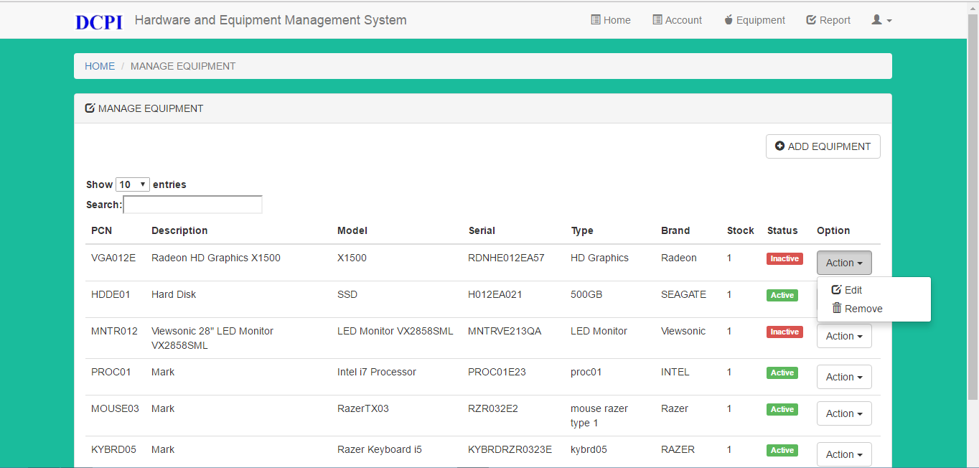

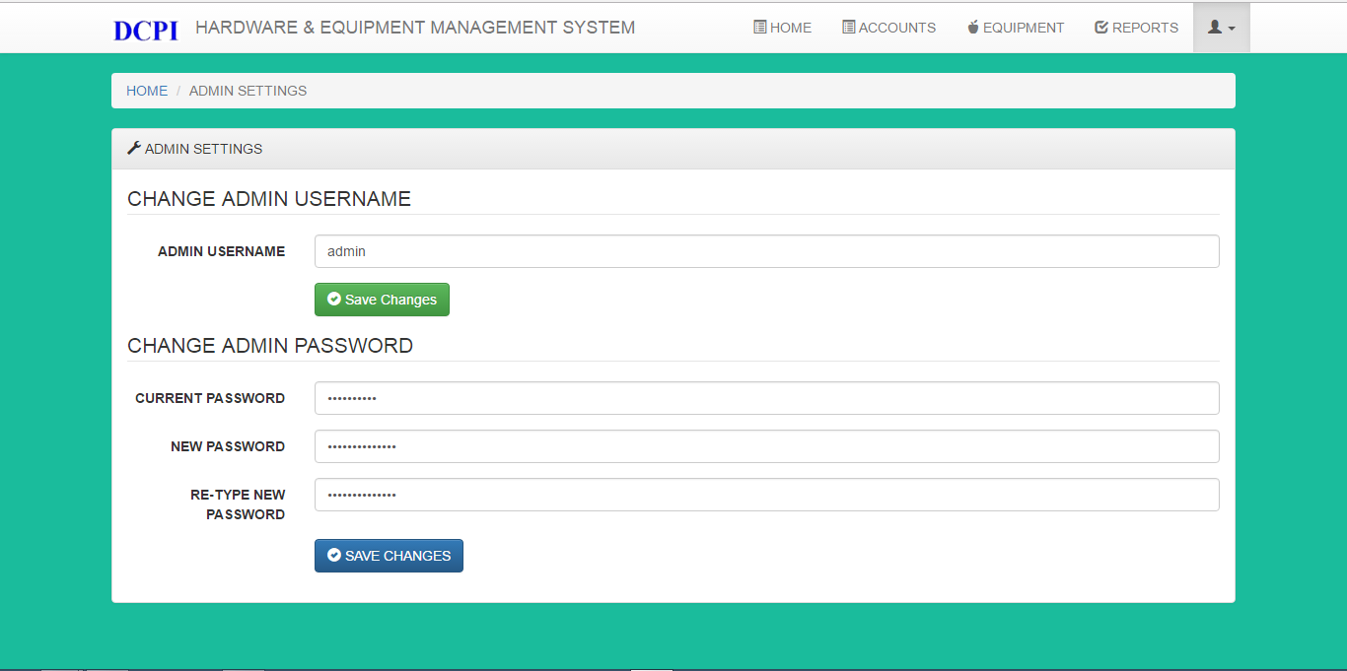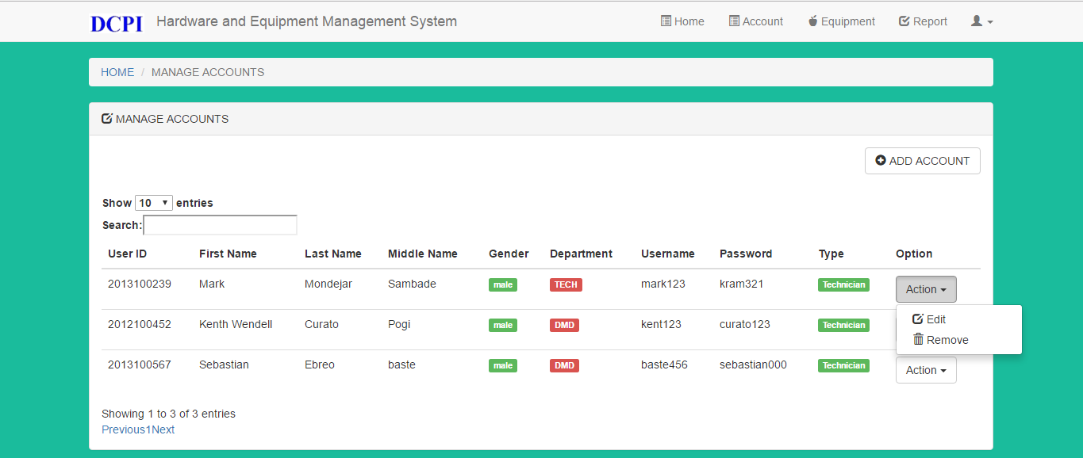

## 

## 

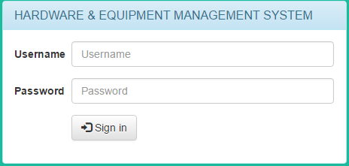

## **Implementation Plan**

Please see figure Figure 11-A

# **Conclusions and Recommendations**

Implementation of the proposed Web-based MySQL Database system with the expected benefits of satisfied user experience and budget savings.

1. Accurate historical data of assets.

> Better decision making.

2. Faster and easier asset management.

> Reduce 20% or more management time.

3. Faster troubleshoot service request.

4. Maximize the effective lifespan of assets.

> Budget savings

# **Appendices**

## **Use-Case Diagram**

### Supervisor, Technician Admin, Management

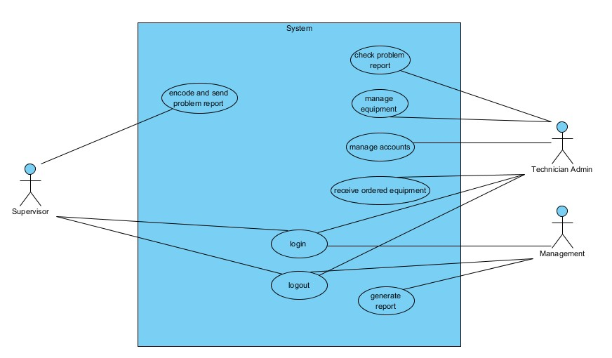

Figure 1-A

### Supervisor, Technician, Management

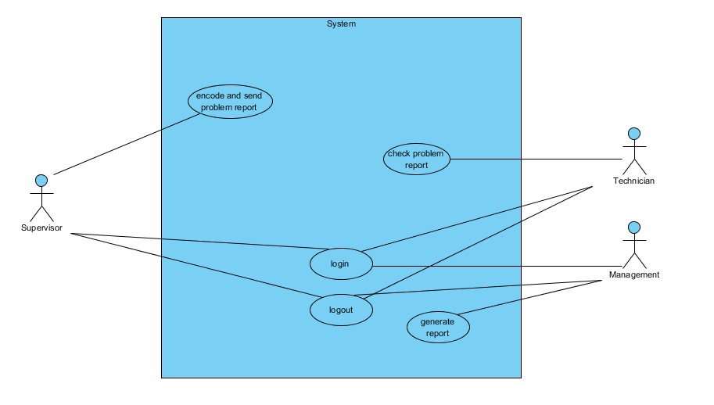

Figure 1-B

## Use-Case Narrative

|  |  |
| --- | --- |
| Use Case Name | Encode and send report |
| Actors | System  Supervisor |
| Successful Completion | 1. Supervisor encodes report 2. Supervisor sends report 3. System pop-ups notification to Supervisor 4. System sends report to all technician |
| Alternative | None |
| Precondition | Supervisor has problem to hardware equipment |
| Post-condition | System sends feedback |
| Assumptions | None |

|  |  |
| --- | --- |
| Use Case Name | Check problem report |
| Actors | System  Technician Admin  Technician  Technician Purchaser |
| Successful Completion | 1. System notifies Technician about the report 2. Technician views problem report 3. Technician verifies problem 4. Technician sends feedback to Supervisor |
| Alternative | None |
| Precondition | System notifies Technician |
| Post-condition | Supervisor receives feedback |
| Assumptions | None |

|  |  |
| --- | --- |
| Use Case Name | Login |
| Actors | System Management  Supervisor  Technician Admin  Technician  Technician Purchaser |
| Successful Completion | 1. User inputs username and password. |
| Alternative | * 1. Wrong input |
| Precondition | Needs to access the system |
| Post-condition | System used |
| Assumptions | None |

|  |  |
| --- | --- |
| Use Case Name | Logout |
| Actors | System Supervisor  Technician Admin Technician  Technician Purchaser Management |
| Successful Completion | 1. User logouts |
| Alternative | None |
| Precondition | Done accessing the system |
| Post-condition | System creates log |
| Assumptions | None |
| Use Case Name | Generate report |
| Actors | System Management |
| Successful Completion | 1. Management requests for report 2. System generates report 3. System sends report to Management |
| Alternative | 2.2 System error |
| Precondition | Management needs to check report |
| Post-condition | Management receives report |
| Assumptions | None |

|  |  |
| --- | --- |
| Use Case Name | Manage account |
| Actors | Technician Admin |
| Successful Completion | 1. Technician Admin creates user accounts for authorized personnel.    1. System verifies created account 2. Technician updates user accounts for authorized personnel.    1. System verifies updated account 3. Technician deletes user accounts for terminated personnel.    1. System verifies deleted account |
| Alternative | None |
| Precondition | Users should be employees of the company |
| Post-condition | none |
| Assumptions | None |

|  |  |
| --- | --- |
| Use Case Name | Manage equipment |
| Actors | Technician Admin |
| Successful Completion | Add:   1. Technician Admin adds equipment   Update:   1. Technician Admin updates equipment   Dispose:   1. Technician Admin disposes equipment   Spare:   1. Technician Admin views spare equipment   Equipment for Repair:   1. Technician Admins views equipment that needs to be repaired |
| Alternative | None |
| Precondition | Needs to manage equipment table |
| Post-condition | Equipment updated |
| Assumptions | None |

## Class/Object Diagram

Figure 3-A

## State Transition Diagram

### Equipment State Transition Diagram

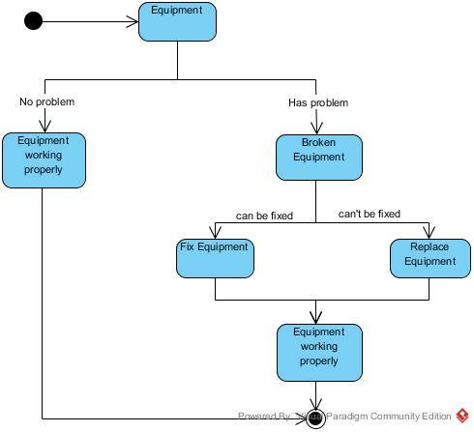Figure 4-A

### New Equipment State Transition Diagram

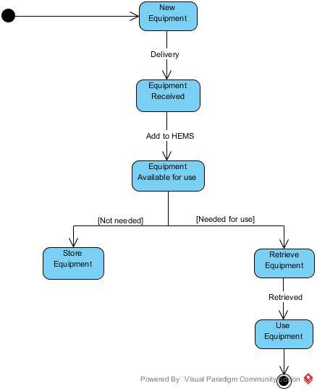Figure 4-B

## Activity Diagram

### Technician Admin Manages Account

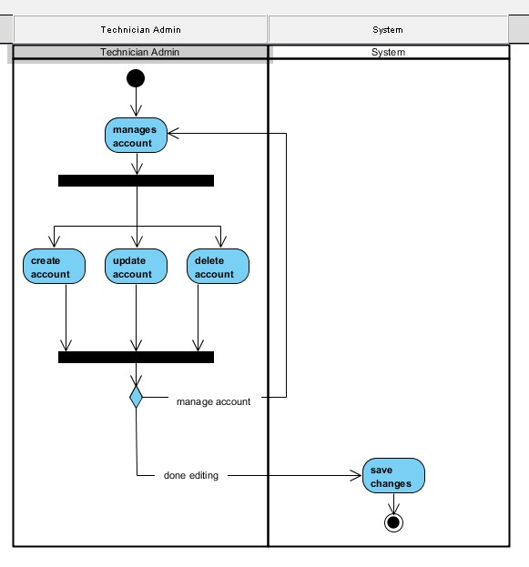Figure 5-A

### Technician Admin Manages Account

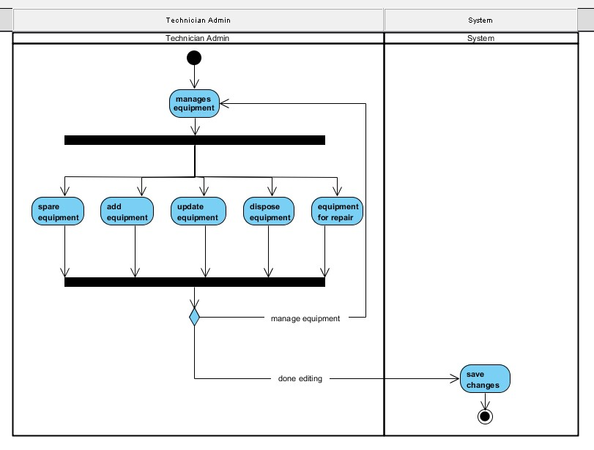Figure 5-B

### Supervisor Sends Problem Report, Technician Diagnose Problem

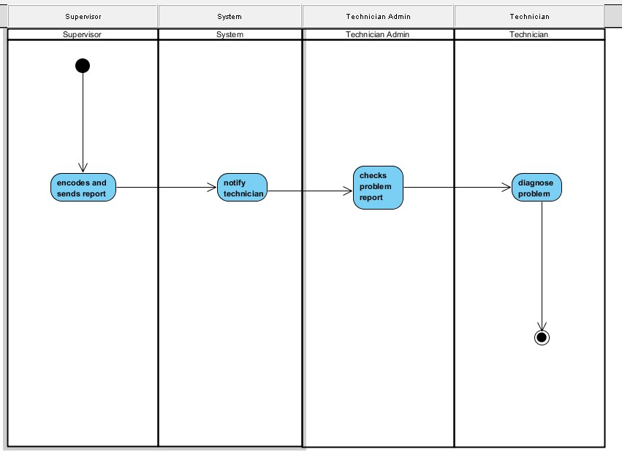Figure 5-C

## Data Flow Diagram

### Data Flow Diagram Level 0: Context Diagram

Figure 6-A

### Data Flow Diagram Level 1: Management

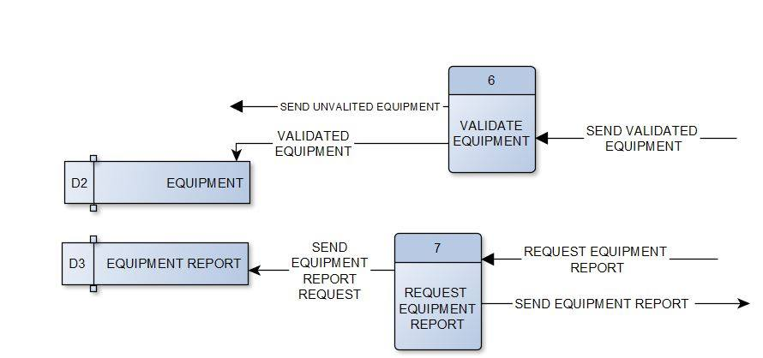Figure 6-B

### Data Flow Diagram Level 1: Supervisor

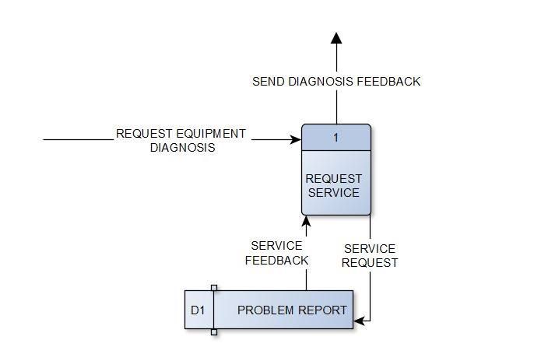Figure 6-C

### Data Flow Diagram Level 1: Technician

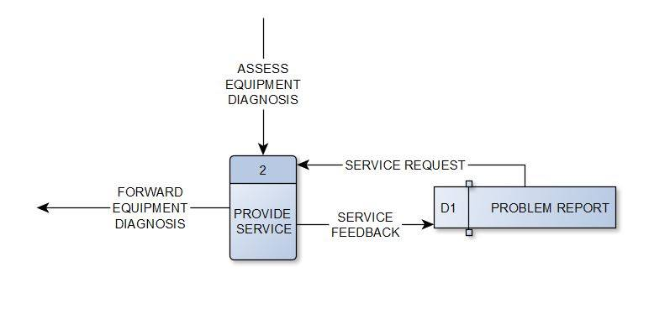Figure 6-D

### Data Flow Diagram Level 1: Technician Admin

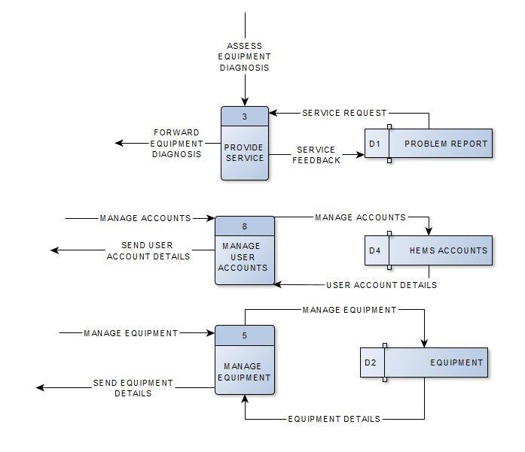Figure 6-F

## Entity Relational Diagram

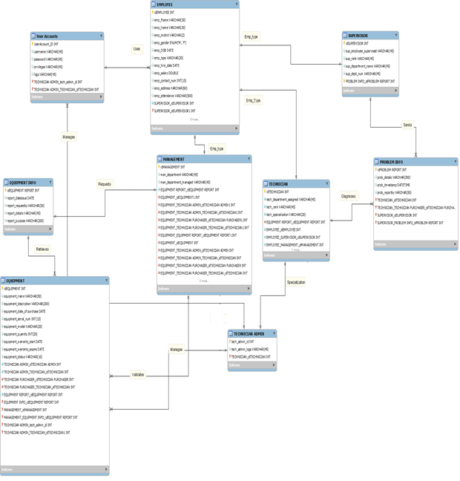

Figure 7-A

## Sequence Diagram

### Agent Reports Problem

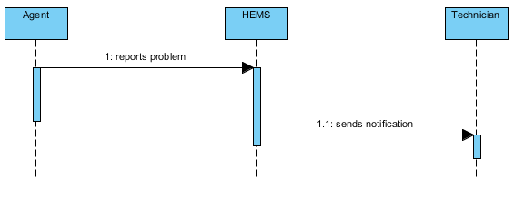Figure 8-A

### Supervisor Sends Report

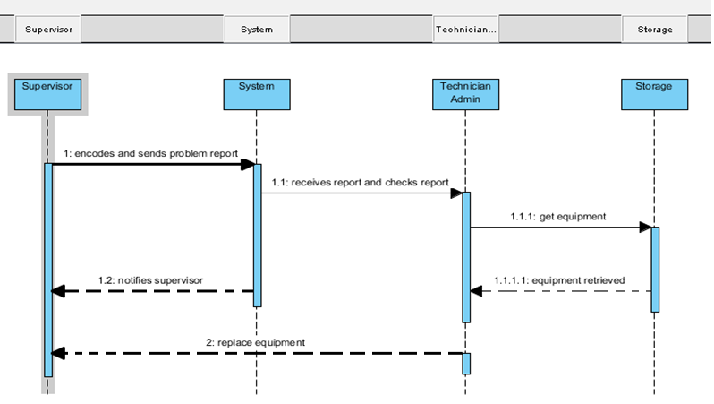Figure 8-C

### System Generates Report

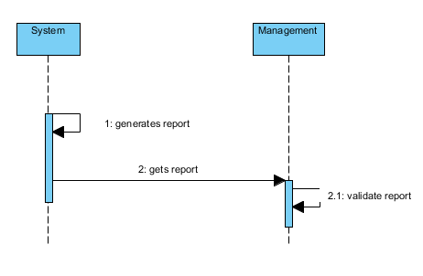Figure 8-D

### Technician Admin Manages Account

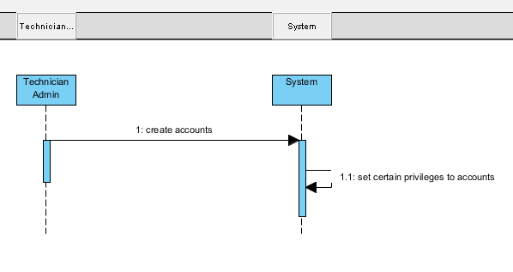Figure 8-E

### Technician Admin Manages Equipment

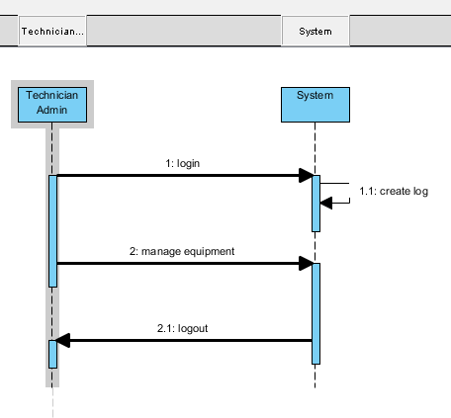Figure 8-F

### Technicians Check Problem Report

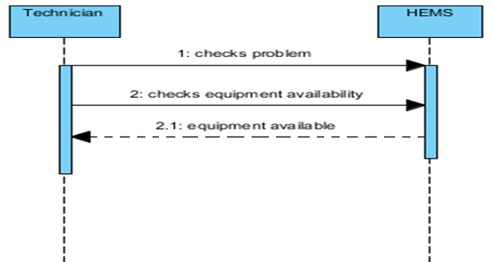Figure 8-G

Technician Fixes Problem 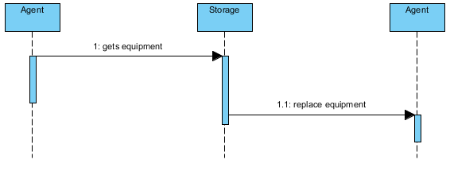Figure 8-H

User Login/Logout 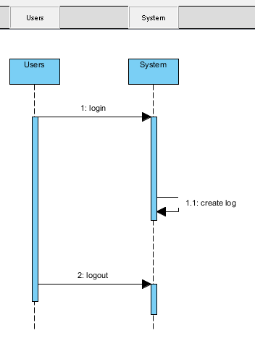Figure 8-J

## **Functional Decomposition Diagram**

Figure 9-A

## **Component Diagram**

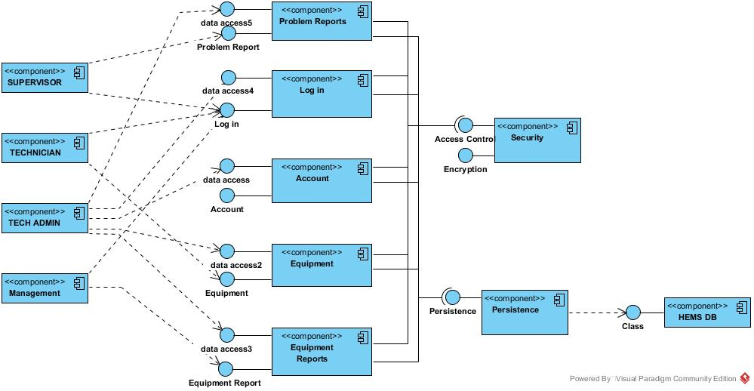Figure 10-A

## **Deployment Diagram**

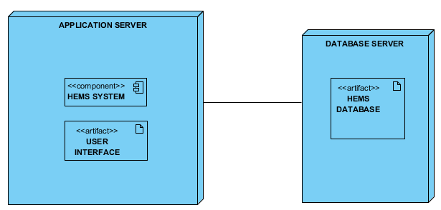

Figure 11-A

## **Vision and Scope Document**

### **Business Requirements**

DCPI’s Hardware & Equipment Management System is a manual system that is done by paperwork and through Microsoft Excel as means of storing and managing the Hardware and Equipment Assets of each department of the company. DCPI is currently open for upgrades and improvements to its current Hardware & Equipment Management System.

### **Background**

Currently the DCPI Tech Department is experiencing issues in equipment management such as:

1. Slow manual process of data input / encoding that leads to an average of 2 to 8 minutes of managing a single process in the system.
2. Confusing and repetitive manual process of data input / encoding because the admin must switch from 3 - 5 different excel files and sheets.
3. Inaccurate records of equipment assets that causes inconvenience to the admin when managing the system.

These issues include inconvenience for their equipment users, inaccurate / redundant records of existing and available equipment in the company.

Although MS excel is used as a means of storing and managing hardware and equipment assets, the client's processes are mostly paperwork i.e. letters, forms.

By using HEMS, it will reduce the current equipment management time by 20% and it will increase the accuracy and speed in terms of searching for equipment information by displaying all detail information (Equipment name, ID, quantity, etc.) specified as compared to searching one by one in Microsoft Excel.

### **Business Opportunity**

A Hardware and Equipment Management System is efficient and effective to use because it provides storage to hardware assets of the client wherein data stored are used as a historical data in terms of budget savings, asset maintenance, reorder of new assets, maximizing the effective lifespan of assets.

The Hardware and Equipment Management System differ from existing Hardware Management Systems because HEMS are designed specifically for the client wherein all modules that are included like equipment search / inquiry, adding new equipment, update equipment, archiving equipment, equipment for repair, equipment for disposal are primarily used in the maintenance of equipment assets of the client.

### **Business Objectives and Success Criteria**

Business objectives or goals are very significant in creating a project because it provides guidance and direction and it must be measurable and quantifiable given on the limited amount of time. The following are the general and specific objectives or goals of Hardware and Equipment Management System:

General Objective(s):

* To provide DCPI easier administration by reducing the current equipment management time, faster and accurate process.

Specific Objective(s):

* To provide DCPI the Hardware and Equipment Management System (HEMS) by reducing their current process time by 20%

Success Criteria(s):

* The Technician admin can create, read, update, and archive equipment and accounts from HEMS.
* The Technician admin and other technicians can read emails sent by Management and Supervisors of DCPI.
* Process time reduced by 20% or more.
* Users more satisfied in using the upgraded system vs the old system.

### **Customer or Market Needs**

The Datascope Communications Philippines Inc. will gain benefits when using the Hardware and Equipment Management System. Fast process of data input, avoiding confusing and repetitive process of data input, and accurate records of equipment assets are some of the needs of the customer. These needs lead us to make a Hardware and Equipment Management System (HEMS).

By using HEMS, it can improve overall performance on the speed of processing and managing the hardware and equipment system it can reduce the process time by 20% and an increase in accuracy in the processes of managing the hardware and equipment assets by our customer.

### **Business Risks**

Whenever there are improvements to the processes and procedures of a department, there are factors that are needed to be considered during the transition period for the processes and procedures. The first factor is the user integration wherein new users will have difficulty in managing, navigating and working using the new system. User training are essential for users to be able to fully utilize the new system. Once the new system is fully controlled and managed by the users, then the benefits in using the system will be realized such as managing time reduction ease in managing equipment assets, increased accuracy in query to the items.

Proper planning and testing must be made before the implementation of the new system to prepare the system users to fully learn how to manage and use the system.

### **Vision of the Solution**

The Hardware and Equipment Management System will focus on the automation of the equipment management process by migrating their current Excel based to a web-based database application, preferably open source software. The system will reduce the current equipment management time by 20%. Also, increase in accuracy and speed in terms of searching for equipment information by displaying complete equipment information (equipment, name, id, quantity, etc.) as compared to searching one by one in Microsoft Excel.

### **Vision Statement**

"As the Datascope Communications Phil's., Inc. moves toward the objective to be well known and leading provider of world-class quality service in the field of Business Process Outsourcing, DCPI Hardware and Equipment Management System is supporting their goal by making their Business Process Outsourcing service well known and trusted both locally and overseas by providing DCPI the Hardware and Equipment Management System that will enable the maintenance personnel to effectively manage the hardware and equipment assets of the company.”

### **Major Features**

Listed below are the following features of Hardware and Equipment Management System (HEMS):

* Supervisor can send troubleshooting service request to Technicians.
* Technicians receive the troubleshooting service request sent by Supervisors.
* Technician Admin can add, read, update, and archive equipment.
* Technician Admin can add, read, update, and archive user accounts.
* Technician Purchaser can send purchasing approval letter to Management.
* Management can approve or decline purchasing approval letter sent by Technician Purchaser.

System will notify the Technician admin when reorder point is reached.

### **Assumptions and Dependencies**

While developing the project, the project members assumed that the Datascope Communications Phils., Inc. (DCPI) employees already has an account that contains the employee information that the employees can use to access the proposed HEMS. Wherein department supervisors will use the system to report hardware and equipment problems, technicians will be able to receive the service request as soon as possible in order to quickly assess and provide troubleshooting and repairs, management can request equipment assets report such as budget reports for new equipment, equipment for repair.

### **Scope and Limitations**

**Scope**

* Improvement to the equipment management process of DCPI.

1. Automation of the current system by migrating to a MySQL Database.
2. Design for the infrastructure of the HEMS.
3. Reduce the current equipment management time by 20%
4. Increase in accuracy and speed in terms of searching for equipment information by displaying complete equipment information (equipment name, id, quantity, etc.)

**Limitations**

* Control and monitoring of system are limited to technicians only.
* The system can only be used for Hardware and Equipment assets only.

### **Scope of Initial Release**

The project has 3 user account privileges namely: Department supervisor, Technicians, Management.

Department supervisor has only access to reporting a hardware problem. Technicians has 3 levels wherein technician admins controls and manages the system, Technicians view the problem service request(s) of department supervisor(s) to quickly provide troubleshooting, technician purchaser manages the reorder point of new equipment’s. Management requests reports regarding list of assets that are active, spare, for repair, disposed, budget reports regarding active assets, disposed assets, current reorder equipment cost.

The Department supervisors will benefit in this project because of faster equipment problem service request to quickly resume the work / operations of the employee affect by the equipment problem.

The Technician department will greatly benefit in this project because of easier equipment assets management, faster problem service request response, easier reorder equipment process.

The Management will benefit in this project because of accurate and up to date equipment reports that is possible to be acquired immediately.

### **Scope of Subsequent Releases**

No subsequent releases will be released.

### **Limitations and Exclusions**

The system will be operable within the company only and will only focus on hardware and equipment assets only as categorized by the client particularly to computer and electronic parts only.

Hardware are categorized as the parts or components such as memory card, video card, hard disk drive, processors and such small parts.

### **Business Context**

The main issues in the project will be the account access privileges must be observed by the system at all times to prevent data leakage to unprivileged employees and correct data storage.

### **Stakeholder Profiles**

The stakeholders of DCPI Hardware and Equipment Management System are the DCPI itself and their Technician Department who will implement the use of HEMS. The benefits that the Hems provide are:

* Budget savings.
* Efficient and effective lifetime of hardware and equipment assets.
* Easier to report equipment problems.
* Easier to manage hardware and equipment assets.
* Fast service to hardware and equipment assets.

|  |  |  |  |  |
| --- | --- | --- | --- | --- |
| **Stakeholder** | **Major Value** | **Attitudes** | **Major Interest** | **Constraints** |
| DCPI | Cost Savings. | Increase in savings and efficiency. | Budget reports on expenses and operational cost of hardware and equipment assets. | Budget |
| Department Supervisor | Ease in reporting equipment problems. | Accurate pre-assessment equipment problem | Report problems immediately so as to resume operational activity of employees | Service |
| Technician Department | Ease in managing Hardware and Equipment assets of DCPI, faster service response. | Fast and flexible hardware and equipment management and service. | Provide service and results immediately. | Service |
| Management | Request equipment reports anytime | Request reports anytime with ease and accuracy | Up to date equipment reports acquired. | Service |

### **Project Priorities**

|  |  |  |  |
| --- | --- | --- | --- |
| **Dimension** | **Driver (state objective)** | **Constraint (state limits)** | **Degree of Freedom (state allowable range)** |
| Schedule | release 1.0 to be available by the beginning of February 2017,  release 2.0 to be available by the march 2017,  release 3.0 to be available by the beginning of April 2017. | Time constraint | 80 - 100% of the DCPI Hardware and Equipment Management System function must be done |
| Features | The main function must be properly working |  | 70-80% of high priority features must be included in release 1.0 |
| Quality | Provides DCPI Technician Department easier management of HEMS | Bugs and errors are expected during release 1.0 | 90-95% of user acceptance tests must pass for release 1.0, 95-98% for release 1.1 |
| Staff |  | maximum team size is 3 developers + 4 testers |  |
| Cost | The expenses must not exceed the maximum budget | Maximum budget | budget overrun up to 15% acceptable without executive review |

### **Operating Environment**

The system will be built using HTML and PHP.

To transfer or connect the data, Apache Web Server through XAMPP will be used. All data that requires preservation, will be stored in a database powered by MySQL. The DCPI-HEMS are only accessible within the company and only authorized personnel can use the system.

## **Software Requirements Specifications**

### **Purpose**

Software Requirements Specifications for HEMS. DCPI aims to maintain and monitor their hardware and equipment assets by migrating their current manual HEMS into an automated, PHP MySQL Database System which will greatly reduce every transaction time.

### **Document Conventions**

In writing this SRS, every requirement statement has its own priority to be followed and specific personnel are expected to follow the particular requirement.

### **Intended Audience and Reading Suggestions**

This SRS is applicable to system administrators, system developers, management of the client DCPI. The document is divided into 6 parts. Introduction, Overall Description, External Interface Requirements, System Features, Other Nonfunctional Requirements, Other Requirements chronologically.

### **Product Scope**

The upgraded HEMS will provide the design and infrastructure of the system, will enable technicians to manage the hardware and equipment assets with ease by reducing the transaction time by 20% or more, provide accurate and up-to date information per item, provide automation of the current manual excel system by migrating it into PHP MySQL.

### **References**

SRS Template: http://moodle2.apc.edu.ph/pluginfile.php/82831/mod_resource/content/1/srs_template-1.pd

### **Product Perspective**

This document is the SRS for the proposed upgrade to the existing HEMS of DCPI.

### **Product Functions**

* Supervisor can send report to Technician Admin, Technician Purchaser, and Technician.
* Technician Admin, Technician Purchaser, Technician can read the report sent by Supervisor.
* Technician Admin can add, read, update, and archive equipment
* Technician Admin can add, read, update, and archive user accounts.
* Technician Purchaser can send purchasing approval letter to Management.
* Management can approve or decline purchasing approval letter sent by Technician Purchaser.
* System will notify the Technician admin when reorder point is reached.

### **User Classes and Characteristics**

Admin Privilege – Technician Admins who has full control and access to the system.

Technician Privilege – Technicians who has access and control to the monitoring and maintaining of the hardware and equipment assets, service control.

Management Privilege – Management of departments that has access to the reports of the equipment usage, costs & budget concerns.

Supervisor Privilege – Supervisors of each department that forwards the troubleshoot service request to the technicians for diagnosis.

### **Operating Environment**

The HEMS platform used are browsers that can process HTML and PHP codes. To transfer or connect the data, Apache Web Server and XAMPP will be used. All data that requires preservation, will be stored in a database powered by MySQL. The DCPI-HEMS are only accessible within the company and only authorized personnel can use the system.

### **Design and Implementation Constraints**

* Control and monitoring of system are limited to technicians only.
* The system can only be used for Hardware and Equipment assets only.
* Two servers to be used. 1st server is the main server and the 2nd server

+for backup.

* The system will be used for intranet system only within the company.

### **User Documentation**

To be created and discussed with the client.

### **Assumptions and Dependencies**

The proponents of the project assumed that the workstations of the client can handle the HTML and PHP service and functions in connection with the client’s LAN network.

### **User Interfaces**

The user interface for the department supervisors is the troubleshoot service request interface as to provide initial information for the technicians responding to the request.

The user interface for the technicians is the troubleshoot service requests interface that enables them to receive the troubleshoot service requests by the department supervisors for the technicians to respond.

The user interface for the technician admins is to manage the hardware and equipment assets and user accounts for the system.

### **Hardware Interfaces**

The software will be used on PC workstations particularly with windows OS and LAN connection within the departments of DCPI.

### **Software Interfaces**

The commands issued by the technicians, management and supervisors are all coded in PHP and HTML. The recommended web browsers to be used is Mozilla firefox and Google chrome. The database used Is MySQL or MariaDB through XAMPP.

### **Communications Interfaces**

LAN Connection among the department workstations is needed for the integration of the proposed system. Apache HTTP and PHP protocols are used in the communication between the database and the workstations.

### **System Features**

#### Information Handling

* + 1. High Priority

- The system shall generate the specified values / details information of the items.

4.1.2 Response

- The users must receive their respective and specified information requested to the system.

4.1.3 Functional Requirements

- REQ-1: Connected to HEMS

- REQ-2: User Account Logged In

#### User Account Privileges Handling

4.2.1 High Priority

- The system must provide access and control accordingly to the user account privileges. 4.2.2. Response

- The users are given the functions and accessibility to the system according to their user account privilege once they logged in to the system.

4.2.3 Functional Requirements

- REQ-1: Connected to HEMS

- REQ-2: User Account Logged In

#### Login / Logout Handling

4.3.1 Medium Priority

- The system must process the authenticity of the username and password of the user and provide or deny access.

4.3.2 Response

- The users enter their username and password and receives notifications regarding responses in logging in / out.

- The user session will be processed so as to login or logout the user account from the system.

4.3.3 Functional Requirements

REQ-1: Connected to HEMS

REQ-2: Workstation on system logon screen

#### Hardware & Equipment Items Management

4.4.1 High Priority

- The system must process the specified create, read, update and archive commands by the tech admins.

4.4.2 Response

- The tech admins insert a new equipment item, updates the item information, archives the item once the item status is disposed.

4.4.3 Functional Requirements

REQ-1: Connected to HEMS.

REQ-2: Tech admin account logged in.

#### User Accounts Management

4.5.1 High Priority

- The tech admin manages the user accounts of all the users using the system.

4.5.2 Response

- The tech admin creates a new user account, updates information details, archives a user account.

### **Other Non-Functional Requirements**

#### **Performance Requirements**

#### - The system shall produce results in 15 seconds or less

#### - The system shall execute the commands issued in 15 seconds or less

#### - The system shall be accessible anytime.

#### - The system shall provide the corresponding user privilege to each user.

#### **Safety Requirements**

#### - Only system admins can commit changes to the system and user accounts.

#### - Changes must be reviewed twice or thrice before being approved to avoid errors and damages to the system.

#### **Security Requirements**

#### - Proper implementation of user accounts privileges must be maintained by the system at all times.

#### - System admins must routinely check for data and information leaks to unrestricted and unprivileged personnel.

#### **Software Quality Attributes**

#### - The system must process the requests with speed and accuracy.

#### - The system must remove redundancies to information.

#### **Business Rules**

- Supervisor requests troubleshoot service for workstations / equipment.

- Technician troubleshoots the service request.

- Technician admins manage the items in HEMS.

- Technician admins manage the user accounts of HEMS.

- Management requests reports regarding equipment.

#### **Other Requirements**

-Two servers can be used so that the second server will act as a backup.