**Software Requirements**

**Specification**

for

Hardware and Equipment Management System (HEMS)

Curato, Kent Wendell  
Ebreo, Sebastian   
Mondejar, Mark Daniel

Asia Pacific College

February 8, 2017

# Table of Contents

Table of Contents 2

Revision History 2

1. Introduction 1

1.1 Purpose 1

1.2 Document Conventions 1

1.3 Intended Audience and Reading Suggestions 1

1.4 Product Scope 1

1.5 References 1

2. Overall Description 2

2.1 Product Perspective 2

2.2 Product Functions 2

2.3 User Classes and Characteristics 2

2.4 Operating Environment 3

2.5 Design and Implementation Constraints 3

2.6 User Documentation 3

2.7 Assumptions and Dependencies 3

3. External Interface Requirements 4

3.1 User Interfaces 4

3.2 Hardware Interfaces 5

3.3 Software Interfaces 5

3.4 Communications Interfaces 5

4. System Features 6

4.1 Item Information Handling 6

4.2 User Account Privileges 6

4.3 Login / Logout Handling 7

4.4 System Performance 7

5. Other Nonfunctional Requirements 8

5.1 Performance Requirements 8

5.2 Safety Requirements 8

5.3 Security Requirements 8

5.4 Software Quality Attributes 8

5.5 Business Rules 8

6. Other Requirements 8

# Revision History

|  |  |  |  |
| --- | --- | --- | --- |
| **Name** | **Date** | **Reason For Changes** | **Version** |
| Mondejar,  Ebreo,  Curato | 02/08/17 | SRS Draft | 1.0 |

# Introduction

## Purpose

Software Requirements Specifications v1.0 for HEMS. DCPI aims to maintain and monitor their hardware and equipment assets by migrating their current manual HEMS into an automated, PHP MySQL Database System which will greatly reduce every transaction time.

## Document Conventions

In writing this SRS, every requirement statement has its own priority to be followed and specific personnel are expected to follow the particular requirement.

## Intended Audience and Reading Suggestions

This SRS is applicable to system administrators, system developers, management of the client DCPI. The document is divided into 6 parts. Introduction, Overall Description, External Interface Requirements, System Features, Other Nonfunctional Requirements, Other Requirements chronologically.

## Product Scope

The upgraded HEMS will provide the design and infrastructure of the system, will enable technicians to manage the hardware and equipment assets with ease by reducing the transaction time by 20% or more, provide accurate and up-to date information per item, provide automation of the current manual excel system by migrating it into PHP MySQL.

## References

SRS Template:

•http://moodle2.apc.edu.ph/pluginfile.php/82831/mod_resource/content/1/srs_template-1.pdf

# Overall Description

## Product Perspective

This document is the SRS for the proposed upgrade to the existing HEMS of DCPI. The HEMS will provide automation of their existing system where they use Excel to manually process their transaction.

## Product Functions

* Supervisor can send report to Technician Admin, Technician Purchaser, and Technician.
* Technician Admin, Technician Purchaser, Technician can read the report sent by Supervisor.
* Technician Admin can add, read, update, and archive equipment
* Technician Admin can add, read, update, and archive user accounts.
* Technician Purchaser can send purchasing approval letter to Management.
* Management can approve or decline purchasing approval letter sent by Technician Purchaser.
* System will notify the Technician admin when reorder point is reached.

## User Classes and Characteristics

•Admin Privilege – Technician Admins who has full control and access to the system.

•Technician Privilege – Technicians who has access and control to the monitoring and maintaining of the hardware and equipment assets, service control.

•Management Privilege – Management of departments that has access to the reports of the equipment usage, costs & budget concerns.

•Supervisor Privilege – Supervisors of each departments that forwards the problem request to the technicians for diagnosis.

## Operating Environment

The HEMS platform used are browsers that can process HTML and PHP codes. To transfer or connect the data, Apache Web Server and XAMPP will be used. All data that requires preservation, will be stored in a database powered by MySQL. The DCPI-HEMS are only accessible within the company and only authorized personnel can use the system.

## Design and Implementation Constraints

* Control and monitoring of system are limited to technicians only.
* The system can only be used for Hardware and Equipment assets only.
* Two servers to be used. 1st server is the main server and the 2nd server

for backup.

* The system will be used for intranet system only within the company.

## User Documentation

To be created and discussed with the client.

## Assumptions and Dependencies

The proponents of the project assumed that the workstations of the client can handle the HTML and PHP service and functions in connection with their company network.

# External Interface Requirements

## User Interfaces

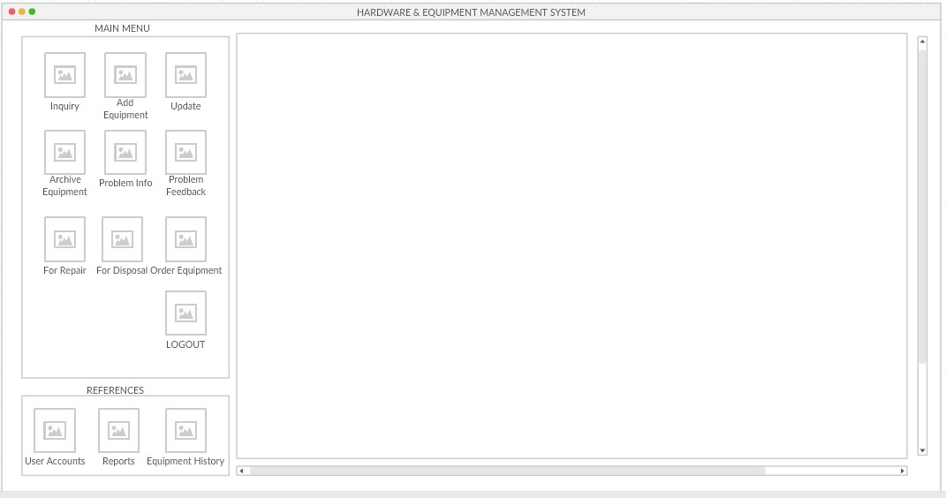**MAIN MENU**

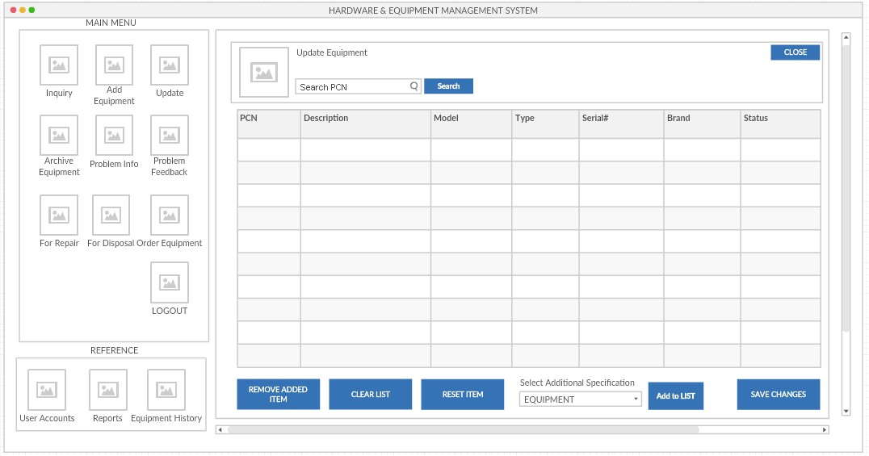**SEARCH / INQUIRY**

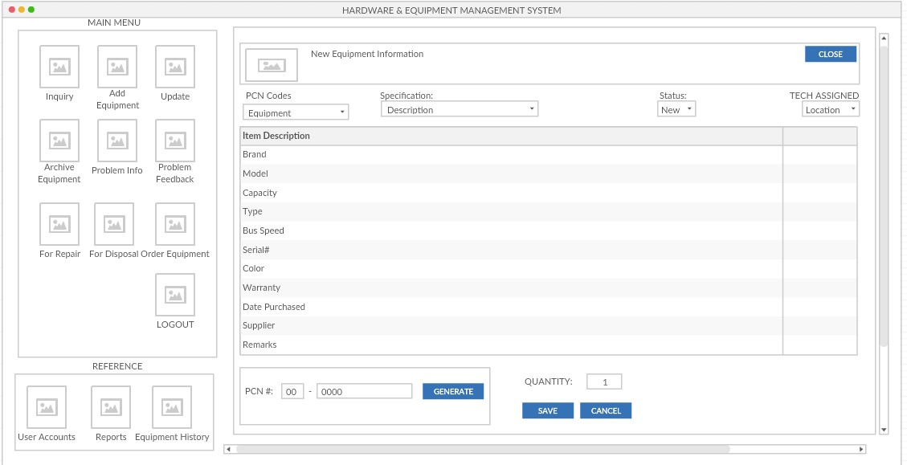**ADD ITEM**

## Hardware Interfaces

The software will be used on PC workstations particularly with windows OS and LAN connection within the departments of DCPI.

## Software Interfaces

The commands issued by the technicians, management and supervisors are all coded in PHP and HTML.

## Communications Interfaces

The recommended web browsers to be used is Mozilla Firefox and Google chrome.

HTTP and PHP protocols will be the main features of the system.

# System Features

## Item Information Handling

4.1.1 High Priority

- The system shall generate the specified values / details information of the items.

4.1.2 Response

- The users must receive their respective and specified information requested to the system.

4.1.3 Functional Requirements

* REQ-1: Connection to the HEMS
* REQ-2: User Account Logged In

## User Account Privileges

4.2.1 High Priority

- The system must provide access and control accordingly to the user’s privileges.

4.2.2. Response

- The users are given the functions and accessibility according to their privilege.

4.2.3 Functional Requirements

* REQ-1: Connection to the HEMS
* REQ-2: User Account Logged In

## Login / Logout Handling

4.3.1 Medium Priority

- The system must process the authenticity of the username and password of the user and provide or deny access.

4.3.2 Response

- The users enter their username and password and receives notifications regarding errors in logging in / out.

4.3.3 Functional Requirements

* REQ-1: Connection to the HEMS
* REQ-2: Workstation on system logon screen

## System Performance

4.3.1 High Priority

-The system must process the transaction specified in 10 seconds or less.

4.3.2 Response

-The system should always produce up to date information for each transaction.

- Changes to the system must be done by system admins only and review the revisions before applying the changes.

-The system should always produce up to date information for each transaction.

4.3.3 Functional Requirements

* REQ-1: Connection to the HEMS
* REQ-2: Workstation on system logon screen

# Other Nonfunctional Requirements

## Performance Requirements

* The system shall produce results in 15 seconds or less
* The system shall execute the commands issued in 15 seconds or less
* The system shall be accessible anytime.

## Safety Requirements

* Only system admins can commit changes to the system and user accounts.
* Changes must be reviewed twice or thrice before being approved to avoid damages to the system.

## Security Requirements

* Proper implementation of user accounts privileges must be maintained by the system at all times
* System admins must routinely check for data and information leaks to unrestricted and unprivileged personnel.

## Software Quality Attributes

* The system must process the requests with speed and accuracy.
* The system must remove redundancies to information

## Business Rules

* Supervisors requests problem diagnosis for workstations / equipment
* Technicians attend the problem requests.
* Technician admins manages the items in HEMS.
* Technician admins manages the user accounts of HEMS.
* Management requests reports regarding equipment’s.

# Other Requirements

• Two servers can be used so that the second server will act as a backup.