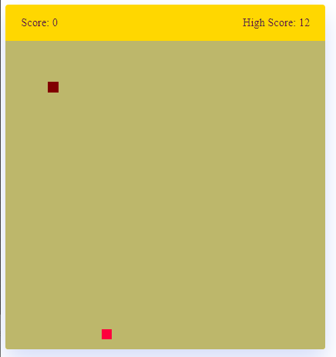

Cod :

<!DOCTYPE html>

<html lang="en">

<head>

<meta charset="utf-8">

<title>Snake Game CIT112 </title>

<link rel="stylesheet" href="style.css">

<meta name="viewport" content="width=device-width, initial-scale=1.0">

<link rel="stylesheet" href="https://cdnjs.cloudflare.com/ajax/libs/font-awesome/6.3.0/css/all.min.css">

<script src="script.js" defer></script>

</head>

<body>

<div class="wrapper">

<div class="game-details">

<span class="score">Score: 0</span>

<span class="high-score">High Score: 0</span>

</div>

<div class="play-board"></div>

<div class="controls">

<i data-key="ArrowLeft" class="fa-solid fa-arrow-left-long"></i>

<i data-key="ArrowUp" class="fa-solid fa-arrow-up-long"></i>

<i data-key="ArrowRight" class="fa-solid fa-arrow-right-long"></i>

<i data-key="ArrowDown" class="fa-solid fa-arrow-down-long"></i>

</div>

</div>

</body>

</html>

Styly

margin: 0;

padding: 0;

box-sizing: border-box;

font-family: 'Open Sans', sans-serif;

}

body {

display: flex;

align-items: center;

justify-content: center;

min-height: 100vh;

background: #F0FFFF;

}

.wrapper {

width: 65vmin;

height: 70vmin;

display: flex;

overflow: hidden;

flex-direction: column;

justify-content: center;

border-radius: 5px;

background: #FFD700;

box-shadow: 0 20px 40px rgba(52, 87, 220, 0.2);

}

.game-details {

color: #581845;

font-weight: 500;

font-size: 1.2rem;

padding: 20px 27px;

display: flex;

justify-content: space-between;

}

.play-board {

height: 100%;

width: 100%;

display: grid;

background: #BDB76B;

grid-template: repeat(30, 1fr) / repeat(30, 1fr);

}

.play-board .food {

background: #FF003D;

}

.play-board .head {

background: #800000;

}

.controls {

display: none;

justify-content: space-between;

}

.controls i {

padding: 25px 0;

text-align: center;

font-size: 1.3rem;

color: #B8C6DC;

width: calc(100% / 4);

cursor: pointer;

border-right: 1px solid #171B26;

}

@media screen and (max-width: 800px) {

.wrapper {

width: 90vmin;

height: 115vmin;

}

.game-details {

font-size: 1rem;

padding: 15px 27px;

}

.controls {

display: flex;

}

.controls i {

padding: 15px 0;

font-size: 1rem;

}

}