Sentiment Analysis of Customer Service Conversations Using Fine-Tuned RoBERTa
Süleyman Ceran – 2786028 - MMI
DI 725 — Transformers and Attention-Based Deep Networks
Abstract
This report describes a sentiment classification system built for customer service conversations. The goal is to assign one of three labels to each conversation: positive, negative, or neutral. A fine-tuned RoBERTa-base model is used with metadata prepending, head-and-tail truncation, and class-weighted loss. Six experiments were run through greedy hyperparameter search. The best configuration reached a validation F1-macro of 0.96 and a test F1-macro of 0.84.

I. Introduction
Detecting customer sentiment from support conversations can help companies improve their service. Rule-based methods tend to fall short when dealing with the kind of informal, multi-turn language that appears in these dialogues. Transformer models like BERT and its variants have been shown to handle such tasks well because of the self-attention mechanism they rely on.
In this work, RoBERTa-base is fine-tuned for three-class classification on a customer service dataset. RoBERTa was preferred over BERT since it uses an improved pretraining procedure while keeping the same model size (125M parameters) [1]. DeBERTa-v3 was also considered but it has a larger footprint and there was a risk of running into memory issues on a free-tier Colab T4 GPU.
II. Dataset
The dataset consists of 970 training samples and 30 test samples. Each entry has a conversation between a customer and an agent, along with 10 metadata columns like issue area, product category, issue complexity, and agent experience level. No missing values were found in either split.
There is a clear class imbalance in the target variable. Negative and neutral make up most of the data. The positive class has only about 1.7% of all training samples (17 out of 970 total). Fig. 1 shows the sentiment distribution across the four metadata categories used in preprocessing.
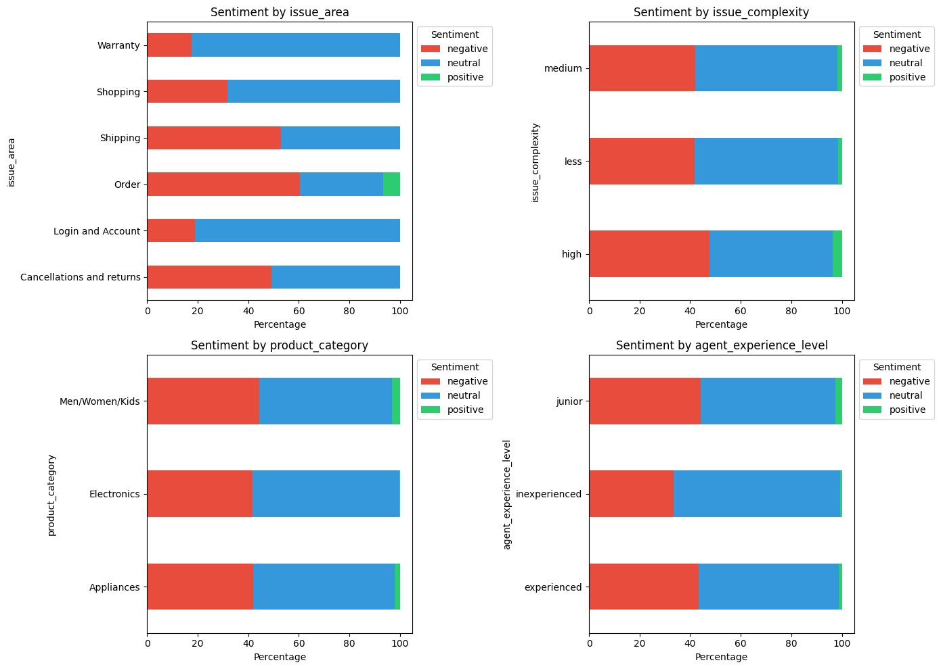
Fig. 1. Sentiment distribution across metadata categories in the training set.
A tokenization analysis with the RoBERTa tokenizer showed that the average conversation length is around 512 tokens. About 44.3% of all conversations go beyond the 512-token limit. This was one of the main reasons for choosing a truncation strategy rather than simply cutting off at the end.
A. Preprocessing
Four metadata fields (issue area, issue complexity, product category, agent experience level) were prepended to each conversation as plain text. The format is: “Area: X | Complexity: Y | Product: Z | Agent: W | [conversation]”. This way the model can use structured information without needing any changes to its architecture. Basic whitespace normalization was also applied.
B. Truncation
A head-and-tail approach was adopted. The first 128 tokens and the last 382 tokens are kept, totalling 510 content tokens plus 2 special tokens. Customer service conversations usually state the problem early on and reach some kind of resolution toward the end. The middle part is often repetitive troubleshooting steps, so dropping it should not lose much useful information.
C. Data Split
The training set was split 80/20 into train and validation subsets using stratified sampling to keep the class proportions intact.
III. Modeling
RoBERTa-base was loaded with a sequence classification head for 3 output classes. The training setup is as follows:
• AdamW optimizer with a weight decay of 0.01
• Linear warmup scheduler (warmup over 10% of total steps)
• Gradient clipping at max norm 1.0
• Early stopping with patience of 2, monitored on validation F1-macro
• Cross-entropy loss weighted by inverse class frequency (positive: 19.02, negative: 0.79, neutral: 0.60)
All experiments were tracked using Weights and Biases.
IV. Evaluation
F1-macro was chosen as the primary metric. Accuracy alone would be misleading here because a model that just predicts neutral every time would still get a reasonably high accuracy score, but it would completely fail on the other classes. F1-macro treats all classes equally regardless of their size in the dataset.
Accuracy, F1-weighted, and per-class precision/recall/F1 are reported as well for a fuller picture.
V. Results
Six experiments were conducted in a greedy fashion. Each one changes a single factor and the best result carries forward to the next experiment. Table I summarizes these results.
TABLE I
Greedy Hyperparameter Search Results
# | Change | LR | BS | Truncation | Meta | Val F1
1 | Baseline | 2e-5 | 16 | Head | Yes | 0.70
2 | Trunc. | 2e-5 | 16 | H+T | Yes | 0.96
3 | Low LR | 1e-5 | 16 | H+T | Yes | 0.67
4 | High LR | 5e-5 | 16 | H+T | Yes | 0.82
5 | Batch | 2e-5 | 8 | H+T | Yes | 0.88
6 | No meta | 2e-5 | 16 | H+T | No | 0.76
The biggest improvement came from switching to head-and-tail truncation. Validation F1-macro jumped from 0.70 to 0.96. The default learning rate of 2e-5 turned out to be the best option. When metadata was removed in Experiment 6, performance dropped from 0.96 down to 0.76, which shows that the prepended features carry useful signal.
The best model (Exp 2) was then evaluated on the 30-sample test set. Table II presents the per-class results.
TABLE II
Test Set Per-Class Results (Best Model, Exp 2)
Class | Prec. | Recall | F1 | Supp.
Negative | 1.00 | 0.80 | 0.89 | 10
Neutral | 0.69 | 0.90 | 0.78 | 10
Positive | 0.89 | 0.80 | 0.84 | 10
Macro avg | 0.86 | 0.83 | 0.84 | 30
Test accuracy came out at 0.83 and F1-macro at 0.84. The negative class has perfect precision. The positive class, despite having only 17 training examples, still reached an F1 of 0.84 on the test set. The class-weighted loss clearly helped here.
VI. Discussion
What stands out is that the way input is represented matters more than hyperparameter tuning for this particular task. Head-and-tail truncation by itself gave a bigger boost than any learning rate or batch size change. This makes sense given how customer service calls are structured—the beginning and the end carry the most sentiment-relevant content.
There is a noticeable gap between validation F1 (0.96) and test F1 (0.84). Some of this might be overfitting, but the test set only has 30 samples so it is hard to draw strong conclusions from it. A bigger test set would give a more reliable picture.
The dataset itself is quite small at 970 samples. Strong validation numbers could partly reflect the model memorizing patterns rather than truly generalizing. Data augmentation or domain-adaptive pretraining might help with this in future work.
VII. Conclusion
A fine-tuned RoBERTa-base model with head-and-tail truncation, metadata prepending, and class-weighted loss was shown to be effective for classifying customer service conversations into three sentiment categories. The model achieved a test F1-macro of 0.84. Ablation experiments confirmed that both the truncation strategy and metadata enrichment play an important role in the final performance.
References
[1] Y. Liu et al., “RoBERTa: A Robustly Optimized BERT Pretraining Approach,” arXiv:1907.11692, 2019.

