An Antenna with Linear Polarization which Orientation can be Controlled Electrically

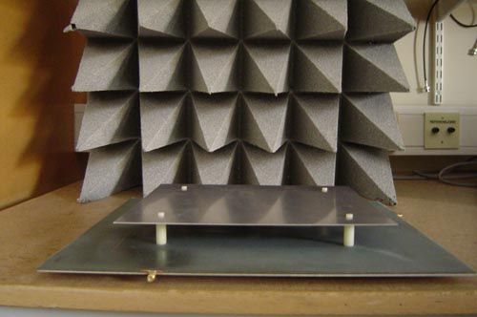

A master thesis report by:
Šefik Cerić
Michael Sund
At the Department of electroscience at Lunds Tekniska Högskola

30’th of May 2006

