Software requirements specification – Team 01

Inhaltsverzeichnis

Introduction 2

Purpose 2

Stakeholders 3

Definitions 3

System overview 3

References 3

Overall description 4

Use cases 4

Actor characteristics 4

Company/Logisticians: 4

Drivers: 4

Customers: 4

EPK 5

Objects 6

Specific requirements 6

User Interfaces 6

Hardware Interfaces 6

Software Interfaces 6

Communication Interfaces 6

Functional requirements 6

User Class 1 – The Logistician 6

User Class 2 – The Driver 6

User Class 3 – The customer 6

Non-functional requirements (external, performance, etc.) 6

Design constraints 6

Software System attributes 6

# Introduction

## Purpose

The client requests an application to simplify the process from ordering to delivery. In the current situation everything is done by hand from each employee in the process line, leading to an excessive amount of paper work. With an automated system the company wants to improve the efficiency of their logistics.

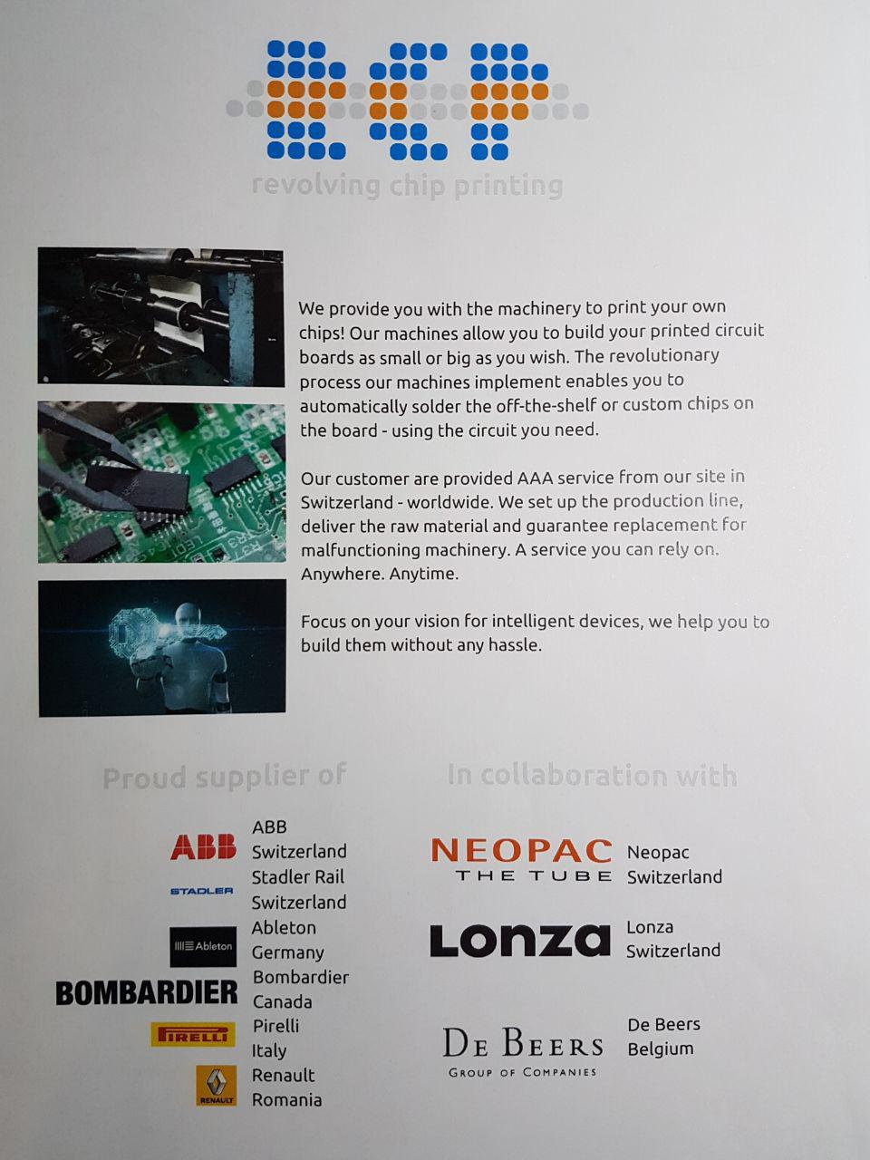

## Stakeholders

* Logisticians: Prepare tours with a few clicks on their screen, then the system will automatically assemble tours.
* Drivers: Should see their tours for the next few days on their mobiles. Has to mark the deliveries as successful or unsuccessful.
* Customers: Might reject delivery or might not be available.

## Definitions

## System overview

The system should:

* Save the logisticians in the database, they have the access to add, change and look up things
* Save the drivers in the database, they can just look up things and add the state of the order
* Save the customers with their addresses in the database
* Save the orders from the client in a database
* Prepare tours with the different addresses of the clients
* Show the tours for the logisticians on a mobile device
* Let the drivers access the orders for changing the state of the order (delivered, rejected, not there)

## References

„here come what literature we use“

# Overall description

## Use cases

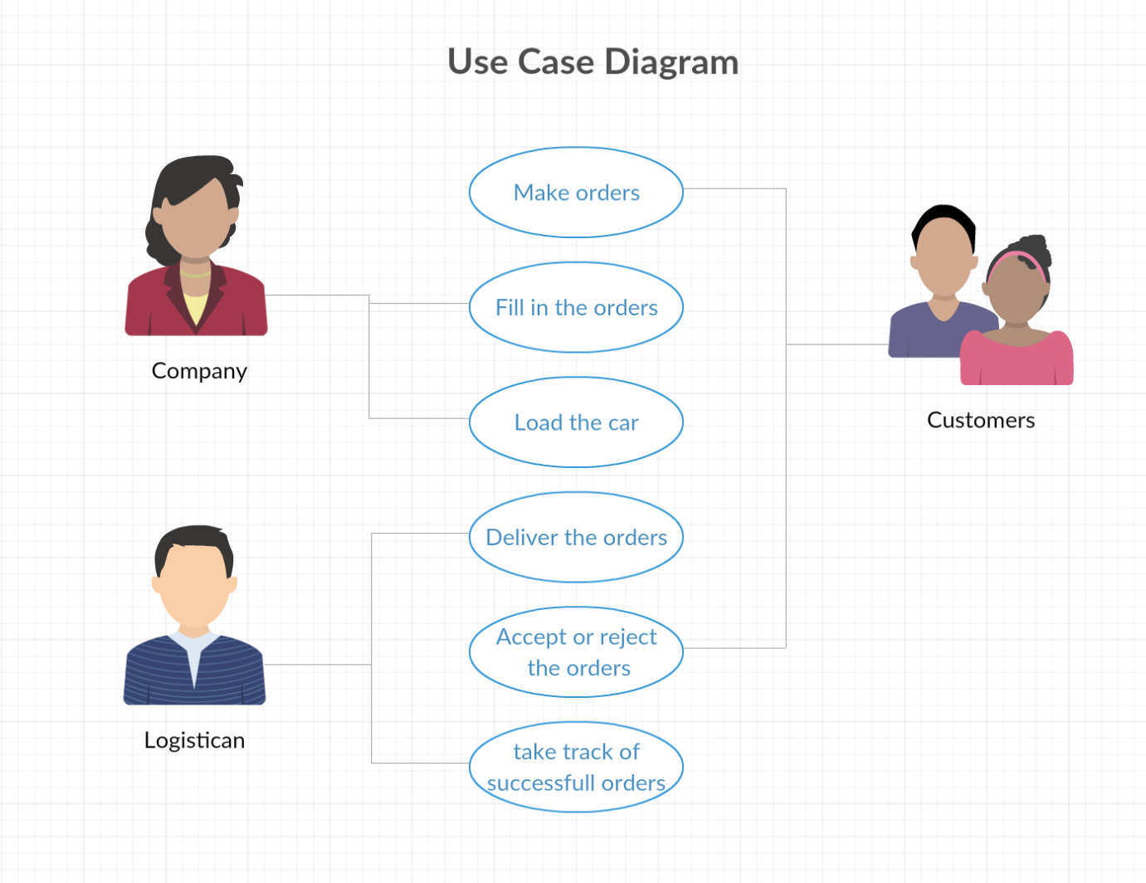

## Actor characteristics

### Company/Logisticians:

The company that orders the program is taking the orders of the customers. They are making the loading lists and filling the trucks with the ordered goods.

### Drivers:

They are taking the delivery lists and drive the ordered goods to the customers place. They have to take track of the accepted and rejected deliveries.

### Customers:

They order the goods from the company. They get the goods from the logistician and can accept or reject them when they are there.

## EPK

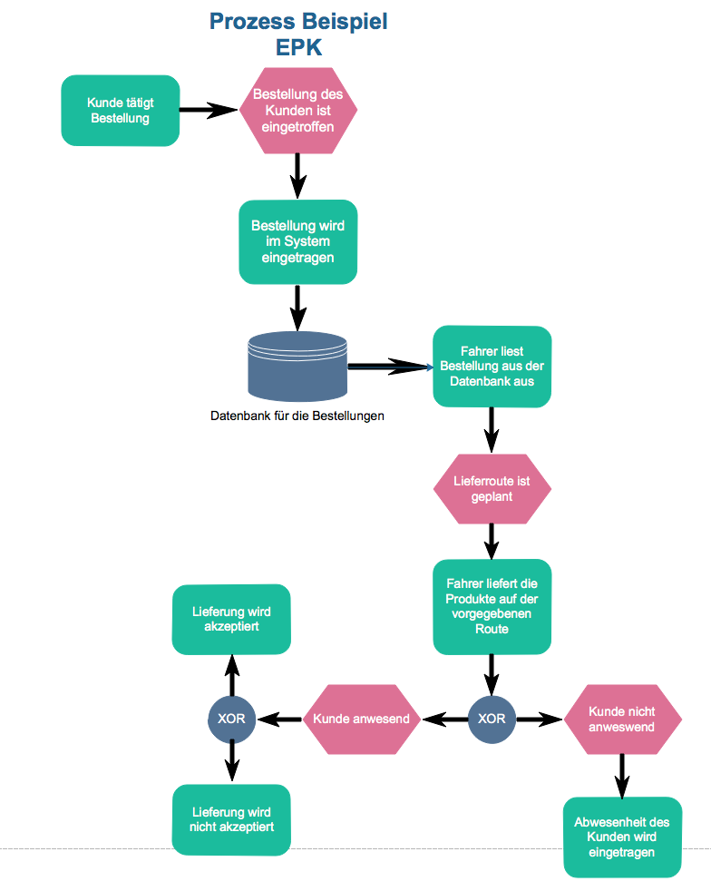

# Objects

# Specific requirements

### User Interfaces

### Hardware Interfaces

### Software Interfaces

### Communication Interfaces

## Functional requirements

### User Class 1 – The Logistician

### User Class 2 – The Driver

### User Class 3 – The customer

## Non-functional requirements (external, performance, etc.)

## Design constraints

## Software System attributes