Software requirements specification – Team 01

Inhaltsverzeichnis

Introduction 2

Purpose 2

Stakeholders 2

Definitions 2

System overview 2

References 2

Overall description 2

Use cases 2

Actor characteristics 2

Specific requirements 2

Functional requirements 2

Non-functional requirements (external, performance, etc.) 2

# Introduction

## Purpose

The client requests an application to simplify the process from ordering to delivery. In the current situation everything is done by hand from each employee in the process line, leading to an excessive amount of paper work. With an automated system the company wants to improve the efficiency of their logistics.

## Stakeholders

* Logisticians: Prepare tours with a few clicks on their screen, then the system will automatically assemble tours.
* Drivers: Should see their tours for the next few days on their mobiles. Has to mark the deliveries as successful or unsuccessful.
* Customers: Might reject delivery or might not be available.

## Definitions

## System overview

## References

# Overall description

## 

## Use cases

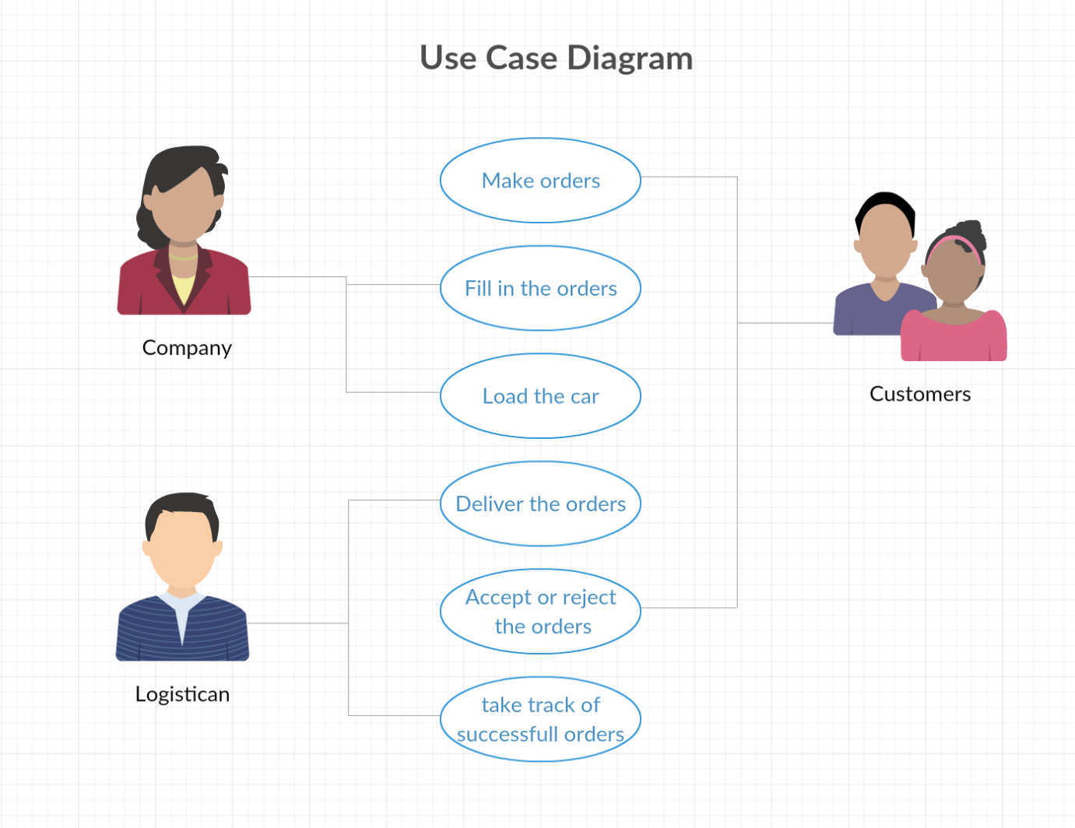

## Actor characteristics

Company:

The company that orders the program is taking the orders of the customers. They are making the loading lists and filling the trucks with the ordered goods.

Logisticians:

They are taking the delivery lists and drive the ordered goods to the customers place. They have to take track of the accepted and rejected deliveries.

Customers:

They order the goods from the company. They get the goods from the logistician and can accept or reject them when they are there.

# Specific requirements

## Functional requirements

## Non-functional requirements (external, performance, etc.)