Software Requirements Specification Document

Introduction into Software Engineering 2017
Computer Science
University of Bern

Albana Jaha, Dardana Jaha, Jan Eich, Renda Badar

Table of Contents

1. Introduction 3
1.1 Purpose 3
1.2 Stakeholders 3
1.3 Definitions 3
1.4 System Overview 3
1.5 References 3
2. Overall description 4
2.1 Use case diagram 4
2.2 Use cases 4
2.2.1 Register as logistician 4
2.2.2 Register as driver 5
2.2.3 Login as logistician 6
2.2.4 Login as driver 7
2.2.5 Add a trip 7
2.2.6 Edit a trip 8
2.2.7 Remove a trip 9
2.2.8 View a list of trips as logistician 10
2.2.9 View a list of trips as driver 11
2.2.10 View a trip as logistician 11
2.2.11 View a trip as driver 12
2.2.12 Confirm a trip 12
2.2.13 Log out 13
3. Specific requirements 14
3.1 Functional requirements 14
3.2 Non-functional requirements 14

1. Introduction

  - Purpose
The aim of the software is to provide a practical and easy to use platform for handling customer orders and making them accessible to the employees.
This Software Requirements Specification document for the animal transport project is relevant to us, the development team, and our customer Anitrans to create a common understanding of what requirements the system should meet in the end.

  - Stakeholders
The company Anitrans

  - Definitions
- Logistician – Handles customer orders and assigns them to drivers
- Truck driver – Delivers the orders according to the logisticians instructions
- Trip – Consists of one delivery
- Editing state – Not all of the optional fields of a trip are filled out.
- Assigned state – The driver is assigned to a trip, but the time and date aren’t necessarily given. The trip can’t be deleted anymore in this state.
- Active state – All fields are filled out and the start time is exceeded. The trip can’t be modified nor deleted.
- Expired state – Time is expired, but there was no driver assigned to the trip. So a new date has to be selected and a driver chosen.
- Successful state – When the trip is finished successfully.
- Unsuccessful state – When the trip isn’t finished successfully.

  - System Overview
The purpose of the system is to create a platform where the logistician can place customer orders, process them and make the orders public for the employees. The driver should then be able to access that information and comment on the success of the trip.

  - References

2. Overall description

2.1 Use case diagram
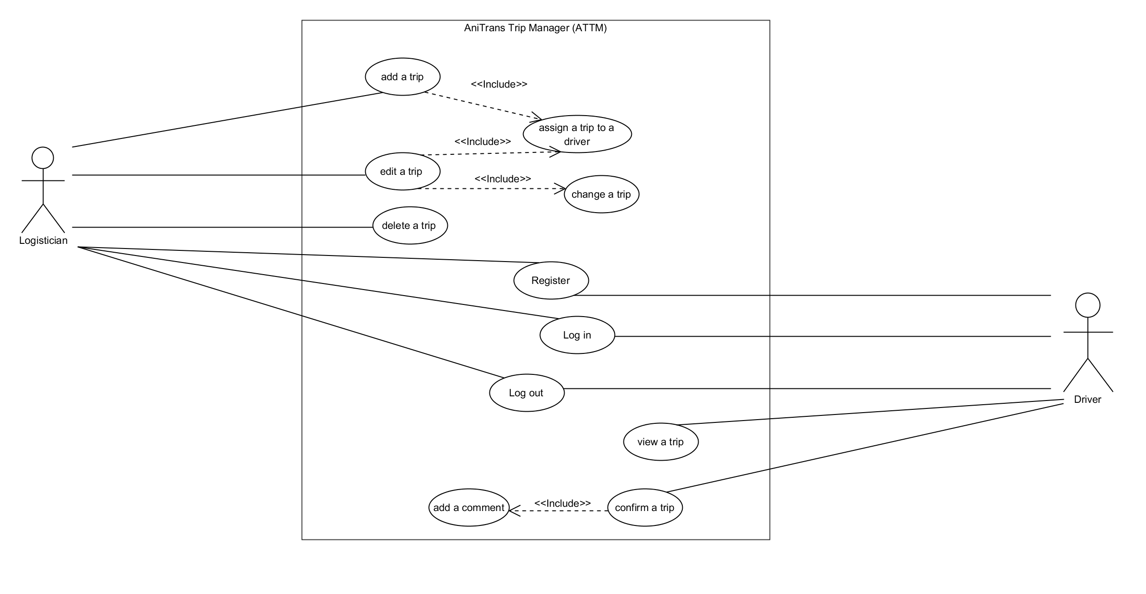

2.2 Use cases

2.2.1 Register as logistician
Actors
The logistician

Description
The logistician wants to register.

Trigger
The logistician clicks on the “Register” button.

Precondition
- The logistician can’t have an existing account
- He must have a valid company code for a logistician.

Postcondition
- The logistician has an account.
- He has access privileges such as adding, editing and deleting a trip.

Main scenario
1. The logistician clicks on the “Register” button. He is then being redirected to the register page.
2. He has to fill out the register data such as:
- Name
- E-mail address
- Valid company code for a logistician
- Choose if he wants to register as a logistician or a driver and select “Logistician”.
- A password and then confirm it.
3. He clicks on the “submit” button.
4. The system checks if the form was filled out with valid data.
5.The logistician has a valid account now.

Alternative scenario
1. The form isn’t filled out correctly (invalid input or blank fields).
- Next to the invalid fields is a description of valid inputs and he’s asked to go over the invalid fields again.
- Return to step 2 from the main scenario.
2. The form is filled out with data from an existing account.
- A window pops up warning the driver that the account already exists and is asked to return to step 2 from the main scenario.

2.2.2 Register as driver
Actors
The logistician

Description
The driver wants to register.

Trigger
The driver clicks on the “Register” button.

Precondition
- The driver can’t have an existing account
- He must have a valid company code for a driver.

Postcondition
- The driver has now an account where he can see his trips.

Main scenario
1. The driver clicks on the “Register” button. He is then being redirected to the register page.
2. He has to fill out the register data such as:
- Name
- E-mail address
- Valid company code for a driver
- Choose if he wants to register as a logistician or a driver and select “Driver”.
- A password and then confirm it.
3. He clicks on the “submit” button.
4. The system checks if the form was filled out with valid data.
5.The driver has a valid account now.

Alternative scenario
1. The form isn’t filled out correctly (invalid input or blank fields).
- Next to the invalid fields is a description of valid inputs and he’s asked to go over the invalid fields again.
- Return to step 2 from the main scenario.
2. The form is filled out with data from an existing account.
- A window pops up warning the driver that the account already exists and is asked to return to step 2 from the main scenario.

2.2.3 Login as logistician
Actors
The logistician

Description
The logistician wants to log into his account.

Trigger
The logistician clicks on the “Logistician” button.

Precondition
- The logistician must be logged out from his account.
- He must have a valid account as a logistician.

Postcondition
- The logistician is now logged into his account.
- He now has access privileges such as adding, editing and deleting a trip.

Main scenario
1. The logistician clicks on the “Logistician” button. He is then being redirected to the log in page as a logistician.
2. He has to fill out the login data such as E-mail address and password.
3. He clicks on the “submit” button.
4. The system checks if the form was filled out with valid data.
5.The logistician is now logged in.

Alternative scenario
1. The form isn’t filled out correctly (invalid input or blank fields).
- The invalid fields are marked with a red star and the logistician is asked to go over the marked fields again.
- Return to step 2 from the main scenario.
2.2.4 Login as driver
Actors
The driver

Description
The driver wants to log into his account.

Trigger
The driver clicks on the “driver” button.

Precondition
- The driver must be logged out from his account.
- He must have a valid account as a driver.

Postcondition
- The driver is now logged into his account.
- He now has access to view his trips.

Main scenario
1. The driver clicks on the “driver” button. He is then being redirected to the log in page as a driver.
2. He has to fill out the login data such as E-mail address and password.
3. He clicks on the “submit” button.
4. The system checks if the form was filled out with valid data.
5.The driver is now logged in.

Alternative scenario
1. The form isn’t filled out correctly (invalid input or blank fields).
- The invalid fields are marked with a red star and the driver is asked to go over the marked fields again.
- Return to step 2 from the main scenario.

2.2.5 Add a trip
Actors
Logistician

Description
The logistician wants to add a new trip.

Trigger
The logistician uses the “add” button to add the new trip.

Precondition
- Logistician has to be logged into his account.

Postcondition
- A new trip is added and can be viewed.
- The logistician should be able to delete and edit the trip as long as the start time isn’t exceeded.
- As long as the optional fields are not filled out the trip is in edit mode.
- If all of the fields are filled out the trip is in process mode.

Main scenario
1. The logistician logs into his account.
2. The logistician clicks on “add a trip” button.
3. He fills out the form and provides the following details:
- Customer name
- Pickup point
- Destination
- Animals
- Date (optional)
- Start time (optional)
- Delivery time (optional)
- Driver (optional)
4. The logistician clicks on the “save” button.
5. The system checks if the form was filled out with valid data.
6. The logistician receives a confirmation that the trip was added and is redirected to the page where all of the trips are listed, including the newly added trip.

Alternative scenario
1. The form isn’t filled out correctly (invalid input or blank fields).
- Next to the invalid fields is a description of valid inputs and he’s asked to go over the invalid fields again.
- Return to step 3 from the main scenario.

2. The logistician clicks on the ”cancel” button.
- The logistician is asked by the system to confirm the cancellation of the process.
- He can then choose to either stay on the page or confirm the cancellation and be redirected to the page where all of the trips are listed.

2.2.6 Edit a trip
Actors
The logistician

Description
The logistician wants to edit a trip.

Trigger
The logistician uses the “edit” button to edit the trip.

Precondition
- Logistician has to be logged into his account.
- He must have already created the trip he wants to edit.
- Start time should not have been exceeded.

Postcondition
- At least one of the fields got modified.
- As long as the optional fields are not filled out the trip is in edit mode.
- If all of the fields are filled out the trip is in process mode.

Main scenario
1. The logistician logs into his account.
2. The logistician selects the trip he wants to edit.
3. The logistician clicks on the “edit” button.
4. He modifies\fills out at least one of the fields.
5. The logistician clicks on the “save” button.
6. The system checks if the form was filled out with valid data.
7. The logistician receives a confirmation that the trip was edited and is redirected to the page where the trips are listed, including the edited trip.

Alternative scenario
1. The form isn’t filled out correctly (invalid input or blank fields).
- Next to the invalid fields is a description of valid inputs and he’s asked to go over the invalid fields again.
- Return to step 4 from the main scenario.

2. The logistician selects a trip where the start time is exceeded.
- He wants to click on the “edit” button but this doesn’t work.

3. The logistician clicks on the ”cancel” button.
- The logistician is asked by the system to confirm the cancellation of the process.
- He can then choose to either stay on the page or confirm the cancellation and be redirected to the page where all of the trips are listed.

2.2.7 Remove a trip
Actors
The logistician

Description
The logistician wants to delete a trip.

Trigger
The logistician uses the “delete” button to delete the trip.

Precondition
- Logistician has to be logged into his account.
- He must have already created the trip he wants to delete.
- Start time should not have been exceeded.
- No driver is assigned to the trip.

Postcondition
- The trip is removed from the system.

Main scenario
1. The logistician logs into his account.
2. The logistician selects the trip he wants to delete.
3. The logistician clicks on the “delete” button.
4. He is asked to confirm this process.
5. The trip is removed from the system.

Alternative scenario
1. The logistician selects the trip he wants to delete which is already assigned to a driver.
He gets a warning from the system that this process can’t be executed.

2.2.8 View a list of trips as logistician
Actors
The logistician

Description
The logistician wants to view the trips.

Trigger
The logistician logs into his account to view the trips.

Precondition
- The logistician must be logged into his account.

Postcondition
None

Main scenario
1. The logistician logs into his account to view the trips.
2. He can choose one or more of the following modes which then will be shown:
- Editing state
- Assigned state
- Active state
- Expired state
- Successful state
- Unsuccessful state

Alternative scenario
None
2.2.9 View a list of trips as driver
Actors
The driver

Description
The driver wants to view his trips.

Trigger
The driver logs into his account to view his trips.

Precondition
The driver must be logged into his account.

Postcondition
None

Main scenario
1. The driver logs into his account to view his trips.
2. He can choose one or more of the following modes which then will be shown:
- Assigned state
- Active state
- Successful state
- Unsuccessful state

Alternative scenario
None

2.2.10 View a trip as logistician
Actors
The logistician

Description
The logistician wants to view a detailed description of a trip.

Trigger
The logistician clicks the “view” button to see a trip.

Precondition
The logistician must be logged into his account.

Postcondition
None

Main scenario
1. The logistician logs into his account.
2. He selects a trip he wants to view.
3. He then clicks on the button “view”.
4. The logistician will be redirected to the page with a detailed description of the selected trip.
5. He then clicks on the “back” button to return to the page with the overview of the trips.

Alternative scenario
None

2.2.11 View a trip as driver
Actors
The driver

Description
The driver wants to view a detailed description of one of his trips.

Trigger
The driver clicks the “view” button to see a trip.

Precondition
The driver must be logged into his account.

Postcondition
None

Main scenario
1. The driver logs into his account.
2. He selects a trip he wants to view.
3. He then clicks on the button “view”.
4. The driver will be redirected to the page with a detailed description of the selected trip.
5. He then clicks on the “back” button to return to the page with the overview of the trips.

Alternative scenario
None

2.2.12 Confirm a trip
Actors
The driver

Description
The driver wants to confirm his trip.

Trigger
The driver clicks on the active trip and edits the confirmation of the trip.

Precondition
- The driver must be logged into his account.
- The trip must have been started.

Postcondition
- The state of the trip will be changed to either successful or unsuccessful.

Main scenario
- The driver logs into his account.
- He then chooses the finished active trip.
- He clicks on the “confirm” button, which leads to a small window showing up where he can select whether the trip was successful or unsuccessful and comment on it.
- After choosing the state of the trip, he then can confirm it and is being redirected to the page with an overview of the trips.

Alternative scenario
None

2.2.13 Log out
Actors
The logistician and the driver.

Description
The logistician/driver wants to log out from his account.

Trigger
The logistician/driver clicks on the “log out” button.

Precondition
- The logistician/driver is logged into his account.

Postcondition
- The logistician/driver is logged out from his account.

Main scenario
1. The logistician/driver clicks on the “log out” button.
2. He gets a confirmation of his successful log out.

Alternative scenario
None

3. Specific requirements

3.1 Functional requirements
- Logistician has a login.
- Driver has a login.
- A trip cannot be deleted if a driver is assigned to a trip.
- An active trip cannot be clicked on/edited.
- Logistician can place a new trip, modify it, assign a driver to it and be able to delete it.
- Driver can see his assignments and can give feedback.
- Logistician should be able to see feedback and modify order as necessary.
- Not all data should be visible to drivers.

3.2 Non-functional requirements
- Desktop and mobile version
- System should be usable all over Switzerland

