Event mangement platform
ESE-2019
Janis Kunz
Jérémie de Faveri
Maksim Fomin
Michael Dooley

Content
Introduction 2
Purpose: 2
Definitions 2
Use cases. 3
Case 1: Visitor 3
Case 2: User contact the provider of an Offer 3
Case 3: User creates an Offer 3
GUI and Navigation 4
GUI 4
Navigation 4
Functional and non-functional requirements 5
Functional 5
User requirements: 5
Visitor requirements: 5
Admin requirements: 5
Policy requirements 5
Non-functional 5
Security: 5
Privacy: 5
Platforms: 5
User friendly: 5

Introduction

Purpose:
On this platform several types of service providers such as Venue owners, Entertainers, Caterers can register their services. Other registered users, in turn, can search for desired services required for their event, and receive the contact Information.
This Software Requirements Specification document serves as a guideline for the project and gives an overview of the functionalities of the software.

Definitions
Visitor: Unregistered guest on the platform can search and browse offers.
User: Register User on the platform. Can create Offers and read contact info of Offers from other users has an Email and a password and possibly a phone number.
Admin: Is a user with additional rights, decides which offers are published.
Offer: Service which is offered by users consist of:
Title
Description
Price
Date from
Date to
Category

Use cases.

Case 1: Visitor
Bob is planning to throw a birthday party for his brother. He needs an Italian caterer.
He visits the platform and searches for Italian in the catering category.

Case 2: User contact the provider of an Offer
Bob found a great offer.
To see the contact information, he registers on the platform and afterward he writes an E-mail from his personal mail account to the Italian cook.

Case 3: User creates an Offer
Alice a gifted violinist, wants to offer an evening of musical experience.
She logs into her Account at the Platform and creates the offer.

GUI and Navigation

GUI
A simple easy to understand GUI.
The different actors (visitor, user, admin) only see what they can use. E.g. no buttons or navigations should lead to pages they aren’t allowed to visit.

Navigation
Every Page is reachable trough the navigation bar.
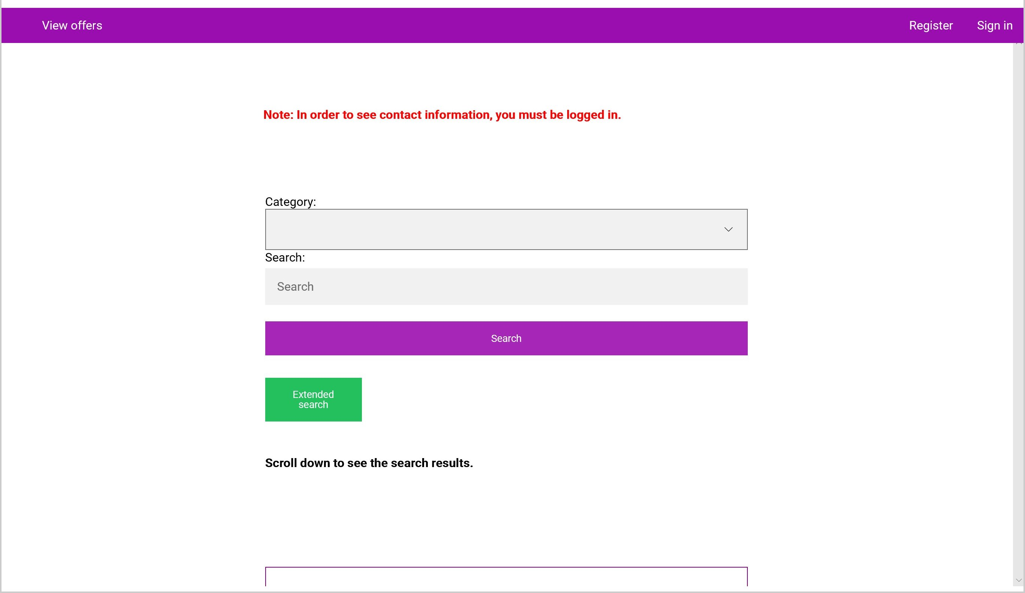
Figure 1 Main Page Visitor
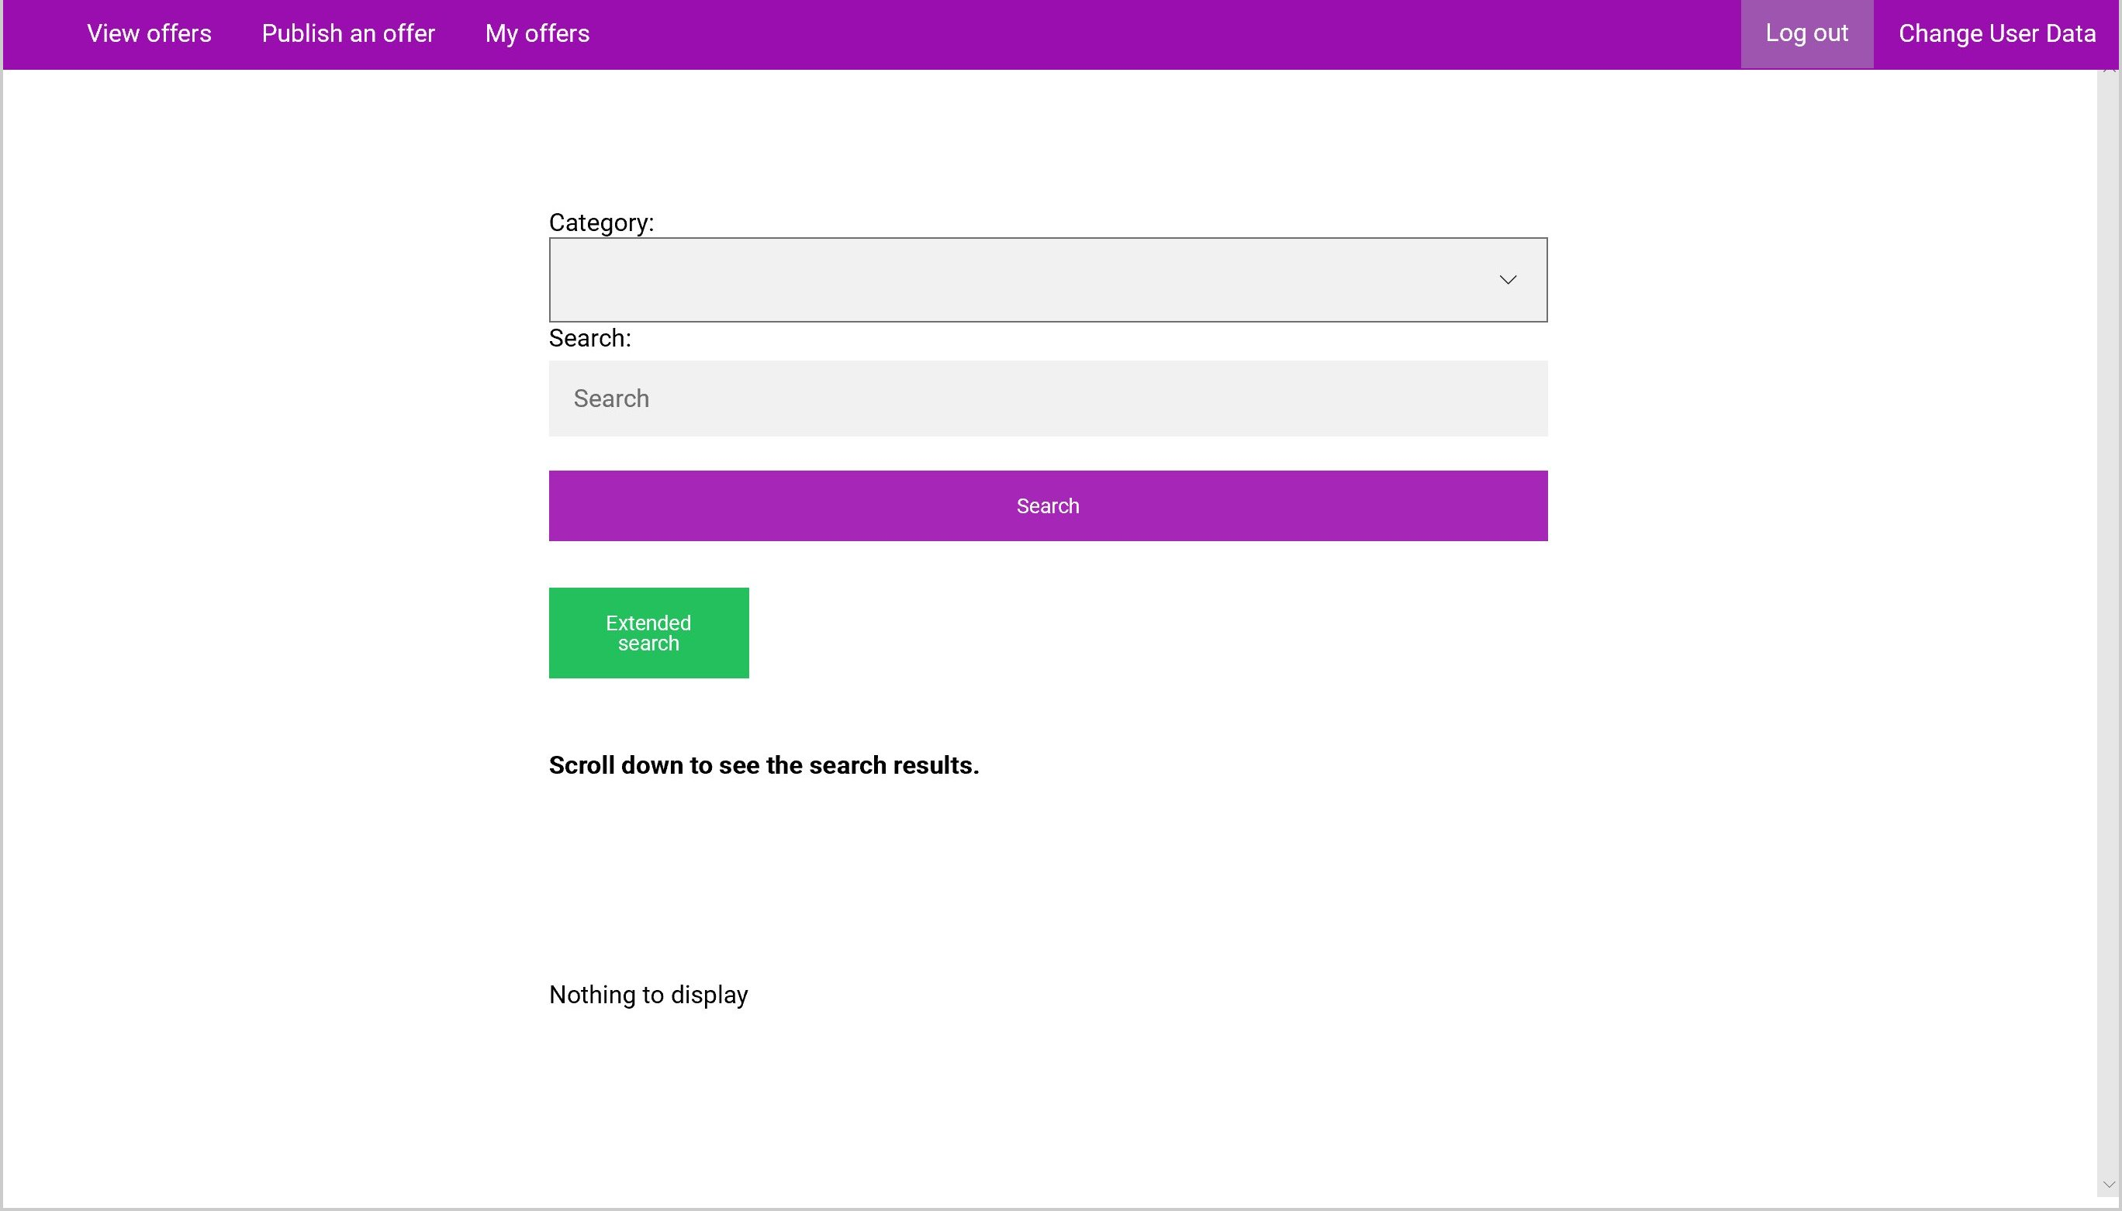
Figure 2 Main Page User
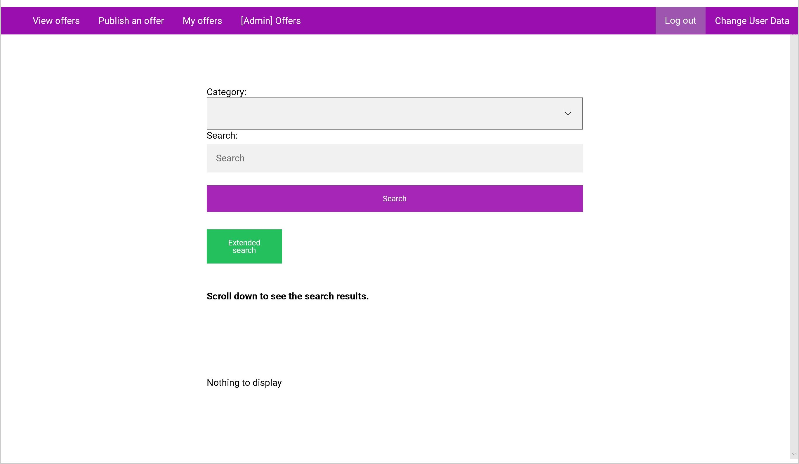
Figure 3 Main Page Admin

Functional and non-functional requirements

Functional

User requirements:
- Every user can delete his Account.
- Every user can log-in and log-out of the system.
- Every user has a name, password and E-mail.
- Every user can add, modify and delete his offers.
- Every user can add and modify information about himself.
- Every user can change his password.

Visitor requirements:
- Every visitor can register.
- Every visitor can search and browse Offers without registration.

Admin requirements:
- The admin can do everything a user can.
- The admin can approve and deny pending offers.
- The admin can delete any offer.

Policy requirements
- Each offer is approved by the admin before its publicly displayed.

Non-functional

Security:
- User data is saved in the database confidently.
- Admin rights are not saved in the user table.
Privacy:
- User data is not available for visitors.

Platforms:
- The system works on common browsers.
- The system works on mobile platforms.

User friendly:
- No Manual is needed.

