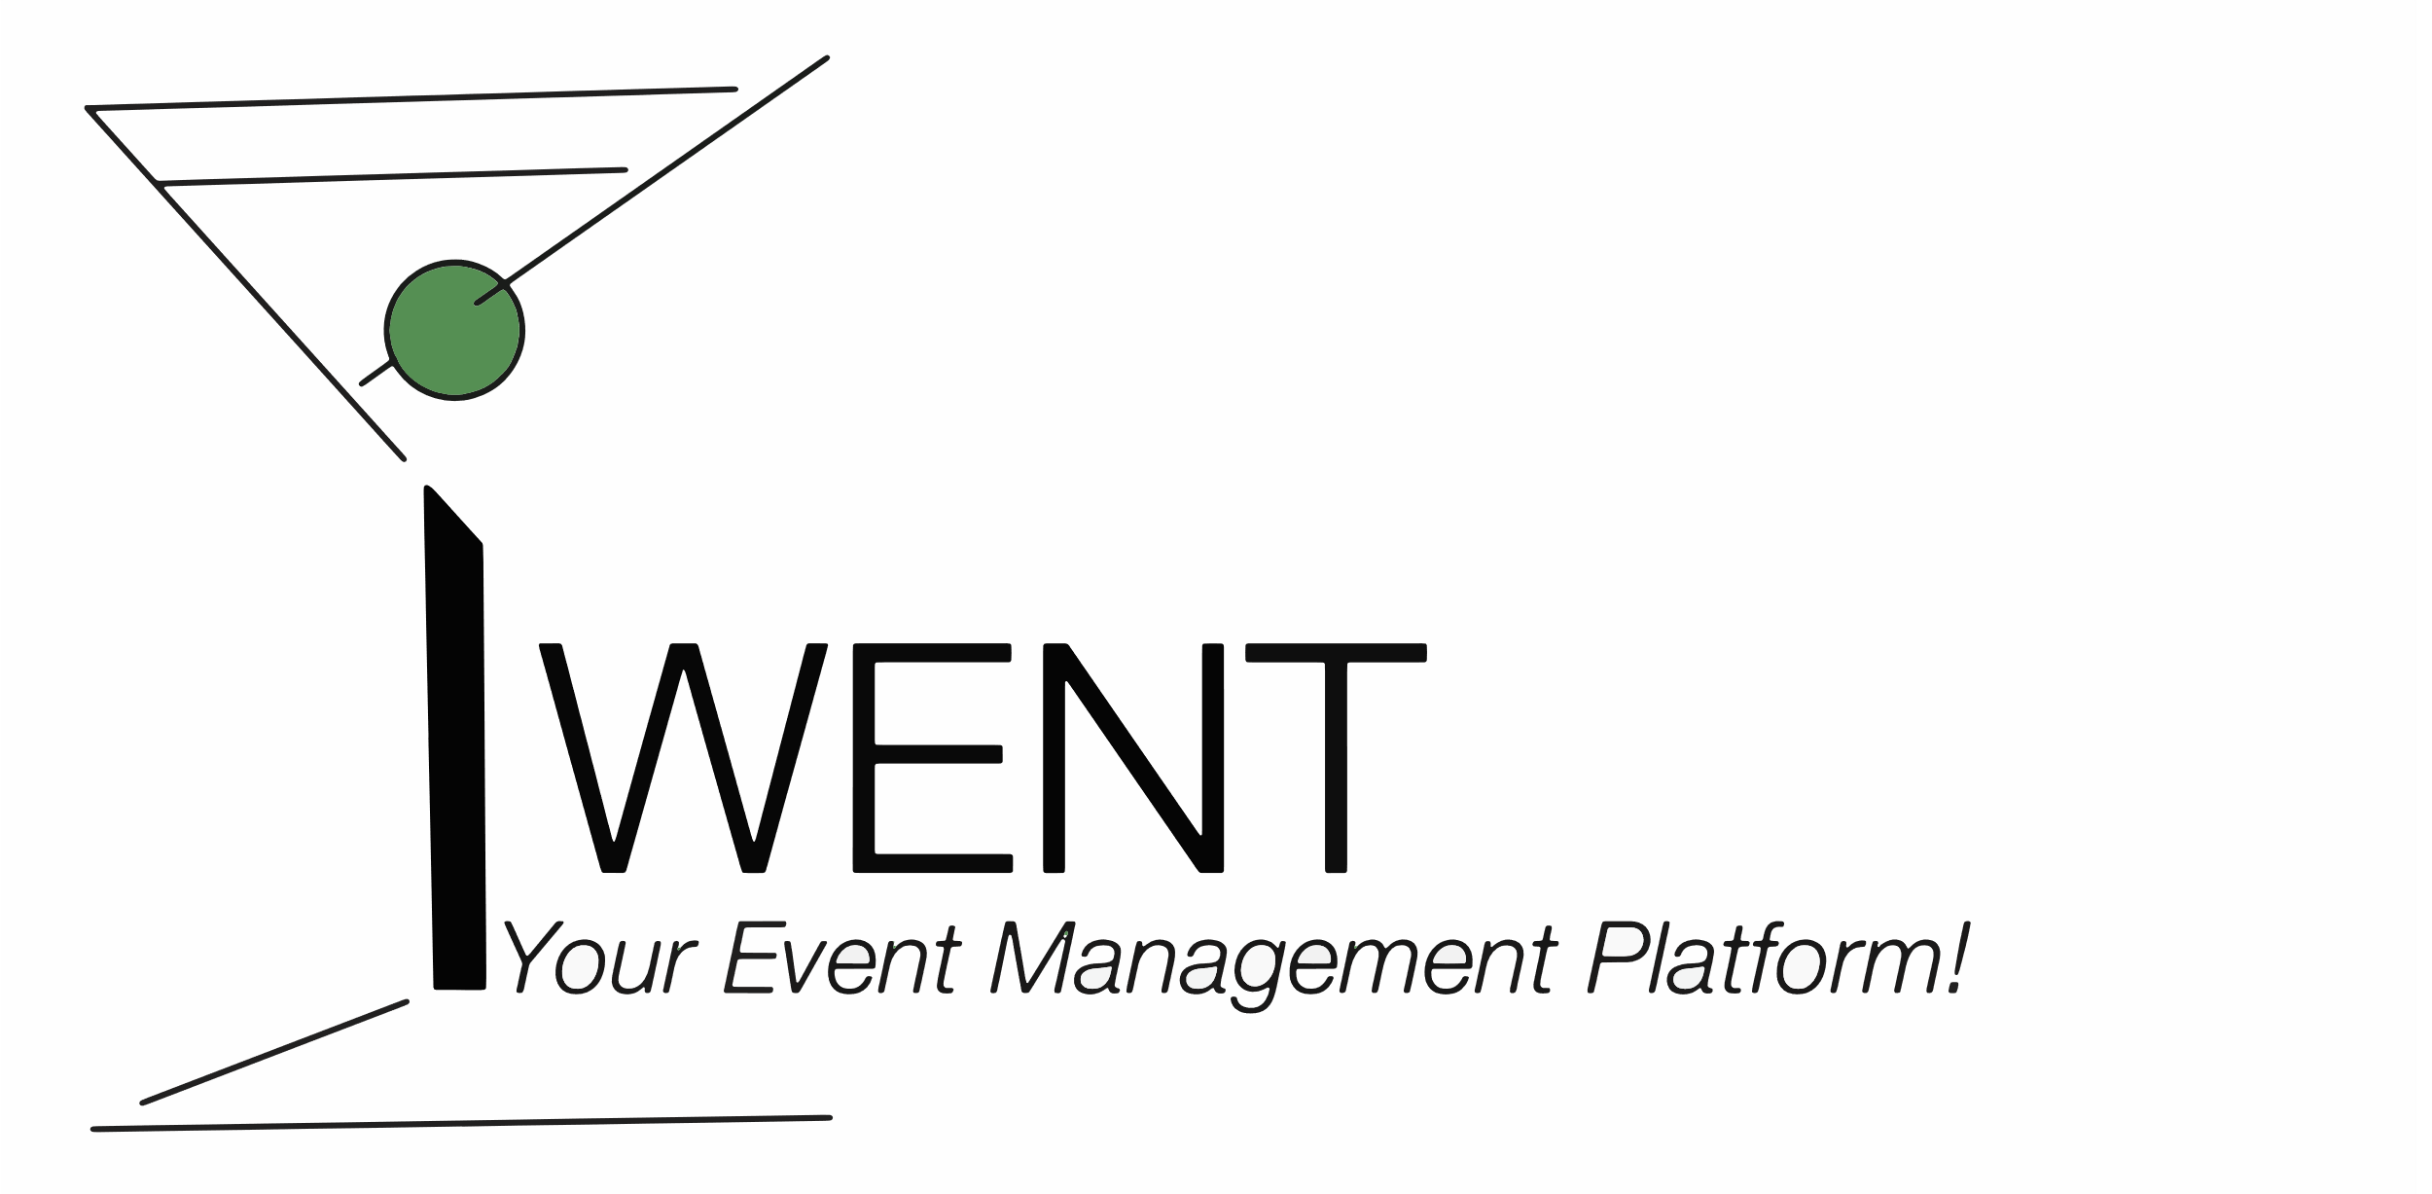iWent

Your Event Management Platform

Admin Manual

Table of Contents

Introduction 3

Admin User Panel 3

Approve/disapprove user 3

Delete User 3

Version 2019-12-05

This document was created for the lecture Introduction to Software Engineering, HS 2019, University of Berne.

Team 8:  
Nina Baumgartner  
Jonas Ph. Kocher  
Lukas Schacher

# Introduction

This is the admin manual for iWent – Your Event Management Platform.

This manual is intended for system administrators and platform managers. This user group is called "admins" for short.

Admins have at least the same right as all normal users. For general operating instructions, see the user manual.

# Admin User Panel

To access the admin user panel, click "Admin User Panel" on the "home" page.

There you see a list of all registered users.

You see the username, email address and zip of a user. Warum sieht man Postadresse und Stadt nicht?

You see if the user is approved and if the user is a service provider.

Bild

Approve/disapprove user

You can approve and disapprove users, respectively.

To approved a not approved user, click the button "approve user".

To disapprove an approved user, click the button "disapprove user".

Bild

Delete User

To delete a user, click the button "Delete User".

You will be asked again, if you really want to delete the user. If you click "Delete [username]", this user will be deleted completely.

If the user a service provider, all his services will be deleted as well.

Attention: The deletion can't be undone!

Bild