iWent

Your Event Management Platform

User Manual

Table of Contents

Introduction 3

Registration 3

Login 4

Profile page 4

Edit profile 4

Change password 5

Delete profile 5

Finding a service 6

Search a service 6

Make me a random party 6

Need inspiration? 7

Featured services 7

Book a service 7

Service providers 8

Approval 8

Add a new service 8

Modify/delete a service 9

Version 2019-12-10

This document was created for the lecture Introduction to Software Engineering, HS 2019, University of Berne.

Team 8:  
Nina Baumgartner  
Jonas Ph. Kocher  
Lukas Schacher

# Introduction

This is the user manual for iWent – Your Event Management Platform.

This manual is intended for all users: service providers and normal users.

Parts which are exclusively addressed to service providers are marked accordingly.

# Registration

All users have to register before they can use the platform.

Click the button "Register a new profile" on the start/login page.

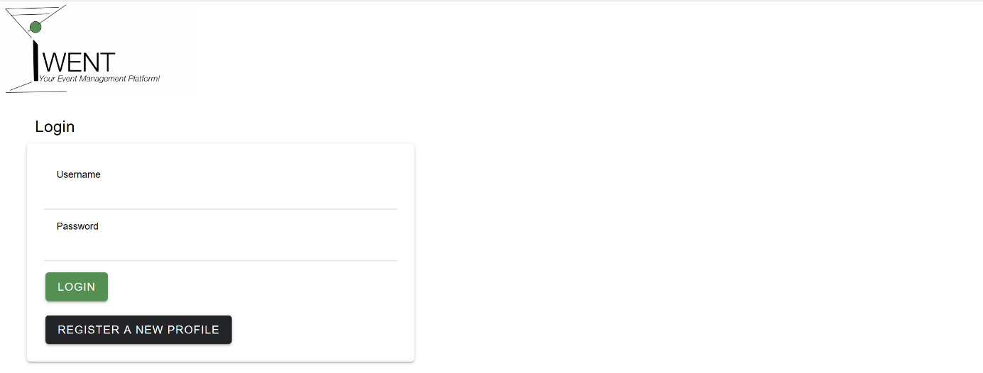

You're required to choose a username, a password, and to enter your email address.

* The username has to be unique. You are informed, if the username is already taken.   
  Attention: You are not allowed to change your username afterwards, and the other users can see your username. Choose wisely!
* The password has to be at least 5 characters long and must contain at least one upper case letter, one lower case letter and one number. You must enter your password twice to confirm it.

Optionally, you can enter your postal address and phone number.

If you are a service provider, check the box "Register as service provider".

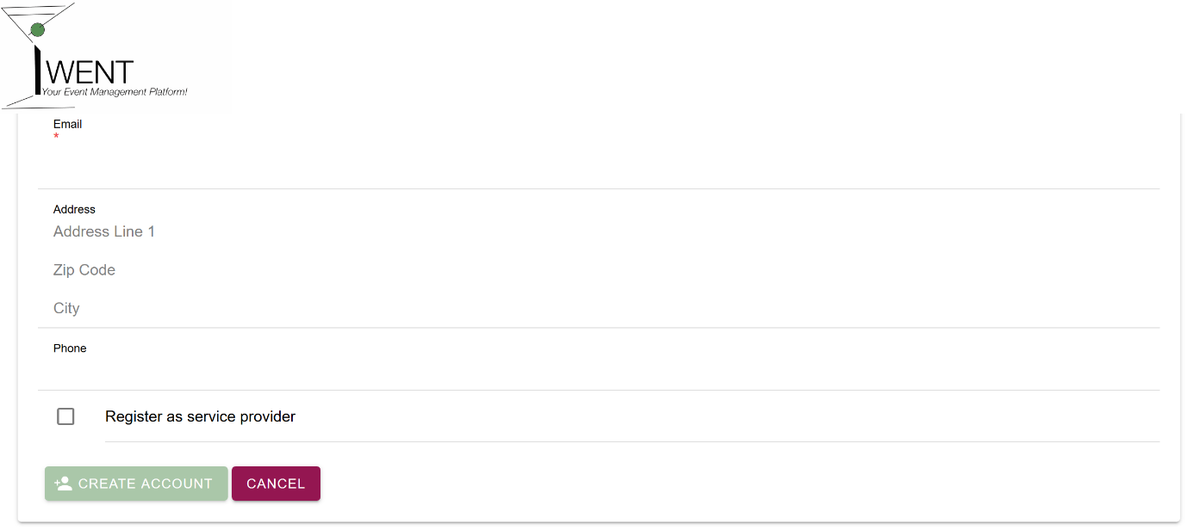

# Login

If you are a registered user, you can log in with your username and password on the start/login page.



If you are not registered 🡪 see "Registration".

# Profile page

You can reach your profile page by clicking the "person" icon in the upper right corner.

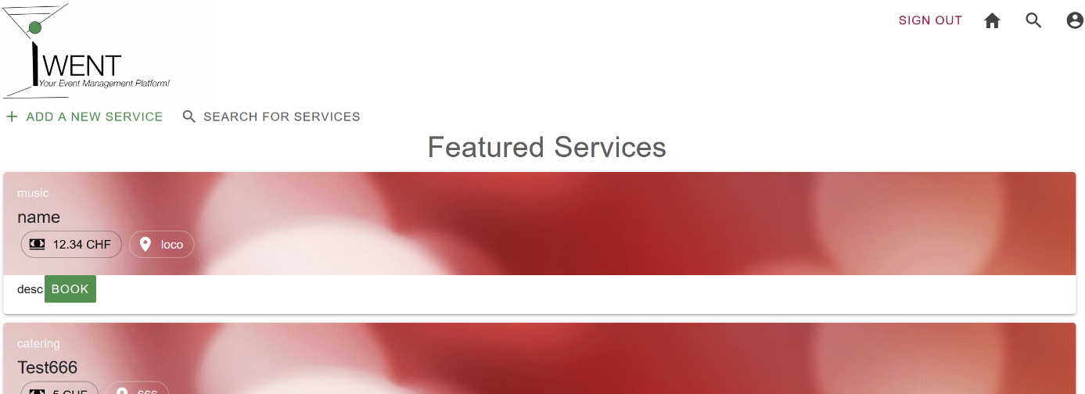

Edit profile

Here, you can **edit your profile** by change your email address, postal address and phone number. Confirm your changes by clicking the button "save".

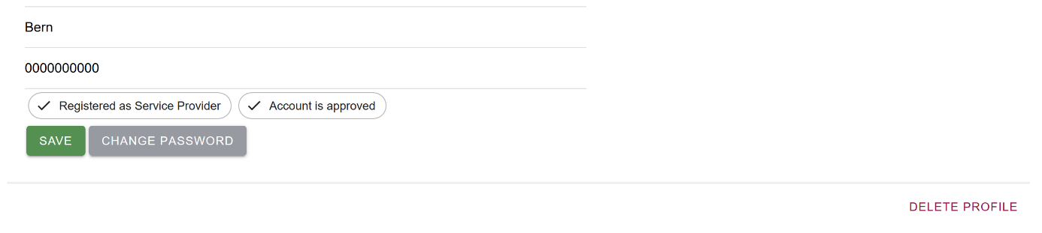

Change password

To **change your password**, click the button "change password".



Here you can enter your new password.

* The password has to be at least 5 characters long and must contain at least one upper case letter, one lower case letter and one number. You must enter your password twice to confirm it.

Click the button "save password" to save your new password.

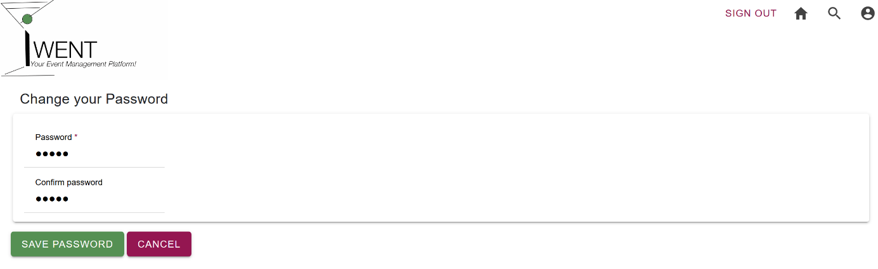

Delete profile

To **delete your profile**, click "Delete Profile".



You will be asked again, if you really want to delete your profile. If you click "Delete my Profile", your profile will be deleted completely.

If you’re a service provider, all your services will be deleted as well.

Attention: The deletion can't be undone!

# Finding a service

If you are looking for a service, click the "magnifying glass" icon in the upper right corner or click on "search for services" on the "home" page.



Search a service

You can enter any **search** string in the "What do you need?" text field and click the button "Search". You're shown all services on the platform which contain the search string anywhere (in the service name, the description or else). The search is not case-sensitive. If your search string is empty, you're shown all available services.

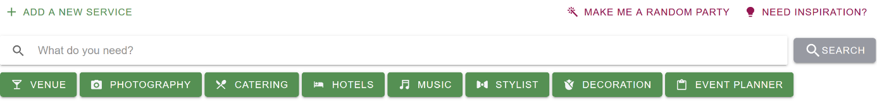

If you want to look at all services within one category, you can click the according button.



Make me a random party

You want to have a party but aren't sure, what you're looking for?

No problem! As a special feature, you can click the button "**Make me a random party**".



Our special algorithm will assemble a combination of different services, to suggest a possible party. Feel free to switch one or all the suggested services for your party.

Need inspiration?

You are missing the crucial twist to the perfect party?

Click the button "**Need inspiration**" and let you surprise by a random service.



Featured services

If you are looking for the best services, go to the "home" page by clicking the "house" icon in the upper right corner.



The "**featured services**" contain special services selected by our platform managers. These services come from our most loyal and best service providers on the platform and are particularly recommended to you.

Book a service

If you want to **book a service** you like, click the button "book". A message book will open and show the email address of the service provider. You can copy the email address by clicking "Copy email to clipboard".

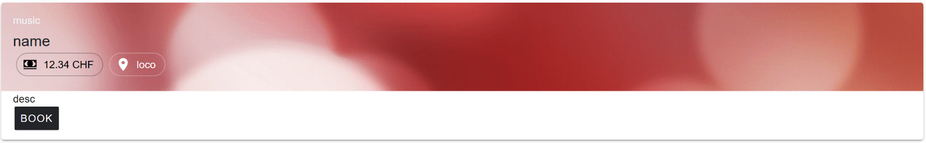

# Service providers

This section is only relevant for service providers.

Approval

All new registered service providers have to be **approved** by one of our platform managers.

You do not need to take action to be approved. As soon as you're approved, you can add services to the platform.

You see it on your profile page if your approved or disapproved.



Add a new service

To **add a new service**, you must be registered as service provider and approved by one of our platform managers.

Go to the "home" page by clicking the "house" icon in the upper right corner. There, click "+ Add a new service".



To add a new service, you must enter a service name containing at least two characters.

You can add a category, price, location and description, so your service will be found by the other users.

Click the button "Add your service". Your service is now on the platform and can be seen by the other users.

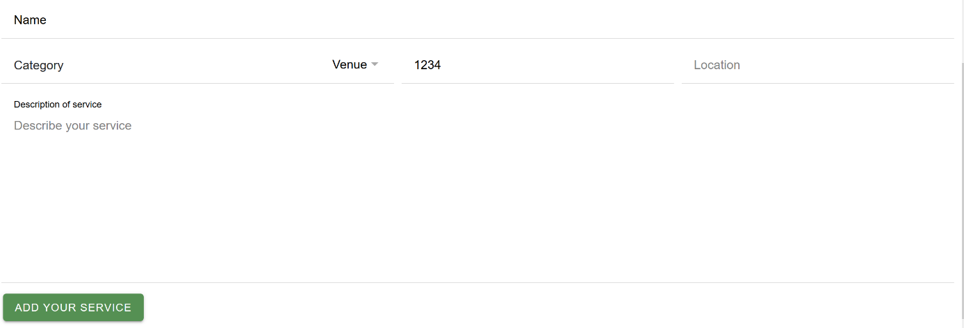

Modify/delete a service

To **modify or delete a service** you added to the platform, go to your 🡪 profile page by clicking the "person" icon in the upper right corner.

Click "Show my services" to show the services you added to the platform.

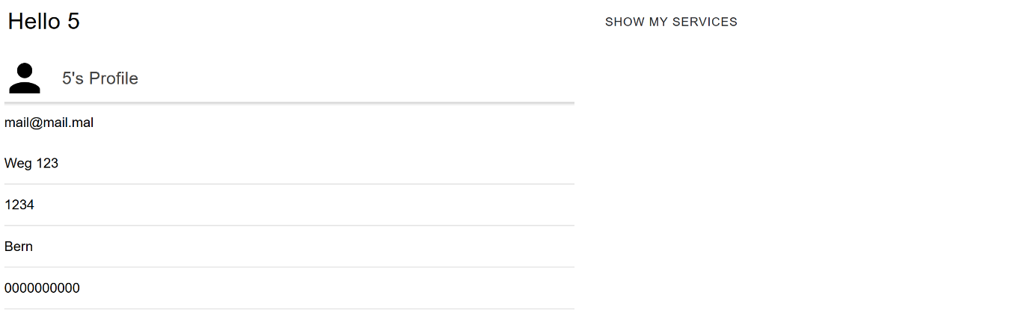

Then click "more", to modify or delete them.

To **modify a service**, click "Modify service". Here you can change the service name, category, price, location and description. The service name must contain at least two characters.

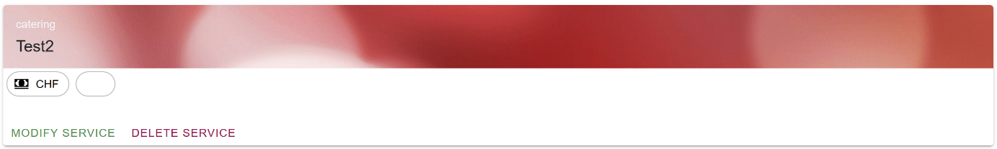

Click "Save your changes" to confirm your entries.

To **delete a service**, click "Delete service" below the service you want to delete.



You will be asked again, if you really want to delete the service. If you click "Delete [serviceName]", the service will be deleted.

Attention: The deletion can't be undone!