**Use Cases:**

***Actor: User:***

**Use Case S1:** Creates an Account

Summary: A User visits the website and creates a new Account.

Actors: User, Website, Data Base

Precondition: The user does not have an Account already.

Basic Flow: 1. The user visits the Website

2. He goes to the Registration tab

3. He types in his information’s and his desired password

4. His account is successfully created and saved in the DB of the website

Alternate Flow S1.1:

1. The user visits the Website
   1. The website doesn’t respond

1.2.a He checks his internet connection

1.2.b He waits a couple minutes (because of fault of the website)

1.3. He retries

(1.3.1 Nothing works -> Bad end)

2-4. (From Basic Flow)

Alternate Flow S1.2:

1.-3. (From Basic Flow)

3.1 His username is already in use

3.2 He types in a different one

4. His account is successfully created and saved in the DB of the website

**Use Case S2:** Logging in to Account

Summary: A user visits the website and logs in to his Account.

Actors: User, Website; Data Base

Precondition: The User does have an Account.

Basic Flow: 1. The user visits the Website

2. He goes to the logging section.

3. He types in his information’s and his password

4. His password corresponds to the one saved in the DB

5. He is logged in.

Alternate Flow S2.1:

1. Seller visits the Website
   1. The website doesn’t respond

1.2.a He checks his internet connection

1.2.b He waits a couple minutes (because of fault of the website)

1.3. He retries

(1.3.1 Nothing works -> Bad end)

2-5. (From Basic Flow)

Alternate Flow S2.2:

1.-3. (From Basic Flow)

3.1 His password does not correspond to one saved in the DB

3.1.a Types it again

3.1.b Choses the option: Password Forgotten

3.1.b.1 Receives an email with a link to reset his password

3.1.b.2 The new password is now stored in the DB.

4.-5. (From Basic Flow)

**Use Case S3:** Places an item for sale

Summary: A user puts an item for sale with its information and price

Actors: User, Website, Data Base

Precondition: The user is logged in

Basic Flow: 1 Goes to sell/buy tab

1. Chooses to sell something and types in the Information, price and places the item on sale
2. The item is now in the list for sale, which is stored in the DB

**Use case S4:** Remove an item from sale

Summary: A user wants to remove an item which is on sale

Actors: User, Website, Data Base

Precondition: The seller is logged in, the item is in the selling list and it is his item

Basic Flow:

1. Goes to his list of selling goods
2. Chooses the item he wishes to remove
3. The item is now removed from the Website and DB

**Use Case S5:** Changes an item which is on sale

Summary: A user wants to change an item for sale

Actors: Seller, Website, Data Base

Precondition: The seller is logged in, the item is in the selling list and it is his item

Basic Flow:

1. Goes to his list of selling item
2. Chooses the item he wishes to change
3. Types in new information’s or/and price
4. The item is updated on the Website and DB

Alternate Flow S5.1:

1. Goes to his list of selling item
2. Chooses the item he wishes to change
3. Types in new information’s or/and price
   1. The Website does not correspond anymore
   2. Waits a couple minutes and retries
4. The item is updated on the Website and DB

**Use Case S6:** Searches through a sales list

Summary: A user wants to check what is already on sale

Actors: User, Website, Data Base

Precondition: there is at least one item being sold

Basic Flow:

1. The seller visits the website
2. He goes to the selling items tab
3. He sees a list of available items to buy

**Use Case S7**: User buys a good which is on sale

Summary: A user visits the website and buys an item on sale.

Actors: User, Website; Data Base

Precondition: The user is logged in, there is at least one item on sale

Basic Flow: 1. User visits the Website

2. He goes to list of selling items.

3. He choses an item of his desire and buys it

4. Transaction gets executed

5. Item is now not anymore on sale

6. The bought item is now on the bought list of the buyer

(7. evtl. Shipping gets prepared?)

**Use Case S8**: User looks trough his buy history

Summary: A user wants to check his buy history

Actors: User, Website, Data Base

Precondition: The user is logged in, the user has bought at least one item

Basic Flow:

1. The user visits the website, and logs in.
2. He goes to his buy history items tab
3. He sees a list of items he bought

**Use Case A1**: Admin removes an item on the selling list

Summary: An admin wants to remove an item from the selling list (because it breaks some regulation)

Actors: Admin, Website, Data Base

Precondition: The Admin(user) is logged in, has the Rank to be an admin, there is at least an item in the selling list

Basic Flow:

1. The Admin visits the website and goes to the selling list.
2. He goes to the item and removes it
3. The item is now removed from the selling list and the Data Base (and maybe the user of the item gets notified?)

**Use Case A2**: Admin upgrades a user account to an admin

Summary: An admin wants to give a user admin rights

Actors: Admin, User, Website, Data Base

Precondition: The Admin(user) is logged in, the user has an account and is not already an admin

Basic Flow:

1. The Admin goes to the special user tab
2. Types in the username in the filter
3. Clicks on the user and gives him admin rights

Diagram:

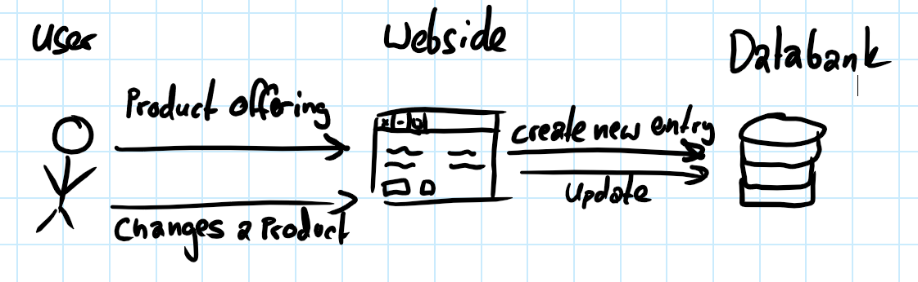

**User Stories:**

1. As a User, I want to sell my goods, so I can easily make profit.
2. As a User, I want to have an overview of bought items (logging), so I can keep track and have control over what I spend money.
3. As a User, I want to have the freedom to change/or remove placed selling items, to adapt to the current market.
4. As a User, I want to be able to see all available items to buy, without being logged in, in order to decide whether I want to buy something and then create an account or go look somewhere else.
5. As a User, I want to have an overview over my current selling list, what has ben sold and how many profits I made, so I can check my balance.

Non-Functional User Stories:

1. As a User, I want the site to be available 99.999 percent of the time I try to access it, so that I do not get frustrated and find another site to use.
2. As a User, I want to be able to visit the website on all current devices such mobile, tablets, computer, so I am not bound to one device/place to do my selling/buying.
3. As a User, I want this website to be secure, in Order to protect me and my data from outside attackers.