|  |
| --- |
| C964 Capstone |
| Diagnostic Chest X-Ray Image Classification |
| A predictive Machine Learning model to classify X-Ray images by diagnosis. |

|  |
| --- |
| Stephen Gerkin  12-14-2020 |

Contents

Section A - Project Proposal/Recommendation 3

Problem Summary 3

Application Benefits 3

Application Description 3

Data Description 4

Objectives 4

Hypothesis 5

Methodology 5

Funding Requirements 6

Stakeholders Impact 6

Data Precautions 6

Developer Expertise 6

Section B - Business Requirements and Technical Summary 7

Problem Statement 7

Customer Summary 7

System Analysis 7

Data Analysis 9

Project Methodology 10

Requirements Analysis 10

Systems Design 10

Coding and Implementation 10

Systems Testing 11

Deployment to Cloud Environment 11

Maintenance 11

Project Deliverables 11

Implementation Plan 12

Evaluation Plan 13

Resources and Costs 13

Programming Environment 13

Environment Costs 13

Human Resource Requirements 14

Timeline and Milestones 14

Section C - Application Design and Development 15

Data Methodologies 15

Descriptive (KMeans Clustering) 15

Predictive (Neural Net) 17

Datasets Discussion 18

Analytics and Decision Making 19

Data Cleaning 19

Data Visualization 20

Real-Time Query 25

Adaptive Element 26

Outcome Accuracy 26

Security Measures 27

Product Health Monitoring 27

Dashboard 27

Section D - Implementation Review Analysis 31

Project Purpose 31

Datasets 31

Hypothesis Verification 34

Visualizations and Reporting 37

Accuracy Analysis 38

KMeans Clustering Accuracy Analysis 38

Neural Net Accuracy Analysis 39

Accuracy Conclusion 41

Application Testing 41

Application Files 41

User’s Guide 42

Summation of Learning Experience 43

References 44

# Section A - Project Proposal/Recommendation

## Problem Summary

Arrow Medical Imaging is a medical imaging company that provides on-going or on-call as needed radiologic image readings for physicians and clinicians in various settings ranging from urgent care facilities to general practitioners and family medicine. Clinicians rely on fast and accurate diagnostic readings of a wide range of imaging techniques but chief among these are chest X-ray images. Chest X-ray imaging is inexpensive, fast, and has a low radiologic risk to patients and as such is often the first-line diagnostic tool for disease diagnosis and patient treatment planning.

As Arrow Medical Imaging expands, more and more facilities and practitioners are contracting the expertise of Arrow Medical Imaging’s expertise in providing results in a timely fashion. This influx of clientele has stretched the existing resources beyond their current capabilities. As such, Arrow Medical Imaging has expressed a desire to create a pilot program for automating the diagnostic process with chest X-ray imaging with machine learning models to assist the existing radiologist staff with improving the turn-around time for diagnostic results in this high volume service.

## Application Benefits

The proposed solution is to create a predictive model that can receive a chest X-ray image and determine the probabilities of specific diagnostic labels being applied to the image. With a sufficiently accurate model, an automated system can be created to provide immediate results rather than necessitating manual review that can take several minutes or hours. These results can then be forwarded to radiologists for confirmation of the findings and aid them in looking for specific diagnostic markers that indicate the specified findings. Additionally, this service can be provided to existing clients of Arrow Medical Imaging to provide immediate results in urgent care situations.

## Application Description

The application will be segmented into four distinct parts:

* A data pipeline that can receive new image batches and information to continually improve the existing model.
* A REST[1] API[2] endpoint for submitting images for classification and returning classification probabilities.
* A frontend dashboard for exploring the training data and results of training sessions.
* A web-based interface for interacting with the aforementioned API in a rate-limited fashion allowing prospective end-users to demo the prediction model.

## Data Description

The data[3] to be used for training and creating a model to assist radiologists and physicians in the diagnostic process has been collected by the National Institutes of Health data made public for data exploration and machine learning modeling. The data includes over 100,000 chest X-ray images collected from a little more than 30,000 unique individuals. Additionally, a comma-separated value file accompanies the data listing the diagnostic labels applied to each image as well as patient age and sex, view position, and image dimensions.

The finding labels consist of 15 different potential labels, 14 of which indicate a cause for follow-up and 1 label indicating none of the 14 labels could be applied to the individual image. Each X-ray can be assigned any combination of these labels (excluding “No Finding” which is always a unique label for an image). The diagnostic labels include:

* Atelectasis
* Cardiomegaly
* Consolidation
* Edema
* Effusion
* Emphysema
* Fibrosis
* Hernia
* Infiltration
* Mass
* Nodule
* Pleural Thickening
* Pneumonia
* Pneumothorax

Further discussion regarding these data can be found in the Data Analysis section.

## Objectives

Three broad objectives have been identified to designate this project as a success. The objectives are the following:

1. Create a predictive model with a minimum 90% accuracy rate on label classification for new chest X-ray images.
2. Deploy this model as a web application that can be utilized by Arrow Medical Imaging and contracted clients.
3. Provide prospective Arrow Medical Imaging clients with an informative dashboard that can discuss the model, model accuracy, and training process as promotional material for drawing in additional business.

## Hypothesis

Through the use of a KMeans Clustering model, Convolutional Neural Network, or a combination of both, a predictive model can be trained and generalized to provide an accurate diagnostic classification system per the objective listed above. This model will be able to be deployed as a standalone web service and receive new imaging data and return the predicted label classifications.

## Methodology

With the initial prototype development consisting of a single developer, the Sashimi Waterfall methodology will be used for the development process. Additionally, the requirements are well understood for this project making this development lifecycle a prime candidate for use during development. The overall development will be broken down into the following phases and executed in order, with feedback and fine-tuning of each stage as necessary:

1. **Requirements gathering and analysis.** The requirements have been well defined throughout this document and are unlikely to change during development.
2. **Data collection.** As discussed previously, data for training the application prediction model has been gathered and will be further analyzed during the lifecycle of the project.
3. **Data analysis.** The data will be analyzed for outliers, suitability for training, trimmed down to manageable batches, and explored for best results. This analysis is discussed further in the Data Analysis section below.
4. **Model creation, training, and evaluation.** A predictive machine learning model will be created, trained, and evaluated on a variety of metrics to determine suitability for deployment and use for generalizing to new data. This is an iterative process and will persist until either a suitable model is created or it is determined that a model cannot be created with the given data or constraints.
5. **Deployment.** The model will be deployed to a cloud service provider as a web service API for use in predicting and generalizing to testing data not presented during the training phase.
6. **Web Application Development.** The data collected during data analysis and model training will be collated and made presentable as a web application. This application will then be wired to the deployed predictive model for demonstration purposes.
7. **Maintenance.** At this time, the application will enter the maintenance phase of development. The predictive model will be fully modular and can be replaced by a new model that has been trained on new data points. Different versions of the model will be maintained and version-controlled to allow for gradual roll-outs to improvements to the overall system. At this time, the project will be handed over to the client.

## Funding Requirements

Total funding for project development and implementation is estimated at $9,920 with an ongoing, yearly maintenance cost of approximately $4,800 to $5,100 for maintaining the cloud server environment on which the component services will live. A full cost breakdown of these costs is provided in the Resources and Costs section.

## Stakeholders Impact

The stakeholders for this project include Arrow Medical Imaging and their clients. The predictive model created will enable Arrow Medical Imaging to provide greater efficiency in evaluating chest X-ray images for diagnostic classification and can potentially be offered as an additional service to its clients that require immediate diagnostic classification of chest X-rays but do not require the full usage of services from Arrow Medical Imaging radiology specialists.

## Data Precautions

The data used to train the prediction model complies with all HIPAA regulations and contains no protected health information (PHI) or personally identifiable information (PII). The data has been issued a CC0 1.0 Universal License[4] and dedicated to the public domain. Furthermore, any new data that is to be gathered and consumed by the resultant web service will consist only of chest X-ray images with no identification information and no images will be retained by the web service. Finally, TLS/SSL encryption protocols will be enacted to only allow communication with the web service via HTTPS protocols.

## Developer Expertise

The developer has 8 years of experience in software engineering, specializing in web applications and web service deployments. Additionally, the developer has 3 years of experience in architecting artificial intelligence systems and machine learning models for predictive analysis. Consultation with regards to radiologic expertise will be made available by Arrow Medical Imaging as needed for understanding the data during development.

# Section B - Business Requirements and Technical Summary

## Problem Statement

Chest X-ray imaging is a very common, quick, and effective technique for diagnosing a wide variety of diseases related to the lungs and heart. The machines used for these scans can be easily deployed to a variety of settings including hospitals, small clinics and offices, and even disaster areas. However, the requirement for these scans to be read and interpreted by highly trained physicians limits the efficiency with which these scans can be utilized. Applying a machine learning methodology to analyze and predict probable diagnostic findings in a chest X-ray can save countless time, money, and resources to providing actionable diagnostic intelligence to physicians and clinicians in a matter of seconds. While some models do exist for binary classifications, such as a finding of pneumonia vs. no finding of pneumonia, no all-encompassing methodology exists for a multi-label classification problem.

## Customer Summary

Arrow Medical Imaging is an industry leader in medical imaging and interpretation. The company continues to grow at a record pace and is continually expanding its reach of off-site imaging systems and contracted image interpretation. As a result of this growth, Arrow Medical Imaging must keep pace with current technologies to continually improve and advance the medical imaging industry. With this in mind, Arrow Medical Imaging has decided to move forward with a prototype of a multi-label classification system for chest X-ray imaging.

It is the hope that this prototype project will yield actionable information with regards to further expanding automated diagnostic classification within other imaging techniques, such as Computed Tomography (CT), Magnetic Resonance Imaging (MRI), and other high precision scanning techniques. Should a model prove effective on X-ray imaging, a technique that has a significantly lower image and diagnostic precision overall than these more expensive scans, it is believed that this can be used to catapult Arrow Medical Imaging to significant advances in automated diagnostic medicine.

## System Analysis

This project is considered a pilot program for Arrow Medical Imaging and currently no infrastructure exists to support the development or deployment of the predictive model as a web service. Fortunately, the systems requirements for deployment are uncomplicated and can be easily provisioned in the cloud. Amazon Web Services has been selected as the cloud provider for this project as they provide the greatest number of resources for future scaling of the business needs for Arrow Medical Imaging.

The deployed web service will exist as two applications on a single server: a REST endpoint for receiving images and converting them to data that can be used by the prediction model and the prediction model itself. The forward endpoint will be served as a Flask[5] RESTful service contained in a Docker image. This application will then communicate directly with the REST endpoint created by TensorFlow Serving[6] Docker container, receive the results, and then return them to the originating end-user. Both containers will be run in tandem using Docker Compose[7] on a single server.

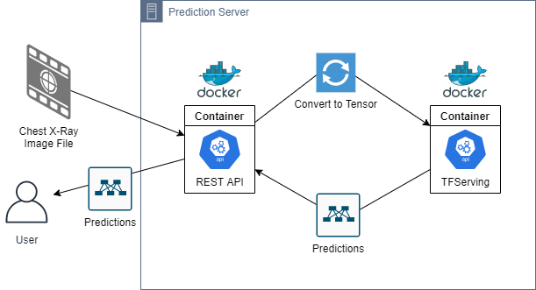

Prediction Server Diagram

The servers will be deployed in an auto-scaling group to maintain high availability of the application, with a network load balancer to direct traffic between the servers. Two instances will be online at all times with each living in a separate availability zone. During peak traffic, additional servers will be provisioned automatically to adjust for this increase in traffic. When traffic begins to taper out, these servers will be automatically terminated to save on costs.

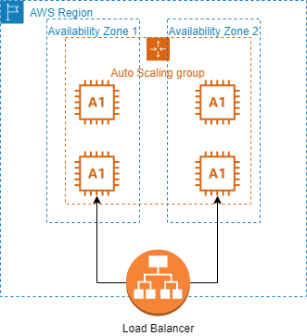

Systems Architecture Diagram

## Data Analysis

The data used for training the predictive model has been published for use on Kaggle.com and can be located at <https://www.kaggle.com/nih-chest-xrays/data>. It consists of 112,120 distinct chest X-ray images taken both posterior-to-anterior (PA) and anterior-to-posterior (AP). Accompanying the images are comma-separated value files containing image metadata, patient diagnostic findings, follow-up information, and non-identifying patient ID numbers.

This data will be analyzed for outliers, incomplete data, and otherwise unusable data. Any data that is determined to be unusable will be excluded from the overall process. Metadata will be reformatted and/or reshaped to provide ease of usability. Lastly, training a model on image data will require that images are converted to raw number values that can be fed into the model for training.

## Project Methodology

This project will use the Sashimi Waterfall methodology for project development. Requirements are well understood and discussed throughout this document in detail. These factors make this project a prime candidate for the Waterfall methodology of project development. However, as development continues to progress and constraints are identified, feedback may require revisiting previous stages of development. The adoption of the Sashimi variation of Waterfall is therefore prudent during the development of this project. Further discussion regarding the individual stages of development follow.

### Requirements Analysis

The full requirements of this document will be analyzed for accuracy and understanding prior to any development of the project. This document will be modified or appended as necessary during this stage of development.

### Systems Design

The full system will undergo a complete design of broad functionality and individual parts and their interactions will be identified. Some basic systems design has been undertaken to better understand the requirements and is illustrated in the Systems Analysis portion of this document. This model will undergo refinement during the following phase as necessary.

### Coding and Implementation

This phase of development will be broken down into three distinct pieces, each contingent on the previous. During this phase, each individual piece will be evaluated and tested independent of the full project. Unit testing will be conducted at a granular level of each component.

#### Data Analysis

A complete understanding of the given data will be performed. During this time, any augmentation, additional collection, trimming of outliers, and collating into manageable chunks will result in visualizations for use describing the data. This is key to creating the predictive model.

#### Predictive Modeling

The keystone of the overall application, the predictive model, will be created, tested, and evaluated. As this is the most important part of the project, the majority of development time spent will be during this phase.

#### API Development

The completed (or prototypical) predictive model will be containerized. Following this, the middleware server API will be created to allow interaction with the predictive model.

#### Front-end Application Development

A front-end, single-page web application will be created, built, and deployed to cloud storage for demonstrating the predictive model to prospective clients and further evaluation.

### Systems Testing

Upon completion of each individual item above, the full environment will be evaluated for accuracy and integration.

### Deployment to Cloud Environment

Upon successful integration testing of the environment, the full project will be deployed to a prototyping cloud environment that will mirror the final specifications of the overall environment. During this time, further integration testing and acceptance testing will be undertaken. Should acceptance testing result in a successful outcome, the environment will be moved to a full production environment and transitioned to maintenance.

### Maintenance

The full project will undergo routine health checks, monitored via log output to AWS CloudWatch[8]. These logs will monitor individual server health metrics and activity. A full maintenance pipeline will be created to allow retraining and deployment of the predictive model to the production environment.

## Project Deliverables

Project success is dependent on the following deliverables:

* Python script for instantiating, training, and saving a predictive model.
* Dockerfile for building a trained and saved model within a Docker container.
* Python Flask middleware server script for converting image data and interacting with the aforementioned container.
* Dockerfile for building the middleware server within a Docker container.
* Docker Compose file for initiating and linking these containers.
* Source code for the front-end, single-page web application build with the React.js[9] and Gatsby.js[10] Javascript framework libraries.
* A complete analysis of the data used for training, as well as the results of the trained model.
* A zip file containing the subset of images used for training, validation, and testing.

In addition to the above, the project will undergo full version-controlling using Git during development. This repository will be made available at <https://github.com/scgerkin/C964_Capstone>.

## Implementation Plan

The implementation plan for creating the predictive model and deploying it as a consumable API will follow these steps:

1. Data will be collected and collated for training the model. This will include a selection of chest X-ray images of similar dimensions and quality. The images will consist of a wide-range of diagnostic labels.
2. The data will be explored and cleaned for outliers, unusable scans, and otherwise invalid data.
3. A random sampling of each diagnostic label will be collated. Initial plans are to have an equal number of samples per label with a minimum number of 500 scans per diagnostic label. A portion of this data will be withheld for validation and testing purposes.
4. The images will undergo standardization and normalization before being fed into machine learning models.
5. KMeans clustering will be explored as a method for dimensionality reduction. Should this prove effective, it will be used to streamline the predictive model and provide less complex training data.
6. A basic convolutional neural net[11] (InceptionV3[12]) will be fed the training data and evaluated for diagnostic accuracy.
7. The trained model will be containerized using Docker and deployed to AWS EC2[13].
8. A Flask REST middleware will be created for interacting with the aforementioned model and deployed alongside in a separate Docker container.
9. A front-end, single-page application will be built using React.js and Gatsby.js to interact with the backend API.
10. Data visualization regarding the training, validation, and testing data will be incorporated with the aforementioned application.
11. The application will be compiled and deployed to Amazon S3[14] for hosting.
12. The full application will undergo acceptance testing and modification as needed.
13. Ongoing maintenance and model updates will be performed as needed.

## Evaluation Plan

The application will be evaluated and verified for acceptance in a combination of methods.

* The prediction model will be evaluated for classification accuracy from validation and testing data that has been separated from all training. This evaluation will involve plotting the confusion values of true-positive rates vs the false-positive rates for individual diagnostic labels.
* The REST API will be tested and monitored for load by issuing expected traffic requests to the API. The results of these tests will be used to adjust the server instance, auto-scaling settings, and resiliency of the API.
* The front-end application will undergo end-user acceptance testing to validate the application meets the specifications and requirements created by Arrow Medical Imaging for usability.

## Resources and Costs

### Programming Environment

The following environments are to be used for the development and deployment of the final project. This is not meant to be a complete list and a full environment list will be available in the final source code. All tools listed below are open-source software. Licensing fees may apply, but are the responsibility of Arrow Medical Imaging. - Python 3.7.9 - Anaconda 4.9.1 - Docker 19.03.13 - Node.js 12.16.3

### Environment Costs

Each instance of the full server application will reside on an AWS EC2 a1.xlarge instance. On-demand pricing in the US-EAST1 region is $0.102 per hour. 2 servers are to be online at all times to maintain availability, costing a total of $1787.04 per year. This can be discounted by 60% by purchasing reserved instances for these servers, bringing the yearly cost for both servers down to $714.82. Additional costs will be incurred for additional on-demand servers during peak traffic hours. This is expected to be an average of 30 hours per week, adding $160 to $480 per year.

This makes the combined environment cost for maintenance approximately $2,000 to $2,300 per year.

### Human Resource Requirements

Total upfront development for the project is estimated at 4 weeks at 40 hours per week. The contracted cost of the project developer is $62/hr. This comes to a total of $9,920 total cost for development.

Ongoing maintenance of the project is expected to take an average of 1 hour per week, assuming no additional development is required. This cost is prorated to $55/hr, totaling $2,860/yr.

## Timeline and Milestones

|  |  |  |  |
| --- | --- | --- | --- |
| Phase | Start | Complete | Duration |
| Requirements Analysis | 11/01/2020 | 11/04/2020 | 3 Days |
| Data Collection | 11/5/2020 | 11/7/2020 | 2 Days |
| Data Analysis | 11/7/2020 | 11/11/2020 | 4 Days |
| Model Creation | 11/12/2020 | 11/26/2020 | 14 Days |
| Deployment | 11/27/2020 | 12/4/2020 | 7 Days |
| Web Application Development | 12/5/2020 | 12/19/2020 | 14 Days |
| Testing | 12/20/2020 | 12/30/2020 | 10 Days |
| Maintenance | 1/1/2021 | - | Ongoing |

# 

# Section C - Application Design and Development

## Data Methodologies

### Descriptive (KMeans Clustering)

KMeans clustering[15] was explored as a means of dimensionality reduction for the training data before processing by the neural net. Using the training data selected to be fed into the neural net, the appropriate number of clusters was assumed to be 13 (the number of classification labels present on the trimmed data). However, this assumption was tested by testing a range of clusters from 2 to 100 and the respective inertias and silhouette scores for each model created for these clusters were analyzed.

The following code snippet[16] was used for evaluating the number of clusters:

models = []  
inertias = []  
scores = []  
   
for k in range(2, 101):  
 print(f"Creating KMeans for {k} clusters")  
 kmeans = MiniBatchKMeans(n_clusters=k, random_state=RND_SEED).fit(imgs)  
 models.append(kmeans)  
 score = silhouette_score(imgs, kmeans.labels_)  
 scores.append(score)  
 inertias.append(kmeans.inertia_)  
 pickle_model(kmeans, k, score)

The results of this cluster determination were inconclusive, showing no particular number of clusters as an appropriate means of evaluating the data. The inertia of each model continued on a downward trend, save a few unusual findings in the 20-30 range, and again from 70-80.

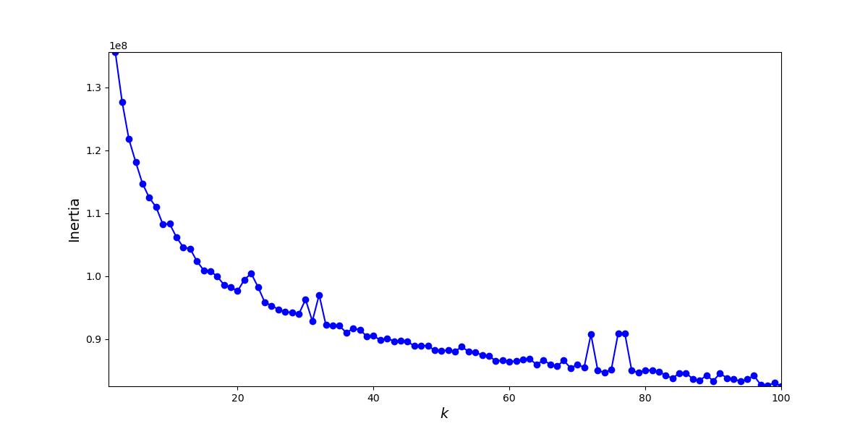

KMeans Inertia Scores

The inertia of a model is also not as indicative of the appropriate cluster range as the silhouette score, or the number of samples appearing accurately within a cluster. These scores are plotted below:

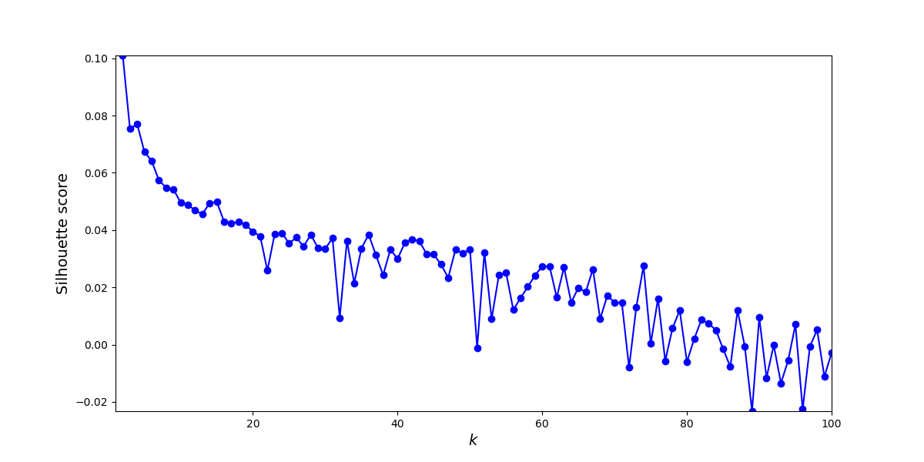

KMeans Silhouette Scores

With the highest silhouette score at 2 clusters of 0.10, the indication is clear that no number of clusters accurately represents the data fed into the model. As such, and because the number of labels we wish to analyze is known, the number of clusters chosen for the model is 13. But, as discussed, it is not clear that this number of clusters is an appropriate value for the model. Below, the scores for each are shown more clearly on the graphs and annotated for clarity:

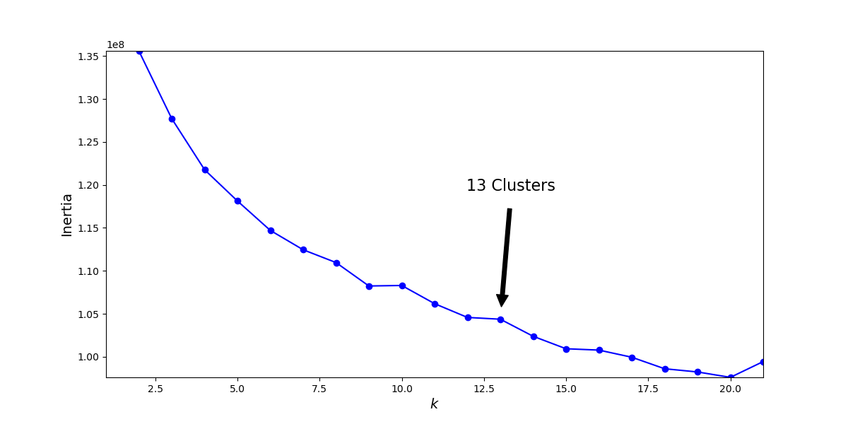

KMeans Inertia Scores with annotation

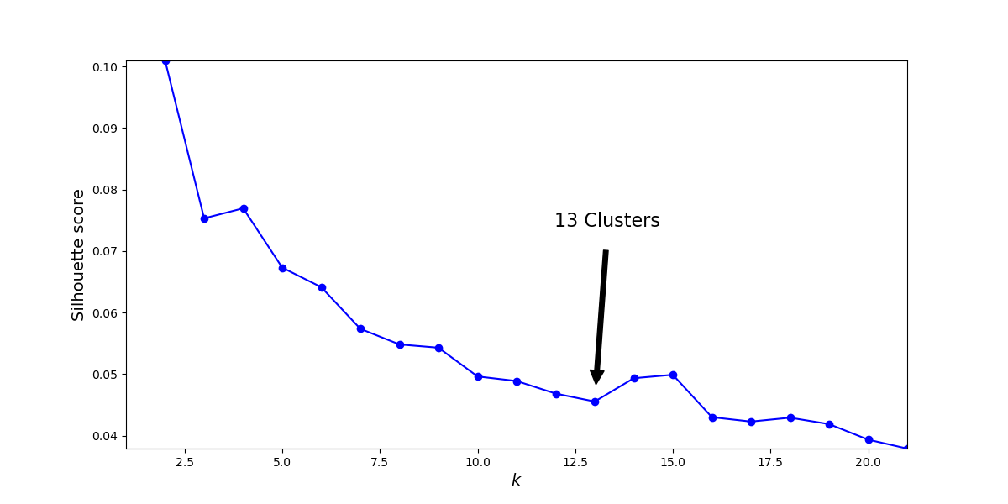

KMeans Silhouette Scores with annotation

The results of this modeling and the validity of KMeans for dimensionality reduction is discussed in the Accuracy Analysis section.

### Predictive (Neural Net)

A convolutional neural net (CNN), more specifically InceptionV3[17], was used for image classification and prediction. Inception, sometimes referred to as GoogLeNet[18], is a CNN created by Google and trained on the ImageNet database. It shows a significant accuracy rate on this database and has been used in several computer vision problems since. As such, it was selected to provide the predictive model for this application. The model used for this application was given the pre-trained weights created with ImageNet to potentially show greater accuracy in the overall model and provide a reasonable training time.

The following code snippet[19] shows how the model was instantiated, compiled, and trained for use in the application:

def init_model():  
 base = Sequential()  
 base.add(InceptionV3(input_shape=train_gen.image_shape,  
 include_top=False,  
 weights="imagenet"))  
 base.add(GlobalAveragePooling2D())  
 base.add(Dense(512))  
 base.add(Dense(len(sample_labels), activation='sigmoid'))  
 optimizer = tf.keras.optimizers.Nadam(learning_rate=0.001)  
 base.compile(optimizer=optimizer,  
 loss="categorical_crossentropy",  
 metrics=["accuracy", "mae"])  
 return base  
   
   
model = init_model()  
num_epochs = 100  
model_name = "dx-weighted-inception"  
model = train_checkpoint_save(model, train_gen, valid_gen,  
 model_name, num_epochs=num_epochs, version="00")

The training information and accuracy analysis are discussed in the Accuracy Analysis section.

## Datasets Discussion

As noted in the paper[20] about the data, provided by the NIH, the diagnostic findings for each image are gathered by an NLP program, parsing from the original radiology reports. Unfortunately, these reports are not available, and there are some noted errors found in some of the diagnostic labels, as referenced in the provided table from the paper. A selection of these scans has been reviewed for accuracy by a third party radiologist[21] and his findings indicate the labels may have significant accuracies, although he notes that the original diagnostic labels by the originating radiologists most likely had additional clinical information to assist them in determining a diagnosis.

Unfortunately, without a complete review of each scan by a trained radiologist, it is not possible to limit the data used for training the predictive model to only use particularly indicative images. This may lead to difficulty in creating a sufficiently accurate predictive model and, even if one should be created, it is unlikely that the resultant model is likely to generalize well to new information. However, at this time no additional data has been provided by Arrow Medical Imaging for creating a predictive model, and as such, best efforts will be made given these constraints with the ability to retrain the model on new or improved data when it is available.

Lastly, the metadata about each image possibly contains several errors in reporting. For instance, the “age” column for images range from 1 to 414 with no associated units. As such, it is impossible to use this information for any significant information when analyzing or using for predictive modeling. The assumption has been made that this column is meant to indicate years. As such, any image with an age of greater than or equal to 100 has been trimmed from the prospective data.

## Analytics and Decision Making

The application has the ability to assist clinicians in the diagnosis of patients via chest X-ray. As a demonstration of the ability, the web application can be used to interact with the prediction API with a few simple clicks. The results of the analysis give probabilistic classification labels and are displayed to the end-user. A demonstration of this in action can be viewed in the Real-Time Query section below.

## Data Cleaning

As discussed previously regarding the age column of the data, results with an age greater than or equal to 100 have been removed. The methodology behind this and the results is demonstrated with the following code snippets, using the Pandas[22] data analysis tool for Python:

import pandas as pd  
df = pandas.read_csv("..")  
df["Patient Age"].describe()

count 112120.000000  
mean 46.901463  
std 16.839923  
min 1.000000  
25% 35.000000  
50% 49.000000  
75% 59.000000  
max 414.000000

df["Patient Age"][df["Patient Age"] < 100].describe()

count 112104.000000  
mean 46.872574  
std 16.598152  
min 1.000000  
25% 35.000000  
50% 49.000000  
75% 59.000000  
max 95.000000

Additional modifications to the image metadata file have been made to allow for easier use with analysis and modeling. This includes normalizing the column names to remove spaces, splitting the diagnostic findings by label and creating a one-hot encoded array for each image, and removing additionally identified unusable images (either from poor image quality, sizing constraints, or others) in the cxr14_bad_labels.csv file.

The following code snippet illustrates a broad overview of how data cleaning was accomplished[23]. After cleaning, the resultant DataFrame was saved to a new CSV for future usage.

img_metadata = pd.read_csv(img_metadata_loc)  
img_metadata.rename(columns={  
 "Image Index" : "img_filename",  
 "Patient ID" : "pt_id",  
 "Patient Age" : "pt_age",  
 "Patient Gender": "pt_sex",  
 "View Position" : "view_position",  
 "Image Width" : "img_width",  
 "Image Height" : "img_height",  
 "Spacing X" : "x_spacing",  
 "Spacing Y" : "y_spacing"}, inplace=True)  
unusable_imgs = pd.read_csv(unusable_img_loc)  
finding_labels = get_finding_labels(img_metadata)  
save_labels_to_csv(finding_labels)  
img_metadata = remap_labels(img_metadata, finding_labels)  
img_metadata = drop_known_unusable(img_metadata, unusable_imgs)  
save_usable_to_csv(img_metadata)

## Data Visualization

Data exploration is accomplished by visualizing the diagnostic labels associated with each image. This information helped to understand the given dataset and determine the course for standardizing the eventual training data to be fed to the model.

In the following graph, we can visualize the number of diagnostic labels per image, separated by patient sex to understand the potential bias of the data sampling, in order to better understand the weights of each image sample. Images with “No Finding” are separated as this accounts for nearly half of the data and does not give a complete picture of the label classifications.

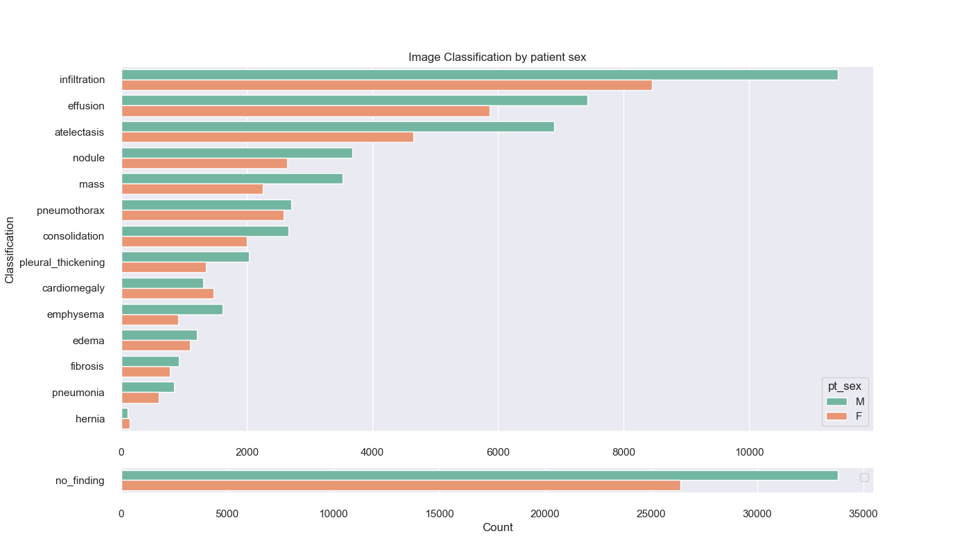

Diagnostic Classification Frequency by Sex

The numbers above show an imbalance of the data, favoring infiltration and effusion above other diagnostic markers. Additionally, there are fewer samples for hernia and pneumonia diagnosis, indicating that there may not be enough samples of this data for training and it should be trimmed from the dataset before training. Patient sex also indicates a higher number of scans for men; however, without further information about these findings and their respective prevalence among the population, it is difficult to determine if this will introduce a significant bias in our model. Theoretically, the images themselves should not affect the model training, but this does not account for the potential physiological differences between men and women vis a vis breast tissue.

Next, the label frequency is plotted against the age of each patient. The combined scatter plot below paints a similar picture to the markers above, showing a higher number of scans for infiltration.

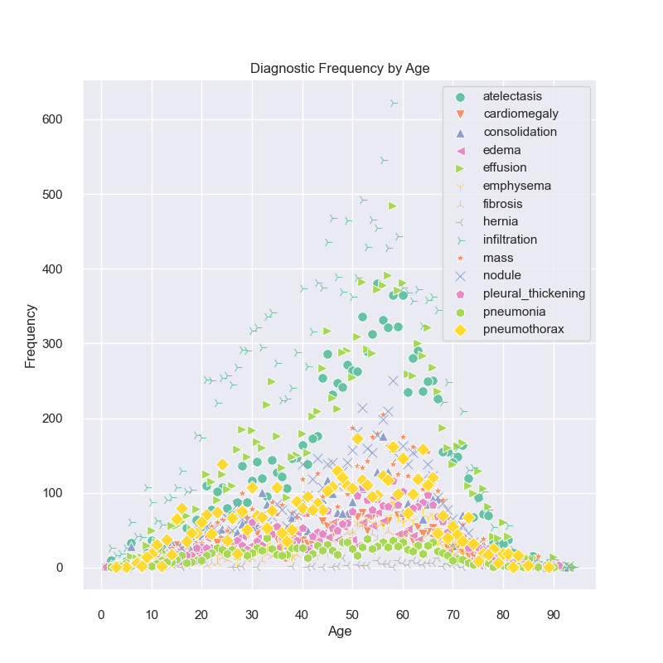

Diagnostic Classification Frequency by Age

With 14 potential labels, the image above is a bit cluttered and it is hard to make any determinations from this alone. Therefore, each individual diagnostic label is plotted below to show the frequencies by age for each.

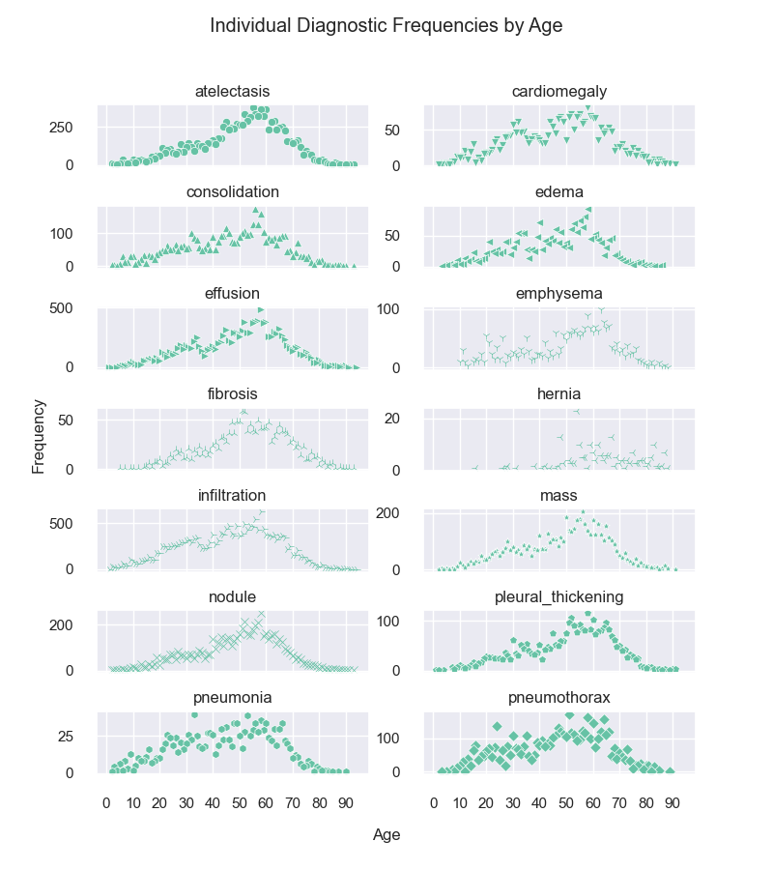

Diagnostic Frequency by Age, (separated by label)

These individual plots show an overall normal distribution for the data, with the median value for most around the same area (between 50-60 years old). However, hernia again stands as an outlier, showing an unusual distribution that does not fit into a typical bell-curve. This also indicates that it is likely this should be trimmed from the data before training.

Lastly, the correlation of diagnoses shows the potential comorbidities for each label with the following correlation matrix:

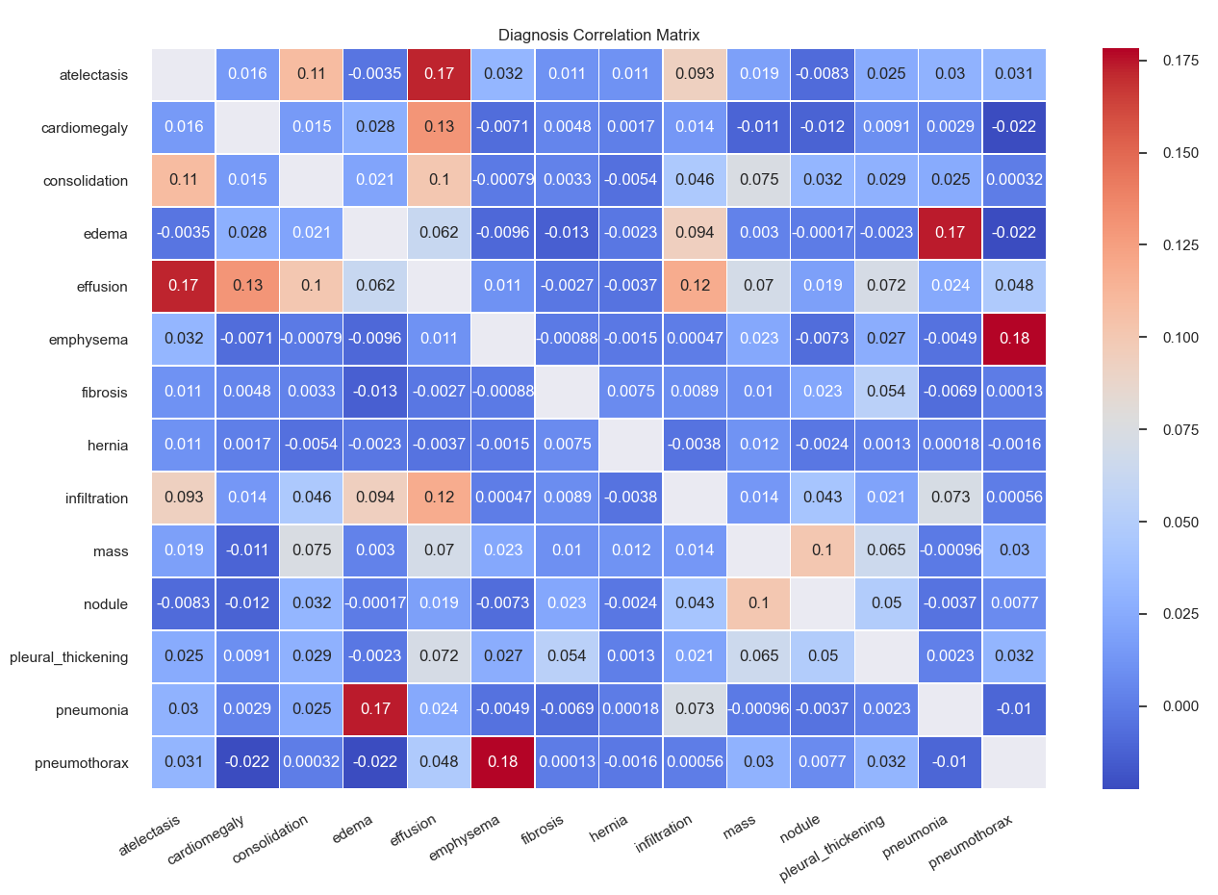

Diagnostic Correlation Matrix

With this matrix, we can see that there is a correlation for atelectasis and effusion, as well as edema and pneumonia. These correlations are worth noting for training the model, as it is possible that this may confuse the model during training and lead to a lower degree of accuracy with differentiating between these labels.

## Real-Time Query

The front-end application allows a user to upload a chest X-ray image directly to the prediction model through their browser with a simple form element: 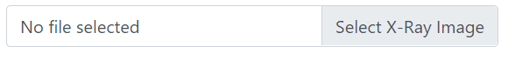

Clicking on this form element will bring up a File Selector: 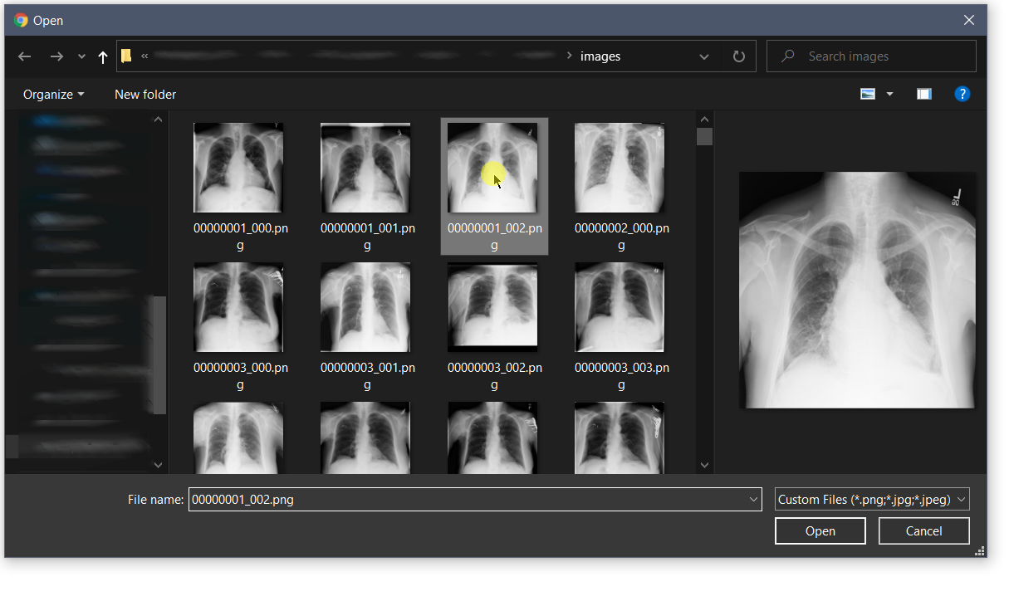

During analysis, the original image will be displayed on-screen. Once the analysis is complete, a graph will display the indicated classification probabilities: 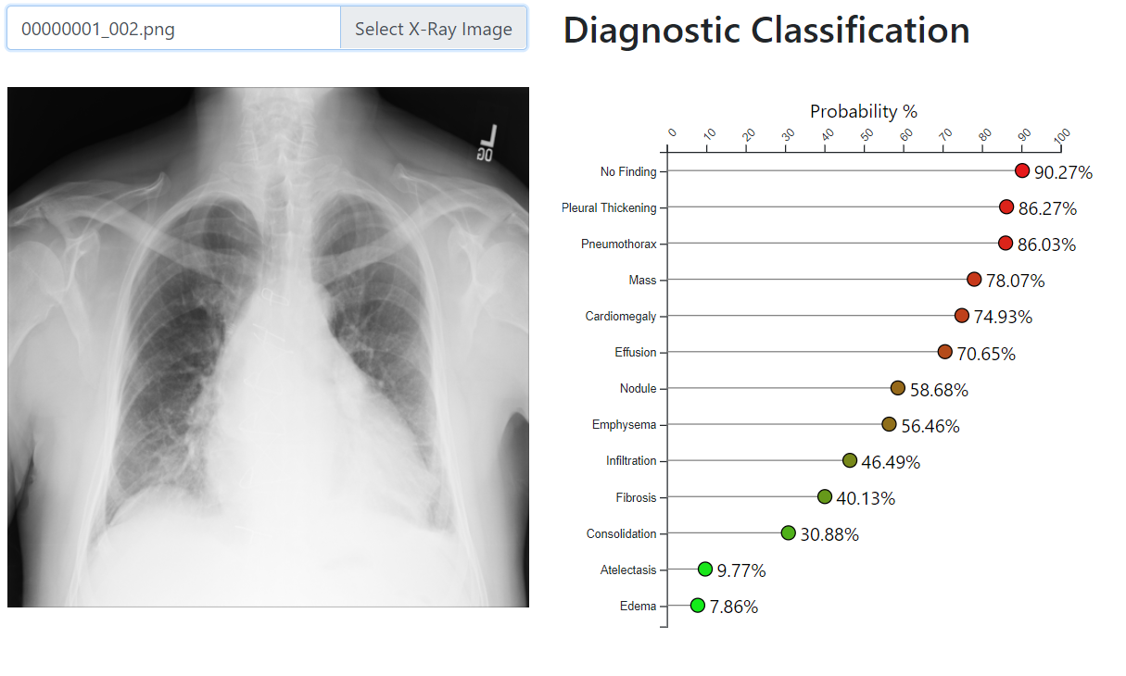

This portion of the web application functionality can be accessed at <http://cxr-dx.scgrk.com/analyze>.

## Adaptive Element

The included scripts and code for the prediction model have been included. These items can be used to create a data pipeline for continual improvement and adaptation to new information. Additionally, the simplicity of use inherent with TensorFlow/Serving as a means of serving the model as a REST API allows for versioning the system. The container for the model only needs to be rebuilt with updated training weights for the model and phased into the existing server architecture. This allows a seamless transition of models that can be deployed or rolled back as new models are trained and evaluated.

## Outcome Accuracy

The model will be evaluated on several metrics during the iterative training sessions, or epochs. Categorical cross-entropy[24] will be used as the main loss function and targeted for improvement by the neural net during training. This measures the model on its ability overall to classify the input for a multi-label classification problem. A lower score for this metric indicates a better model. Additional metrics will also be collected during training, including overall model accuracy, and mean absolute error. However, it should be noted that with a multi-label classification problem, while attempting to determine the probabilities of classification, accuracy is not necessarily a metric generally indicative of individual label classification accuracy. As such, upon a full training session of the model, it will be evaluated on a per-label basis to measure the true-positive rate (the sensitivity of classification) against the false-positive rate (the specificity of classification) the Receiver Operating Characteristic (ROC Curve)[25]. This will then be plotted and analyzed for the Area Under the Curve (AUC) to determine the viability of each label classification.

## Security Measures

It is a simple fact that any information that is not stored is not subject to a breach of confidentiality via intrusion or compromise of data stores. To whit, and in compliance with HIPAA and to protect patient health information, the application is built to require as little information as possible, and absolutely no information is persisted following communication. As the only input that is necessary to feed into the model and receive a prediction is an X-ray image, it is the responsibility of the end-user to verify that these images do not contain any protected information. However, as a routine matter of course and to protect information from interception, the application communication channels are to be encrypted with modern TLS standards that include HTTPS protocols to maintain secure message passing.

## Product Health Monitoring

The health of the servers can be monitored and automated using AWS CloudWatch logs. These logs can provide specific server metrics over 5-minute intervals including average CPU and RAM usage which can be used to validate the servers are not overloaded with too many network requests. The architecture of the auto-scaling group is meant to be self-correcting and will automatically terminate unhealthy servers and replace them with new servers.

With regards to the prediction accuracy, this will have to be monitored separately from the application. The application does not save any image, prediction, or any other information locally or externally. Evaluations should be performed routinely by feeding images with known classification labels to receive predictions on this data. This can then be compared to the ground-truth of these images to evaluate the model on an ongoing basis. These images and labels can additionally be used in the future to provide ongoing training to the model.

## Dashboard

The dashboard is available online at <http://cxr-dx.scgrk.com>.

From this site, a user can view the data analysis information:

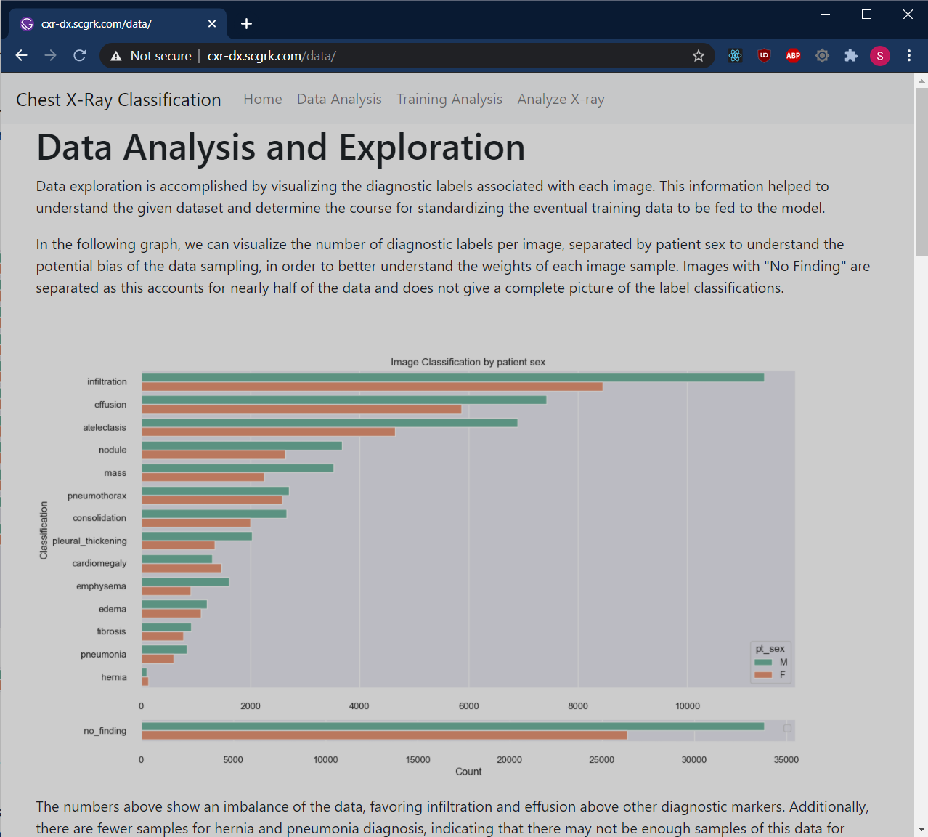

Data Analysis Dashboard

They can also see the training methodology and analysis:

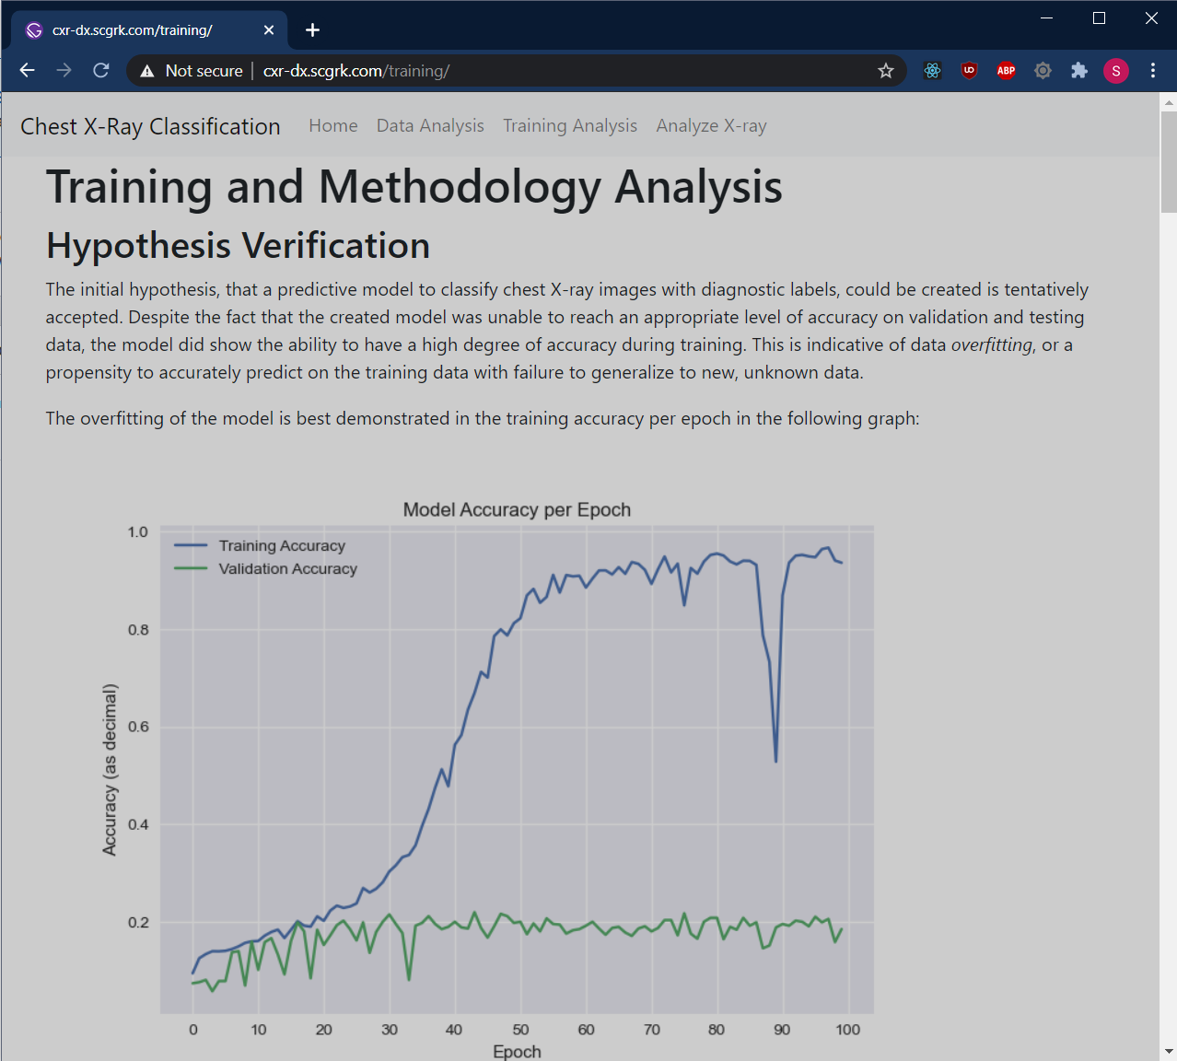

Training Analysis Dashboard

Finally, they can interact with the prediction application:

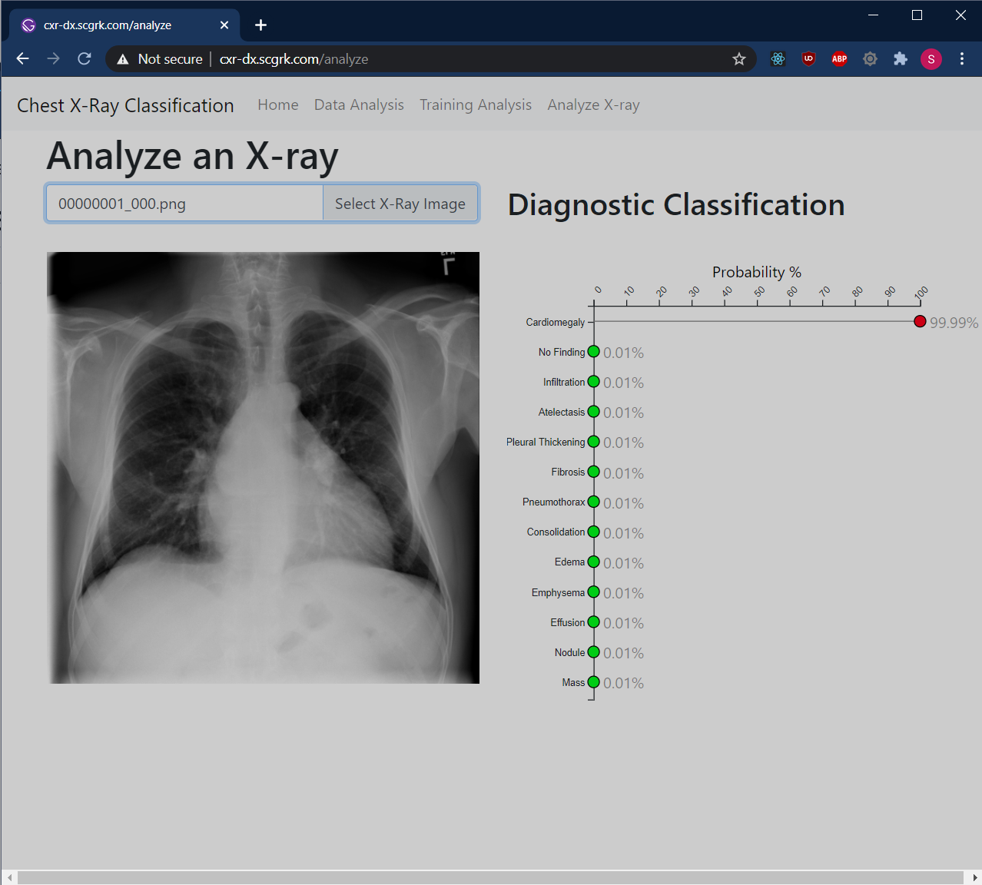

X-Ray Prediction Dashboard

# Section D - Implementation Review Analysis

## Project Purpose

The purpose of this project is three-fold:

1. To take given data containing chest X-ray images and diagnostic labels regarding those images and create a dashboard for exploring the data.
2. To create a predictive classification model for determining the diagnostic labels for images new to the model and evaluate the model for efficacy and accuracy.
3. To deploy the model as a RESTful service for consumption by Arrow Medical Imaging and its contracted clients.

Each point of the project was solved separately but combined to create the overall product. The first and third objectives were able to be met satisfactorily and can be explored at APPLICATION_URL for verification.

Unfortunately, while it was possible to create a *working* model for the second objective, the accuracy of the model created was not able to meet the standards set by Arrow Medical Imaging to be considered an effective aid for automated diagnosis at this time. A full review of the model, datasets and issues within, and conclusions regarding the prediction model can be found in the following sections.

## Datasets

Machine learning models require numerical data for analysis and prediction. Therefore, all images used for training, validation, testing, or otherwise must be converted to a numerical format to be fed into the models. This was accomplished using an image preprocessor from Keras, ImageDataGenerator[26]. This automatically reads in data in batches (or individually), converts the images to numerical arrays of 0 to 255 per each image channel (RGB), and can be used for normalization and standardization.

The code for initializing the ImageDataGenerator follows:

def init_image_data_generator(split=False):  
 split_value = SPLIT_VALUE if split else 0.0  
 return ImageDataGenerator(  
 samplewise_center=True,  
 samplewise_std_normalization=True,  
 fill_mode='constant',  
 cval=1.0,  
 validation_split=split_value)

The original dataset includes a significant amount of images. As the data fed into a model increases, so does the training time. Initial attempts to use the entire dataset resulted in epoch training times of well over 15 minutes each, leading a full training session of 100 epochs to effectively require over 10 hours of training time. As this was impractical for prototyping purposes, the dataset was trimmed to include only 500 images of single-label images. Using this threshold additionally limited the number of classification labels from 15 to 13 as not all single-label classifications had at least that many samples.

The trimming of the data was accomplished using the following code (#... indicates truncation of uninteresting code or code used for sanity checks)[27]:

# Load only records with a single finding  
img_metadata = get_img_metadata()  
single_finding_records = img_metadata[  
 img_metadata["findings_list"].apply(lambda val: len(val) == 1)]  
   
df = single_finding_records  
dx_labels = get_dx_labels()  
   
#...  
   
SAMPLE_THRESHOLD = 500  
# Remove any records with a finding below the threshold  
# also remove the column for that label  
removed_labels = set()  
for label, count in pre_drop_counts.items():  
 if count < SAMPLE_THRESHOLD:  
 indices = df[df[label] > 0.5].index  
 df = df.drop(indices)  
 df = df.drop(labels=[label], axis=1)  
 removed_labels.add(label)  
   
#...  
   
# Get equal number of samples of each finding label  
RANDOM_SEED = 42  
   
target = pd.DataFrame()  
sample_counts = {}  
for label in sample_labels:  
 sample = df[df[label] > 0.5].sample(n=SAMPLE_THRESHOLD,  
 replace=False,  
 random_state=RANDOM_SEED,  
 axis=0)  
 sample_counts[label] = len(sample.index)  
 target = pd.concat([target, sample])  
   
# Shuffle the dataset  
target = target.sample(frac=1, random_state=RANDOM_SEED)

This DataFrame was then used for creating the data batches used for training the model, allowing for a much more manageable dataset during training and reducing each epoch training time to 1 to 2 minutes. This trimming of data theoretically does not contribute to the overall accuracy of the model, as will be discussed further in the Accuracy Analysis section. While increasing the size of the dataset can increase overall accuracy, other factors were likely at play with regards to the validation accuracy failing to improve over time.

Once the target DataFrame was created, this was fed into the ImageDataGenerator to create the data batches. This was accomplished with a few functions, as follows:

IMG_SIZE = 256  
BATCH_SIZE = 32  
   
def get_train_valid_test_split(img_data):  
 train_df, test_df = train_test_split(img_data, test_size=0.10,  
 random_state=42)  
   
 training_data = get_data_batch(train_df, subset="training")  
 validation_data = get_data_batch(train_df, subset="validation")  
 test_gen = get_data_batch(test_df, subset=None)  
 return training_data, validation_data, test_gen  
   
   
def get_data_batch(img_metadata,  
 batch_size=None,  
 rnd_seed=None,  
 subset=None):  
 if batch_size is None:  
 batch_size = BATCH_SIZE  
   
 valid_subset = subset == "training" or subset == "validation"  
 if subset is not None and not valid_subset:  
 raise ValueError(f"Invalid subset value: {subset}")  
   
 shuffle = subset == "training"  
   
 idg = init_image_data_generator(split=valid_subset)  
   
 return idg.flow_from_dataframe(img_metadata,  
 directory=str(PurePath(IMG_DIR)),  
 x_col="img_filename",  
 y_col=Y_COL_NAME,  
 target_size=(IMG_SIZE, IMG_SIZE),  
 color_mode="rgb",  
 class_mode="categorical",  
 batch_size=batch_size,  
 shuffle=shuffle,  
 seed=rnd_seed,  
 subset=subset)  
   
#...  
   
train_gen, valid_gen, test_gen = get_train_valid_test_split(target)

In the functions above, the DataFrame is split into training, validation, and testing subsets for training and evaluating the neural net. Despite the images being grayscale, the images are converted to a faux-RGB by copying the single color channel across all color channels. This was to allow the model to use the pre-trained weights of ImageNet without major modification to the underlying model. Again, this likely did not contribute to the inaccuracy of the model, but instead likely increased the training time of the model with duplicated data. This trade-off was evaluated against having to reconstruct all weights from an initial state and increase the number of training epochs required by a significant amount. It was determined that this trade-off decreased overall training time as a result.

Lastly, each image was resized from the original 1024x1024 down to 256x256 to fit with InceptionV3 (and to decrease the training time).

## Hypothesis Verification

The initial hypothesis, that a predictive model to classify chest X-ray images with diagnostic labels, could be created is tentatively accepted. Despite the fact that the created model was unable to reach an appropriate level of accuracy on validation and testing data, the model did show the ability to have a high degree of accuracy during training. This is indicative of data *overfitting*, or a propensity to accurately predict on the training data with failure to generalize to new, unknown data[28].

The overfitting of the model is best demonstrated in the training accuracy per epoch in the following graph:

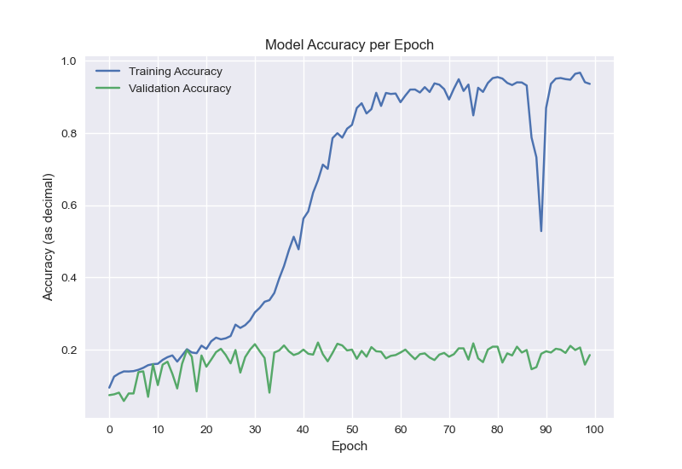

Model Accuracy per Epoch

As the model received more and more training information, the overall accuracy adapted to the data; however, this was not present in the validation phase of training. When compared to the loss function of the model, this is again evident as the training loss decreases, while the validation loss increases, indicating poor generalization of the model:

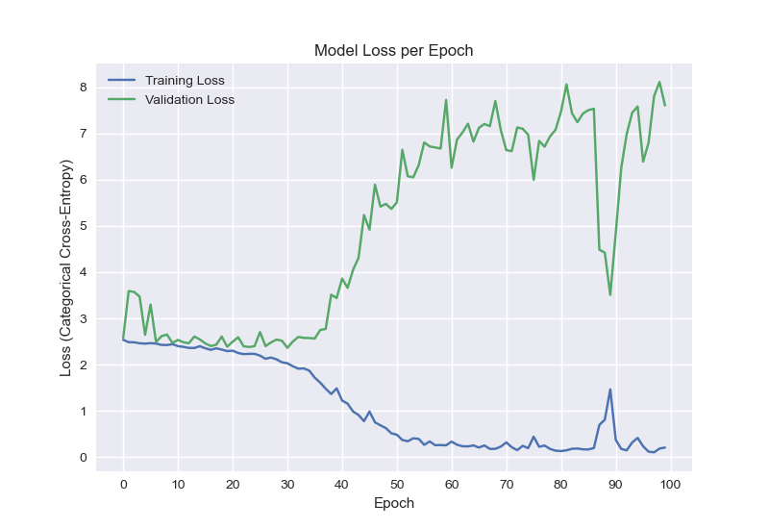

Model Loss per Epoch

Interestingly, the model did see a marked improvement in the mean absolute error over training periods:

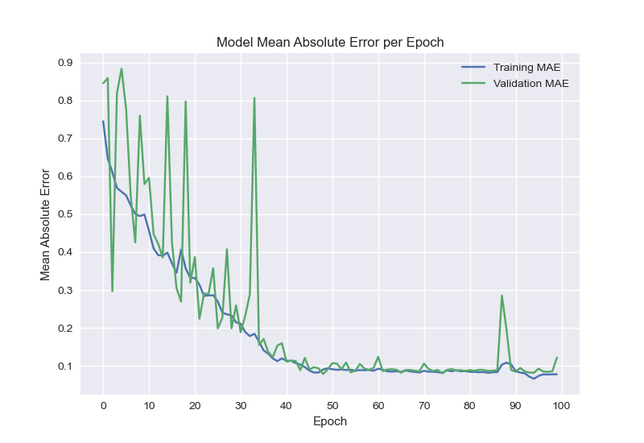

Model Mean Absolute Error per Epoch

These findings indicate that, while the model overall may not generalize to new data, the error rate of the model overall improves and can likely be used for classification in low-risk situations where precision is not a requirement.

The failure to generalize can be mitigated in future iterations of the project with a variety of methods, such as longer training sessions or increasing the dataset, but were unable to be explored due to the time constraints of this project. However, it should be noted that, with the model successfully deployed within a simple Docker container, future iterations of training and prediction will be trivial to implement due to the modular design of the application overall.

## Visualizations and Reporting

To protect patient confidentially, and to comply with HIPAA, little data regarding the images used was provided for training the model. Additionally, the developer has no experience or qualifications for reviewing X-ray images. This necessitated extrapolating as much information as possible from the few points of data present. The visualizations created helped to determine potential outliers from the images as much as possible without a full review of the data. The visualizations created and displayed in the Data Visualization demonstrated that it was likely a wise decision to trim particular diagnostic labels from the overall training data, due to sampling weights and to decrease the complexity and training time of the model.

Additional visualizations were created throughout to get a better understanding of the model itself and the parameters used for determining how the model was to be created and used. The metrics from the neural net training show an interesting story of the model’s adaptation to generalization and the potential for increasing the overall usefulness of the model with additional data, longer training sessions, or by modifying the training data to have the model generalize to new data better.

## Accuracy Analysis

The accuracy of the application overall is broken down between the descriptive analysis of the KMeans clustering for dimensionality reduction and the accuracy of the neural net for classification.

### KMeans Clustering Accuracy Analysis

For analysis of the KMeans clustering, the model and predictions for testing data, along with the accuracy metrics, were created using the following code[29]:

N_CLUSTERS = 13  
   
x, y, lbls = load_imgs_for_kmeans()  
   
kmeans = KMeans(n_clusters=N_CLUSTERS)  
print("Fitting and predicting...")  
predictions = kmeans.fit_predict(x)  
   
precision = round(precision_score(y, predictions, average="micro") * 100, 2)  
recall = round(recall_score(y, predictions, average="micro") * 100, 2)  
f1 = round(f1_score(y, predictions, average="micro") * 100, 2)  
cf = confusion_matrix(y, predictions)

The results of the confusion matrix can be best viewed with the following graph:

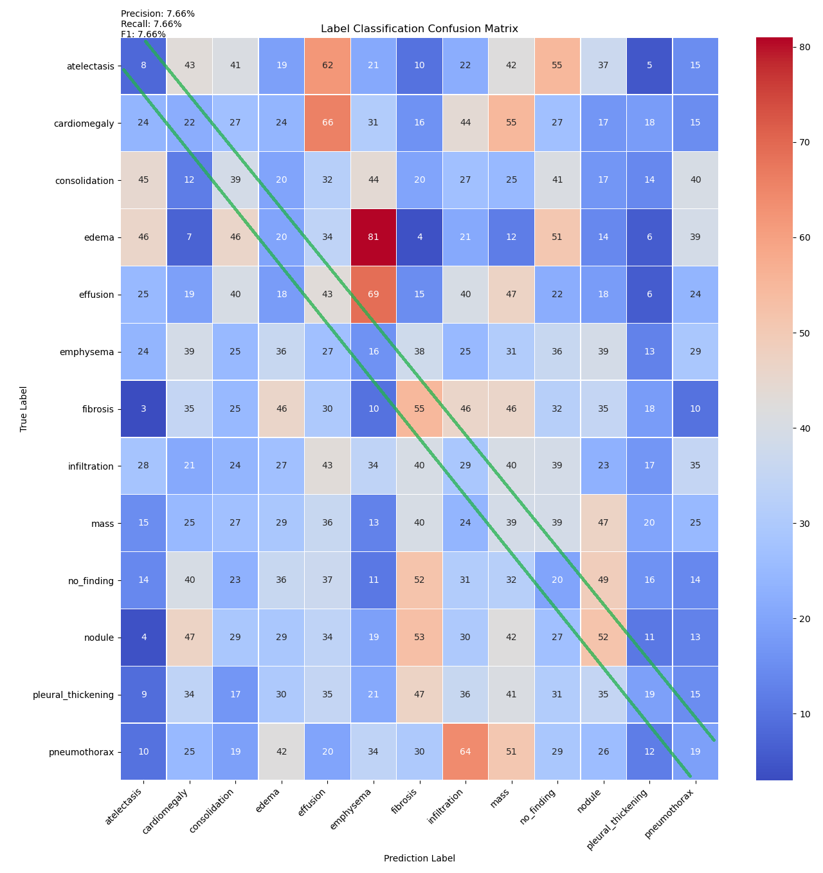

KMeans Confusion Matrix

As shown on these results, the precision, recall, and F1 scores are all 7.66%, indicating a significantly inaccurate result. The heat-map shows the true labels of an image on the y-axis, with the predicted label on the x-axis. The diagonal (highlighted with the green line) are frequencies of accurate predictions. As can be seen from the scores and this heat-map, the model is fully inadequate at providing a reasonable classification of the images via 13 clusters for KMeans. As a result, this method of dimensionality reduction was abandoned.

### Neural Net Accuracy Analysis

The accuracy of the neural net was evaluated in a combination of methods. As previously discussed in the Hypothesis Verification section, the validation data used during training of the model indicated a poor adaption to the data, showing very poor scores for categorical cross-entropy as a loss function and accuracy overall. However, when plotting the true-positive rate and false-positive rate for the model to create the ROC curves, this paints a completely different picture[30].

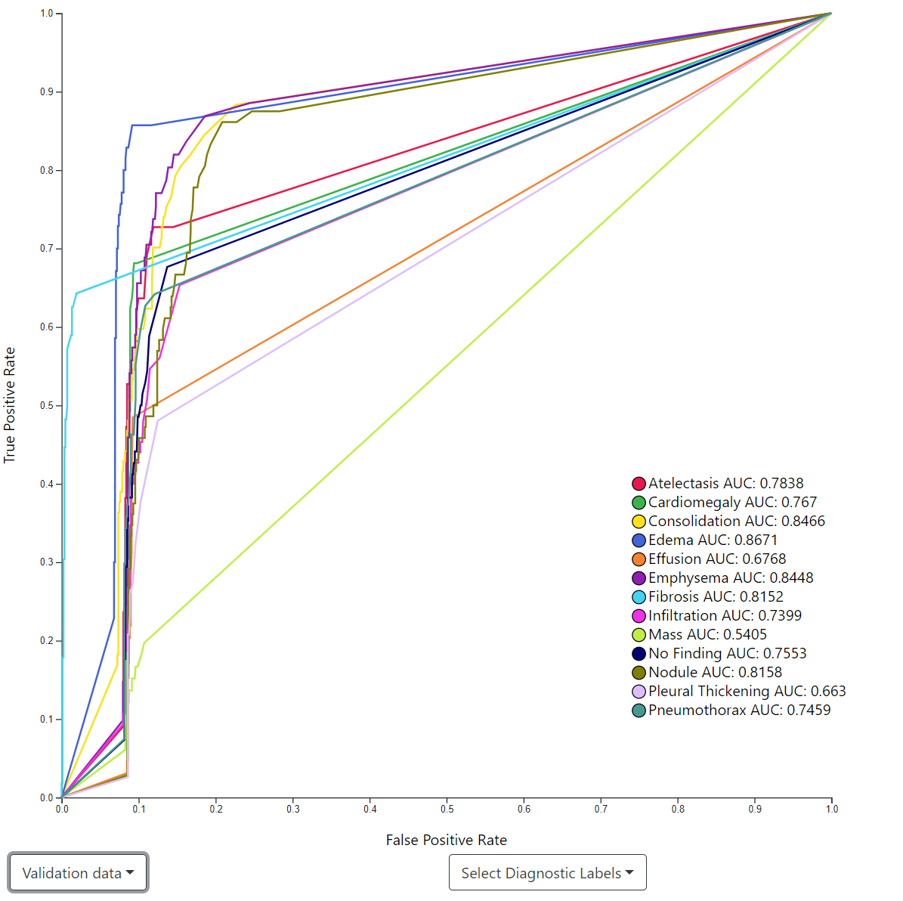

ROC Curves for Validation Data

The area under the curve for each classification label shows a wide range of values, from 0.5405 for *Mass* vs. up to 0.8466 for *Consolidation*. A score of near 0.5 for this value indicates that the model was no better at determining a matching label than flipping a coin. For *Mass*, it is clear that the model was unable to match well to this diagnostic label. This may have skewed the overall combined accuracy of the model, as well as other low scoring classification labels. Additionally, as categorical cross-entropy is a measure of the overall probability matches, this may cloud the findings of individual diagnostic classifications. This indicates that the model may adapt well to some labels but not others. However, it should be noted that this is an unusual finding overall and may be due to an error in the overall evaluation process.

### Accuracy Conclusion

Based on the results of the above evaluations and metrics and the unusual nature of the findings above, it is concluded that the model overall failed to meet the expectations of Arrow Medical Imaging for accuracy. However, individual diagnostic labels show some promise overall, indicating that the model may be adapted for binary classification of *Finding* vs. *No Finding* should the training data and model be modified to fit this classification model.

Lastly, it is worth mentioning that increasing the size of the dataset and the training sessions may have produced a more favorable outcome. The training data may have also been improved by providing random transformations to individual images, such as rotations, inversions, shifting horizontally or vertically, or other such image transformations. However, due to the time constraints of this project, this could not be explored in more detail.

## Application Testing

Throughout development, the application was tested at a modular level manually. The REST API was tested using Postman[31] to validate that the API could receive image POST requests and return an expected JSON response to be utilized by the end-user. This testing involved a very simple, happy path testing and was not exhaustive by any means. Similarly, the front-end application was tested manually throughout development. Due to the overall simplicity of the project, extensive unit testing was determined to be counter-productive to the overall creation of a prototype project. Once all components were successfully created and deployed, manual testing was again utilized to verify each component could integrate successfully and provide a functioning application.

## Application Files

The complete source code required for this project can be found on GitHub at <https://github.com/scgerkin/C964_Capstone>. The repository contains three modules, api, ml, and presentation, as well as a directory for this document.

* api This module contains the source code for the prediction model and REST server to interact with the model. The following is a hierarchy of the files and their purpose:
* ml This module contains the source for creating the model and all data analysis as well as the dataset. The original dataset is not included in the repository as it is significantly larger than allowed by GitHub.
* presentation This module contains the frontend React application for interacting with the project and back-end application.
* paper This directory contains the original source for this paper as well as all image assets used within. The paper has been written in MarkDown and automatically parsed to a Word Document by [Pandoc](https://pandoc.org/) for additional formatting before converting to a PDF. In the repository, only the original MarkDown is included.

## User’s Guide

The full application requires the use of [Docker](https://docker.com), [Docker Compose](https://docs.docker.com/compose/) and the [Gatsby.js](https://www.gatsbyjs.com/) CLI tool.

To run the application locally, the full source code can be downloaded from GitHub. Both Docker containers must be built and run with Docker Compose.

The following script contains the complete instructions to accomplish this:

git clone https://github.com/scgerkin/C964_Capstone.git  
   
# Build the prediction model  
cd C964_Capstone/api/tf  
docker build -t c964/dx .  
   
# Build the API to interact with the prediction model  
cd ..  
docker build -t c964/svr .  
docker-compose up  
   
# Launch Gatsby developer mode to interact with the frontend.  
cd ../presentation  
gatsby develop

The frontend application will then be available at http://localhost:8000. To interact with the locally deployed containers, the API communication must be modified to use the local host. This is located in presentation/src/api/api.js.

Modify the following function as indicated below:

async function analyzeActual(image) {  
 const request = new FormData()  
 request.append("image", image, image.fileName)  
 return await Axios.post("http://localhost:80", request) // Modify this line  
}

## Summation of Learning Experience

Before starting the capstone, I had no experience with data science or machine learning. This required a very fast education in a variety of subjects and libraries, from the basics of how machine learning is implemented to individual Python libraries such as NumPy and Pandas. This learning was accomplished from a variety of mediums, including a Udemy course[32], the *Hands-on Machine Learning*[33] book and associated resources, and a vast swath of blog posts, documentation, and other resources gathered via Google searches. My previous experience learning programming and learning what to search for proved invaluable in finding these resources and providing a framework for understanding how to implement the requirements of this project. Lastly, I learned that machine learning is not as easy as it might appear from the amazing amount of abstraction provided by the various Python libraries. Although these libraries have been designed for ease of use, an understanding of how they work is very much a requirement for creating a working model. In retrospect, I should have found a subject matter much simpler than computer vision for my brief foray into this subject.

# References

Géron, Aurélien. 2019. *Hands-on Machine Learning with Scikit-Learn, Keras, and TensorFlow: Concepts, Tools, and Techniques to Build Intelligent Systems, 2nd Edition*. O’Reilly Media Inc.

Gómez, Raúl. 2018. “Understanding Categorical Cross-Entropy Loss, Binary Cross-Entropy Loss, Softmax Loss, Logistic Loss, Focal Loss and All Those Confusing Names.” *Raúl Gómez Blog*. <https://gombru.github.io/2018/05/23/cross_entropy_loss/>.

Grace-Martin, Karen. 2020. “What Is an ROC Curve?” *The Analysis Factor*. <https://www.theanalysisfactor.com/what-is-an-roc-curve/>.

Neagoie, Andrei, and Daniel Bourke. 2020. “Zero to Mastery: Complete Machine Learning & Data Science Bootcamp 2021.” Udemy.com. <https://www.udemy.com/course/complete-machine-learning-and-data-science-zero-to-mastery/>.

Oakden-Rayner, Luke. 2017. “Exploring the ChestXray14 Dataset: Problems.” *Luke Oakden-Rayner*. <https://lukeoakdenrayner.wordpress.com/2017/12/18/the-chestxray14-dataset-problems/>.

Szegedy, Christian, Vincent Vanhoucke, Sergey Ioffe, and Jonathon Shlens. 2015. “Rethinking the Inception Architecture for Computer Vision.” arXiv.org. <https://arxiv.org/abs/1512.00567>.

TensorFlow Documentation. 2020. “tf.keras.applications.InceptionV3.” *TensorFlow Core V2.3.1 Documentation*. <https://www.tensorflow.org/api_docs/python/tf/keras/applications/InceptionV3>.

Wang, Xiaosong, Yifan Peng, Zhiyong Lu, Mohammadhadi Bagheri, and Ronald Summers. 2017. “ChestX-Ray8: Hospital-Scale Chest X-Ray Database and Benchmarks on Weakly-Supervised Classification and Localization of Common Thorax Diseases.” *Computer Vision Foundation*. National Institutes of Health. <https://openaccess.thecvf.com/content_cvpr_2017/papers/Wang_ChestX-ray8_Hospital-Scale_Chest_CVPR_2017_paper.pdf>.

Wang, Xiaosong, Yifan Peng, Zhiyong Lu, Mohammadhadi Bagheri, and Ronald Summers. 2018. “NIH Chest X-Rays.” *Kaggle.com*. National Institutes of Health. <https://www.kaggle.com/nih-chest-xrays/data>.

1. [Representational State Transfer](https://en.wikipedia.org/wiki/Representational_state_transfer)
2. [Application Programming Interface](https://en.wikipedia.org/wiki/API)
3. Wang et al. (2018)
4. See [CC0 1.0 Universal https://creativecommons.org/publicdomain/zero/1.0/legalcode](https://creativecommons.org/publicdomain/zero/1.0/legalcode) for the full information regarding this license.
5. <https://flask.palletsprojects.com/en/1.1.x/>
6. <https://www.tensorflow.org/tfx/serving/docker>
7. <https://docs.docker.com/compose/>
8. <https://aws.amazon.com/cloudwatch/>
9. <https://reactjs.org/>
10. <https://www.gatsbyjs.com/>
11. Géron (2019) pp. 447-478
12. TensorFlow InceptionV3 will be used for this application (for the documentation see TensorFlow Documentation 2020)
13. <https://aws.amazon.com/ec2/>
14. <https://aws.amazon.com/s3/>
15. To speed up training analysis, MiniBatchKMeans was used. This method of KMeans shows significantly faster training with little to no difference in model accuracy compared to traditional methods (see Géron 2019 pp 224-245)
16. The complete source code for this can be found at ml/training/cluster-determination.py.
17. Szegedy et al. (2015)
18. Géron (2019) pp 466-467
19. The complete source code for this can be found at ml/training/dx-weighted-inception.py.
20. Wang et al. (2017)
21. Oakden-Rayner (2017)
22. <https://pandas.pydata.org/>
23. The full code for this cleaning can be found in ml/training/clean-data.py.
24. For more information about this, see Gómez (2018)
25. For more information about this, see Grace-Martin (2020)
26. For the documentation regarding this API see <https://www.tensorflow.org/api_docs/python/tf/keras/preprocessing/image/ImageDataGenerator>.
27. The full source code for this can be found at ml/training/dx-weighted-inception.py.
28. Géron (2019) p. 27
29. The full source code is available at ml/training/kmeans-analysis.py.
30. An interactive version of this graph is available at <http://cxr-dx.scgrk.com/training/>.
31. <https://www.postman.com/>
32. Neagoie and Bourke (2020)
33. Géron (2019)