Basic Python Example #2 Extras
CHHS Open House – Stefan Such

IPO Chart
Input, Process, Output. Describes the basic functionality of a program.
Input | Process | Output
The user will input anything they want. | Open up a loop. Allow the user to input whatever they want.  If the user inputs “0”, then exit the loop. Otherwise, keep looping.  Every time the loop repeats, output the user’s input. | The user’s input is returned to them. If they exit the loop, display a goodbye message.

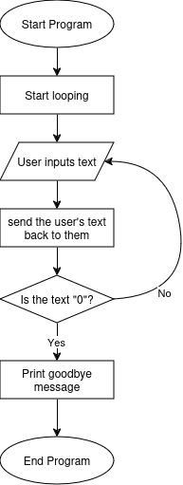
Flowchart
Describes the connections between different parts of a program.

Glossary:

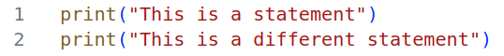
- Statement:
(in Python) a line of code; a command.

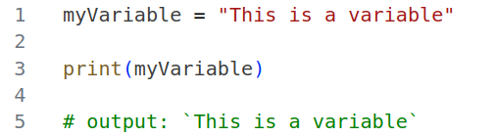
- Variable
A place where data is stored. Contains a “data type”.

- Assignment Operator
A single equals sign. This is used to store data inside of variables.

- Data Type
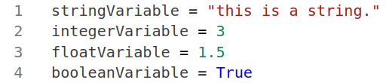
Differing ways to store values. Anything surrounded by quotation marks is a “string” (i.e. text) , whole numbers are “integers”, and numbers with a decimal value are “floating-point”. Values which are True/False are called “boolean”

- Loop
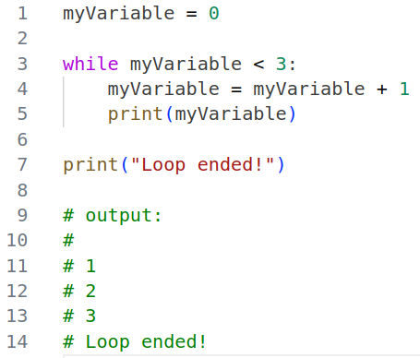
A block of code that will repeat, while a certain condition is met. In the example, the code repeats while myVariable is set to a number which is less than 3.

- Equality Operator / Comparison Operator
Two equals signs (==) can be used to check whether two variables, or numbers, are equal. This is the Equality Operator.
A greater-than (>) or less-than (<) symbol can be used to compare two variables. This is called the Comparison Operator

- If Statement
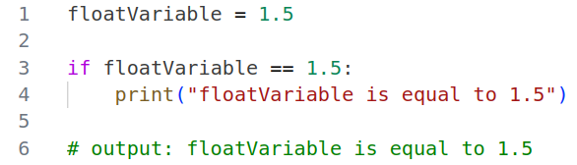
an If statement can be used to check whether a certain condition is true or false. The format of this condition is the same as the condition in the Loop. It can be formed using the Equality or Comparison operators.

Types of statements:

- print(“text”) will output the text contained within it’s brackets.
- To declare a variable, simply type out a name and follow up with an equals sign (the Assignment Operator). After the equals sign, input the value you want to store into the variable.
- You can store, or Assign values to variables using math. For example, you could have: variableOne + variableTwo = variableThree.
- Input() will prompt the user for an input. This input can be stored to a variable.
- While <condition>: will continue looping until it’s condition is met. To make a loop repeat indefinitely, set the condition to True. To break a loop regardless of it’s condition, you can use break.
- If <condition>: statements can be used to check values using the Equality Operator and the Comparison Operator.

