PrimeNumber Mastery Assignment
Reflection Log
Stefan S
CSE 2110 Procedural Programming 1
(PrimeNumber.java)
How has your program changed from planning to coding to now? Explain.
The first version of the program was copy pasted from PrimeNumber in Chapter 5.
The only change, was that I copy pasted the for loop into a method. I changed the IsPrimeNumber variable instead to a “return”. I also added a return true for when the loop completes.
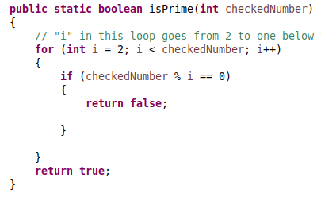
The rest of the program is as follows.
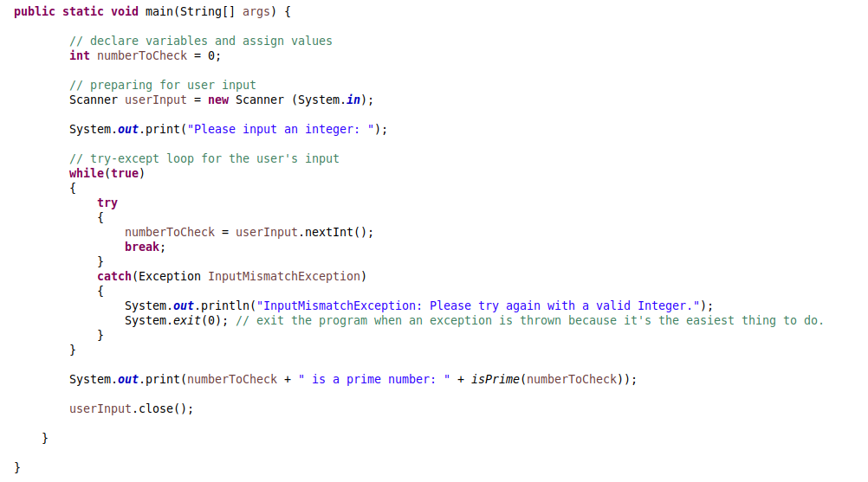
This program took me 6 minutes to write, including page setup for the reflectionlog and errorlog.

