From Carbon to Nature: Building a Biodiversity Slider Tool for Eco-Ideation
Adapting Bocken et al.'s (2011) eco-ideation methodology to a harder impact to picture: biodiversity loss
A Medium-style feature | Design methodology, worked example, and a ready-to-use tool
Ask a product developer to picture a tonne of CO2, and they can more or less do it: a hot-air balloon's worth of gas, a number on a utility bill, a target on a corporate roadmap. Ask the same person to picture “one unit of biodiversity loss,” and the exercise stalls. There is no single, intuitive unit for a hedgerow gone quiet, a reef gone bleached, or a soil gone empty of the insects that used to work it. That abstractness is very likely one reason biodiversity has lagged years behind carbon on the corporate agenda, even though the science says the two crises are tightly linked.
Bocken, Allwood, Willey and King's 2011 paper in the Journal of Cleaner Production, Development of an eco-ideation tool to identify stepwise greenhouse gas emissions reduction options for consumer goods, solved a related problem for carbon: it turned a hard-to-picture impact into a set of 14 visual sliders, each anchored by a leading question, that let a single person generate more — and more radical — ideas than a 12-person brainstorm managed across 15 matched trials.
This piece repeats their exercise for biodiversity. Following the same two steps they describe in Sections 3.1 and 3.2 of their paper — identify the indicators, then build them into a slider tool — it uses open literature (Google Scholar, OpenAlex, and publicly posted reports rather than a paywalled journal library) to work out what actually drives biodiversity loss in a consumer product's life cycle, then turns that into a tool a single person could sit down with.

Why biodiversity resists a simple slider — and why it still needs one
Carbon has one universal currency: CO2-equivalent. Biodiversity does not. The most-cited attempt at a common metric, Mean Species Abundance (MSA) loss, comes from a production-layer decomposition of Dutch consumption published in the Journal of Industrial Ecology, which found that in a single year Dutch consumption caused about 16 million MSA-loss-hectare-years worldwide — and that 88% of that footprint arose not from anything Dutch consumers directly touched, but from upstream suppliers, with more than a third of the total tied to land occupied for arable and livestock farming. A near-identical pattern turns up in a parallel study of Chinese provinces: agricultural production and consumption, not factories or cities, is described as the primary driver of biodiversity loss.
That single finding reframes what a biodiversity eco-ideation tool needs to prioritise. Bocken et al.'s carbon tool spends its opening sliders on packaging, components and transport — sensible, because carbon accumulates fairly evenly across a product's life cycle. A biodiversity tool that copied that structure would spend most of its attention on the parts of the life cycle that matter least. The evidence here — also echoed in a PNAS analysis tracing soy from the Brazilian Cerrado through global commodity traders, and in a Nature Sustainability study attributing most recent land-use-change biodiversity impact to agri-food imports into wealthier regions — points overwhelmingly at one stage: where, and how, the raw materials were grown, harvested or extracted.
So the tool below is deliberately front-loaded. Of its 14 sliders, seven concentrate on sourcing and ingredient choice before a single question is asked about packaging, factories or disposal.

Step 1 — Identifying the indicators (Section 3.1 equivalent)
Bocken et al. built their initial list from two sources: conversations with company experts, and a literature scan for existing eco-design checklists relevant to the target impact. This exercise follows the same two-source structure, substituting open-access literature review for an internal company consultation.

Table 1 — Indicators drawn from applied biodiversity-management and sourcing practice
Area of concern | Indicator | What it captures
Raw material sourcing | Land-use footprint, land conversion, hotspot overlap | Whether growing or extracting an ingredient requires clearing natural habitat
Crop & farm management | Monoculture vs. diverse cropping, agrochemical intensity | Whether farming practice supports or suppresses on-farm and surrounding biodiversity
Wild resources | Wild-harvest volumes, fishing/forestry quotas | Whether extraction from wild populations stays within replenishment limits
Supply chain assurance | Traceability, certification (e.g. deforestation-free, sustainable sourcing standards) | Whether biodiversity-risk ingredients can be verified back to their origin
Site operations | Location of farms/factories relative to protected or high-value habitat | Whether a company's own operations physically encroach on sensitive ecosystems
Water & effluent | Water withdrawal, discharge quality | Whether production depletes or pollutes freshwater ecosystems
End markets | Litter, marine debris, take-back/restoration schemes | Whether a product's afterlife adds to, or helps repair, biodiversity pressure

Table 2 — Indicators identified from the literature
Indicator | Literature source
Five direct/indirect drivers of biodiversity loss: land/sea-use change, direct exploitation, climate change, pollution, invasive species | IPBES Global Assessment, summarised in Biodiversity management: a supply chain practice view, ScienceDirect
Land occupation in agriculture as the dominant contributor to consumption-based biodiversity footprints (Mean Species Abundance loss) | Unravelling biodiversity impacts of consumption, Journal of Industrial Ecology
Agricultural production and imports as the primary sub-national driver of biodiversity loss | China's biodiversity loss across provinces, Journal of Industrial Ecology
Globally traded commodities (soy, palm oil) driving deforestation and biodiversity loss far from the point of consumption | Linking global drivers of agricultural trade to on-the-ground impacts on biodiversity, PNAS/PMC
Land-use change from agri-food exports concentrated in tropical, biodiverse-rich regions | Biodiversity impacts of recent land-use change driven by increases in agri-food imports, Nature Sustainability
Product Biodiversity Footprint: three-module method (habitat change, pollution, climate/species/invasive species) for comparing product variants | Jungbluth et al., Product Biodiversity Footprint (2017)
Potentially Disappeared Fraction of species (PDF) as a company-level biodiversity footprint metric | Sitra / University of Jyväskylä biodiversity footprint project
Certification concepts: RSPO, No-Deforestation-No-Peat-No-Exploitation (NDPE), High Carbon Stock / High Conservation Value areas | Palm oil sustainability glossary and corporate sustainability reporting
Pesticides, especially neonicotinoids, as a major driver of pollinator and insect decline | Pollinator/pesticide literature (Beyond Pesticides; agricultural biodiversity review synthesising 800+ peer-reviewed studies)
Five major value chains (food, energy, infrastructure, fashion) responsible for over 90% of business-driven biodiversity pressure | The Biodiversity Crisis Is a Business Crisis, BCG

One organising idea recurs across almost every source in Table 2: the Intergovernmental Science-Policy Platform on Biodiversity and Ecosystem Services (IPBES) names five direct and indirect drivers of biodiversity loss — land- and sea-use change, direct exploitation of species, climate change, pollution, and invasive species. Those five drivers effectively became the skeleton for the whole tool: every slider below maps onto one of them.

Step 2 — Building the initial tool (Section 3.2 equivalent)
Bocken et al. started with roughly 36 candidate indicators across four life-cycle stages and merged them down, first to 15 through pilot testing, then to a final 14 through individual workshops. Following the same logic, the two tables above were expanded into an initial list of around 32 candidate sliders — for example, separate draft questions on “deforestation risk,” “peatland conversion” and “grassland conversion” all sat under the land-use driver at first.
Two examples of the kind of merge Bocken et al. describe in their own pilot test:
- Separate draft questions on “Is this ingredient linked to deforestation?” and “Is this ingredient linked to peatland or grassland conversion?” were merged into one land-use footprint slider, since both were really asking the same underlying question — does this ingredient require converting natural habitat?
- Draft questions on “Are pollinators harmed by pesticide use?” and “Are soil organisms harmed by fertiliser use?” were merged into a single agrochemical intensity slider, covering the on-farm chemical inputs that affect biodiversity broadly rather than one taxon at a time.
This consolidation — done here as desk research rather than through Bocken et al.'s structured individual workshops with company practitioners — reduced the candidate list from around 32 to a final 14, split into two categories: Sourcing & Ingredient Design (mapping onto where most of the footprint actually sits) and Production, Distribution, Use & End-of-Life (covering the remaining IPBES drivers — climate, pollution, invasive species — plus a closing slider on active restoration).
IMAGE PLACEHOLDER 1 — Figure 1: Development process for the biodiversity eco-ideation tool (fig1_methodology.png)
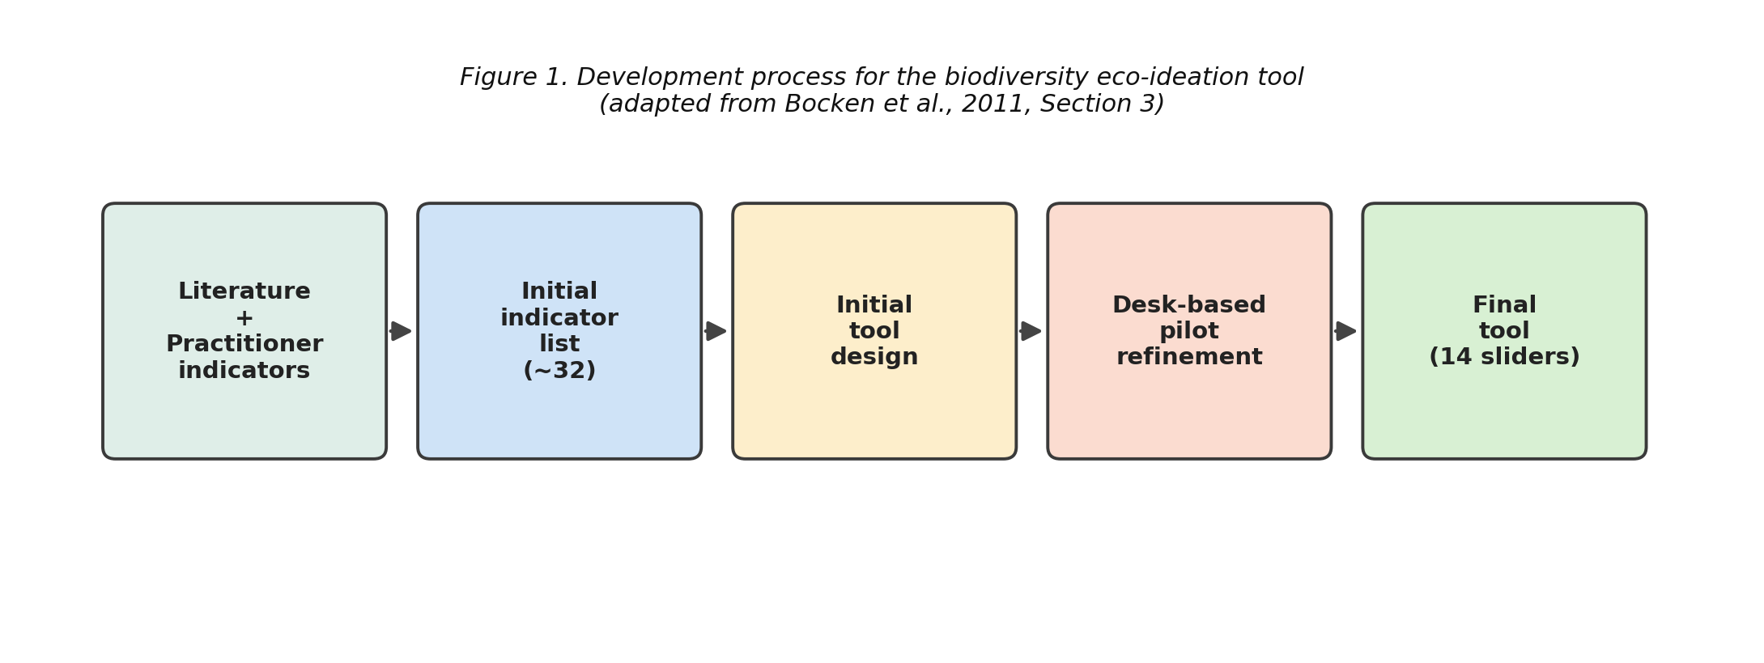
Figure 1. Development process for the biodiversity eco-ideation tool, from literature + practitioner indicators through to the final 14-slider tool.
As in the original, every slider runs from a “best imaginable” green extreme to a “worst imaginable” red extreme with an amber midpoint, each paired with a leading question meant to trigger a short burst of ideas rather than a single answer.
IMAGE PLACEHOLDER 2 — Figure 2: Example slider for “Land-Use Footprint” (fig2_slider_example.png)
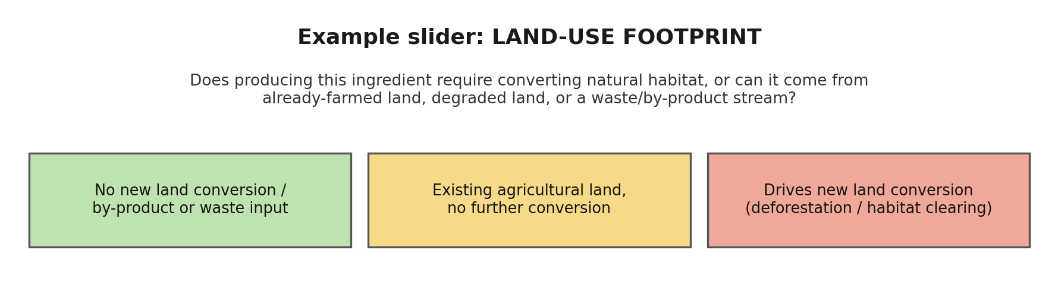
Figure 2. Example slider format used throughout the tool — a title, a leading question, and three colour-coded anchor points.

The final tool: 14 sliders for biodiversity eco-ideation
The finished tool follows the same visual grammar as the carbon original: a short slider title, a leading question, and three colour-coded anchor descriptions running from lowest to highest biodiversity impact.

Category 1: Sourcing & Ingredient Design
IMAGE PLACEHOLDER 3 — Figure 3a: Sourcing & Ingredient Design sliders 1–7 (fig3a_sourcing.png)
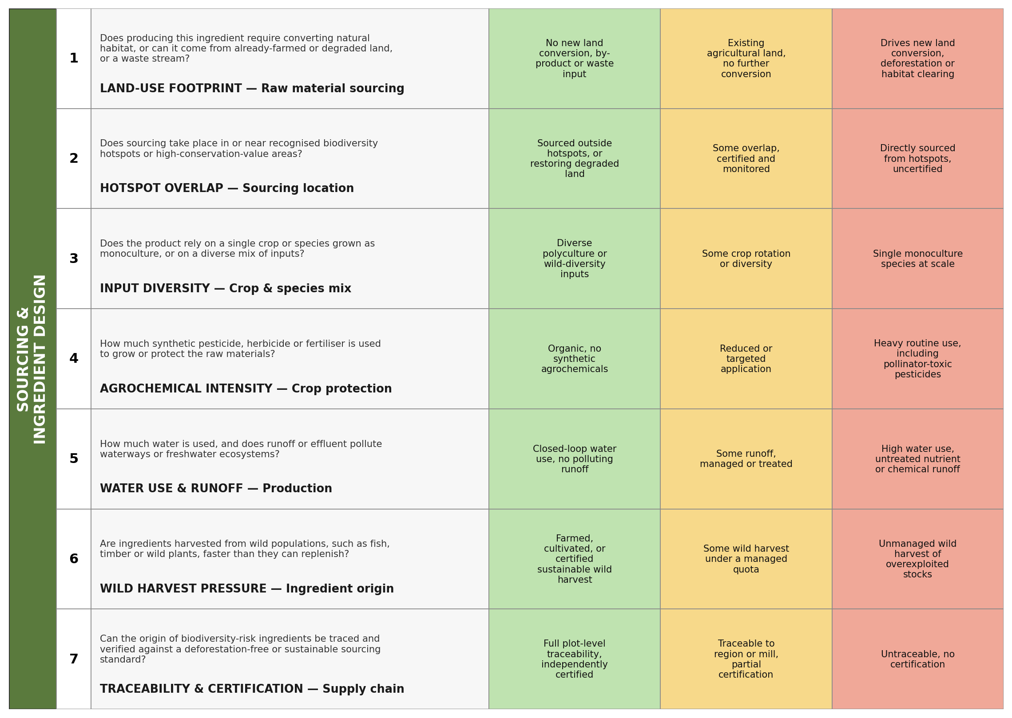
Figure 3a. Sliders 1–7 — Land-Use Footprint, Hotspot Overlap, Input Diversity, Agrochemical Intensity, Water Use & Runoff, Wild Harvest Pressure, Traceability & Certification.

Category 2: Production, Distribution, Use & End-of-Life
IMAGE PLACEHOLDER 4 — Figure 3b: Production, Distribution, Use & End-of-Life sliders 8–14 (fig3b_production.png)
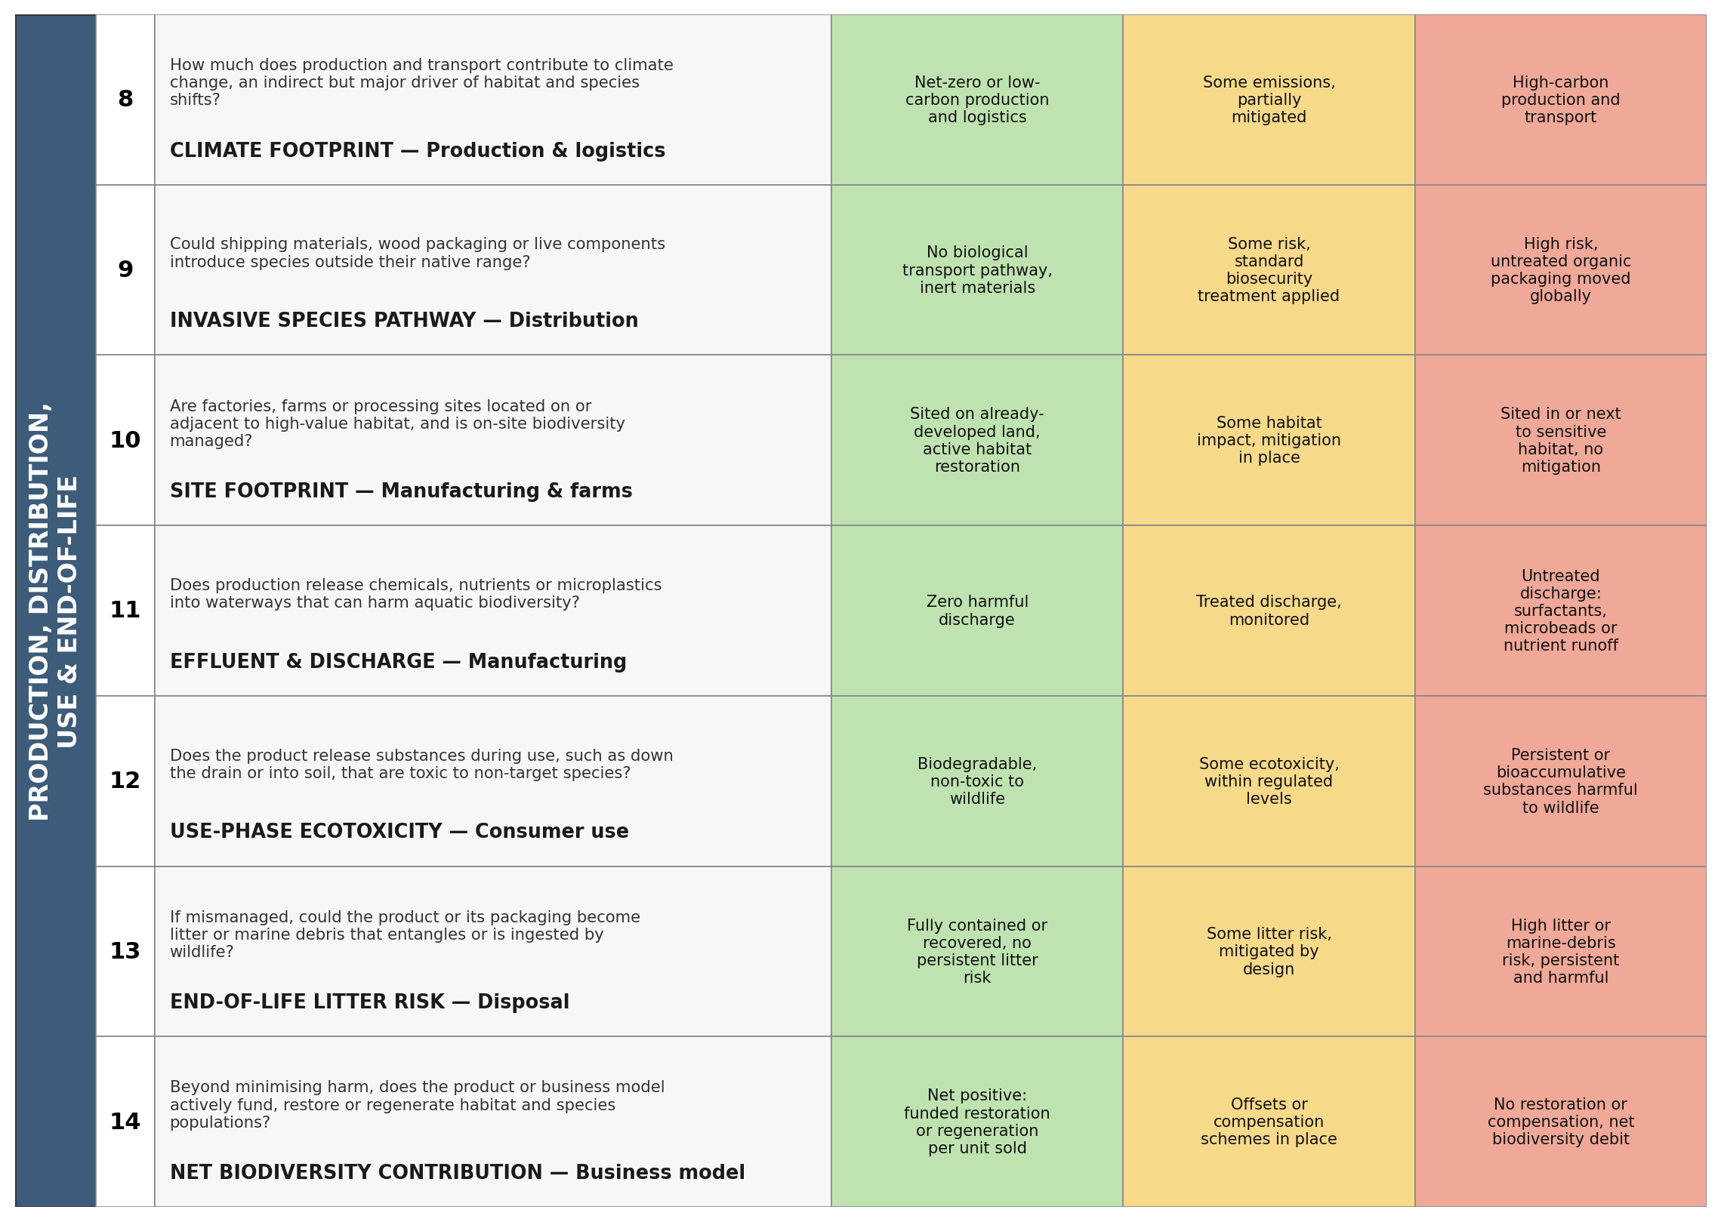
Figure 3b. Sliders 8–14 — Climate Footprint, Invasive Species Pathway, Site Footprint, Effluent & Discharge, Use-Phase Ecotoxicity, End-of-Life Litter Risk, Net Biodiversity Contribution.

Design choices worth calling out
A few decisions are worth flagging, because they show where a biodiversity tool has to depart from the carbon original rather than just relabelling it.
- Sourcing gets seven of the fourteen sliders, not two or three. Because roughly a third of the entire consumption-based biodiversity footprint traces back to land occupied for arable and livestock farming, a tool that spent equal attention on packaging and sourcing — the way the carbon tool reasonably can — would systematically under-weight the one stage that matters most.
- Slider 2 (hotspot overlap) and slider 6 (wild harvest pressure) have no analogue in the carbon tool at all. Emissions are largely indifferent to where they happen; biodiversity loss is not — a hectare cleared in a tropical biodiversity hotspot or a fish stock pulled from an already-collapsing fishery causes disproportionate harm compared with the same activity in an already-degraded or well-managed setting. Carbon accounting has no equivalent “where” question built in.
- Slider 9 (invasive species pathway) addresses an IPBES driver — invasive species — that simply is not a climate-relevant concept, and so is entirely new to this tool: wooden packaging, shipping pallets and live plant material can carry organisms across biogeographic barriers in a way a plastic tub of detergent cannot.
- Slider 14 (net biodiversity contribution) closes the tool by asking about restoration, not just harm reduction. Biodiversity, unlike a tonne of CO2 already emitted, can in principle be rebuilt on the same land within a human lifetime — so the tool's worst-to-best spectrum on this slider deliberately extends past “no impact” into “actively regenerating,” which has no equivalent green extreme in the carbon original.

Using the tool
The mechanics are unchanged from Bocken et al.'s original: one person, ideally without deep expertise in the specific product (so they are not anchored to how sourcing is “usually done”), works through the 14 sliders in turn, imagining the green extreme for each and writing down every idea it prompts before moving on — quantity over quality, and no judging ideas until later, following both Osborn's (1957) original brainstorming rules and Bocken et al.'s replication of them. A facilitator can offer an example from an unrelated product if a slider draws a blank, which the original authors found raised the response rate without steering the content of ideas produced.

What this exercise can't yet tell you
It is worth being clear about a limitation. Bocken et al.'s real contribution was not the slider format itself but the controlled comparison behind it: 15 individual tool sessions run against 15 matched group-brainstorm sessions on the same products, with the resulting ideas counted and rated for radicalness. That comparison is what allowed them to claim the tool actually outperforms group brainstorming, rather than simply looking like a plausible checklist.
This piece has only completed the equivalent of their Section 3.1–3.2: identifying indicators from the literature and assembling them into a candidate tool. It has not been through their Section 3.3–3.4 — pilot testing and iterative refinement with real users spanning different functions — or their Section 4 comparative evaluation. Some sliders here may prove redundant once real users sit down with them, in the same way Bocken et al. found several of their original 36 indicators collapsed together once tested; the wording of the leading questions would likely need the same kind of refinement the original team describes, including clarifying examples, reordering from easiest to hardest, and rephrasing anything that produces narrow or repetitive answers.
In short: this is a first-draft tool, built the way the original was built, not yet validated the way the original was validated. Running it — individually, or head-to-head against a group brainstorm on the same product — is the missing step that would actually show whether it works.

References
Bocken, N.M.P., Allwood, J.M., Willey, A.R., & King, J.M.H. (2011). Development of an eco-ideation tool to identify stepwise greenhouse gas emissions reduction options for consumer goods. Journal of Cleaner Production, 19(12), 1279–1287.
Biodiversity management: A supply chain practice view. ScienceDirect (summarising IPBES's five direct drivers of biodiversity loss).
Unravelling biodiversity impacts of consumption: a production layer decomposition analysis for the Netherlands. Journal of Industrial Ecology.
China's biodiversity loss across provinces driven by agricultural production and consumption. Journal of Industrial Ecology.
Linking global drivers of agricultural trade to on-the-ground impacts on biodiversity. PNAS / PMC.
Biodiversity impacts of recent land-use change driven by increases in agri-food imports. Nature Sustainability.
Jungbluth, N., et al. (2017). Product Biodiversity Footprint — a three-module method linking LCA and biodiversity pressures.
Sitra / University of Jyväskylä. Nature/biodiversity footprint indicator project with S Group (Potentially Disappeared Fraction of species, PDF).
The Biodiversity Crisis Is a Business Crisis. BCG (2021).
Pollinator decline and pesticide literature, including neonicotinoid impact reviews synthesising over 800 peer-reviewed studies (Beyond Pesticides; As You Sow shareholder resolutions).
Osborn, A. (1957). Applied Imagination (2nd ed.). Scribner.

