From Carbon to Waste: Building a New Slider Tool for Eco-Ideation
Adapting Bocken et al.'s (2011) eco-ideation methodology to tackle a different consumer-goods problem: waste
A Medium-style feature | Design methodology, worked example, and a ready-to-use tool
In 2011, a team from Cambridge and Unilever published a deceptively simple idea. Instead of asking a room full of people to brainstorm “greener” products together, they gave individuals a set of sliders — one for each driver of greenhouse gas emissions — and a pointed question attached to every slider. No group, no facilitator dominating the room, no early judgment of ideas. Just one person, a set of visual scales running from “worst imaginable” to “best imaginable,” and a question that forced them to imagine the extreme.
The result, described in Development of an eco-ideation tool to identify stepwise greenhouse gas emissions reduction options for consumer goods (Bocken, Allwood, Willey & King, 2011, Journal of Cleaner Production), was a 14-slider tool that reportedly out-performed conventional 12-person group brainstorming on both the quantity and the radicalness of ideas generated, across 15 paired trials.
Carbon was the obvious first target for this kind of tool: it is the emissions metric governments regulate, and it is comparatively well understood by life-cycle assessment (LCA) practitioners. But greenhouse gas emissions are not the only impact consumer goods companies are under pressure to fix. Waste — packaging waste, food and product waste, and end-of-life waste — is arguably the impact category consumers see most directly, and the one now facing the fastest-moving regulation, from the EU's Packaging and Packaging Waste Regulation to extended producer responsibility (EPR) schemes spreading across dozens of countries.
So this piece asks a narrower question: what would Bocken et al.'s method produce if it were pointed at waste instead of carbon? Below, I follow their own development process — Section 3.1 and 3.2 of the paper — step by step: identify the indicators that drive waste, translate them into sliders, attach a leading question to each, and pare the result down to a workable tool.

Why waste needs its own tool, not a rebadged carbon one
It's tempting to assume the carbon tool already covers waste — after all, the original 14 sliders include categories like “durability and end of life” and “components.” But the drivers of waste and the drivers of carbon frequently pull in different directions, which is exactly why a dedicated tool is useful.
The clearest example is packaging lightweighting. Removing material from a pack is almost always a win for embodied carbon. But recent consumer behaviour research complicates the picture: a 2026 study in the Journal of the Academy of Marketing Science found that once light, low-density packaging reaches consumers, people are measurably more likely to treat it as low-value and dispose of it improperly — including into general waste rather than recycling — than they are with denser, heavier packaging that “feels” more valuable. A slider tuned purely to grams of material per pack would therefore send an eco-ideation session in exactly the wrong direction for waste, even though it is the right direction for carbon.
Food and product waste tell a similar story. Widely cited FAO estimates put food loss and waste at around a quarter to a third of everything produced, and in developed markets roughly 40% of that waste occurs at the retail-and-consumer end of the chain rather than in farming or processing — which means packaging design, portioning, and shelf-life communication (not raw material choice) are the levers that matter most. None of that shows up cleanly on a carbon-per-kilogram slider.
Finally, waste has its own governing logic that carbon doesn't share: the waste hierarchy (reduce, reuse, recycle, recover, dispose), used by regulators to rank interventions by preference. A waste eco-ideation tool should be structured so that its “best imaginable” extremes trace that hierarchy, pushing ideation toward reduction and reuse before it settles for recycling.

Step 1 — Identifying the indicators (Section 3.1 equivalent)
Bocken et al. built their initial indicator list from two sources: internal conversations with company experts, and a literature search for existing eco-design checklists relevant to the target impact. I followed the same two-source structure for waste, using open literature accessible via Google Scholar and OpenAlex rather than an internal company review — Table 1 below stands in for their “company expert” source, drawing instead on published circular-economy and waste-management practice, while Table 2 mirrors their academic literature source.

Table 1 — Indicators drawn from applied circular-economy and waste-management practice
Area of concern | Indicator | What it captures
Packaging format | Pack-to-product ratio, void space, over-wrap | Whether packaging design is proportionate to what it protects
Material mix | Material diversity, mono- vs multi-material construction | Whether a product's materials can realistically be separated and recycled
Product lifetime | Durability, repairability, upgradability | Whether replacement is driven by failure or by design choice
Reuse systems | Refill/reuse infrastructure, deposit-return, take-back | Whether a single unit of packaging or product serves one use or many
Consumer disposal | Labelling clarity, disposability cues, contamination risk | Whether consumers can (and do) dispose of the item correctly
Manufacturing | Scrap rate, off-cuts, reject rates, by-product reuse | Waste generated before the product ever reaches a consumer
Distribution | Secondary/transit packaging, e-commerce void-fill | Waste generated moving the product through the supply chain

Table 2 — Indicators identified from the literature
Indicator | Literature source
Packaging density and consumer disposability perception | Packaging decisions and post-consumption disposal behaviour, Journal of the Academy of Marketing Science (2026)
Resealability and sustainability cues on pack, linked to food waste | Eco-design packaging and consumer food waste, Technological Forecasting and Social Change (2020)
Retail/consumer-stage share of total food loss | FAO food loss and waste reporting, cited in food-packaging waste literature
Design-for-disassembly and material homogeneity | Design for and from Recycling: A Circular Ecodesign Approach, Sustainability (2020)
Recyclability indexing as a design metric | Villalba, Segarra, Chimenos & Espiell, Resources, Conservation and Recycling
Slowing, closing and narrowing resource loops | Bocken, de Pauw, Bakker & van der Grinten (2016), Journal of Industrial and Production Engineering
Waste hierarchy and its use in comparing disposal options | UK / Scottish Government waste hierarchy guidance
Excessive packaging and hazardous materials as manufacturing waste drivers | General literature on production inefficiency as a waste driver
Design-for-disassembly hierarchy of recycling potential | Crowther (2018), European Journal of Sustainable Development — principles transferable from construction to consumer goods

As in the original paper, the two tables overlap considerably — durability, material mix, and end-of-life handling show up from both directions — which gave confidence that the initial list was reasonably complete for a first pass.

Step 2 — Building the initial tool (Section 3.2 equivalent)
Bocken et al.'s initial tool had roughly 36 indicators grouped into four life-cycle stages (sourcing, manufacturing, distribution, use-and-disposal), which they then merged down to 15 through their pilot testing, and finally to 14 through the individual workshops.
Following the same logic, the waste indicator lists above were first expanded into a longer initial set of around 30 candidate sliders, then merged wherever two indicators tended to provoke the same underlying idea. Two examples of merges, mirroring the kind of consolidation Bocken et al. describe:
- “How many materials are in the pack?” and “Can the materials be separated by hand?” were merged into a single material diversity slider, since a tool-user's ideas about reducing material count and improving separability turned out to be the same idea in practice — fewer, more compatible materials.
- “Is the pack oversized for the product?” and “Is there unnecessary void space or headspace?” were merged into a single pack-to-product ratio slider.
This consolidation — done here as a desk-based exercise rather than through Bocken et al.'s structured individual workshops with company practitioners — reduced the candidate list from around 30 to a final 14, organised, as in the original, into two broad categories: Product & Pack Design and Supply Chain, Use & End-of-Life.
IMAGE PLACEHOLDER 1 — Figure 1: Development process for the waste eco-ideation tool (fig1_methodology.png)
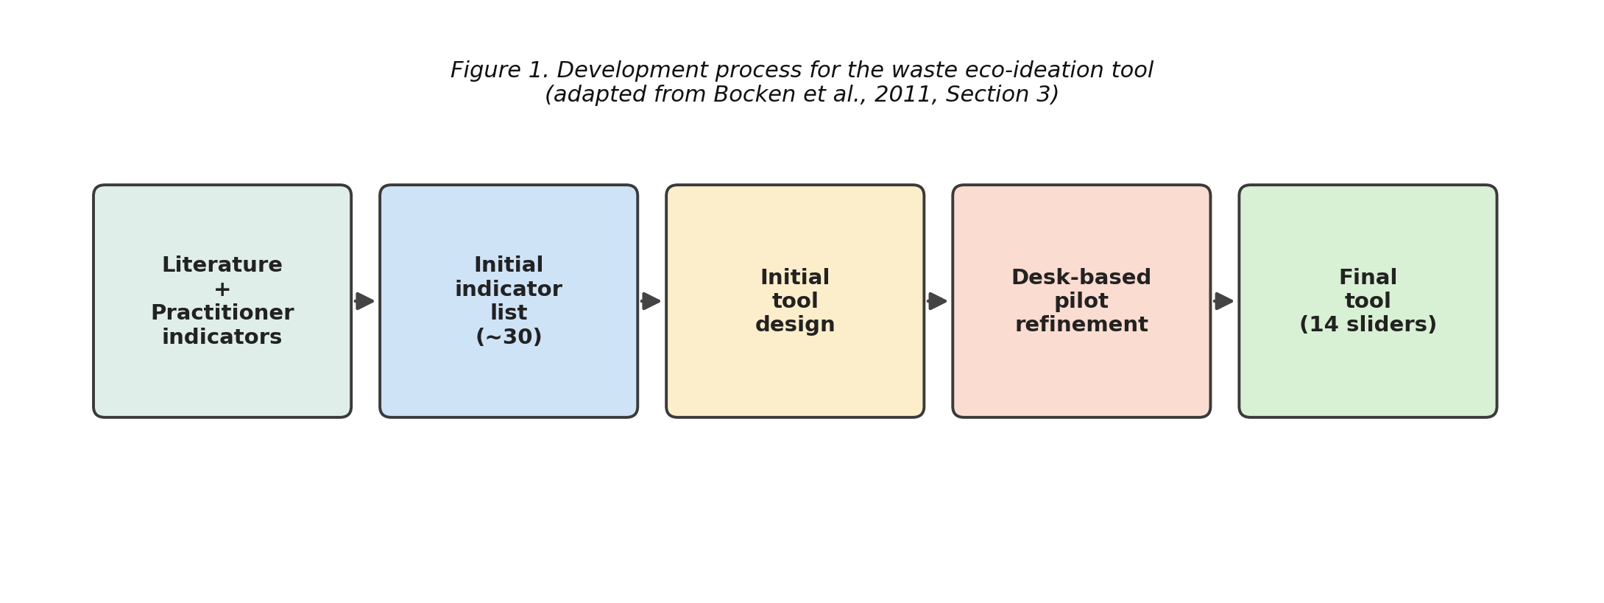
Figure 1. Development process for the waste eco-ideation tool, from literature + practitioner indicators through to the final 14-slider tool.
Each slider, as in the original tool, runs from a “best imaginable” green extreme to a “worst imaginable” red extreme, with an amber midpoint, and is paired with a leading question designed to trigger a short “mini-ideation” burst rather than a straightforward multiple-choice answer.
IMAGE PLACEHOLDER 2 — Figure 2: Example slider for “Packaging-to-Product Ratio” (fig2_slider_example.png)
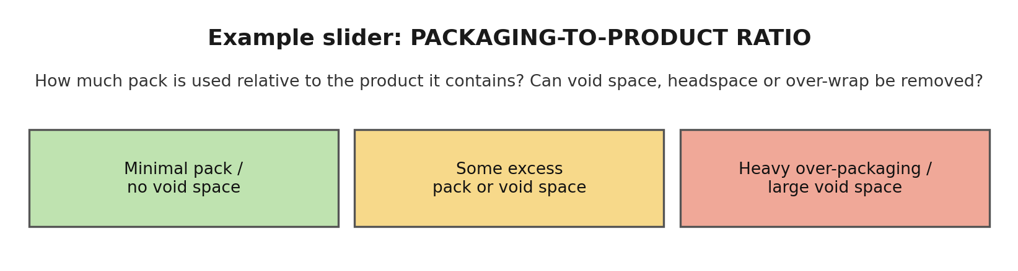
Figure 2. Example slider format used throughout the tool — a title, a leading question, and three colour-coded anchor points.

The final tool: 14 sliders for waste eco-ideation
The finished tool, shown in full below, follows the same visual grammar as Bocken et al.'s original: a short slider title, a leading question underneath it, and three colour-coded anchor descriptions running from lowest to highest waste impact.

Category 1: Product & Pack Design
IMAGE PLACEHOLDER 3 — Figure 3a: Product & Pack Design sliders 1–7 (fig3a_product_design.png)
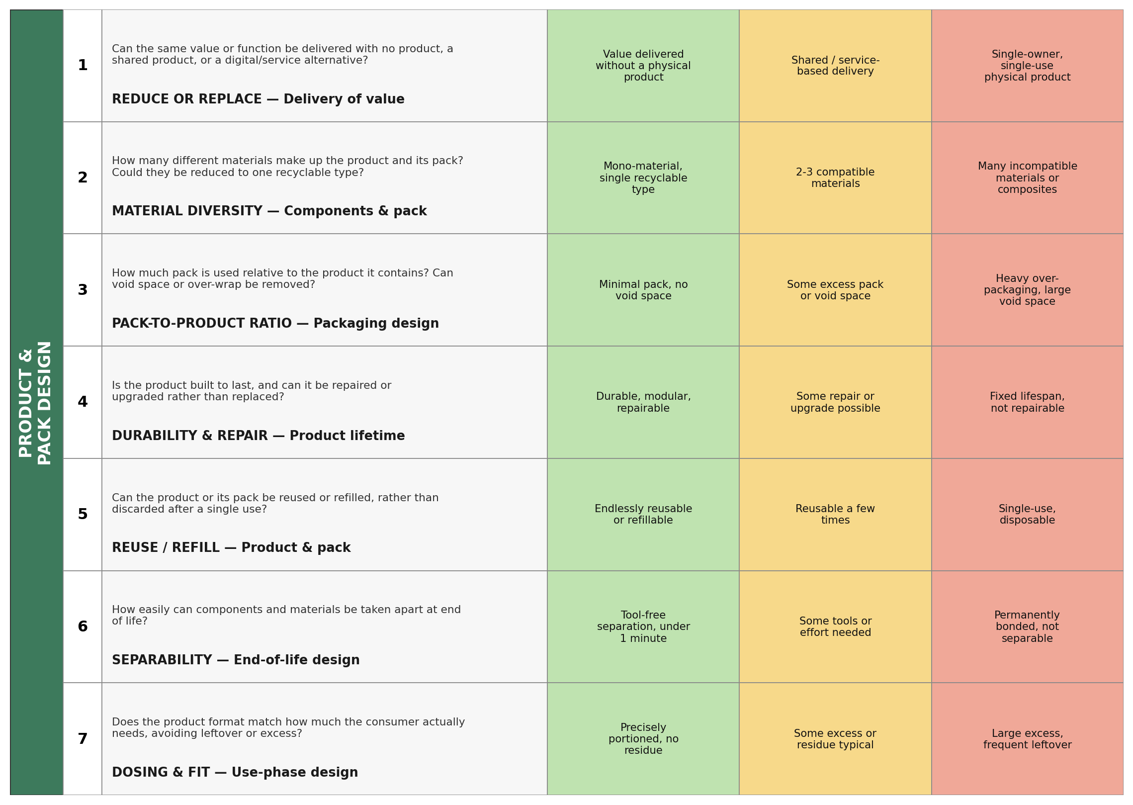
Figure 3a. Sliders 1–7 — Reduce or Replace, Material Diversity, Pack-to-Product Ratio, Durability & Repair, Reuse/Refill, Separability, Dosing & Fit.

Category 2: Supply Chain, Use & End-of-Life
IMAGE PLACEHOLDER 4 — Figure 3b: Supply Chain, Use & End-of-Life sliders 8–14 (fig3b_supply_chain.png)
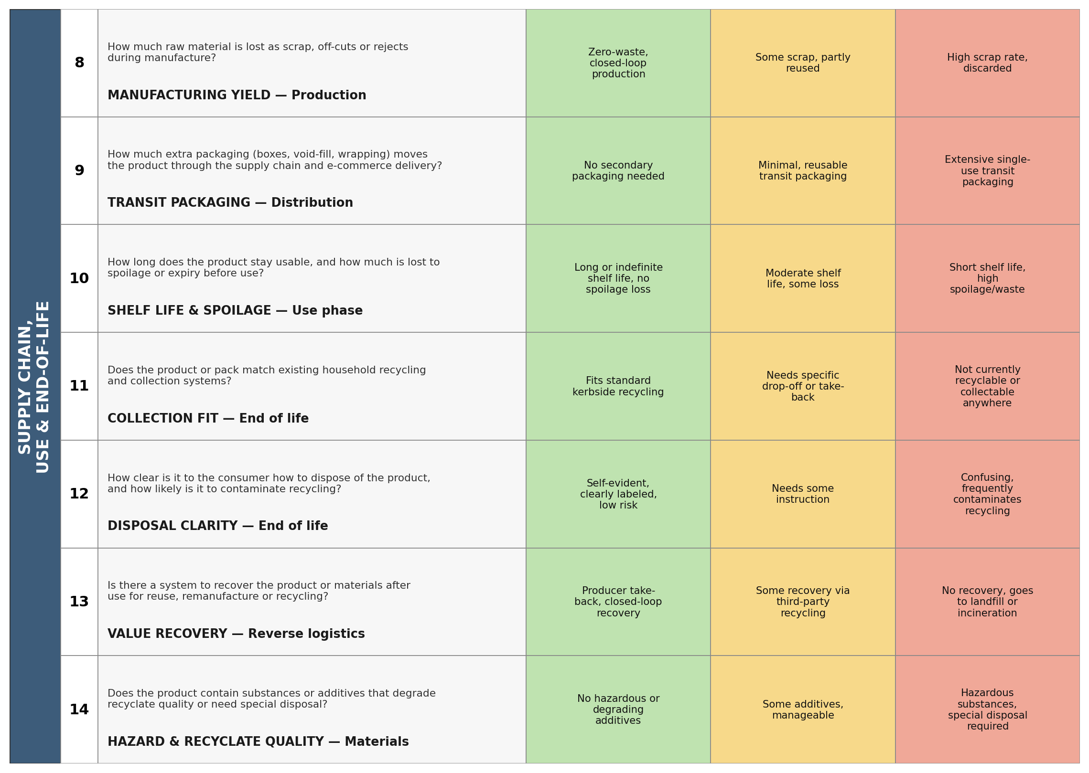
Figure 3b. Sliders 8–14 — Manufacturing Yield, Transit Packaging, Shelf Life & Spoilage, Collection Fit, Disposal Clarity, Value Recovery, Hazard & Recyclate Quality.

Design choices worth calling out
A few decisions are worth flagging, because they show where the waste tool deliberately departs from the carbon original rather than just relabelling it.
- Slider 1 sits above material and packaging questions on purpose. The waste hierarchy ranks reduction above every downstream fix, so — unlike the carbon tool, which opens with “delivery of value” mainly to prompt dematerialisation — this tool's first slider is explicitly framed around eliminating the need for a disposable unit altogether (shared use, service models, refill-at-source), before any question about what the pack is made of.
- Slider 9 (transit packaging) exists as its own line item. In the 2011 tool, transport-related emissions were captured through distance and load-factor sliders. For waste, the more decisive variable is how much disposable secondary packaging — boxes, air pillows, plastic wrap — a product accumulates as it moves through distribution and, increasingly, e-commerce fulfilment, which barely registered as a design concern in 2011 but is now a major residential waste stream.
- Slider 12 (disposal clarity) has no equivalent in the carbon tool. Carbon emissions don't especially care whether a consumer sorts their rubbish correctly; waste outcomes depend heavily on it. Contamination of a recyclable stream by the wrong item can send an entire batch to landfill, so a slider addressing consumer-facing clarity — labelling, sorting cues, intuitive design — earns its place even though it has no carbon analogue.

Using the tool
The mechanics are unchanged from Bocken et al.'s original: a single person (ideally without deep product expertise, so they aren't anchored to “how things are usually done”) works through the 14 sliders one at a time, imagining what a product or process would look like at the green extreme, then noting down every idea that comes to mind before moving to the next slider — quantity over quality, judgement suspended until later, exactly as Osborn's (1957) brainstorming rules and the original paper both prescribe. A facilitator can gently probe with an example from an unrelated product category if a slider produces no ideas, which Bocken et al. found raised response rates without steering the content of the ideas.

What this exercise can't yet tell you
It's worth being upfront about a limitation. Bocken et al.'s real contribution wasn't the sliders themselves — it was the empirical comparison: 15 individual sessions run against 15 matched group-brainstorm sessions, with ideas counted and rated for radicalness. That comparison is what let them claim the tool actually out-performs group brainstorming, rather than merely being a plausible-looking checklist.
This piece has only completed their Section 3.1–3.2: identifying indicators and building a candidate tool from literature and desk research. It has not been through their Section 3.3–3.4 — pilot testing and iterative refinement with real users across different functions — let alone the comparative evaluation in their Section 4. Some sliders here may turn out to be redundant with each other once real users sit down with them (an outcome the original authors hit more than once), and the wording of the leading questions would likely need the same kind of iteration Bocken et al. describe: adding clarifying examples, reordering questions from easiest to hardest, and rephrasing anything that produces narrow or repetitive answers.
In other words: this is a first draft of a tool, built the way the original was built, not yet validated the way the original was validated. If you run it — individually, or against a group brainstorm on the same product — that comparison is the missing piece that would actually tell us whether it works.

References
Bocken, N.M.P., Allwood, J.M., Willey, A.R., & King, J.M.H. (2011). Development of an eco-ideation tool to identify stepwise greenhouse gas emissions reduction options for consumer goods. Journal of Cleaner Production, 19(12), 1279–1287.
Bocken, N.M.P., de Pauw, I., Bakker, C., & van der Grinten, B. (2016). Product design and business model strategies for a circular economy. Journal of Industrial and Production Engineering, 33(5), 308–320.
Crowther, P. (2018). A taxonomy of construction material reuse and recycling: designing for future disassembly. European Journal of Sustainable Development, 7(3), 355–363.
Osborn, A. (1957). Applied Imagination (2nd ed.). Scribner.
Villalba, G., Segarra, M., Chimenos, J.M., & Espiell, F. Using the recyclability index of materials as a tool for design for disassembly. Resources, Conservation and Recycling.
Journal of the Academy of Marketing Science (2026). Through thick and thin? When sustainable packaging design increases consumer waste generation.
Technological Forecasting and Social Change (2020). Can eco-design packaging reduce consumer food waste? An experimental study. ScienceDirect.
Sustainability (2020). Design for and from recycling: A circular ecodesign approach to improve the circular economy. MDPI.
Scottish Government. Waste hierarchy guidance — environmental indicators for waste management options.

