Egg Catcher

Mian Shahzeb Ihsan

Game Description
Egg Catcher is a fun, casual arcade genre game developed for the Android platform. The game is a heavily modified concept of a flash game by the same name which has been adapted to the iPhone as well. Details of the game play are given below.

Story
- The setting of the game is a farm.
- A young farm boy has been tasked to collect eggs from the hens on the farm.
- Three hens have climbed on to a clothes’ line and have started laying eggs.
- A crow is on the lookout for an opportunity to steal the eggs.
- An eagle flying by has spotted the hens and is scheming to attack them.

Objective of the Game
- The objective of the game is to use the farm boy’s character to catch the eggs the hens are laying and collect them in a basket to the left of the screen.
- A maximum of five eggs can be held at any time.
- Once five eggs have been collected, they have to be dumped in the basket to the left of the screen. A minimum of three eggs are required before they can be dumped.
- The score is incremented only when eggs are dumped into the basket.
- A maximum of five eggs can be dropped, after which the game ends.
- The eggs also have to be protected from the crow and the hens have to be protected from the eagle.
- If the eagle is not frightened away within 3 seconds, the number of hens is reduced by one.
- The game ends when all the hens are gone.
- If the crow is not frightened away within 3 seconds, the score is reduced by 5 eggs.
- Each egg dumped into the basket adds 10 to the score.
- Frightening away the crow adds 25 to the score and frightening away the eagle adds 50 to the score.
- After every 500 points, a golden (yellow) egg is laid by one of the hens. A blue egg is laid by one of the three hens after every 1000 points.
- The blue egg increases the number of chances by one; the golden (yellow) egg adds 100 to the score.

Game Play
- The farm boy is controlled by tilting the phone left or right.
- The eggs are caught by intersecting them before they reach the ground.
- Once enough eggs have been collected, they can be dumped in the basket by running to the basket and touching the screen.
- The crow and the egg can be frightened away by moving the character to either bird before the allowed time has expired.
- The game can be paused by pressing either of the MENU or BACK keys. When the game is paused, pressing MENU key exits the game and the game menu is shown. Pressing the BACK key resumes the game.

Game Design and Architecture
The Egg Catcher game has been designed for the Android platform. Android was selected as the platform for this game due to its growing popularity in the smart phone market, the availability of a superb SDK with excellent documentation.

Android Application Fundamentals
Before discussing the architecture of the game, it would be worth taking a very brief detour to discuss the architecture of an Android application.

Android applications are written in Java using the Android SDK. The SDK compiles the Android application and any resource (XML layouts, images, sounds etc.) into a package.

The applications are run by the Android’s Dalvik JVM. Each application runs in its own virtual memory space as a separate Linux process with a unique user ID. The Android system sets the permissions for the application and what system components it is allowed to access. The application has to request access to these components at compile time and the user has to grant permission for these components at install time. Components that require permissions include access to the internet, messaging, contacts, vibration, location etc.

The interface of an application that a user sees or interacts with is known as an activity, which can be loosely considered to be something like a window. Displayed elements inside an activity are views, e.g. buttons, text fields, static text labels etc. All Android application activities need to extend the Activity class. Once an application is launched, its default Activity is launched and its onCreate(…) method is called. The life cycle of an activity is shown in Figure 2.1. Any activity can launch another activity using an Intent.

The layout of views inside an activity are defined using XML files, though the latest version of the SDK includes a graphical layout tool which automatically generates the XML layout.
Figure 2.1 State Diagram of an Android Activity's Lifecycle.
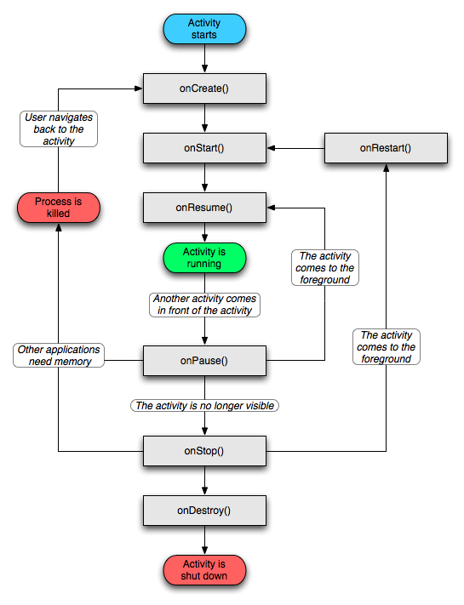

Activities of the Egg Catcher Game
The Egg Catcher game contains three activities. These activities and their views are explained below.

SplashScreen
This is the default activity of the game, it consists of only two views, an ImageView that shows an image containing the name of the game and a TextView that shows the names of the developers. The SplashScreen activity is only displayed for 5 seconds, after which it starts the StartDialog activity and calls finish() to end the SplashScreen activity.

StartDialog
The start dialog is the main game menu and contains three buttons. The first button, “Start Game”, starts a new game, i.e. starts the EggCatcher activity. The second button, “Instructions”, pops up a dialog which displays the game instruction. The “Exit Game” button causes the StartDialog to end.

EggCatcher
This is the activity that implements the game. It consists of a few text views for displaying the score, the number of eggs caught and the number of chances left. It also has a few text views for displaying messages like “Game Over”, “Game Paused” etc. These are set invisible by default and are made visible when required. It has a custom view, GameView, which extends SurfaceView to implement the drawing surface for the game. GameView also implements the game loop as a subclass, GameThread. The EggCatcher class is also responsible for processing the tilt/orientation sensor data and passing it to the game loop.

Additional Game Classes

GameView
The GameView class is a custom view that extends SurfaceView for drawing the game background, the sprites and the game animation. It also implements all the callbacks for touchscreen and key events. GameView implements the game loop as a subclass, GameThread, and is explained in section 2.3.2. GameView also instantiates the GameThread object and initializes all game resource like sprites, bitmaps and audio clips. All images are in PNG format and audio clips in MP3 format. Since Android UI runs in its own thread for each application and UI calls are not thread safe, UI elements can’t be directly updated from another thread. That’s why this class also implements a message handler which is used by GameView.GameThread to send pre-defined messages to update the game score, number of eggs caught and the number of chances left.

GameView.GameThread
This class implements the game loop in a separate thread and extends the Thread class. The game loop is responsible for drawing the background, animating the sprites and handling game play. Based on user interactions and interactions of the sprites as per the game rules, it also updates the game labels containing the game score, number of chances left, number of eggs caught and, when the birds (crow or eagle) appear, the time left before the birds attack. The movement of the farm boy (game avatar), is also handled by the game loop. The movement of the avatar depends on the Android orientation sensor, which is communicated by the EggCatcher activity class to the game loop. The touch input is also used in the game loop when the user wants to dump the eggs into the basket. The listener for touch screen events is attached to the GameView view and touch events are communicated to the game loop as they occur.

The game loop also decides which hen will lay an egg next and whether the crow or eagle should appear or if either should appear at all. The rules which govern these parameters are:
- The next hen which will lay the egg is selected randomly from the number of hens still present (i.e. not eaten by the eagle).
- The birds (either eagle or crow) can appear after a minimum of 20 seconds. The decision on whether the bird should appear or not depends on a random number between 0 – 9, which indexes a 10 element Boolean array containing a distribution of true and false. The resulting Boolean value is then used to decide whether the bird will appear.
- Once it is decided that a bird is going to appear, a similar method is used to randomly decide which bird it is going to be, with the crow having double the probability of the eagle. The process of a bird’s selection and its interaction with the game is summed up in Figure 2.2.

Figure 2.2 Flow Diagram of a Bird's Appearance, Attack and Interaction with the Farm Boy.
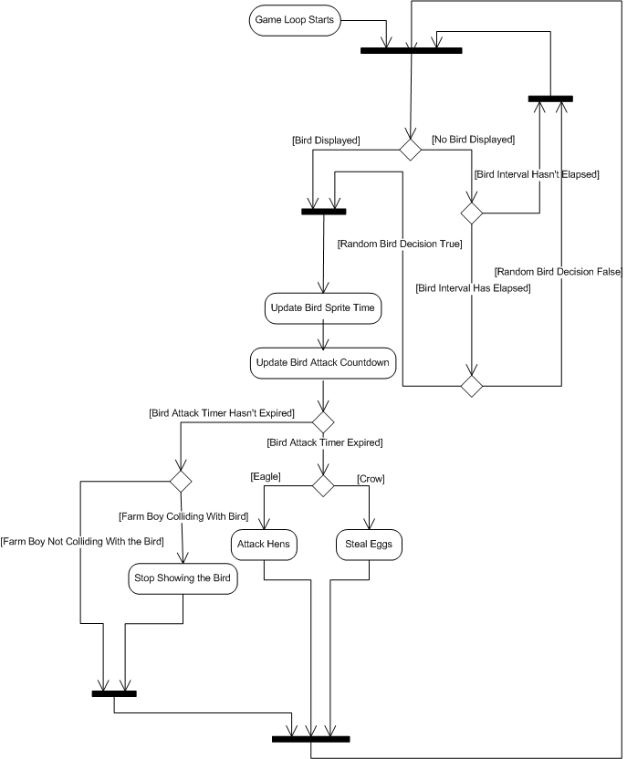

Sprite2D
Android doesn’t have a built-in class for handling sprites, hence, a class was created for this purpose. The sprite sheet and the number of columns, rows, total number of sprites, sprite height and width and collision height and width are defined in an XML file. This XML file is passed to the Sprite2D(…) constructor as an XmlResourceParser object. The syntax for this XML file for describing the sprite is shown in the XML code snippet below:

<?xml version="1.0" encoding="utf-8"?>
<resources>
<Sprite
id="@drawable/avatar_sprite"
title="avatar"
num_sprites="9"
num_columns="9"
num_rows="1"
sprite_width="150"
sprite_height="131"
collision_width="130"
collision_height="100" />
</resources>

Sprites were defined this way to make it easy to change sprite parameters and resources without changing the code. Once a sprite is created, it can be initialized using its initSprite(…) method, which takes the frames per second for the sprite animation and default X/Y positions of the sprite as parameters. The Sprite2D class handles the FPS (frames per second) by expecting the sprite’s time to be update regularly using its updateTime(..) method. The drawSprite(…) draws the sprite’s next frame if the minimum time between frames has passed (as updated through updateTime(…)), otherwise it redraws the current frame. It also provides other utility functions such as getXPos(…), getYPos(), setXPos(), setYPos(…) and getCollisionRect().

Util
The Util class implements basic utility methods for vibrating the phone checking if two game objects (sprites, egg etc.) are colliding and it also implements a subclass, Util.AudioClip, for playing audio clips.

Util.AudioClip
Util.AudioClip is an abstraction class for Android’s MediaPlayer class. It is used to play sounds for the game.

Bird
The Bird class is used as a blueprint for either the crow or the eagle. It contains various public members such as the bird’s sprites are a Sprite2D object, the bird’s call as a Util.AudioClip object, its X/Y position and various flags to indicate the state of the bird. There is only one method, reset(), which is used to reset the bird’s state and position to default values set during instantiation.

Egg
Similar to the Bird class, the Egg class is used to encapsulate the state of different types of eggs (white, yellow and blue).

Game Design Details
The class diagram shown in Figure 2.3 shows the interactions between the classes.

Figure 2.3 Egg Catcher Class Diagram (Public Members Only).
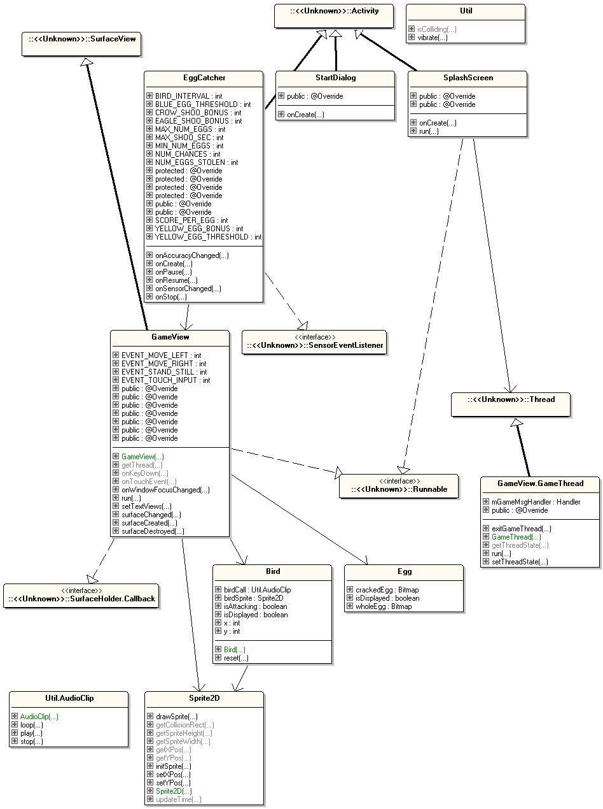
The entry point for the game is the SplashScreen activity and it would be started by the Android system when the game is launched. It displays the game title and developer credits and is only active for 5 seconds, after which it starts the game menu activity, StartDialog, and exits.

The StartDialog activity consists of three buttons, “Start Game”, “Instructions” and “End Game”. The “Instructions” button pops-up a dialog which displays instructions on how to play the game and the “End Game” exits the game. The “Start Game” button starts the EggCatcher activity, which is the game itself. Once the EggCatcher activity starts, the StartDialog activity doesn’t end, but goes to the background as soon as the EggCatcher activity is displayed. So whenever the EggCatcher activity would end, or go to the background, StartDialog will come into the foreground.

The EggCatcher activity creates the GameView view for the game. It also sets the layout for the game score related labels and the game pause and game over labels. After instantiating GameView, EggCatcher sets the references to the game score labels etc. using GameView’s setTextView(…) method.

Besides these UI elements, the EggCatcher class is also responsible for handling the sensor data. It registers itself as a listener for any changes to the orientation sensor. In the callback method for sensor data change, it processes the pitch and roll parameters of the orientation sensor. The azimuth is ignored. The direction of the tilt is calculated from the pitch and roll by using the sign of the change in the angle calculated using the pitch and the roll. The angle is found by treating the pitch and roll as X and Y, which form a point in a Cartesian coordinate system. The angle can then be calculated by taking an inverse tangent of (Y ÷ X) and converting the value to degrees, i.e:

Angle in radians = tan⁻¹ (Y / X)
Angle in degrees = (Angle in radians) / (180 x π)

Once we have the values for the pitch and roll, the above calculation is done using the methods provided by the Math package. After the angle is calculated, if the value is positive; the direction of movement is set to the left. If the value is negative; the direction of movement is to the right.

The constructor of GameView class is responsible instantiating its subclass, GameThread. It also initializes all the resource like sprites, audio clips and bitmaps. Once the resources are initialized, it creates the Egg and Bird objects. The GameView extends SurfaceView for drawing the game background and the foreground objects like sprites etc. GameView also implements the SurfaceHolder.Callback interface so it also creates callback methods for when the surface is changed, created and destroyed. The GameThread or game loop is started when the surface is created. The GameThread is stopped when the surface is destroyed. As mentioned before, the UI can only be updated from its own thread, so the message handler it implements is used by GameThread to notify GameView of messages to update score labels etc. and when it ends because all the chances have run out. The listener for the touchscreen and key events are also in this class. When either the MENU or BACK key is detected, the GameThread is paused and if the MENU key is pressed again, the GameThread is stopped and if the BACK key is pressed, the game resumes.

The GameView.GameThread class is already explained in detail section 2.3.2.
The sequence diagram of all the Android activities is shown in Figure 2.4.

Figure 2.4 Egg Catcher Game Activities.
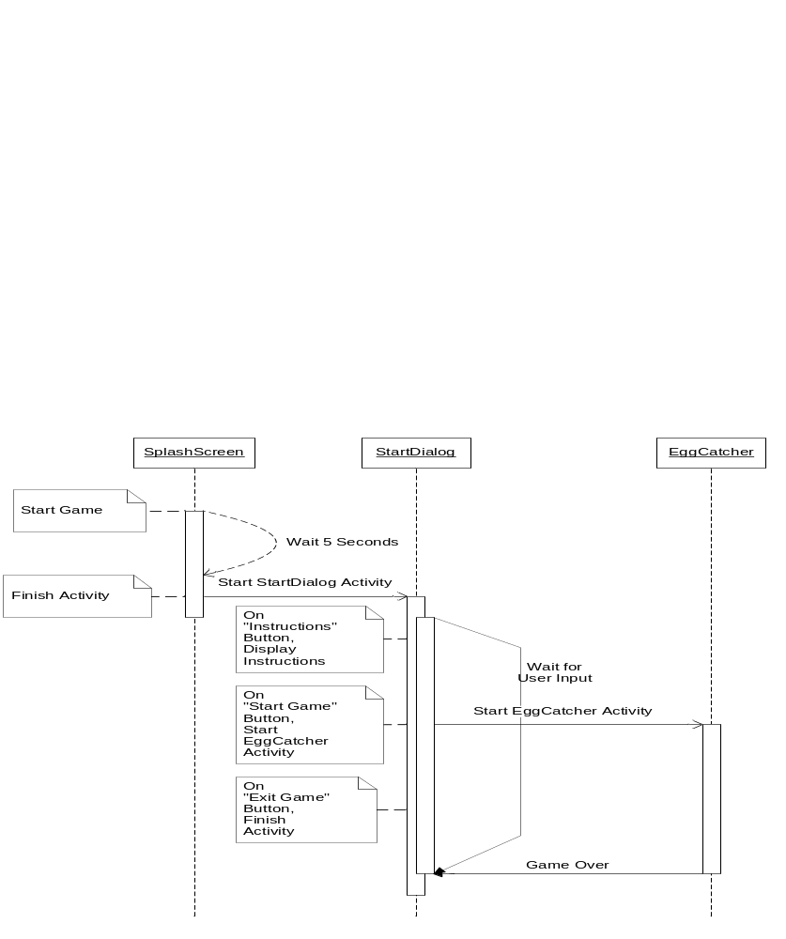
The sequence diagram of the game starting from the EggCatcher activity to the game loop is shown in Figure 2.5.

Figure 2.5 Egg Catcher Activity Representation.
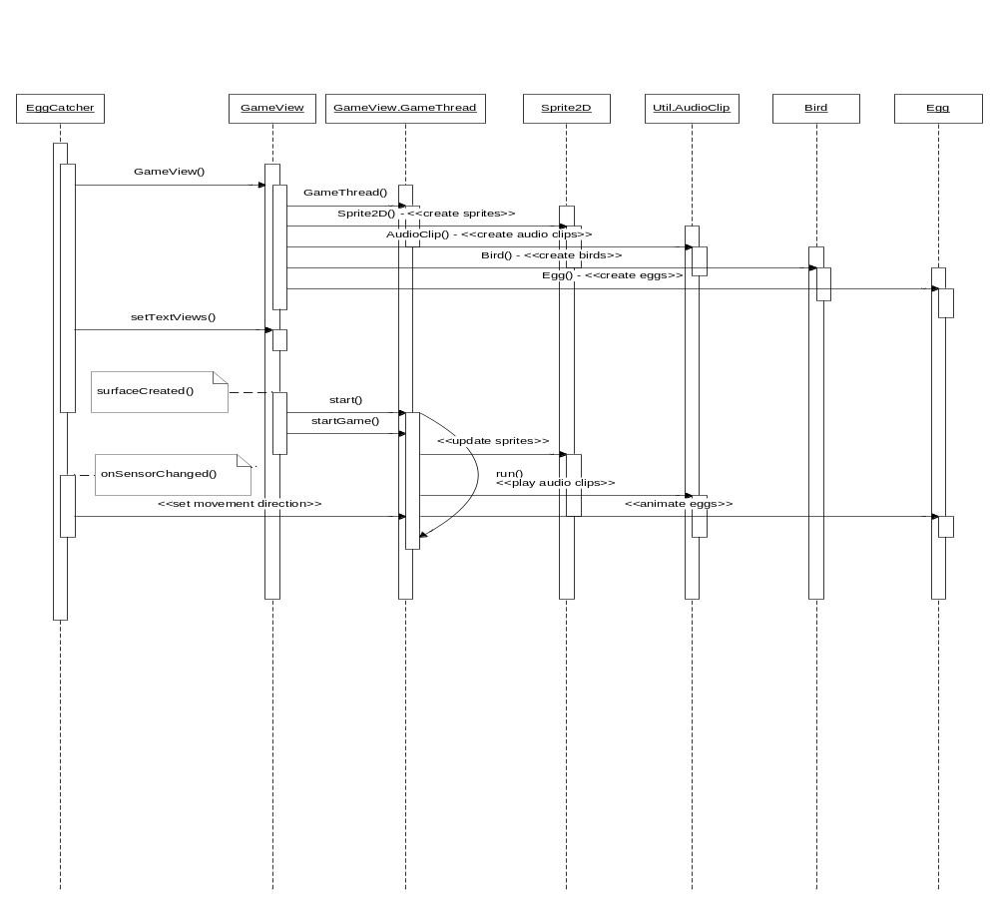

Application Level Configuration
Some additional application level configuration needs to be done for the game in the Android SDK. These are listed below:
- To make sure that the game always runs in landscape mode, the screenOrientation attribute for all the activities in the application’s manifest file is set to landscape.
- So that no titlebar is shown and the application runs in fullscreen, the theme attribute for the entire application is set to Theme.NoTitleBar.Fullscreen.
- To allow the game to vibrate the phone when an egg drops or is caught, the android.permission.VIBRATE is set for the application.

Problems Encountered During Game Design

Learning How to Develop Games on Android
This was one of the biggest challenges before development on the game started. There was a lot of self study involved to learn how to develop Android applications, in general and Android games, in particular.

Selecting which Sensor to Use and How to Process the Data
Initially, the idea was to use the accelerometer to move the farm boy. This worked fine with the emulator using the OpenIntents SensorSimulator. But it didn’t work properly when the game was run on the phone using the actual hardware accelerometer. The choice of the accelerometer was incorrect since it is used to measure the acceleration of the device along a certain axis. Further research showed that the orientation sensor should be used to measure the phone’s tilt. Once the correct sensor was determined, the next step was to figure out how to use the sensor values to calculate the phone’s tilt. This involved understanding the way the orientation sensor works and what the values represent. After figuring out that the orientation sensor values represent pitch, roll and azimuth, the formula mentioned in section 2.4 was used to calculate the tilt angle.

Pausing and Resuming the Game
Pausing, resuming and exiting the game loop (GameThread) was straight forward but there were a lot of force closes when trying to start a new game or exiting the application. The real reason was, once again, about the fundamentals of how an Android application works, to be more particular, how SurfaceView works. Whenever an activity containing a SurfaceView exits or loses focus, it is destroyed and all references to it become null. The GameThread in this game wasn’t stopped before the activity lost focus and kept drawing on the surface’s canvas, hence the force close due to an unhandled exception. The solution we came up with for this problem was to exit the game loop in the surfaceDestroyed(…) and onWindowFocusChanged(…) callbacks.

Animating the Sprites
Unlike J2ME, Android doesn’t have a built-in class for animating sprites. So a custom sprite animation class had to be built, this class is described in section 2.3.3.

Finding Proper Sprites for the Game
This was another major issue. Since neither of us had any experience with digital graphics, we had to look for free sprites online. But due to the unique nature of the game’s characters, we weren’t able to find any sprites that met our requirements. So we went forward with game development using placeholder sprites. Eventually we found some animated GIFs that served our purpose. We found a very useful tool, GifToSprite, which converted animated GIFs to sprite sheets. One of the GIF images was too large in size, so another tool called GifResizer was used to resize the GIF frames before converting them in to a sprite sheet. Once we had the sprite sheets, gimp was used to remove any backgrounds from the image and make the backgrounds transparent. The PNG format was used for the sprite sheets since it supports transparency and Android has built-in support for this format.

UI and Game Play Screen Shots
Figure 4.1 shows a screen shot of the splash screen.

Figure 4.6 The Game's Splash Screen.
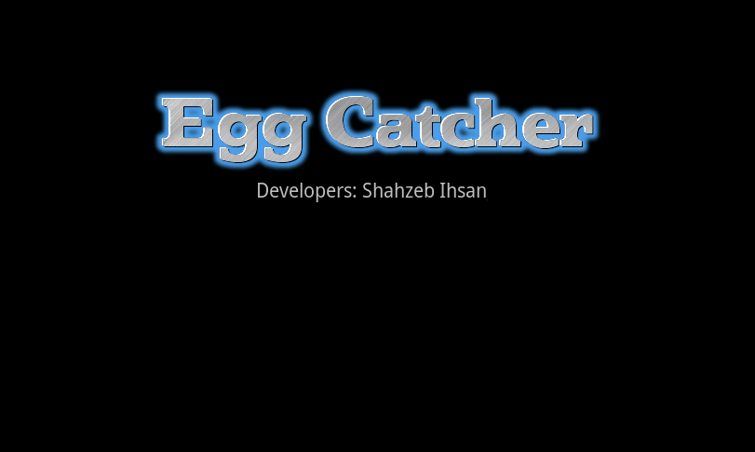
Figure 4.2 shows a screen shot of the game’s menu.

Figure 4.7 The Game's Menu.
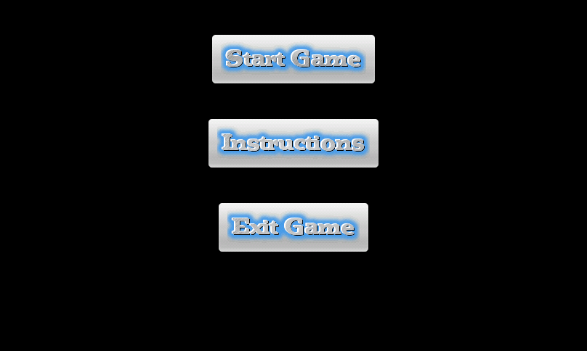

Figure 4.3 shows a screen shot of the game’s instruction dialog.

Figure 4.8 The Game's Instructions Dialog.
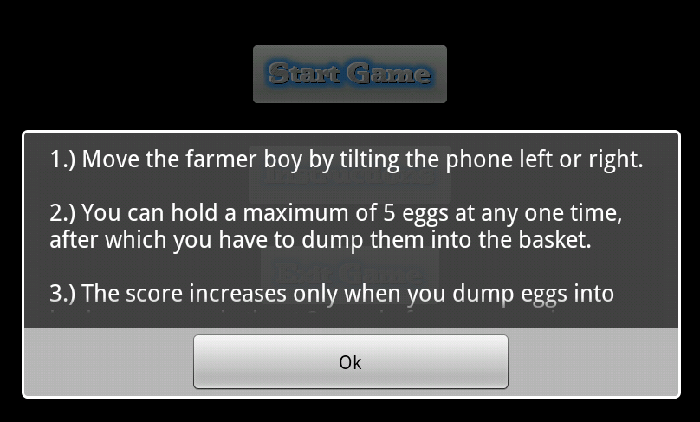
Figure 4.4 shows are screen shot of the game, Figure 4.5 shows a screen shot of the game with an Eagle and the timer on the top right of the screen and Figure 4.6 shows a crow flying towards the eggs basket to steal eggs.

Figure 4.9 A Screen Shot of the Game.
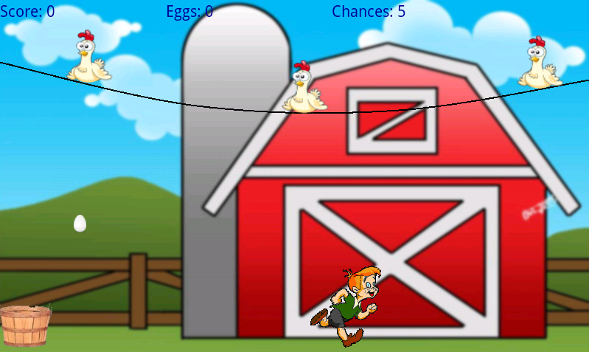

Figure 4.10 A Screen Shot of the Game With th Eagle.
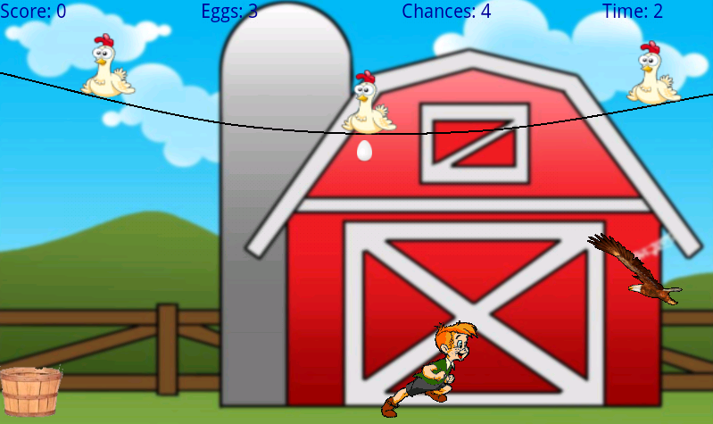
Figure 4.11 A Screen Shot of the Game With the Crow Flying Towards the Eggs Basket to Steal the Eggs.
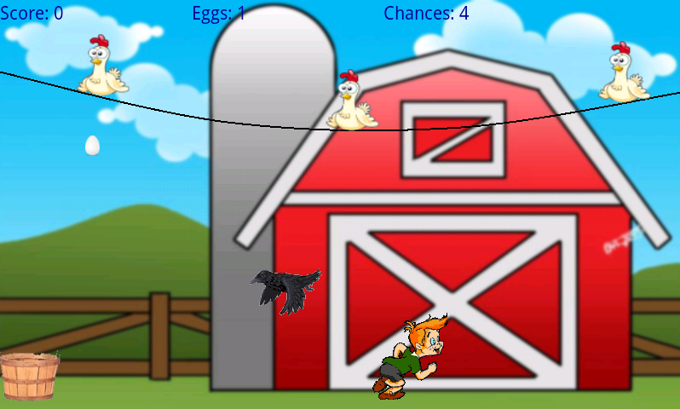

Further Improvements
While the game as it stands right now is pretty much what we set out to create in the beginning of this project, there is still a lot of room for improvement and additional features in the game to make it good enough for a release (e.g. on the Android Market). One of the first thing that comes to mind after playing this game for some time is the repetitive nature of game play. To make it more interesting, we can have more than one level in the game, such as, levels where the hens move as well, or an interactive environment or additional power-ups to make the farm boy move faster for a short while, perhaps a power-up or bonus that adds a guard dog to the game for a limited time, who will take care of the eagle and the crow when they appear. Additional enemies (like the eagle and the crow) would definitely make the game more interesting. Better graphics is another possible improvement.

In terms of game design and software organization, the current game engine can be designed to be as independent of the game play as possible, presently, the game logic/game play control and the game engine responsible for drawing the background and the animations etc are intertwined and interdependent. Making the game engine independent of the game logic would not only make software maintenance easier, but would also make it more re-usable. Additionally, at the moment the sprite animation class, Sprite2D, only supports looping sprite animations. Animation sequences within the sprite cannot be specified and that is one enhancement that can prove to be very useful. With this feature we can have all sprites in a singe file. Another possible improvement to make the Sprite2D class more efficient is to allow the frame to be mirrored while drawing it on the canvas. In the present implementation, if the current frame is required to be flipped, the bitmap for the frame is extracted and then a transform is applied to the bitmap to flip it and then it is drawn on the canvas.

Additional Comments

Source Directory Structure
Source code:
egg_catcher/src/com/tinman/games/egg_catcher/

Image resources:
egg_catcher/res/drawable_hdpi/

Audio resources:
egg_catcher/res/raw

Layout XML files:
egg_catcher/res/layout

Sprite XML files:
egg_catcher/res/xml

Generated resource file:
egg_catcher/gen/com/tinman/games/egg_catcher/R.java

Compiled binaries (egg_catcher.apk is the Android installable package):
egg_catcher/bin

Additional (third party) libraries:
egg_catcher/assets/sensorsimulator-lib-1.1.0-rc1.jar

Loading the Project into Eclipse
Once Android SDK is properly installed and configured, under “File > Import”, the “General > Existing Projects into Workspace” option can be used to import the egg_catcher project into Eclipse.

Using the OpenIntents Sensor Simulator
Before using the OI Sensor Simulator, the sensor simulator’s Android application (SensorSimulatorSettings-1.1.0-rc1.apk) needs to be installed in a virtual Android device (the emulator) for configuring the sensor simulator using the following command:

$ adb install SensorSimulatorSettings-1.1.0-rc1.apk

The application (game) also needs to be linked to the sensor simulator’s Android library (sensorsimulator-lib-1.1.0-rc1.jar).

References
Though the game’s entire source code was written by us, we did consult a lot of web resources and Android documentation. For the sake of completeness, all these resources are listed below.

Installing the Android SDK:
http://developer.android.com/sdk/installing.html

Android application fundamentals:
http://developer.android.com/guide/topics/fundamentals.html

Android developer’s guide:
http://developer.android.com/guide/index.html

A basic Android game loop:
http://obviam.net/index.php/a-very-basic-the-game-loop-for-android/

2D sprite animation in Android:
http://www.droidnova.com/2d-sprite-animation-in-android,471.html

OpenIntents Sensor Simulator:
http://code.google.com/p/openintents/wiki/SensorSimulator

Using an Android phone’s sensors:
http://www.helloandroid.com/tutorials/using-android-phones-sensors

