RV32I CPU User Guide
  - DE10-Lite setup and program loading

Introduction
Use this guide to set up the DE10-Lite, test the RV32I CPU, and upload and run the supplied assembly program. The CPU is implemented in VHDL and runs programs loaded into RAM.
The computer communicates through the board's USB-Blaster connection using JTAG UART. You do not need a COM port, a baud-rate setting, or extra wiring. Basic use of a command window and a text editor is enough to follow the steps.
After a power cycle, load the FPGA configuration again. After pressing KEY0, upload the program again. Current hardware bring-up is still pending in the project records; the steps below describe the expected results.

Description of Equipment
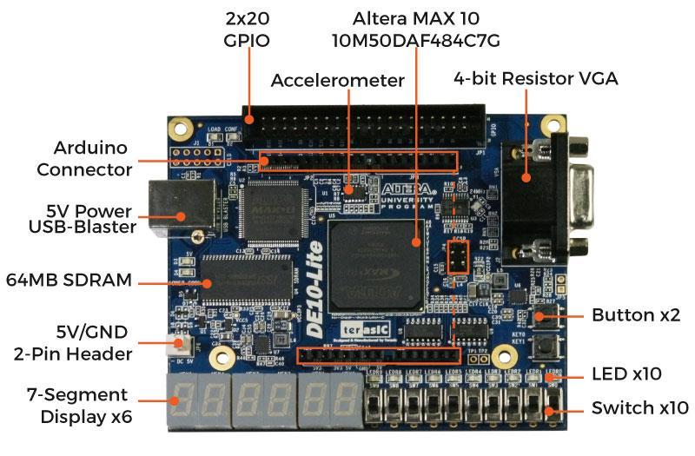
DE10-Lite board and connector locations. Photo from Terasic.
- USB-Blaster J3: the square USB Type B socket on the left. This connection supplies power and carries programming and console data.
- KEY0: the upper push-button near the right edge. Press and release it to restart the loader. KEY1 is unused.
- MAX 10 FPGA: the large center chip that contains the CPU, ROM, RAM, and JTAG UART. Use the console output to check operation.

Materials and Tools Needed
- DE10-Lite board, USB Type A to Type B data cable, and a Windows computer with a suitable USB port.
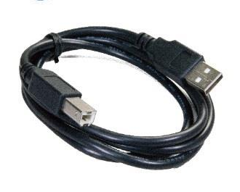
USB Type A to Type B data cable. Photo from Terasic.
- Quartus Prime Lite or Standard with these components:
- MAX 10 support, Platform Designer, the USB-Blaster driver, and the native JTAG UART libraries.
- Python 3 with pip, GHDL, and a bare-metal RISC-V GNU toolchain with gcc, objcopy, and objdump. Use Python that matches the Quartus libraries, normally 64-bit.
- The complete project folder, a text editor, and a clean, dry, nonconductive work surface.
Enter commands in WINDOWS POWERSHELL. Edit application files in software/; find build and upload tools in scripts/. The project scripts call the Quartus tools for you. Install the listed tools before beginning the directions.

Safety Warnings
 CAUTION Handle the board carefully
Handle the board by its edges and follow your lab's ESD procedure. Keep metal objects and liquids away from exposed contacts. Use the USB connection for power and leave expansion headers disconnected.
CAUTION Check the cable and work area
Use an undamaged cable, insert it gently, and keep it out of walkways. If the board smells unusual, smokes, or becomes abnormally hot, stop and disconnect power if safe. Have it checked before reuse.
NOTICE Protect ongoing work
Use the correct board and close other JTAG clients before programming. Save source changes, and wait for programming or uploads to finish before disconnecting. Reset stops the program and requires a new upload.

Directions
Follow these steps in order. Enter each command on its own line and press Enter. Run commands from the project folder; do not type the example output.

1 Open the project
Open the START menu, search for PowerShell, and open WINDOWS POWERSHELL. Go to this project folder, or replace the path with your own:
Set-Location "C:\Users\schad\opencode_projects\risc_v_32i"

2 Check the tools and install host support
Each version command should identify the installed tool. If a command is missing, install it or add its executable folder to PATH, then reopen the shell.
python --version
ghdl --version
riscv64-unknown-elf-gcc --version
quartus_sh --version
Install the project's Python package for JTAG UART:
python -m pip install -r software/requirements.txt

3 Build the example program
This command builds hello.bin and updates the test image. A successful result identifies software/build/hello.bin and entry 0x10000.
python scripts/build_app.py software/hello.S --test-image sim/images/hello.hex

4 Run the tests
Run both commands. The simulations should finish without assertion errors; the host checks should report five tests and OK. Fix any failure before continuing.
python scripts/simulate.py
python scripts/test_jtag_console.py
These tests do not need a connected board. Keep the supplied ROM loader for the first run; the tests do not verify physical USB-Blaster operation.

Directions Continued

5 Connect and build the FPGA design
Connect the board's USB-Blaster J3 socket to the computer with the USB data cable. Close other JTAG terminals and the Terasic control panel, then build the design:
quartus_sh -t scripts/build.tcl
Wait for the build and timing checks to pass. The output is build/quartus/output_files/risc_v_32i.sof. Stop if IP generation, compilation, or timing checks fail.

6 Program the board
List the cables and confirm that the intended USB-Blaster is connected. Then load the fresh configuration:
quartus_pgm --list
quartus_sh -t scripts/program.tcl
Expected result: Configured DE10-Lite with the .sof path. The programming command does not rebuild the file. These steps assume one connected board.

7 Open the console and reset
Open the JTAG UART console, then press and release KEY0, the upper push-button:
python scripts/jtag_console.py console
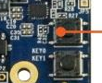
KEY0 is the upper button. Press and release it to reset.
The console should display:
RV32I JTAG loader v1
ready>
Press Ctrl+C and wait for the PowerShell prompt before starting the upload. Keep other JTAG UART clients closed.

Directions Continued

8 Upload and run the program
Upload the compiled binary with the console closed. The helper checks the transfer and starts the program:
python scripts/jtag_console.py upload software/build/hello.bin --run
Expected output:
RUN
Hello from uploaded RV32I assembly!
EXIT 0000002A
ready>
The exit value 0000002A means decimal 42. The new ready prompt confirms that the program returned to the loader.

9 Run it again
Run the loaded program again without pressing reset or removing power:
python scripts/jtag_console.py run
After a reset, repeat the upload command in Step 8 instead.

10 Try a change
Make a copy of the example and open software/my_hello.S in your text editor:
Copy-Item software/hello.S software/my_hello.S
Change the message line to the following, then save. Keep the rest of the example unchanged:
.asciz "Hello from my RV32I program!\r\n"
Build and upload the new file. Your new greeting should appear, followed by the same exit value and ready prompt.
python scripts/build_app.py software/my_hello.S
python scripts/jtag_console.py upload software/build/my_hello.bin --run

11 Finish
Close any console with Ctrl+C, save your files, and wait for transfers to finish. Disconnect the USB cable to power down. Next time, program the .sof again and upload your application.

Troubleshooting
A tool or command cannot be found
Install the tool or correct PATH, then reopen WINDOWS POWERSHELL. For a different RISC-V compiler prefix, set RISCV_PREFIX to the full prefix ending in a hyphen. See docs/uart.md for tool settings.
The FPGA build fails
Read the first error. Check that MAX 10 support and Platform Designer are installed. Fix generation, compile, or timing errors before programming; do not use a .sof left by a failed build.
USB-Blaster is missing or busy
Check the USB data cable and port. Check the USB-Blaster driver in DEVICE MANAGER and use UPDATE DRIVER with the driver supplied by Quartus if needed. Close other JTAG clients and the Terasic control panel.
The helper reports a missing package or library
Repeat the package installation in Step 2 using the same Python interpreter. Match its architecture to the Quartus libraries. If library discovery fails, set the Quartus root to your actual installation, for example:
$env:QUARTUS_ROOTDIR = "C:/intelFPGA_lite/25.1/quartus"
There is no ready prompt or the program hangs
Confirm that you programmed the fresh .sof, then open the console and press KEY0. Upload the original hello.bin again. If that works, check your program's instructions and normal return from main; ECALL and EBREAK halt this CPU.
An upload fails or the loader reports no image
Close the helper, press KEY0, and upload the complete .bin again. A reset or rejected replacement requires a fresh upload.

Conclusion
You should have a configured DE10-Lite and a program that prints its greeting, returns EXIT 0000002A, and shows ready>. You can now rerun it or build and upload changes without rebuilding the FPGA for application-only edits.
Keep your source files and the generated .sof for the next session. For application limits, cable selection, and more detailed recovery, read docs/uart.md and docs/bringup.md.
Photo credit: Terasic DE10-Lite User Manual, Figures 1-1 and 1-2.
Terasic DE10-Lite manual and resources

