

Progress Report 3
Ryan Schader
Name:
Project Title:
RISC-V RV32I CPU on an FPGA

Tell us about last week’s goals. How did they go?

To get all of the possible points for this section, write at least three sentences for each goal. Describe what each goal was and how you accomplished it (or what happened to prevent you from accomplishing it).

Goal #1: Expand RV32I execution coverage
My goal was to expand RV32I execution coverage. I added 13 directed programs that check every load and store width, signed and unsigned extension, preserved byte lanes, and ALU boundary values. The tests also check taken and untaken branches, JALR masking, alignment faults, retirement results, and reset recovery from traps. All 13 programs and the seven existing benches pass.
Status: Complete

Goal #2: Build and inspect the integrated FPGA image
My goal was to build and inspect the integrated CPU image. Quartus initially mapped RAM into flip-flops, so I revised the byte-bank inference structure and reran the tests. The final build generated a programming image with 985 logic elements and 155,648 memory bits. Setup and hold timing passed, with worst slack of +4.803 ns and +0.150 ns, and no unconstrained paths.
Status: Complete

Goal #3: Test the DE10-Lite and prepare architectural tests
My goal was to test the DE10-Lite and prepare architectural tests. The JTAG scan reported no hardware, so I could not program the board or verify its LEDs and reset physically. I added a binary runner, a linker layout, and a RAM completion convention. An assembled adapter self-test checks pass, failure, trap, and timeout paths; upstream certification tests remain pending.
Status: Partially Complete

Set three goals to work on next week.

Progress reports are individual assignments. That means you will be setting goals that you yourself intend to accomplish this week. Be specific; set goals that can be completed in one or two weeks.
As you work on your goals, make sure to take at least one picture or screenshot to show what you have done. The picture or screenshot will need to be submitted in your next progress report.
To get all of the possible points for this section, write at least three sentences for each goal. Describe what the goal is and how you plan to accomplish it.

Goal #1: Validate the physical DE10-Lite
I will connect the DE10-Lite and confirm that Quartus detects its USB-Blaster and MAX 10 device. I will program the verified CPU image and check the 0x155 LED pattern, held reset, and program restart. I will record the source revision, programming result, and a board photo. If hardware is unavailable, I will keep this milestone open and continue simulation.

Goal #2: Extend the architectural-test adapter
I will load the same program image on both ROM ports and add initialized RAM data support. I will select and pin an upstream ACT4 revision, then prepare the DUT configuration and completion macros for this RV32I core. I will run a small compatible test subset and record results and exclusions. Tests needing privileged CSRs or trap handlers will require separate review.

Goal #3: Expand mixed programs and reset coverage
I will add longer programs using backward branches, RAM operations, and GPIO switch reads. I will check expected retirement traces and memory results, and exercise reset during fetch, execute, memory, and writeback states. I will confirm that reset suppresses pending writes and restarts at address zero. The new tests will run through the repeatable simulation command.

Visual Communication

Each report must be accompanied by an updated schedule in the form of a Gantt chart. You need to include the version from the previous progress report and the updated chart for next week. Paste them below or save the charts as pdfs and upload them separately.

Each report must also be accompanied by evidence of your work. This can be a photo, screenshot, graph, chart, code snippet, data table, or any other visual evidence that we discuss in class. Paste it below or upload it as a separate file.
Previous schedule from Progress Report 2
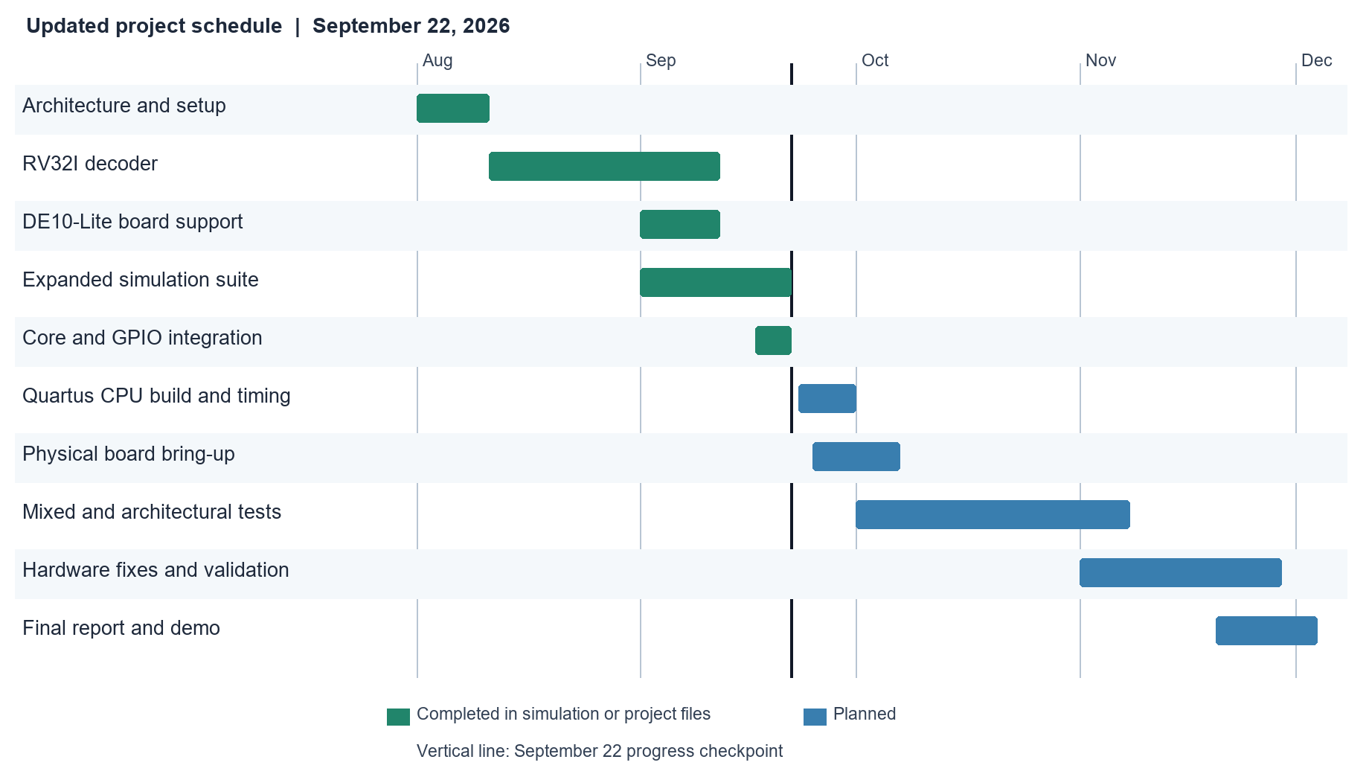
Updated schedule as of September 30 2026
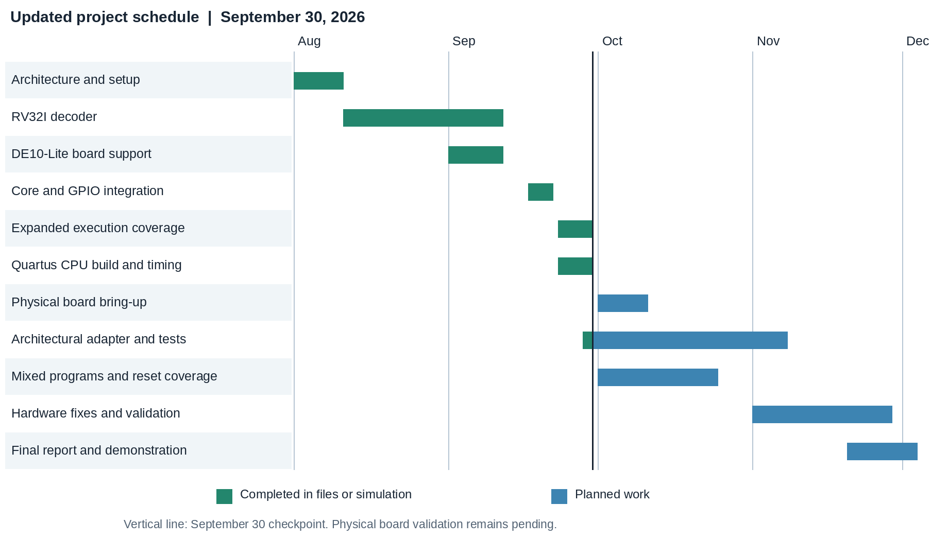
Board testing moves to October because no JTAG hardware was detected. Architectural testing remains planned through November 8; the final demonstration target remains December 4.
Evidence of execution and adapter verification
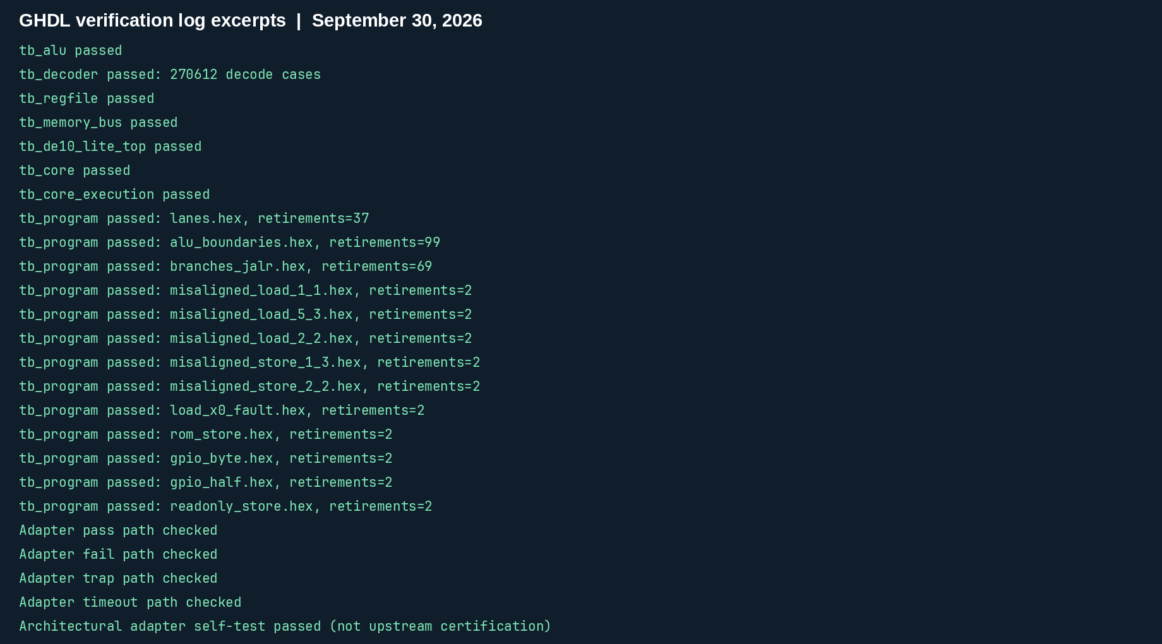
The results above were captured from the September 30 test logs. The directed programs check retirement values and traps through the real data bus. The adapter checks are local self-tests, and do not establish upstream RV32I certification.
Evidence of FPGA build and timing checks
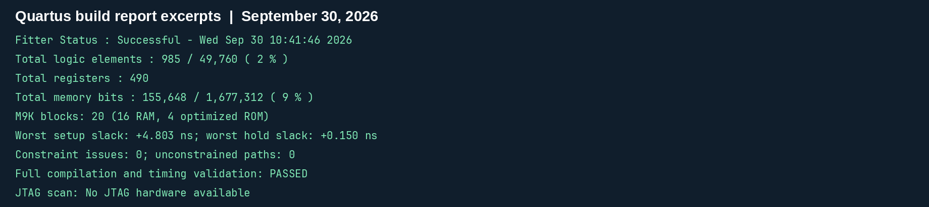
Physical hardware status: quartus_pgm --list reported No JTAG hardware available. Physical LED and KEY(0) reset behavior remain unverified.
Project revision: 8d5333a, September 30 2026.
Repository: https://github.com/schady23/risc_v_32i

