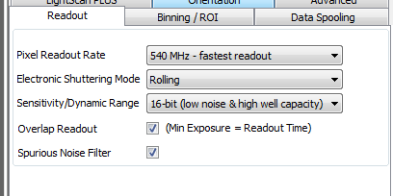

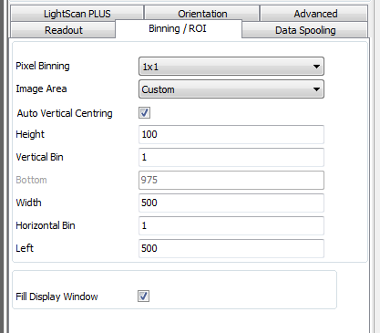

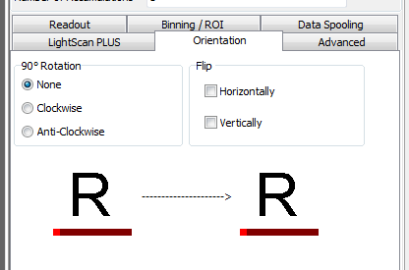

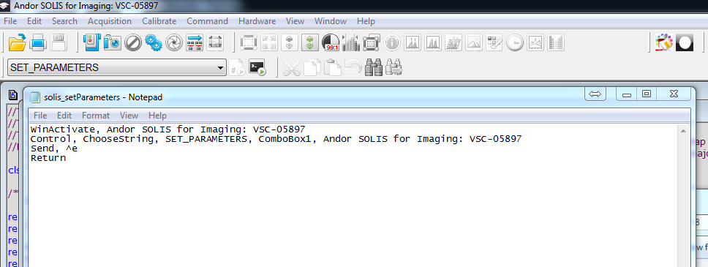

**In galvo GUI figure Guide:**

1. expand panel to see hidden panels + and arrange whichever ones are necessary into window (lasers, filter wheel, motorized stage, etc.)

**In Galvo GUI script:**

1. In scan_calculations, update with correct GUI name

% Step 12: update handles

handles.info = info;

handles.framerateChanged = addlistener(handles.frameRateFile,'Changed', ...

@(hObject,eventdata)SCAPE_simpleGalvoGUI_11('frame_rate_changed',hObject,eventdata,handles));

1. In scan_calculations, update with correct folder locations

% Step 13: Write the config file for Zyla

writeConfigFile(hObject, handles);

system('C:\Users\Andor\Documents\SCAPE_SIMPLE_GUI\NEW\solis_stopPreview.ahk');

system('C:\Users\Andor\Documents\SCAPE_SIMPLE_GUI\NEW\solis_setParameters.ahk');

pause(1); % Needs this to give set parameters time to run (probably to update listener as well);

if inPreview == 1

system('C:\Users\Andor\Documents\SCAPE_SIMPLE_GUI\NEW\solis_startPreview.ahk');

end

system('C:\Users\Andor\Documents\SCAPE_SIMPLE_GUI\NEW\returnToGUI.ahk');

1. In scan_callbacks, update with correct folder locations

function scan_Callback(hObject, eventdata, handles)

system('C:\Users\Andor\Documents\SCAPE_SIMPLE_GUI\NEW\solis_setParameters.ahk');

system('C:\Users\Andor\Documents\SCAPE_SIMPLE_GUI\NEW\solis_startAcquisition.ahk');

system('C:\Users\Andor\Documents\SCAPE_SIMPLE_GUI\NEW\returnToGUI.ahk');

1. Filter Wheel
   1. update gui figure with correct OD options (there are 6 and 12 position filter wheels)
2. Stim section
   1. If using a stim with SCAPE, comment in all stim sections in code and set AO for stim out and AI for data in to correct names
3. Check AOs for correct laser/galvo outputs
   1. Update lasers used (blue and/or red)
   2. If using OBIS, make sure the correct conversion equation for voltage -> laser power for that particular obis is used (if needed, will have to manually calculate relationship by measuring power output at different voltage outputs)
4. Check AIs for correct galvo/camera feedback inputs (and update AI plot titles in scan_callback function if needed)
5. If using OBIS, make sure blue digital shutter is to the correct digital line (it is p0.2 in the generic code)
6. If your system will be using an external stimulus and you have an extra AO channel on your daqboard, uncomment the sections commented with % STIM and set the Dev and AO number correctly
7. Make sure dev is set correctly to the DEV# the daq board is using

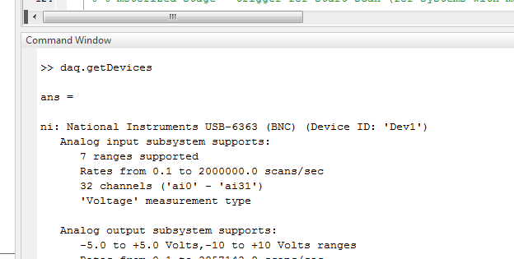

1. Makes sure the COM port for filter wheel is set to the right one

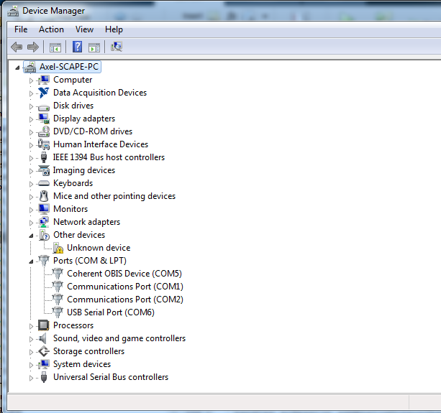

Filter wheel will show up as USB serial port ( and only appears when filter wheel is on and connected)

**Other Files to Update**

1. .ahk files (autohotkeys files) with correct solis window title
   1. Andor SOLIS ALPHA for Imaging: VSC-01571 – (this title changes depending on your solis version name!)
2. .pgm files (SOLIS control scripts) with correct folder locations
3. Makes sure there is a SCAPE_calibrations.txt file with correct calibration factors for the SCAPE system you are using

Setup SOLIS

1. Set ‘File’, ‘Set Program Startup’ to open ‘startupscript.pgm’ (this sets auxiliary output configuration to fire row 1 and opens startup programs)
   1. You have to change the file locations within this code to the correct one

TIPS:

1. Always save an extra copy of the GUI, sometimes the HR/Fast scan tabs crash GUIDE and you have to revert to an older copy of the file
2. Do not delete HR or Fast scan panels in GUI (and edit very carefully if needed) – the tabbed mode is created programmatically in the script
3. SOLIS and MATLAB need to be run with the same privileges (i.e. if solis is run as an Administrator, you must run Matlab as an administrator so that autohotkeys may control solis)
4. If all parameters are not being properly set on SOLIS, try increasing the pause after autohotkeys calls the ‘set parameters’ and ‘start trial’ programs in the MATLAB gui to give SOLIS more time to update all parameters (it’s currently set to pause for 1 sec after each call – the amount of time required may differ from computer to computer)

Read_gui

Update initial folder to where experimental data is stored

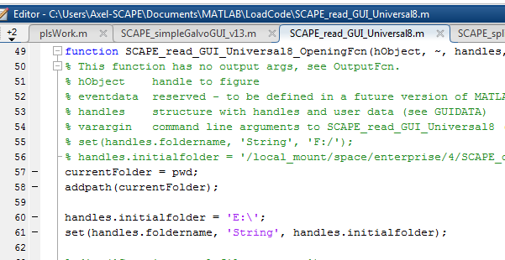

Put instructions for setting up ‘open in fiji’ functionality