Section Header
This is the subheading or section text.
This is a new self-contained paragraph.
This text was added with the addText command. You can add styled text too. You must end the paragraph manually.

ΑΒΓΔΕ
αβγδε
♥♥♥
Normal, this is bold, normal.
Normal, bold-italic, normal.
Sepal Length | Sepal Width | Petal Length | Petal Width | Species
5.1 | 3.5 | 1.4 | 0.2 | setosa
4.9 | 3 | 1.4 | 0.2 | setosa
4.7 | 3.2 | 1.3 | 0.2 | setosa
4.6 | 3.1 | 1.5 | 0.2 | setosa
5 | 3.6 | 1.4 | 0.2 | setosa
5.4 | 3.9 | 1.7 | 0.4 | setosa
 | Sepal Length
Species | 4 | 5 | 6 | 7
setosa | 20 | 30 | 0 | 0
versicolor | 1 | 25 | 23 | 1
virginica | 1 | 6 | 31 | 12
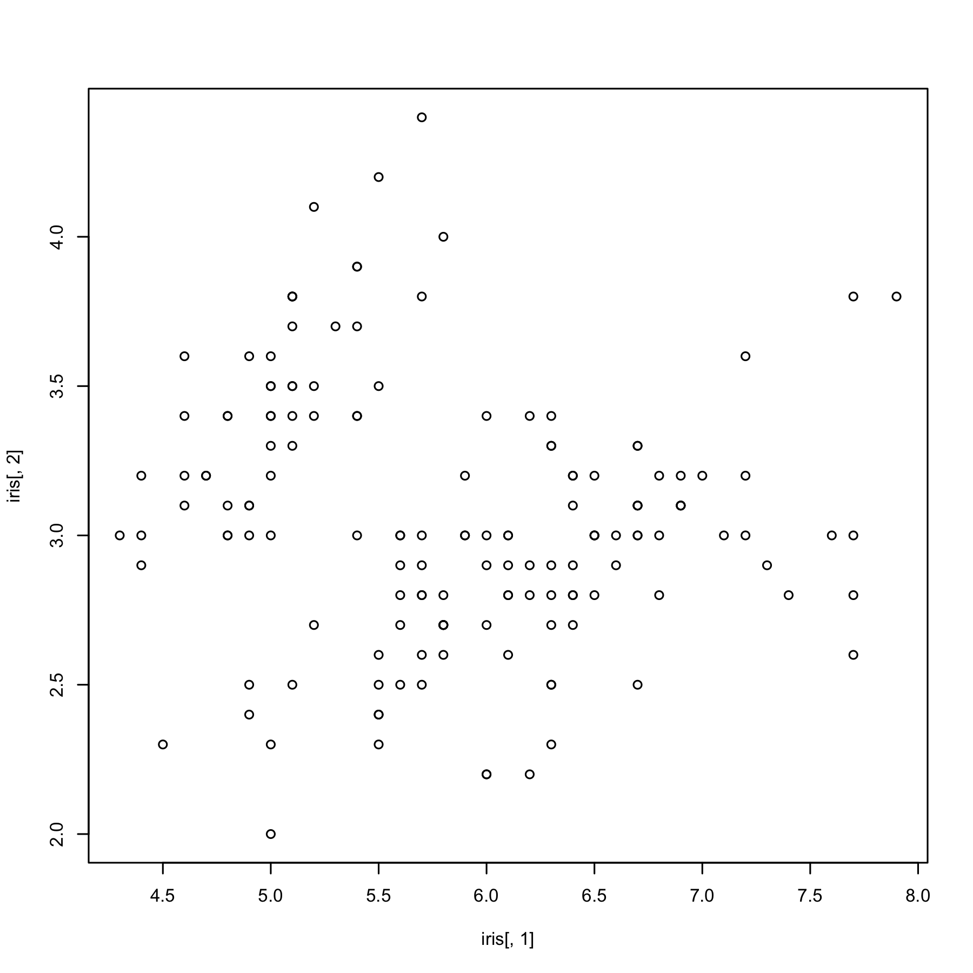
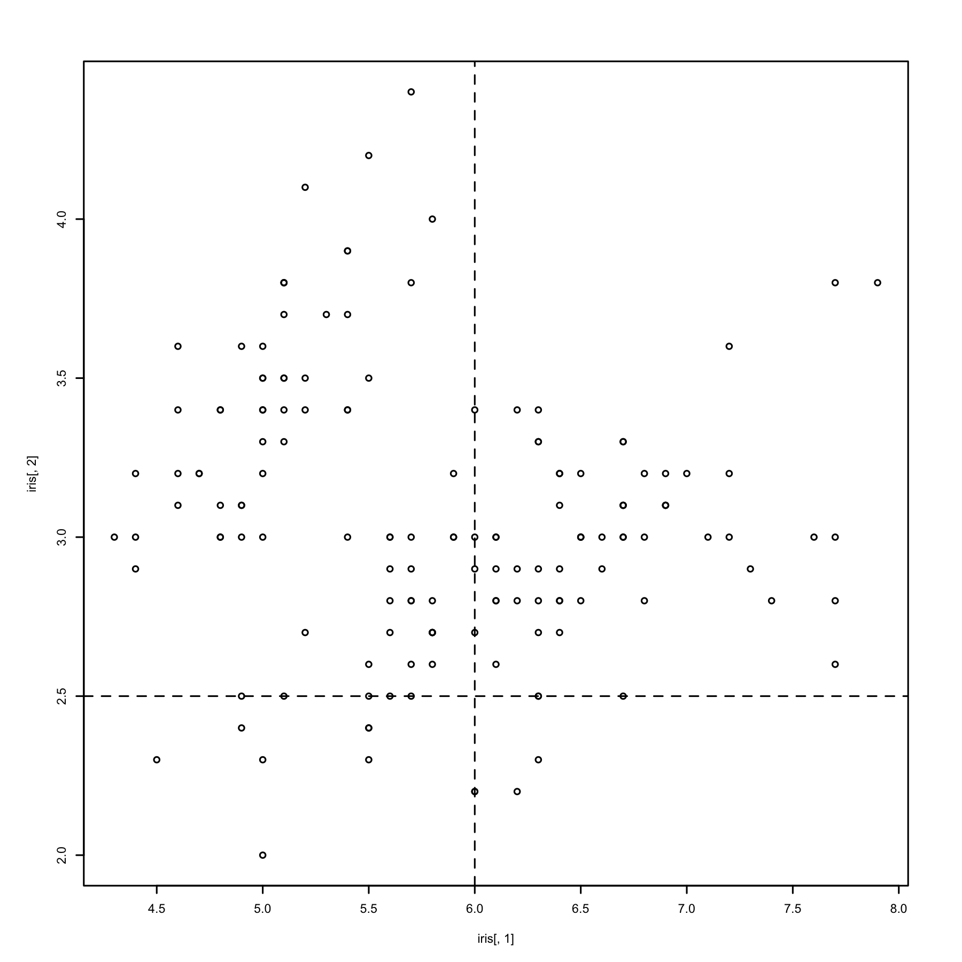
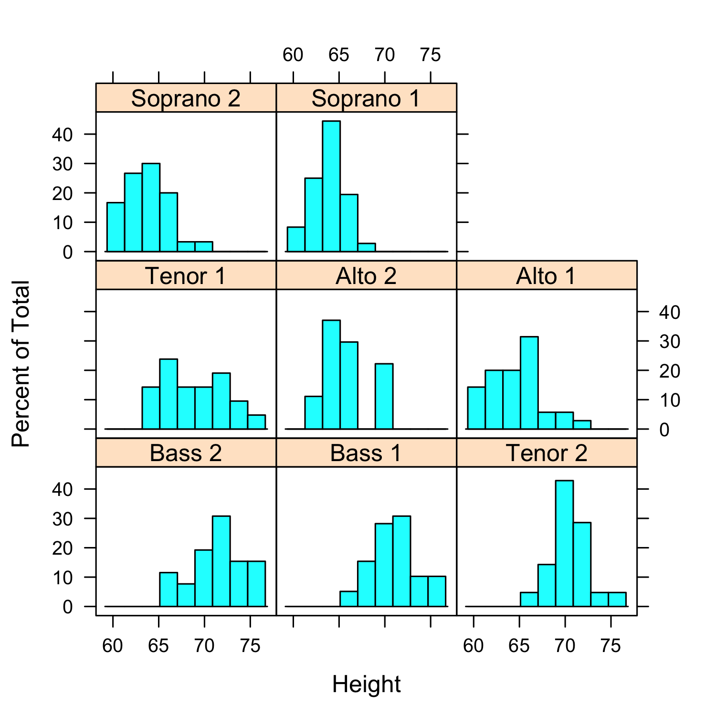
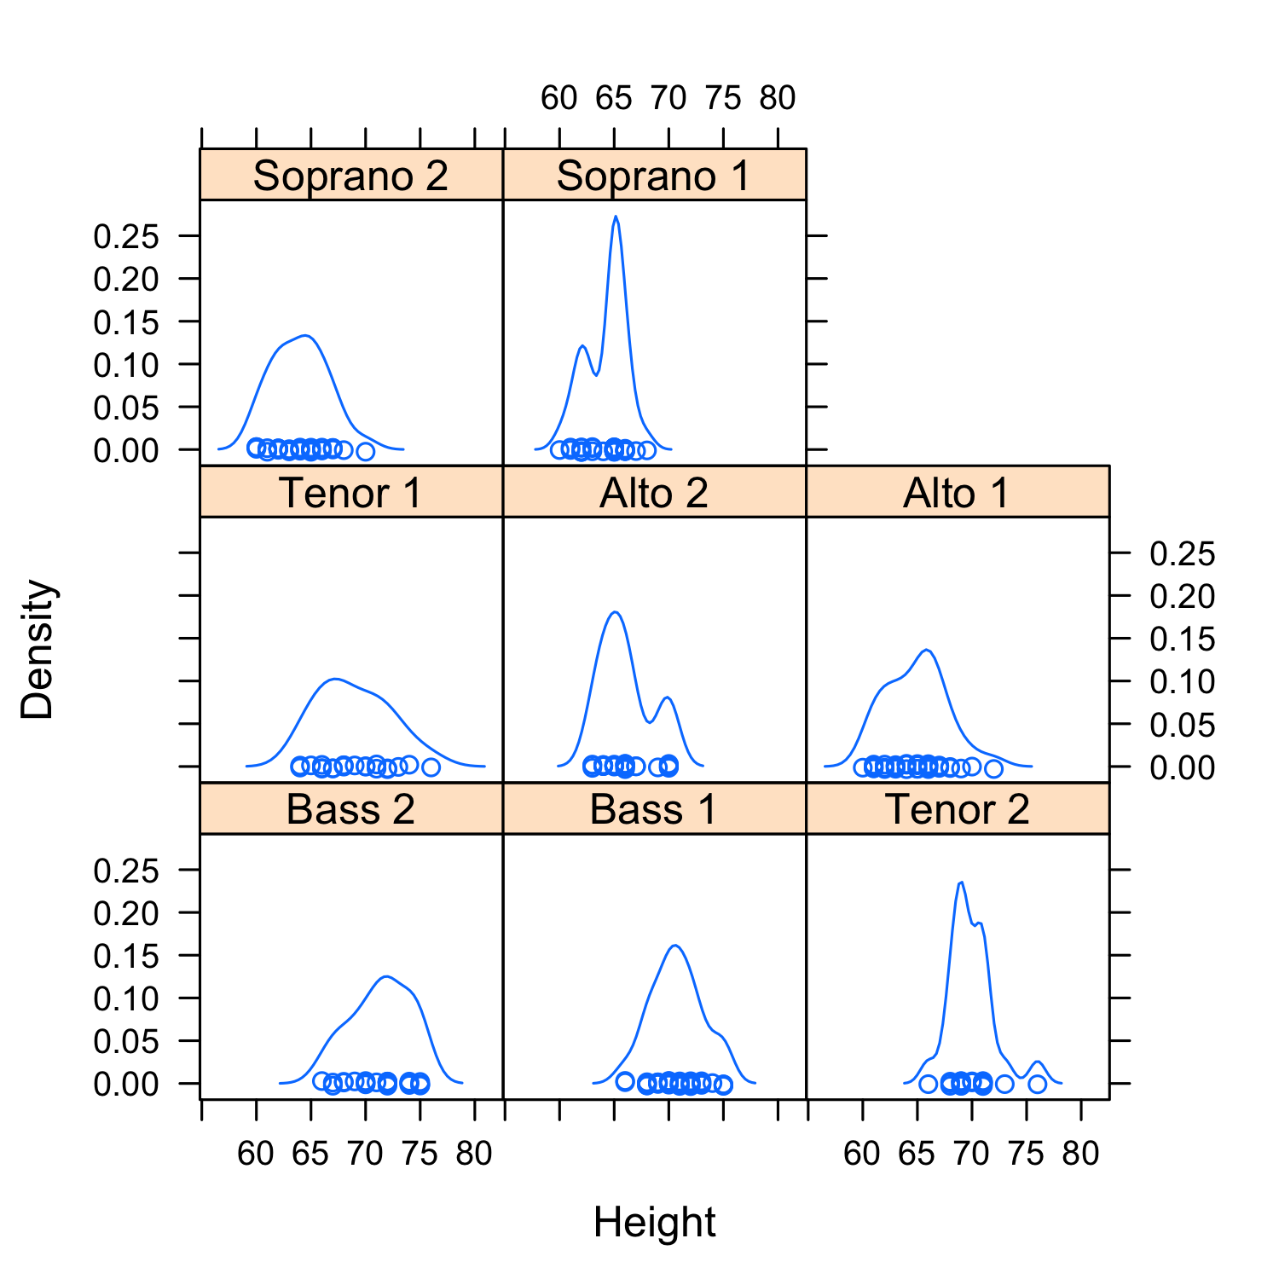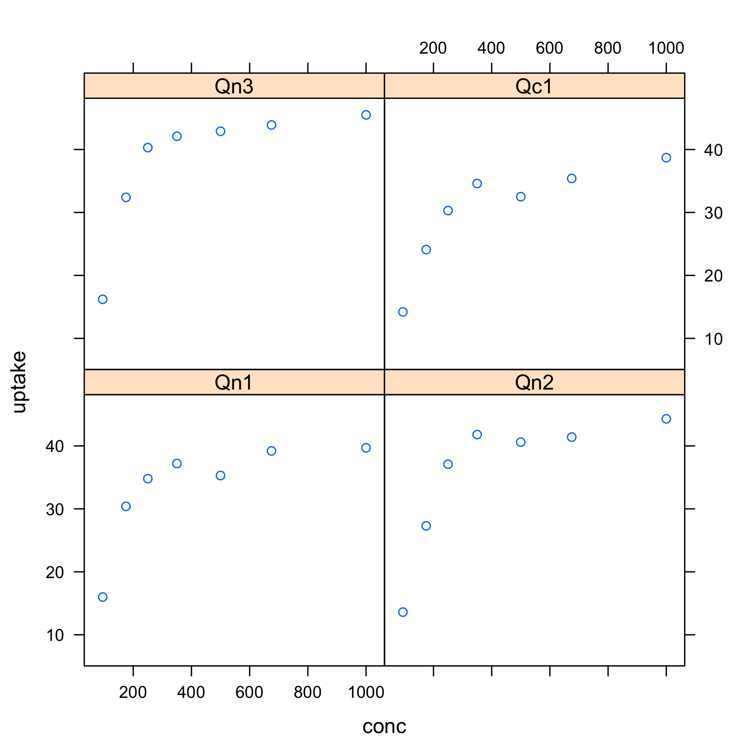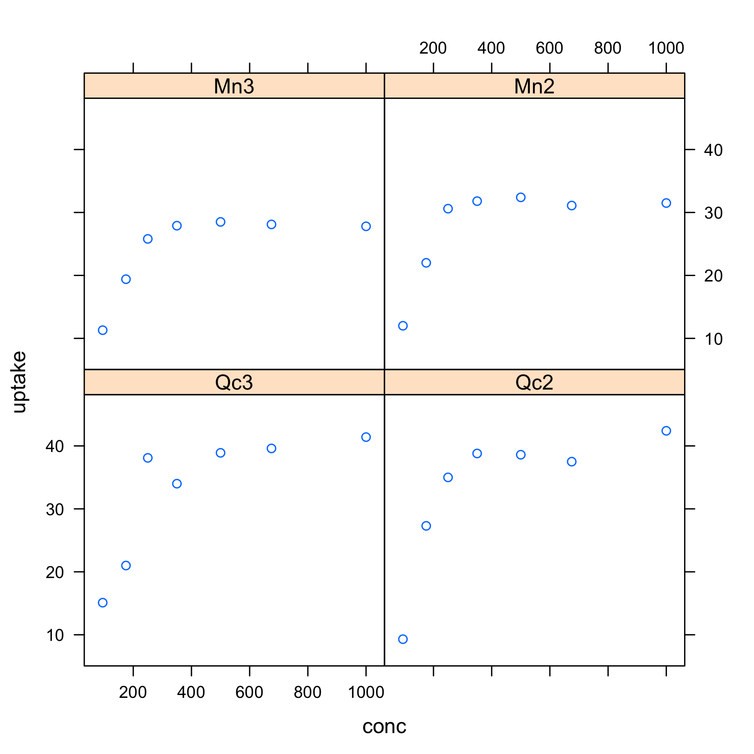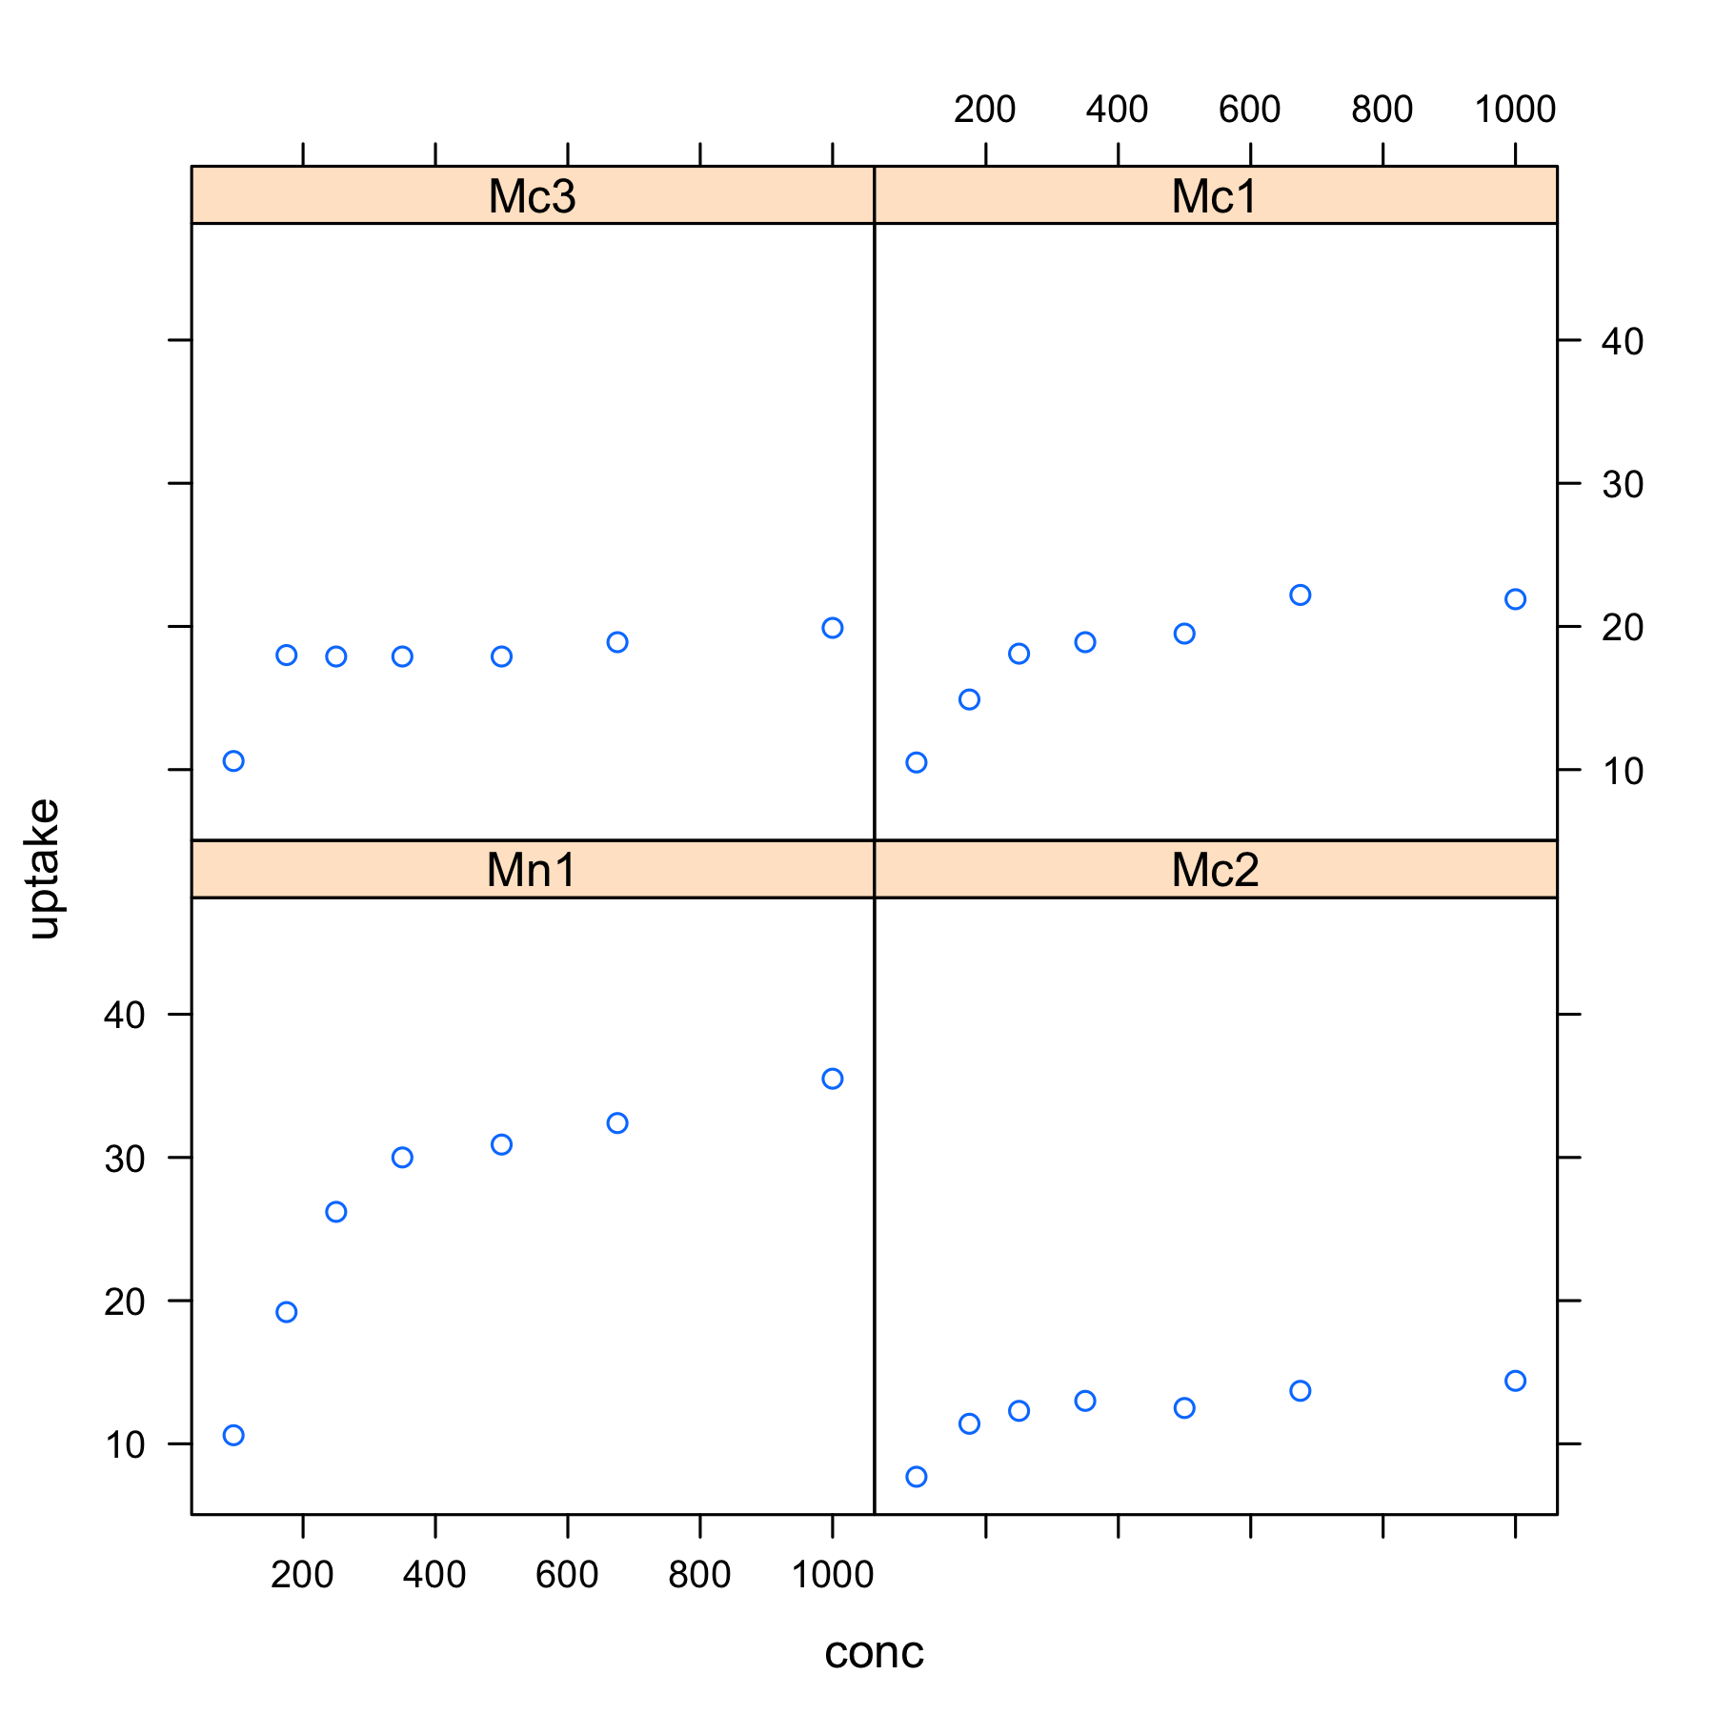
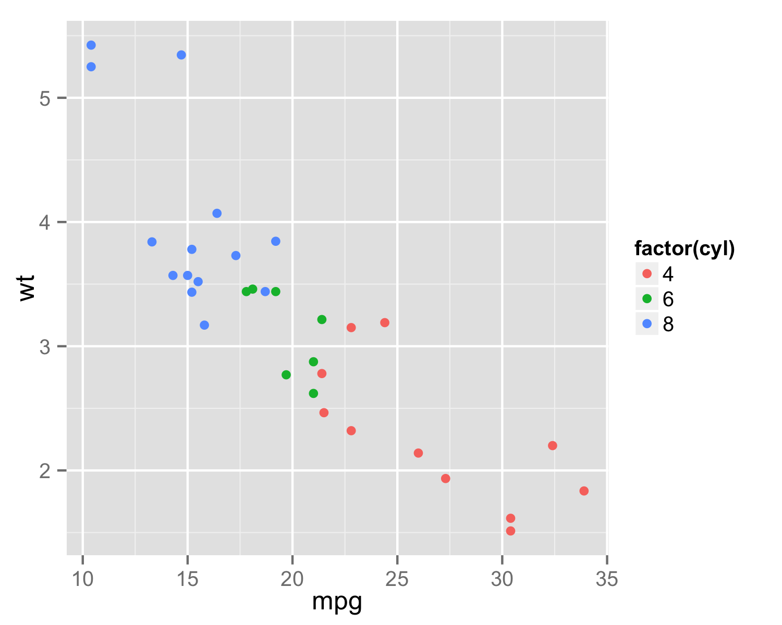
Session Information
R version 3.0.2 (2013-09-25)
Platform: x86_64-apple-darwin10.8.0
Locale: en_US.UTF-8/en_US.UTF-8/en_US.UTF-8/C/en_US.UTF-8/en_US.UTF-8
Packages
Base: base, datasets, graphics, grDevices, methods, stats, utils
Other: ggplot2 (v0.9.3.1), lattice (v0.20-24), rtf (v0.4-11), xtable (v1.7-1)
Loaded (not attached): colorspace (v1.2-4), dichromat (v2.0-0), digest (v0.6.3), grid (v3.0.2), gtable (v0.1.2), labeling (v0.2), MASS (v7.3-29), munsell (v0.4.2), plyr (v1.8), proto (v0.3-10), R.methodsS3 (v1.5.2), R.oo (v1.15.8), RColorBrewer (v1.0-5), reshape2 (v1.2.2), scales (v0.2.3), stringr (v0.6.2), tools (v3.0.2)
Session Details
Working directory: /Users/mschaff/Dropbox/R_packages/rtf/vignettes
Output file: rtf_vignette.doc

