Test
2011-08-15
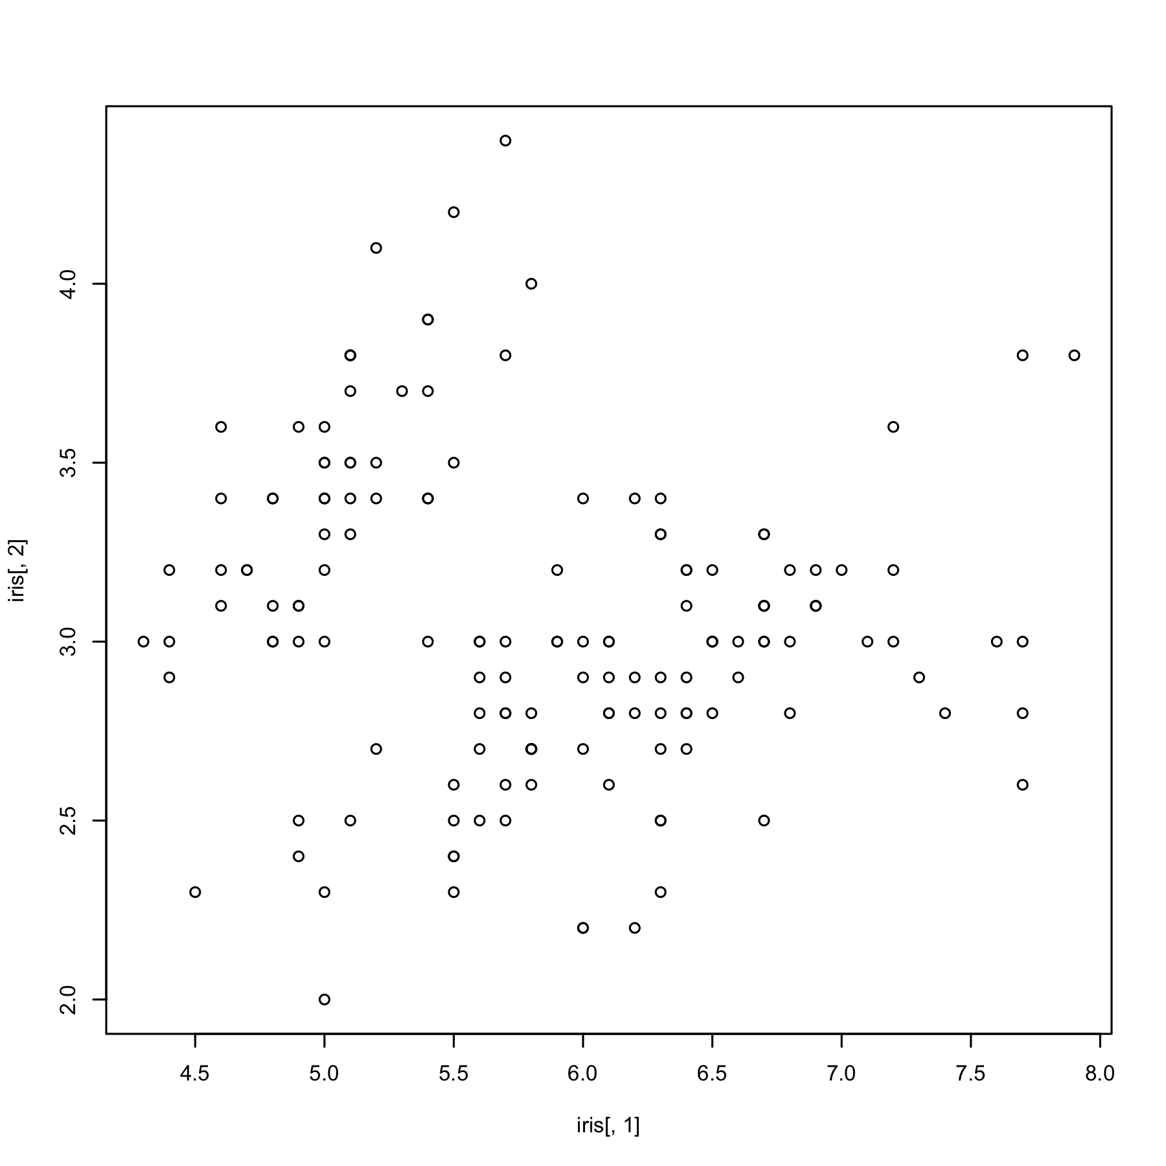
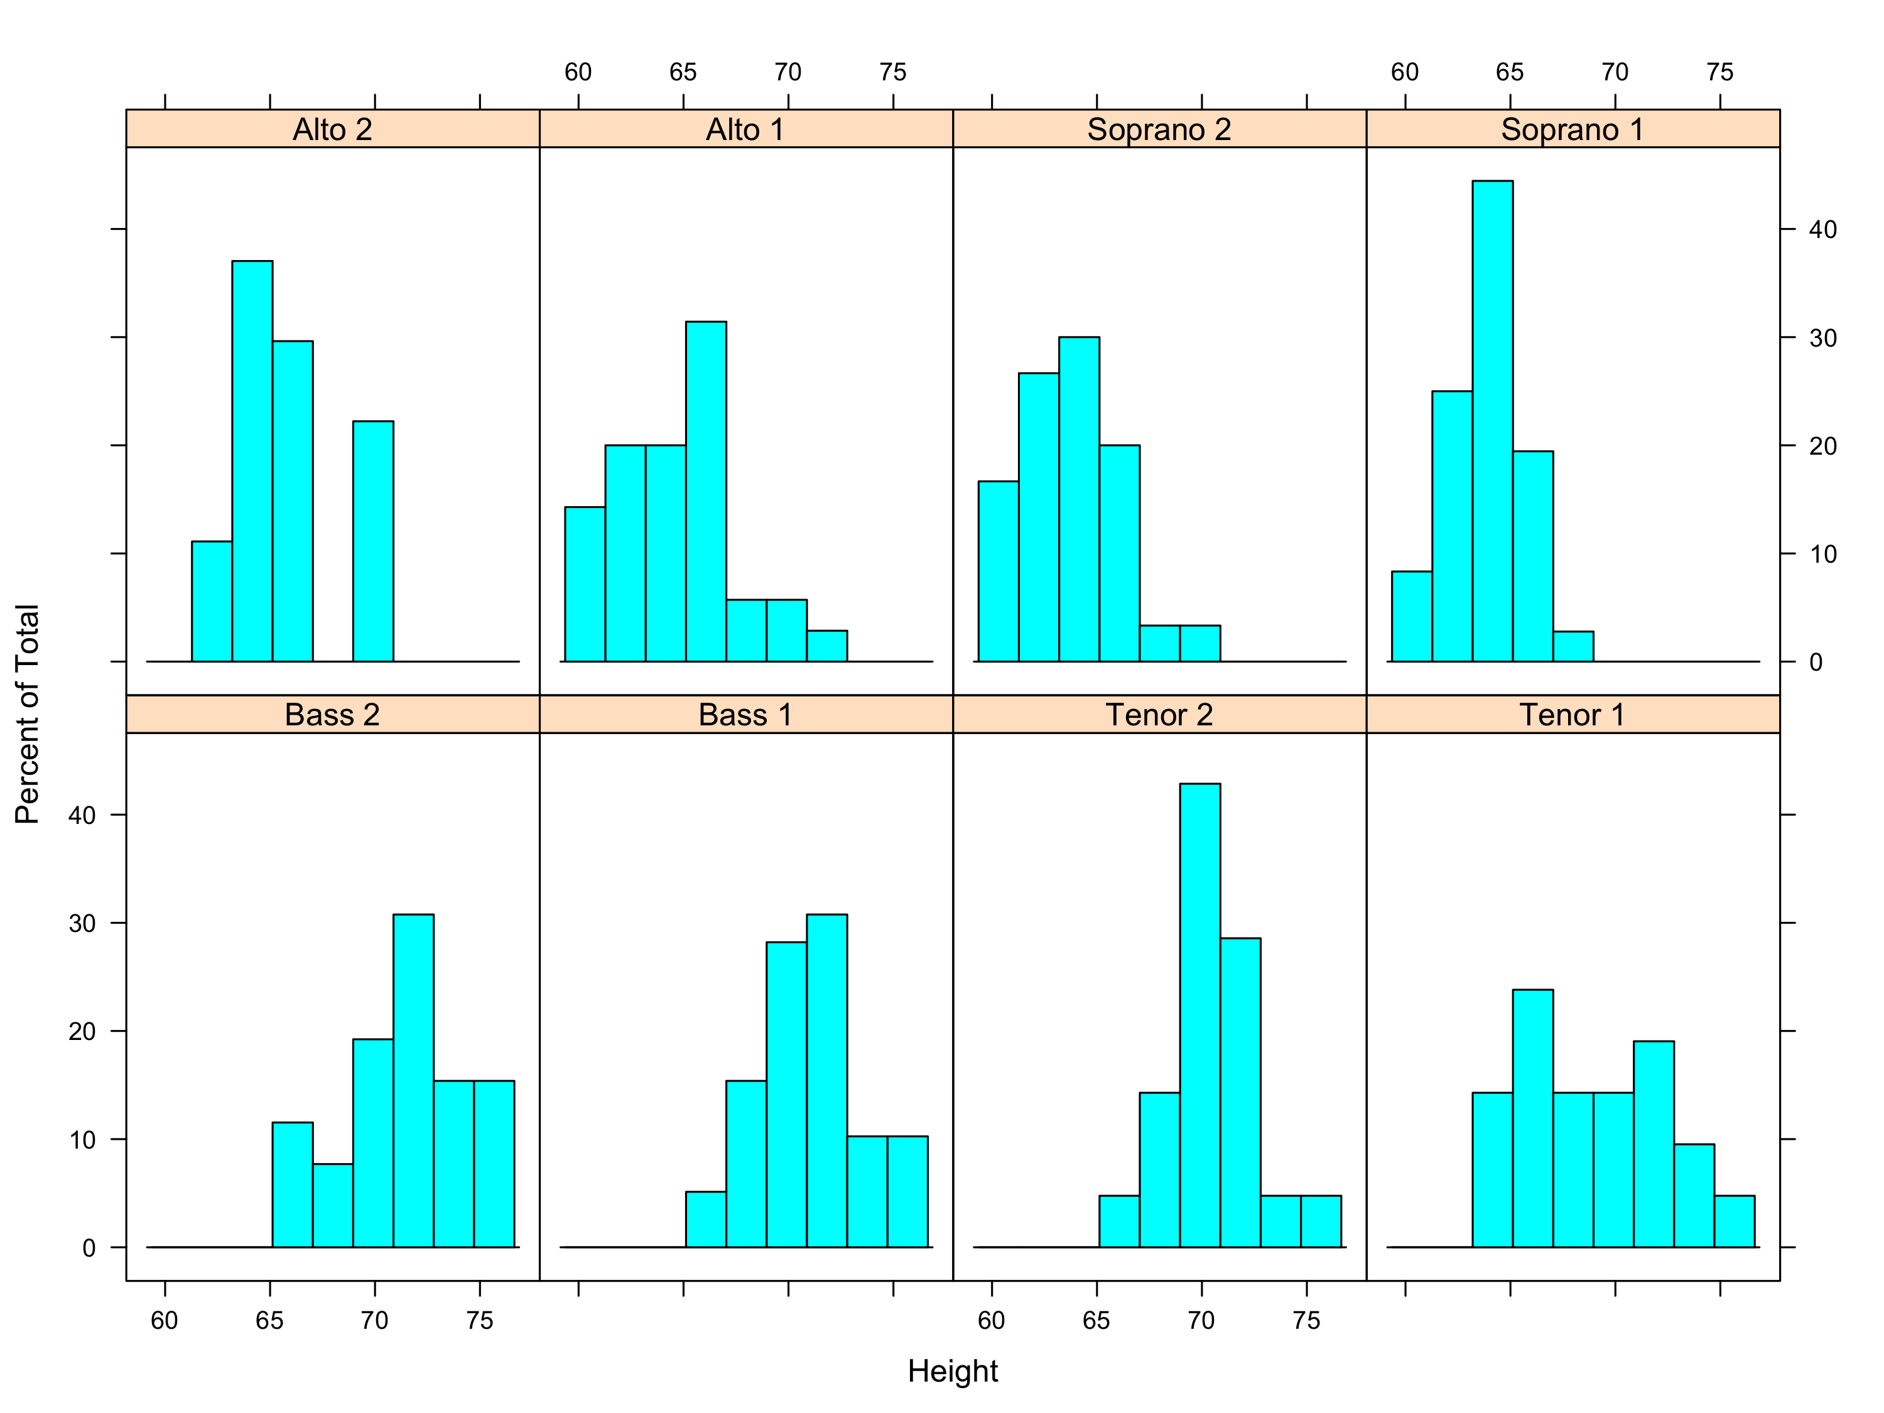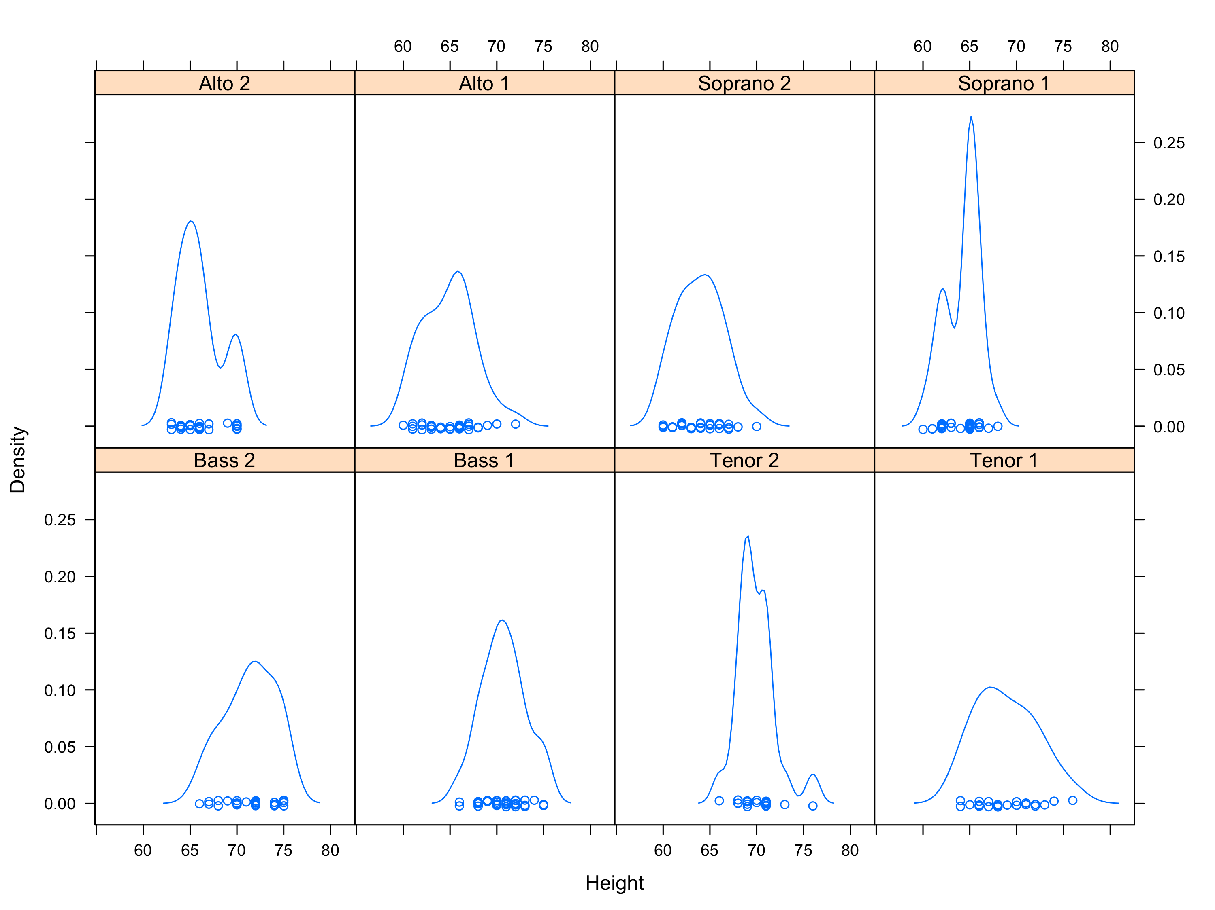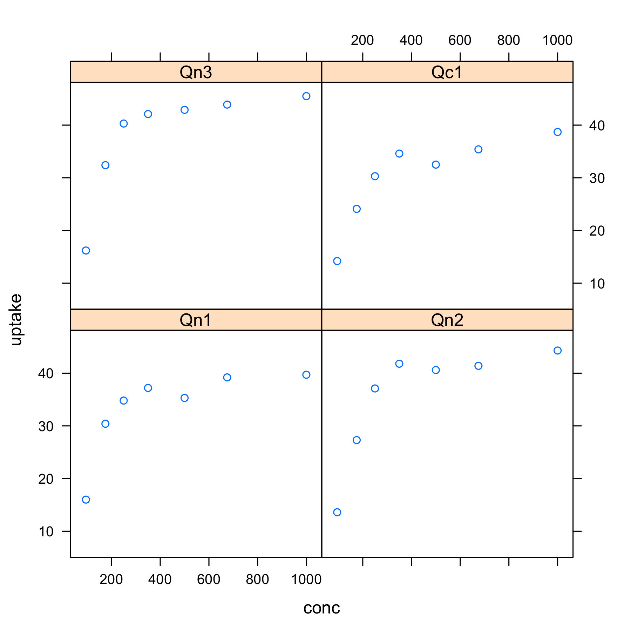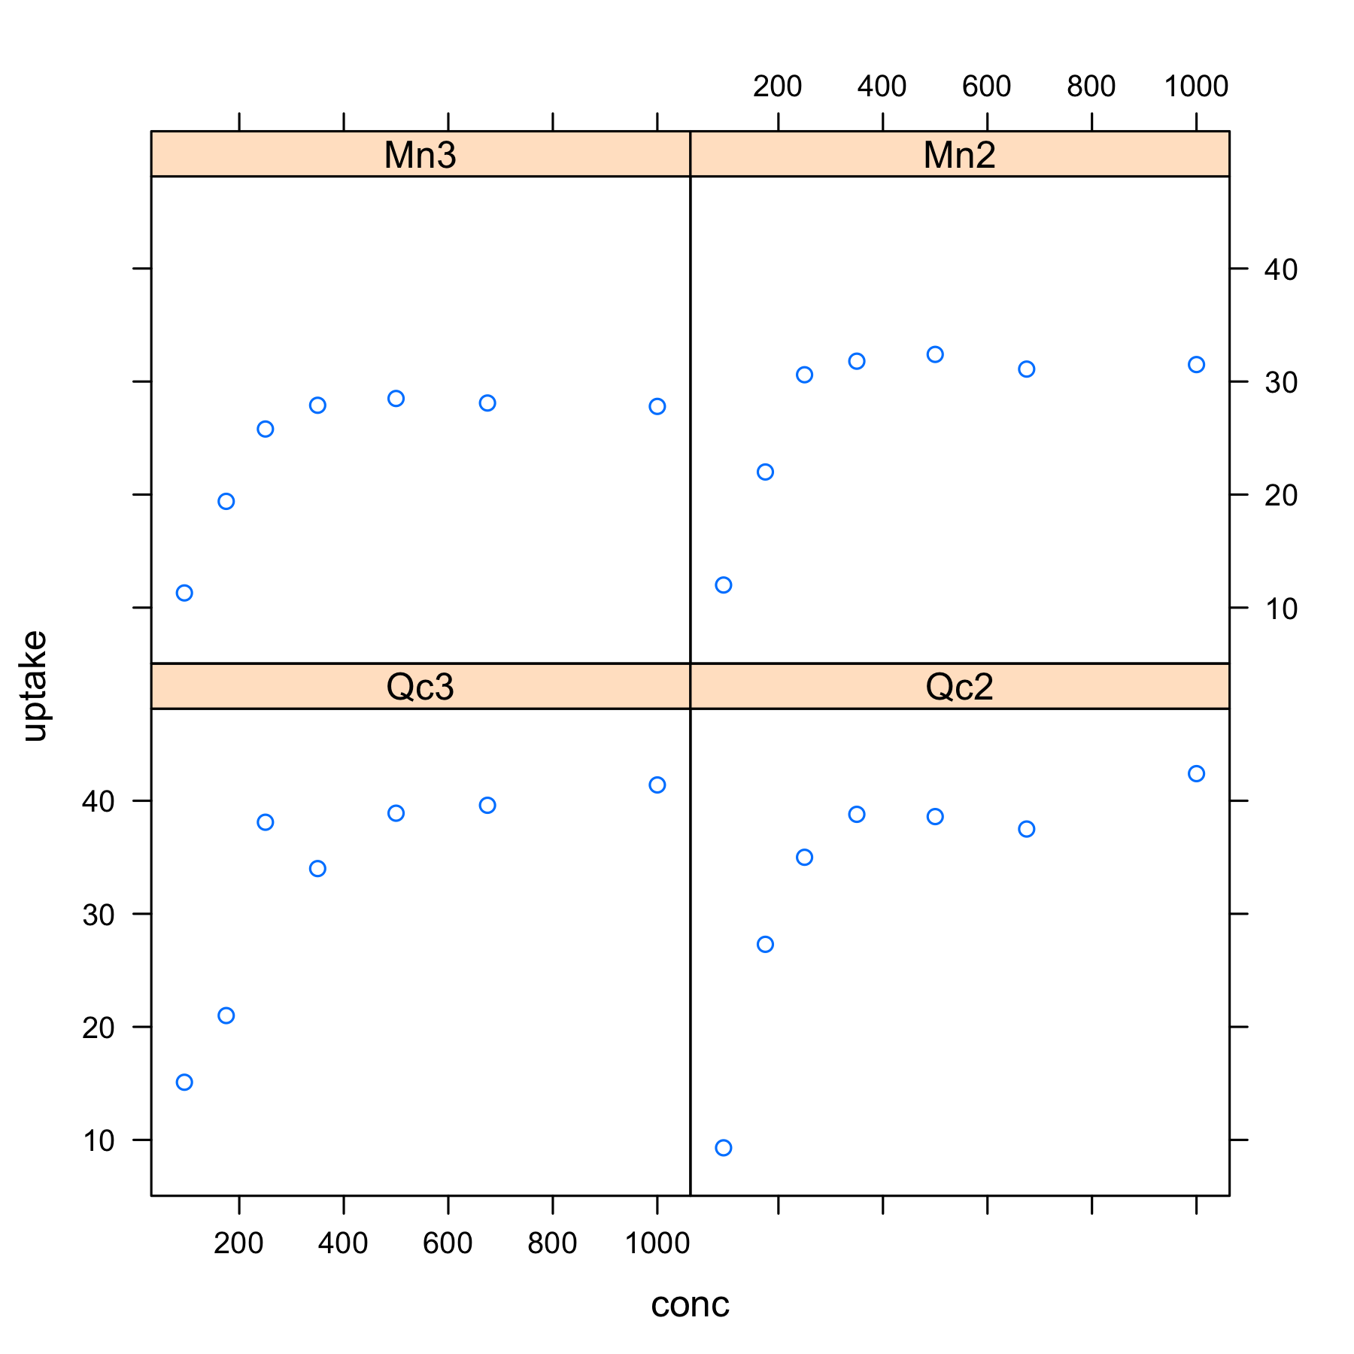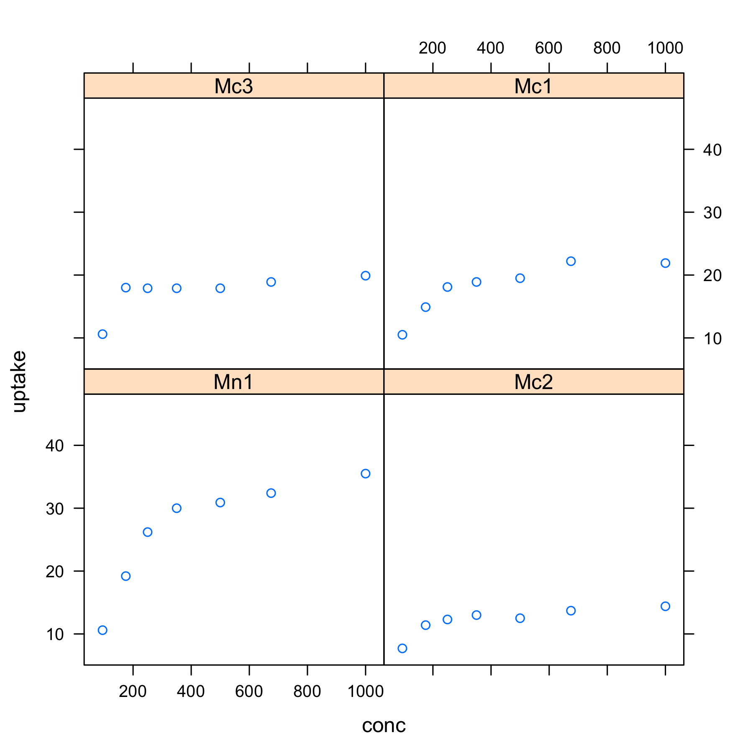
Sepal.Length | Sepal.Width | Petal.Length | Petal.Width | Species
5.1 | 3.5 | 1.4 | 0.2 | setosa
4.9 | 3 | 1.4 | 0.2 | setosa
4.7 | 3.2 | 1.3 | 0.2 | setosa
4.6 | 3.1 | 1.5 | 0.2 | setosa
5 | 3.6 | 1.4 | 0.2 | setosa
5.4 | 3.9 | 1.7 | 0.4 | setosa
Here's a new paragraph with another table:
 | Sepal Length
Species | 4 | 5 | 6 | 7
setosa | 20 | 30 | 0 | 0
versicolor | 1 | 25 | 23 | 1
virginica | 1 | 6 | 31 | 12

