**ITIS 5166 Exercise 6**

**Screenshot: Part-2**

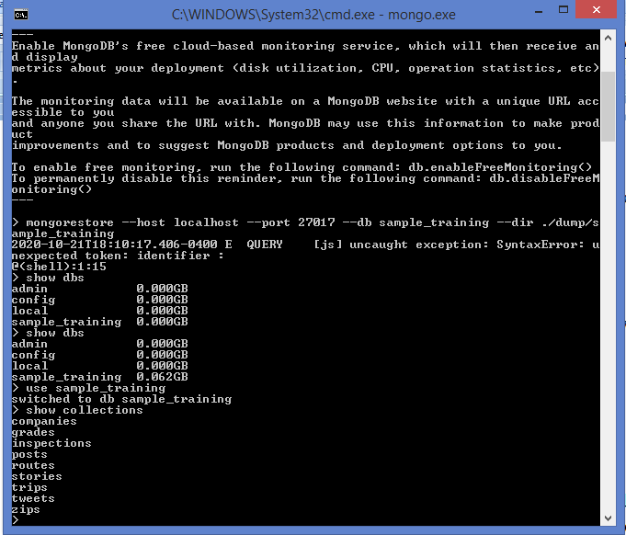

**Part 3: CRUD Operations**

**Part-3 Step 1**

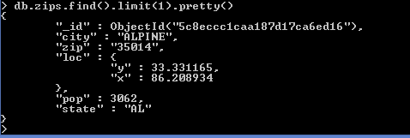

**Part-3 Step 2**

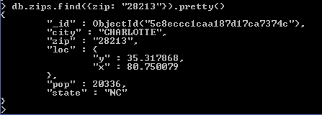

**Part-3 Step 3**



**Part-3 Step 4**



**Part-3 Step 5**



**Part-3 Step 6**

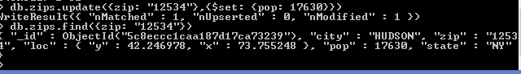

**Part-3 Step 7**

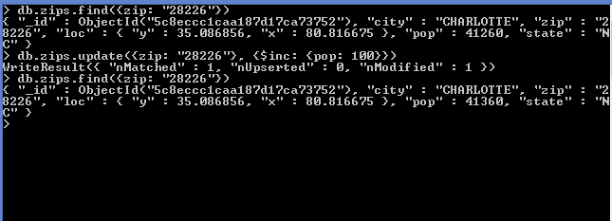

**Part-3 Step 8**

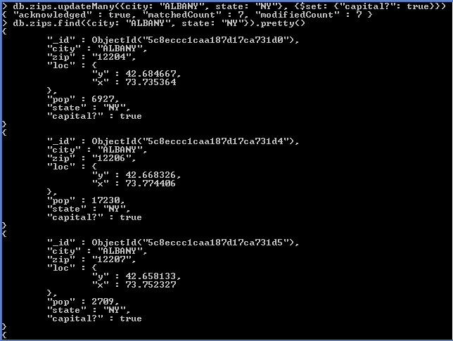

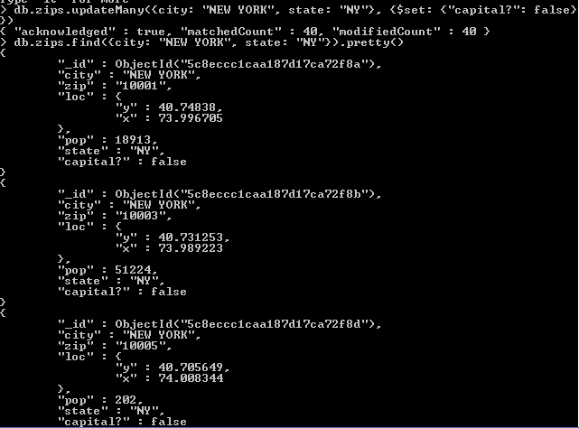

**Part 4: More CRUD Operations**

**Part-4 Step 1**

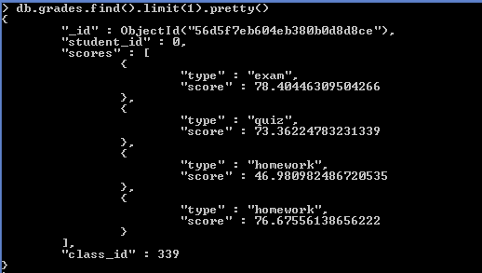

**Part-4 Step 2**



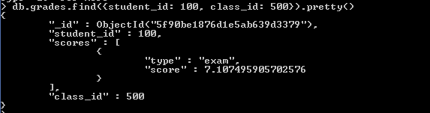

**Part-4 Step 3**

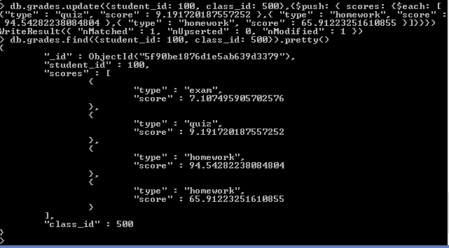

**Part 5: Create a Database and a Collection**

**Part-5 Step 1**

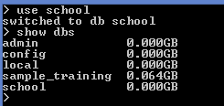

**Part-5 Step 2**

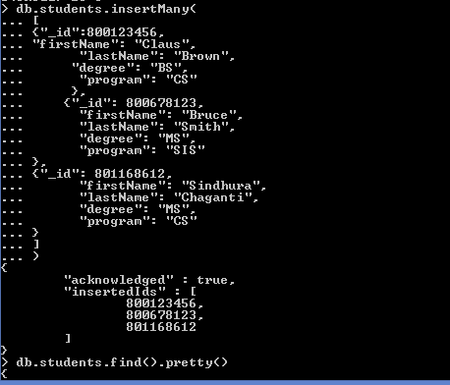

**Part-5 Step3:**

