WorkshopHub

Software Requirements Specification

Developer:
Saptaparno Chakraborty

Table of Contents

1. Introduction 1
1.1 Purpose 1
1.2 Scope 1
1.3 Definitions, Acronyms, and Abbreviations 1
1.4 References 1
1.5 Overview 1
2. General Description 2
2.1 Product Perspective 2
2.2 Product Functions 2
2.3 User Characteristics 2
2.4 General Constraints 2
2.5 Assumptions and Dependencies 2
3. Specific Requirements 3
3.1 External Interface Requirements 3
3.1.1 User Interfaces 3
3.1.2 Hardware Interfaces 3
3.1.3 Software Interfaces 3
3.1.4 Communications Interfaces 3
3.2 Functional Requirements 3-4
3.3 Non-Functional Requirements 4
3.3.1 Performance 4
3.3.2 Reliability 4
3.3.3 Availability 4
3.3.4 Security 4
3.3.5 Maintainability 4
3.3.6 Portability 4
3.4 Design Constraints 3
3.5 Other Requirements 3
4. Analysis Models 5-6
4.1 UML Use Case Diagram 5
4.2 ER Diagram 5
4.3 System Architecture Diagram 6
5. Github link…………………………………………………………………………………………………………………..…….7

1. Introduction

1.1 Purpose
This document provides a detailed Software Requirements Specification (SRS) for the Workshop Management System.

1.2 Scope

The Workshop Management System is a web-based application designed to manage workshops, registrations, attendance, materials, feedback, and certificate generation. The system supports administrators, instructors, and participants. It does not handle payment processing or third-party ticketing.

1.3 Definitions, Acronyms, and Abbreviations

Admin: System administrator
JWT: JSON Web Token
UI: User Interface
API: Application Programming Interface
SRS: Software Requirements Specification

1.4 References
IEEE 830-1998 Recommended Practice for Software Requirements Specifications
MongoDB Documentation
React.js Documentation
Node.js Documentation

1.5 Overview
This document describes the overall system, functional and non-functional requirements, external interfaces, and analysis models used in developing the Workshop Management System.

2. General Description

2.1 Product Perspective
This Workshop Management System web app is a standalone web application built using Node.js with MongoDB for the backend, along with JWT-based authentication, and React.js and Tailwind CSS for the frontend.

2.2 Product Functions
- User authentication and role management
- Workshop creation and management
- Participant registration
- Attendance tracking
- Material sharing
- Feedback collection
- Certificate generation

2.3 User Characteristics
Users are expected to have basic computer literacy and familiarity with web applications.

2.4 General Constraints
The system requires an active internet connection and a modern web browser.

2.5 Assumptions and Dependencies
The system assumes availability of MongoDB and Node.js runtime environment.

3. Specific Requirements

3.1 External Interface Requirements

3.1.1 User Interfaces
The user interface shall be web-based and responsive.

3.1.2 Hardware Interfaces
No specific hardware interfaces are required.

3.1.3 Software Interfaces
The system interfaces with MongoDB and REST APIs.

3.1.4 Communications Interfaces
HTTP/HTTPS protocols are used for communication.

3.2 Functional Requirements

3.2.1 User Authentication
Inputs: User credentials
Processing: Validate credentials and generate JWT
Outputs: Authentication token and user details
Error Handling: Invalid credentials return error messages

3.2.2 Workshop Management
Inputs: Workshop details
Processing: Create, update, or delete workshop records
Outputs: Workshop data
Error Handling: Invalid or missing data handled gracefully

3.2.3 Workshop Registration
Inputs: User ID and Workshop ID
Processing: Register participant
Outputs: Registration confirmation
Error Handling: Duplicate registration prevented

3.2.4 Attendance Tracking
Inputs: Participant and workshop details
Processing: Mark attendance
Outputs: Attendance record
Error Handling: Unauthorized access restricted

3.2.5 Feedback Submission
Inputs: Rating and comments
Processing: Store feedback
Outputs: Feedback confirmation
Error Handling: Invalid inputs rejected

3.2.6 Certificate Generation
Inputs: Attendance completion status
Processing: Generate certificate
Outputs: Downloadable certificate
Error Handling: Certificates generated only for eligible participants

3.3 Non-Functional Requirements

3.3.1 Performance
The system should respond within 2 seconds for standard operations.

3.3.2 Reliability
The system should ensure data consistency and prevent data loss.

3.3.3 Availability
The system should be available 99% of the time.

3.3.4 Security
Passwords shall be encrypted, and access shall be role-based.

3.3.5 Maintainability
The system should follow modular and clean coding practices.

3.3.6 Portability
The system should run on any modern web browser.

3.4 Design Constraints
- Technology stack limited to JavaScript-based frameworks
- Browser-based access only

3.5 Other Requirements
Future enhancements may include analytics and intelligent recommendations.

4. Analysis Models

4.1 UML Use Case Diagram
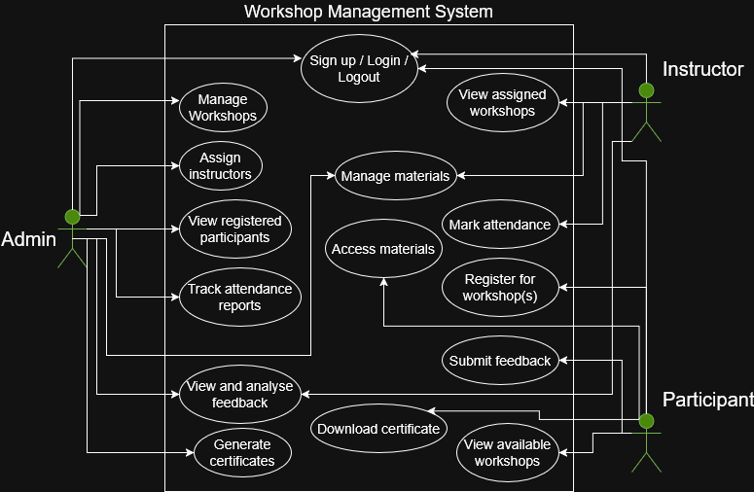

4.2 Entity-Relationship (ER) Diagram
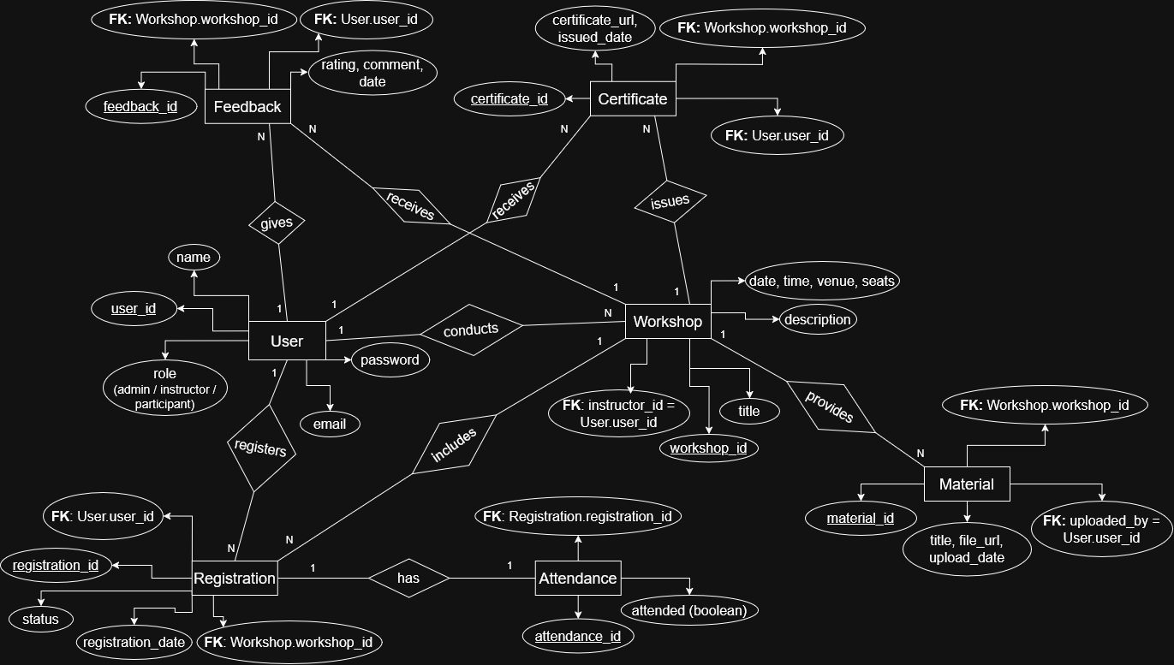

4.3 System Architecture Diagram
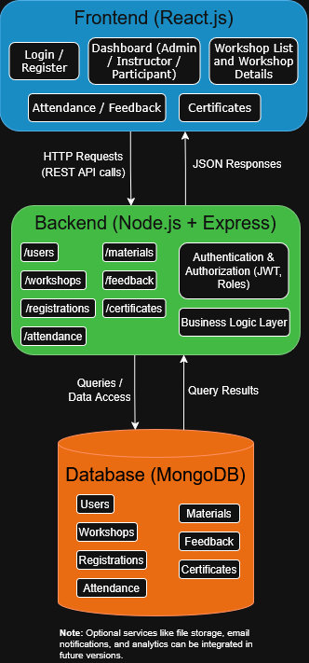

5. GitHub Link
https://github.com/schak04/workshophub

