**Stephen Chambers**

**Assignemnt 5**

**CS875**

**Part 1:**

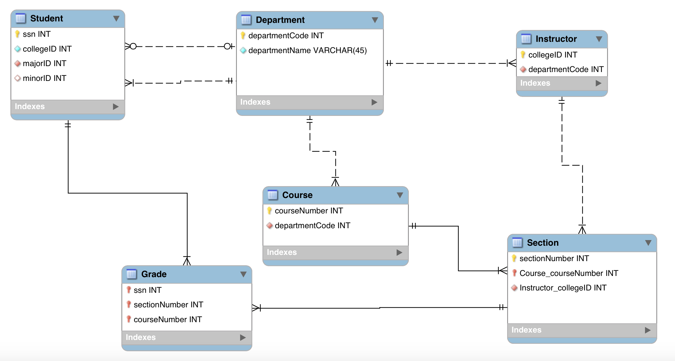

*Assumptions:*

1. Each course can only be offerred by one department.

2. A grade must contain both course number and section number.

3. A student does not have to have a minor but MUST have a major.

4. A student must be in one and only one department.

5. An instructor can teach many sections.

6. A course does not necessarily need to be part of a department

**Part2:**

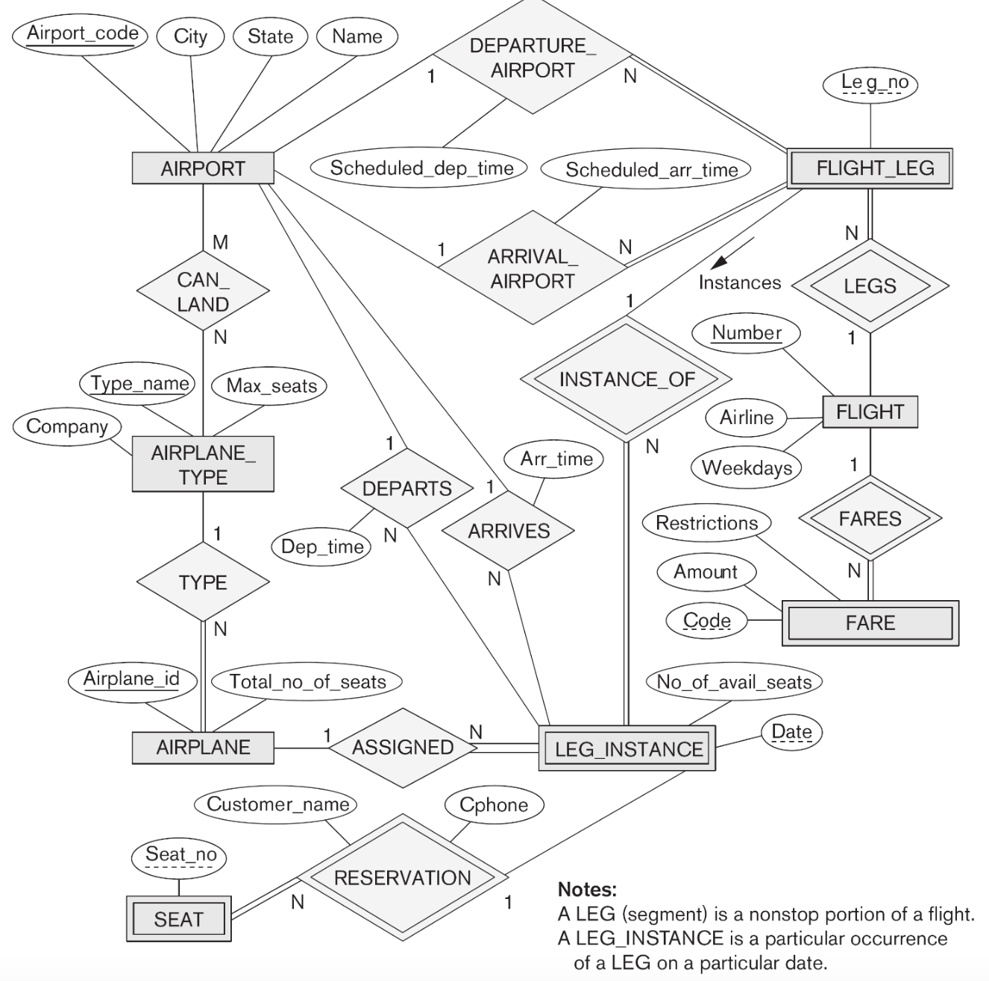

NOTE:

**A bold attribute** is a foreign key.

An underlined attribute is a primary key

*Step 1: Select Strong Entities*

AIRPORT(Airport_code, City, State, Name)

AIRPLANE_TYPE(Type_Name, Max_seats, Company)

AIRPLANE(Airplane_id, Total_no_of_seats)

FLIGHT(Number, Airline, Weekdays)

*Step 2: Select Weak Entities*

Note: Only bringing over double diamond relationship primary keys as foreign keys

SEAT(Seat_no, **Date**, **Leg_no**, **Number**, Cphone, Customer_Name)

LEG_INSTANCE(No_of_avail_seats, Date, **Leg_no**, **Number**)

FARE(Code, **Number**, Restrictions, Amount)

FLIGHT_LEG(Leg_no, **Number**, schedule_arr_time, schedule_dep_time)

*Step 3: 1:1 Relationships*

There are no 1:1 relationships.

*Step 4: 1:N Relationships*

AIRPLANE_TYPE(1) 🡪 (N) AIRPLANE:

AIRPLANE_TYPE(Type_Name, Max_seats, Company)

AIRPLANE(Airplane_id, Total_no_of_seats, **Type_Name**)

All other 1:N relationships are *weak entities* and were taken care of in step 2.

*Step 5: M:N*

AIRPORT(M) 🡪 (N) AIRPLANE_TYPE

CAN_LAND(Airport_code, Type_name)

*Step 6: Multivalued attributes*

There are no multivalued attributes.

Final Database Schema:

AIRPORT(Airport_code)

AIRPLANE_TYPE(Type_Name)

AIRPLANE(Airplane_id, **Type_Name**)

FLIGHT(Number)

SEAT(Seat_no, **Date**, **Leg_no**, **Number**)

LEG_INSTANCE(Date, **Leg_no**, **Number**)

FARE(Code, **Number**)

FLIGHT_LEG(Leg_no, **Number**)

CAN_LAND(Airport_code, Type_name)

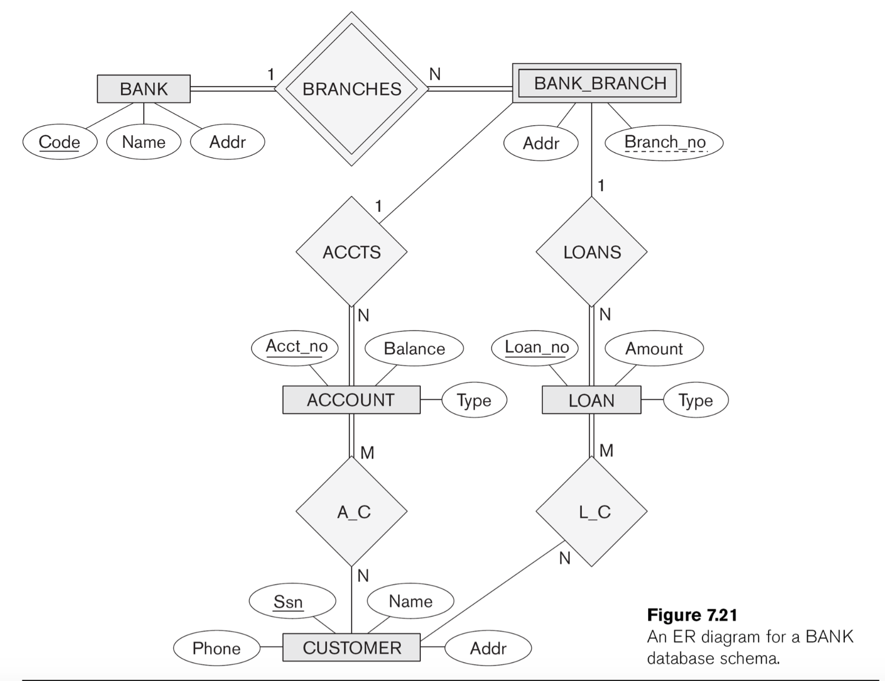

*Step 1: Select Strong Entities*

BANK(Code, Name, Addr)

ACCOUNT(Acct_no, Balance, Type)

LOAN(Loan_no, Amount, Type)

CUSTOMER(ssn, phone, name, addr)

*Step 2: Select Weak Entities*

Note: Only bringing over Code as that is the only *double diamond* relationship connected to this entity.

BANK_BRANCH(Addr, **Code**, Branch_no)

*Step 3: 1:1 Relationships*

There are no 1:1 relationships.

*Step 4: 1:N Relationships*

BANK_BRANCH(1) 🡪 (N) ACCOUNT:

BANK_BRANCH(Addr, **Code**, Branch_no)

ACCOUNT(Acct_no, Balance, Type, **Code**, **Branch_no**)

BANK_BRANCH(1) 🡪 (N) LOAN:

BANK_BRANCH(Addr, **Code**, Branch_no)

LOAN(Loan_no, Amount, Type, **Code**, **Branch_no**)

All other 1:N relationships are *weak entities* and were taken care of in step 2.

*Step 5: M:N*

ACCOUNT(M) 🡪 (N) CUSTOMER

A_C(Acct_no, Ssn)

LOAN(M) 🡪 (N)CUSTOMER

L_C(Loan_no, Ssn)

*Step 6: Multivalued attributes*

There are no multivalued attributes.

Final Database Schema:

BANK(Code, Name, Addr)

ACCOUNT(Acct_no, Balance, Type, **Code**, **Branch_no**)

LOAN(Loan_no, Amount, Type, **Code**, **Branch_no**)

CUSTOMER(ssn, phone, name, addr)

BANK_BRANCH(Addr, **Code**, Branch_no)

A_C(Acct_no, Ssn)

L_C(Loan_no, Ssn)