Stephen Chambers

CS830

Assignment 11 Writeup

1. **Describe any implementation choices you made that you felt were important. Mention anything else that we should know when evaluating your program.**

Nothing too crazy.

1. **What sorts of input will cause your program to fail? In other words, what does it have trouble with?**

It has trouble with very densely packed points. If five lines are on top of each other in the middle of the screen, it has a very hard time differentiating. The reference solution refers similar behavior.

1. **What suggestions do you have for improving this assignment in the future?**

Nothing pressing.

**1 Circle, 1 Line**

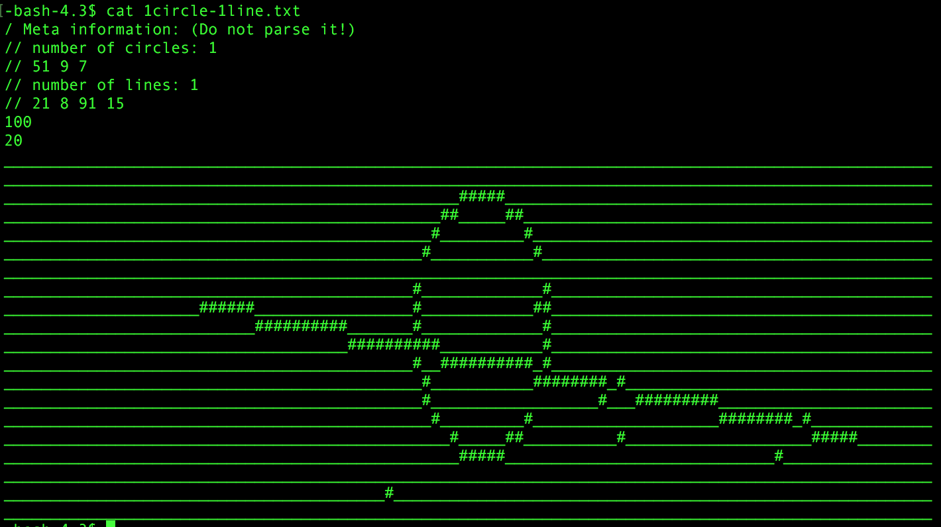

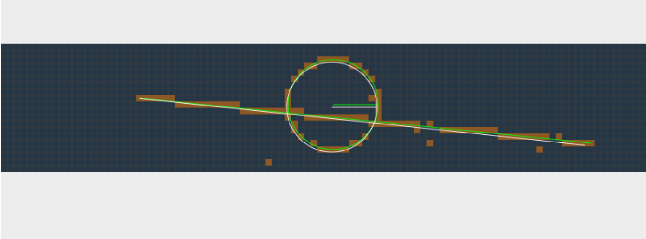

**3 Circles**

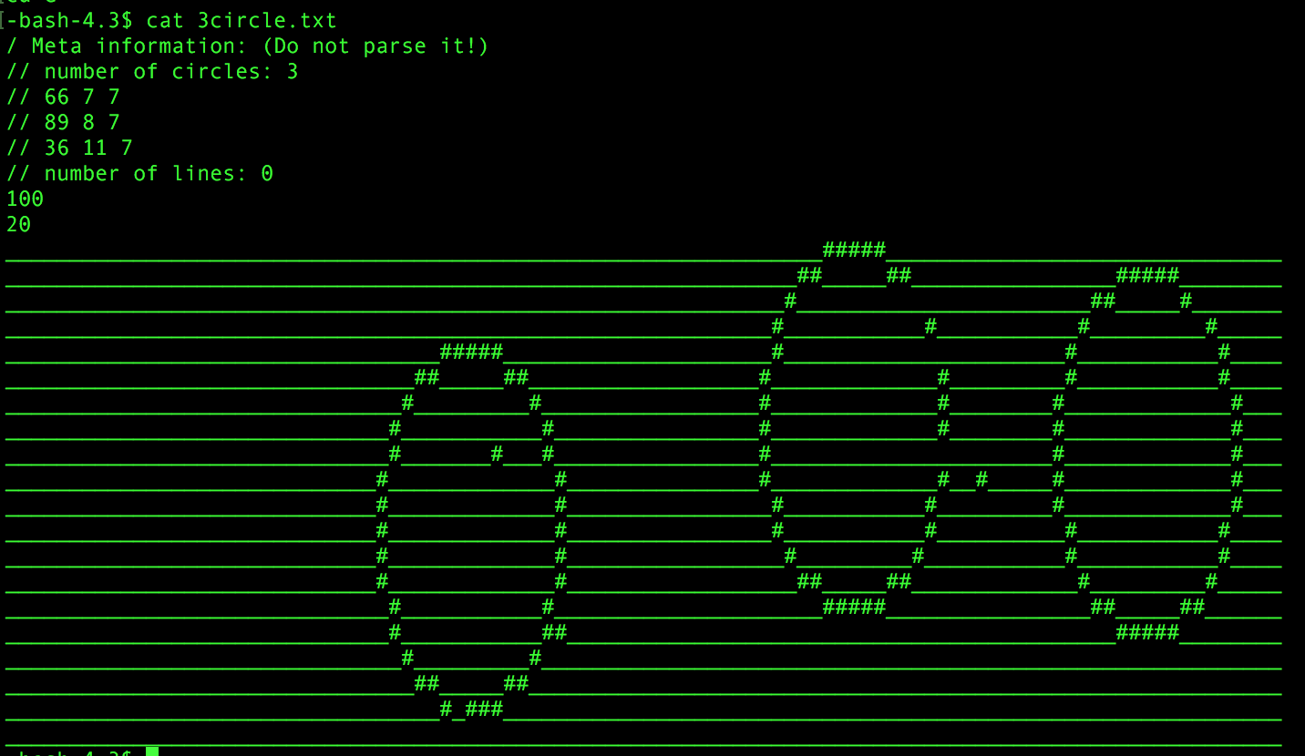

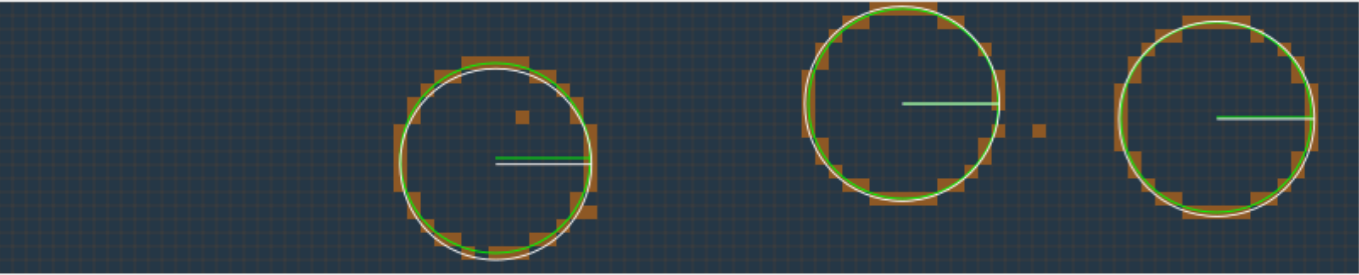

**3 Lines**

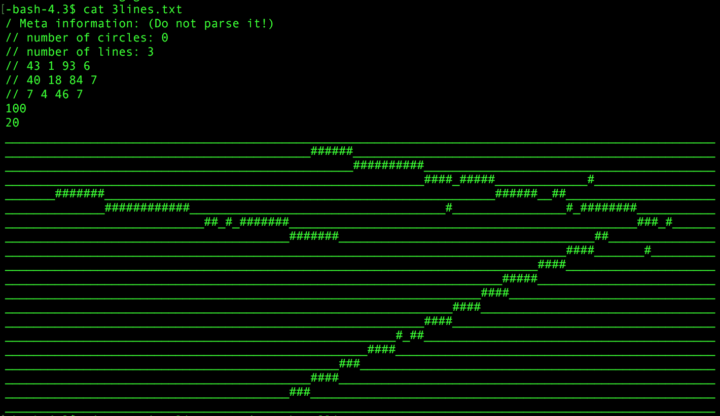

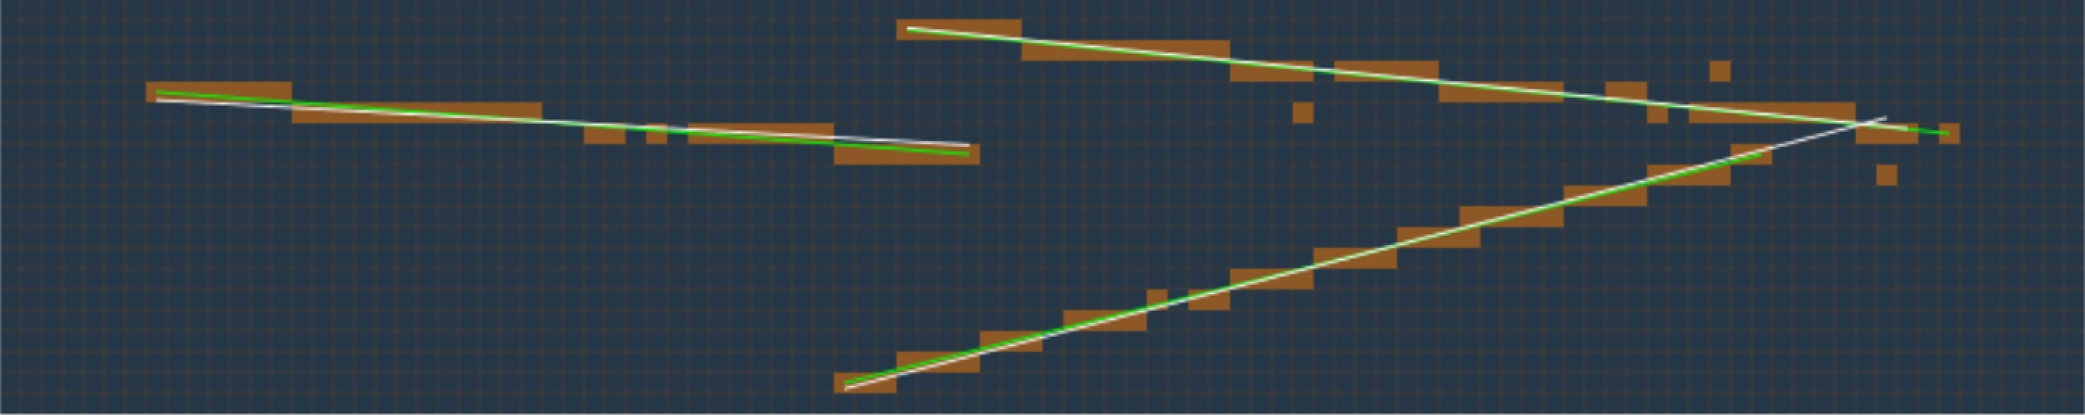

**Complex**

