**2. Problem Statement**

Task 1:

Q- 1. Install Jupyter notebook and run the first program and share the screenshot of the output.

Ans- Open Anoconda Nvigator🡪 Launch jupyter Notebook🡪

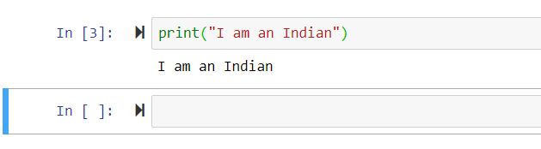

Q-2) Write a program which will find all such numbers which are divisible by 7 but are not a multiple of 5, between 2000 and 3200 (both included). The numbers obtained should be printed in a comma-separated sequence on a single line.

Ans- 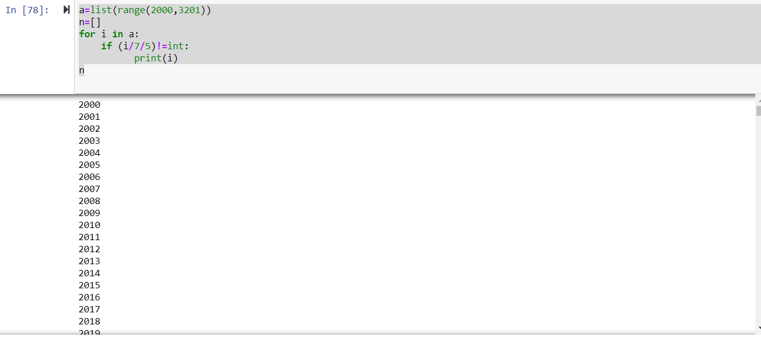

Q-3) Write a Python program to accept the user's first and last name and then getting them printed in the the reverse order with a space between first name and last name.

Ans-

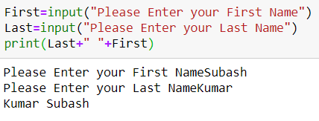

Q-4) Write a Python program to find the volume of a sphere with diameter 12 cm.

Formula: V=4/3 * π * r 3

Ans-

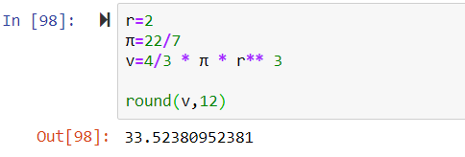

Task 2:

Q-1) Write a program which accepts a sequence of comma-separated numbers from console and generate a list.

Ans- 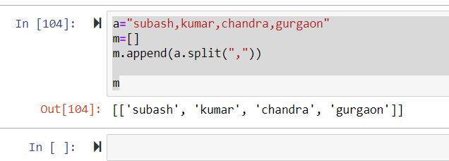

Q-2) Create the below pattern using nested for loop in Python.

Ans-

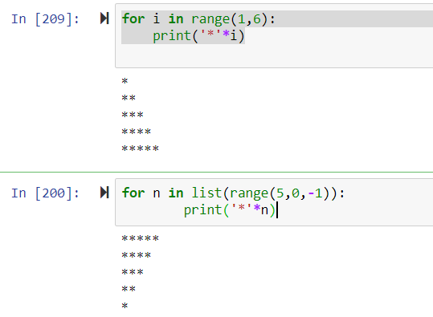

Q-3) Write a Python program to reverse a word after accepting the input from the user

Ans-

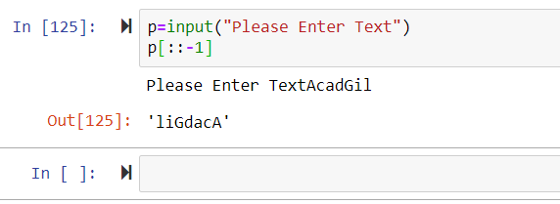

Q-4) Write a Python Program to print the given string in the format specified in the ​sample output.

WE, THE PEOPLE OF INDIA, having solemnly resolved to constitute India into a SOVEREIGN, SOCIALIST, SECULAR, DEMOCRATIC REPUBLIC and to secure to all its citizens

Ans-

