NAAN MUDHALVAN PROJECT DOCUMENTATION
WEATHER WISE
A Weather Information and Forecasting Application
Team Leader: Chandru S
College: Vallal P.T. Lee Chengalvaraya Naicker Arts and Science College
Department: B.Sc. Computer Science
Academic Year: 2026–2027

PROJECT TEAM
No. | Role | Member Name
1 | Team Leader | Chandru S
2 | Team Member | Abishek
3 | Team Member | Chandru S
4 | Team Member | Jeevan Raj
5 | Team Member | Kamalesh

1. ABSTRACT
Weather Wise is a weather information and forecasting application designed to provide users with useful and easy-to-understand weather details. The system can display current weather conditions such as temperature, humidity, wind speed, atmospheric pressure and weather description for a selected location. It can also present forecast information to help users plan daily activities. The project demonstrates user interface design, API integration, data processing and basic software development concepts.

2. INTRODUCTION
Weather affects transportation, agriculture, education, tourism and many daily activities. Weather Wise provides weather information through a simple and user-friendly application. A user can enter a location and obtain weather information in a clear format.
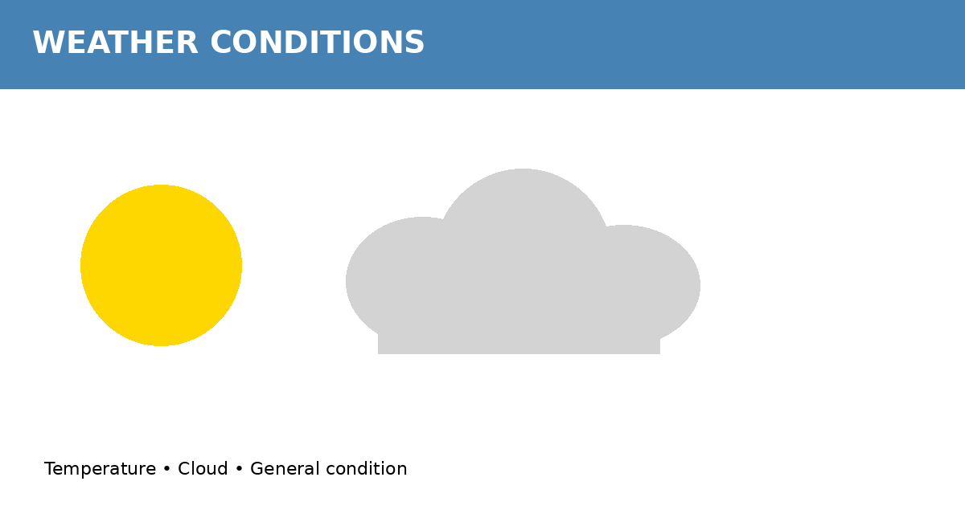
Figure 1: Weather conditions represented in the Weather Wise application.

3. PROBLEM STATEMENT
Users need quick and understandable weather information before planning daily activities. Weather data may be available from different sources, but raw information can be difficult to interpret. Weather Wise brings important weather parameters together in a simple interface.
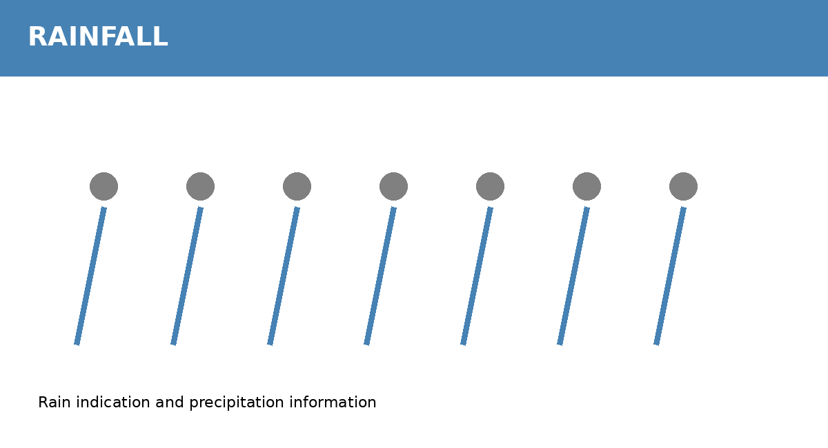
Figure 2: Illustrative rainfall and precipitation information.

4. OBJECTIVES
- To develop a simple and user-friendly weather application.
- To display current weather information for a selected location.
- To provide temperature, humidity, wind speed and other useful parameters.
- To integrate a weather API for obtaining weather data.
- To present weather information in an understandable format.
- To support users in planning activities based on weather conditions.

5. SCOPE OF THE PROJECT
The project focuses on retrieving and presenting weather information for locations selected by the user. The system can later be extended with multi-day forecasts, location detection, weather alerts, historical weather data, charts and mobile notifications.
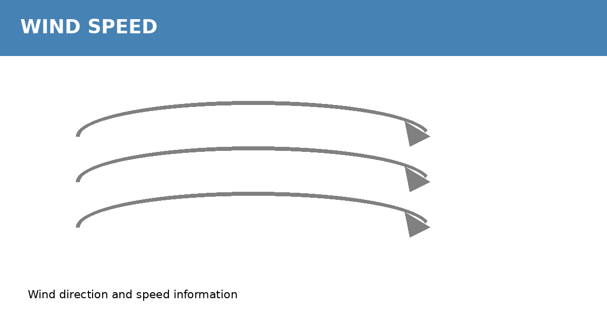
Figure 3: Illustrative wind speed and direction information.

6. EXISTING SYSTEM
Users may depend on television, websites or separate weather applications to obtain weather information. Information may be spread across different sources, and interfaces may contain unnecessary details. This can make quick weather checking less convenient.

7. PROPOSED SYSTEM
Weather Wise provides a centralized interface for viewing weather information. The user enters a city or location, the application sends a request to a weather API, receives weather data, processes the response and displays relevant information.
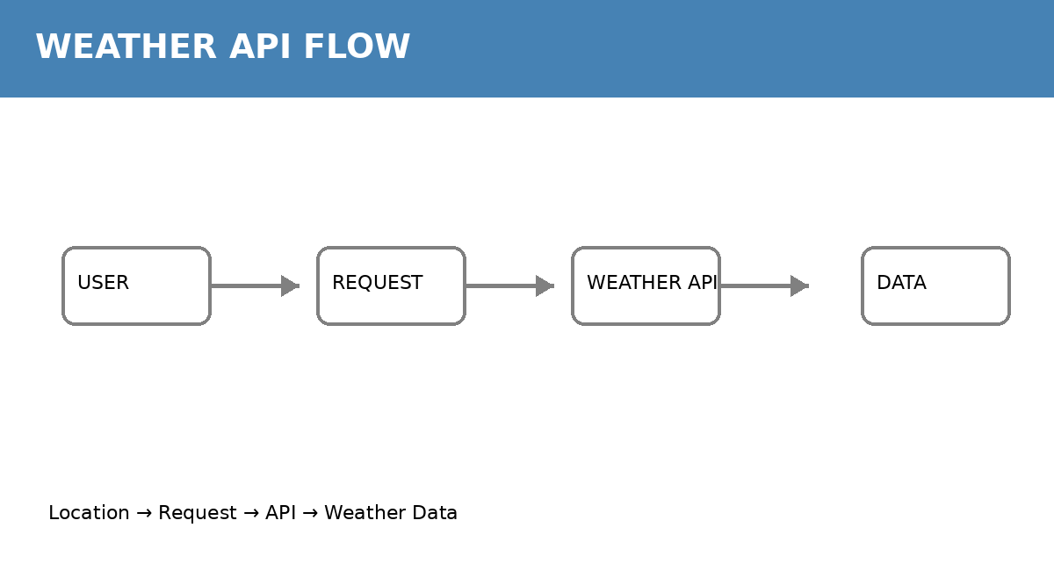
Figure 4: Weather Wise API request and data-flow concept.

8. SYSTEM REQUIREMENTS

8.1 Hardware Requirements
- Computer or laptop
- Minimum 4 GB RAM
- Internet connection
- Keyboard and mouse/touchpad

8.2 Software Requirements
- Windows/Linux/macOS
- HTML, CSS and JavaScript or the framework used
- Suitable weather API
- Google Chrome, Microsoft Edge or equivalent
- Visual Studio Code or equivalent

9. SYSTEM ARCHITECTURE
The basic architecture consists of User Interface → Weather Request → Weather API → Weather Data Processing → Display. The user provides a location, the application sends a request, receives structured data such as JSON, extracts the required fields and displays them.
Figure 5: System architecture and API data flow.

10. MODULES

10.1 User Interface Module
Provides the search box, buttons, weather cards and visual elements through which the user interacts with the application.
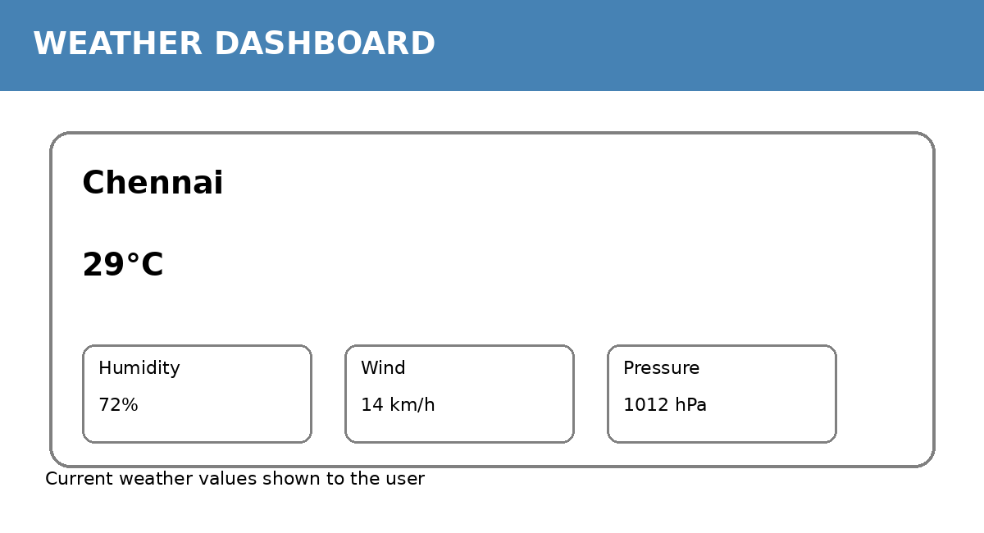
Figure 6: Illustrative Weather Wise dashboard.

10.2 Location/Search Module
Accepts a city or location and validates the input before requesting weather data.

10.3 Weather API Module
Connects the application to a weather-data service and retrieves current or forecast information.
Figure 7: Weather API communication flow.

10.4 Data Processing Module
Processes the API response and extracts values such as temperature, humidity, wind speed and weather condition.

10.5 Weather Display Module
Presents processed weather information in a clear and readable format.
Figure 8: Weather display/dashboard example.

10.6 Error Handling Module
Displays suitable messages when a location is invalid, the network is unavailable or an API request fails.

11. DATA FLOW
1. User enters a location.
2. The application validates the input.
3. A request is sent to the weather API.
4. The API returns weather data.
5. The application processes the response.
6. Weather information is displayed.
7. If an error occurs, an appropriate error message is shown.

12. KEY WEATHER PARAMETERS
Parameter | Meaning | Use
Temperature | Degree of hotness or coldness | Understand heat level
Humidity | Amount of moisture in air | Understand atmospheric moisture
Wind Speed | Speed of moving air | Assess wind conditions
Pressure | Atmospheric pressure | Support weather analysis
Weather Condition | Clear, cloudy, rain, etc. | Quick weather understanding
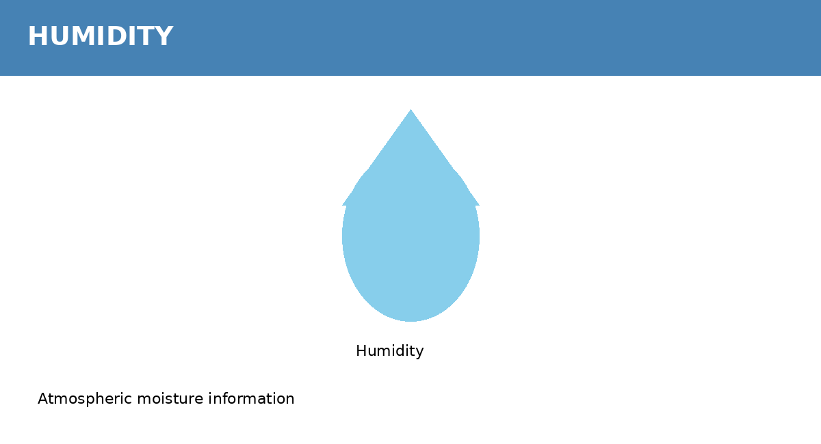
Figure 9: Illustrative humidity information.

13. WEATHER FORECAST
A forecast module can present expected weather conditions for upcoming days. It may display expected temperature, weather condition and other available forecast parameters. Forecast values depend on the selected weather-data service.
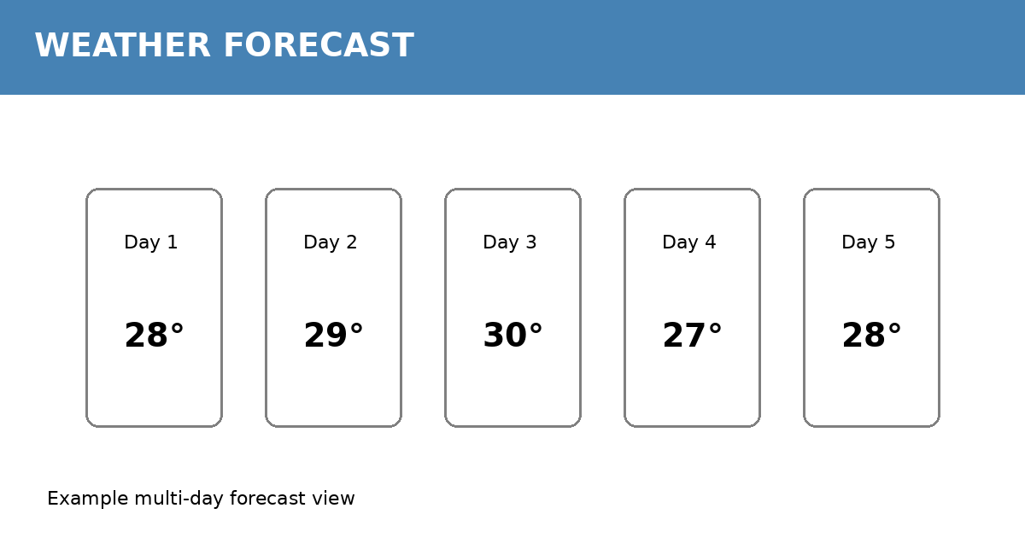
Figure 10: Illustrative multi-day weather forecast.

14. ADVANTAGES
- Simple and user-friendly interface.
- Quick access to weather information.
- Can be used for different locations.
- Reduces the need to check multiple sources.
- Can be expanded with additional weather features.

15. LIMITATIONS
- Weather information depends on the selected API and its data coverage.
- Internet access may be required for live weather updates.
- Forecast accuracy can vary by location and weather conditions.
- API usage may be subject to service limits or authentication requirements.

16. FUTURE ENHANCEMENTS
- Seven-day or extended forecasts.
- Automatic current-location detection.
- Weather alerts and notifications.
- Rain probability and UV index.
- Interactive weather charts.
- Historical weather analysis.
- Mobile application version.
- Multiple-language support, including Tamil.

17. TESTING
The application should be tested with valid locations, invalid locations, empty input, slow or unavailable network connections and API failures. Valid requests should display weather information, while invalid inputs and service failures should produce clear error messages.
Figure 11: Sample screen for testing weather information display.

18. CONCLUSION
Weather Wise is a practical application that demonstrates how weather data can be collected from an online service, processed and presented through a user-friendly interface. The project applies API integration, data handling, user interface development and error handling. With additional features, it can be developed into a complete weather monitoring and forecasting system.

19. REFERENCES
- Official documentation of the weather API used in the project.
- HTML, CSS and JavaScript documentation, if applicable.
- Naan Mudhalvan course/project guidelines provided by the institution.

