README:

1. As Per the given coding assignment I have coded the Concert tickets Project
2. Please import the given project as a Maven project in eclipse
3. Project was built with JDK 8 and Maven 3.0.4
4. A java application has been coded and the project has room for a GUI and a REST API
5. Persistence has been implemented using H2 In memory DB

Solution and Testing:

Once the project is setup in eclipse is completed. Run the TicketDataService class as a Java Application as seen below:

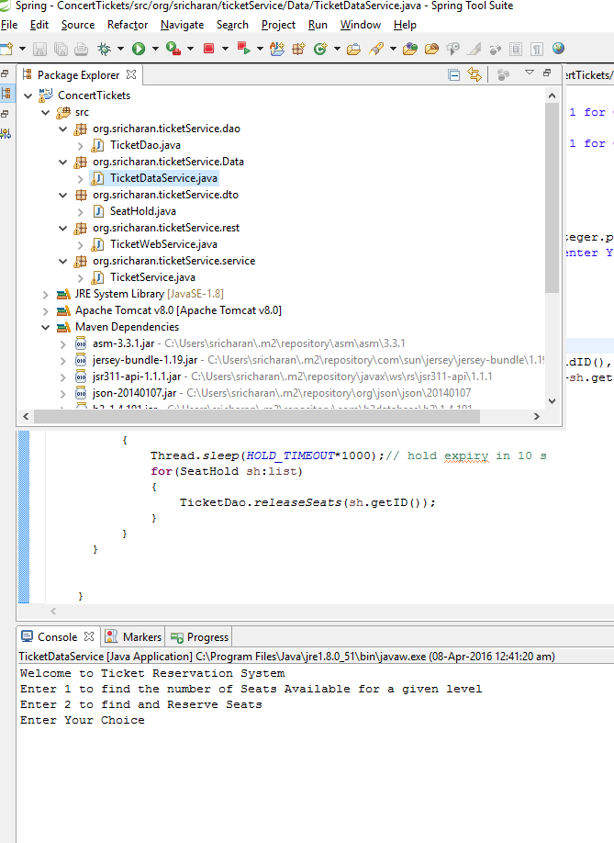

The application returns a dialog menu with options which are self explanatory.

The application can return the number of seats per level in the DB as seen below:

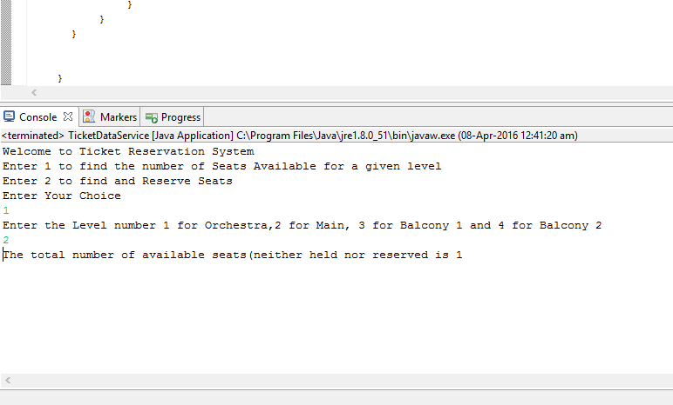

In case of option 2 the reservation is done as seen below:

