How to use RivMaker

# Abstract

To use Rivmaker, please follow the steps below:

1. Import elevation data and water elevation data

2. Draw cross sections

3. Draw Base line

4. Input water surface elevation at cross sections

5. Check the cross section shapes through cross section window

6. Export river survey data as data.riv and data_wse.csv, that can be imported by iRIC.

Currently, 1, 2, 3, are implemented.

Below is how to use RivMaker.

# Import elevation data and water elevation data

You can import elevation data/water elevation data from two file formats:

* *.tpo file
* SAC GUI input files (*.txt)

To import from *.tpo files, use the following menus:

* Import 🡪 Geographic data 🡪 Elevation
* Import 🡪 Geographic data 🡪 Water Surface Elevation

When imported this way, Water surface Elevation is imported as “Arbitrary HWM”, as shown below:

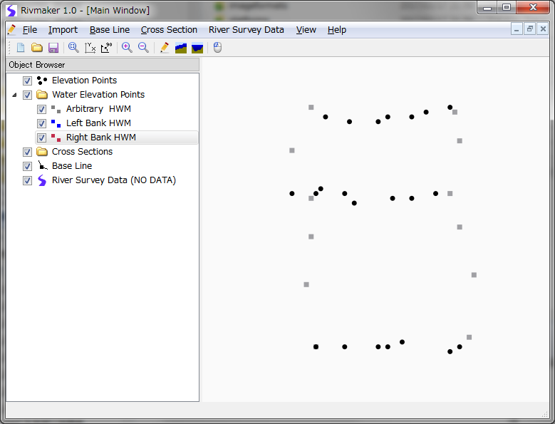

To import from SAC GUI input files, use the following menus:

* Import 🡪 Geographic data 🡪 SAC GUI Input file

When imported this way, Water surface Elevation is recognized correctly as Left bank HWM or Right bank HWM.

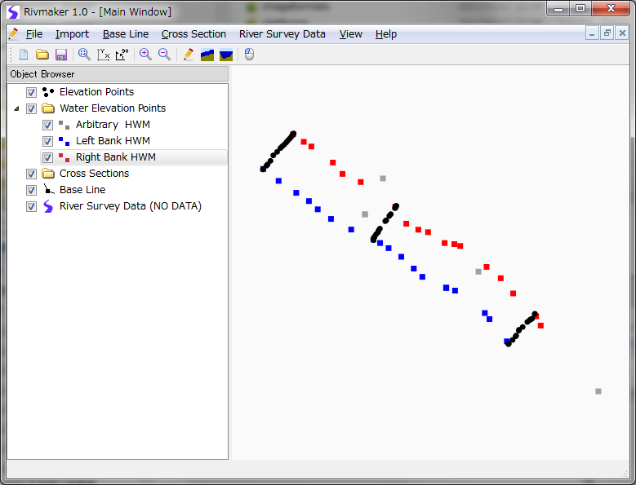

# Draw cross sections

To draw cross sections, follow the step below:

1. Select Cross Section 🡪 Add from menu

2. Drag on MainWindow to define cross sections.

You can repeat the steps to define multiple cross sections.

At last, the main window will be like below:

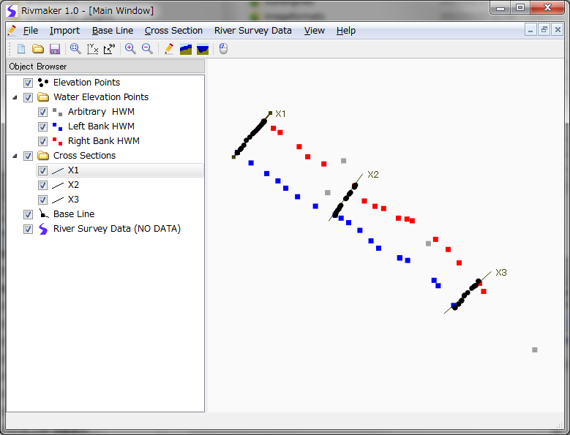

# Draw Base line

To draw base line, follow the step below:

1. Select “Base Line” at Object Browser

2. Click several times to define polyline, and finish defining by double-clicking or pressing Enter key.

At last, the RivMaker will looks like below:

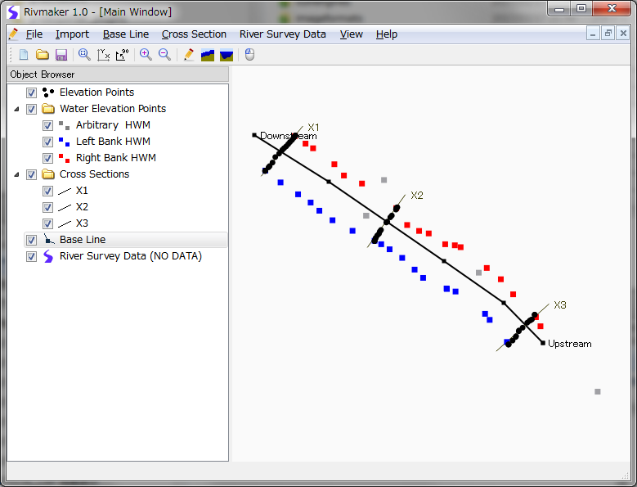

# Input water surface elevation at cross sections

To see high water marks profile, Click on  button at toolbar, to open “Vertical Cross Section Window”.

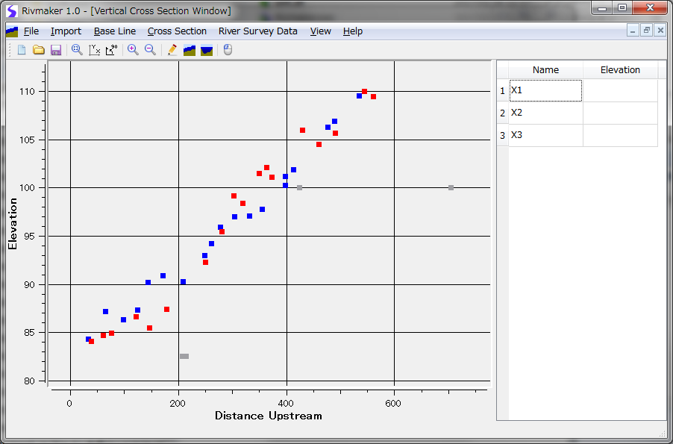

When it is open, You see relationship between Distance Upstream and Elevation.

Here, you can input Water surface elevation values of cross sections, just like on SAC GUI.

**Note:**

This window is not finished, and it is not still possible to input elevation data.